Login to Bluemix

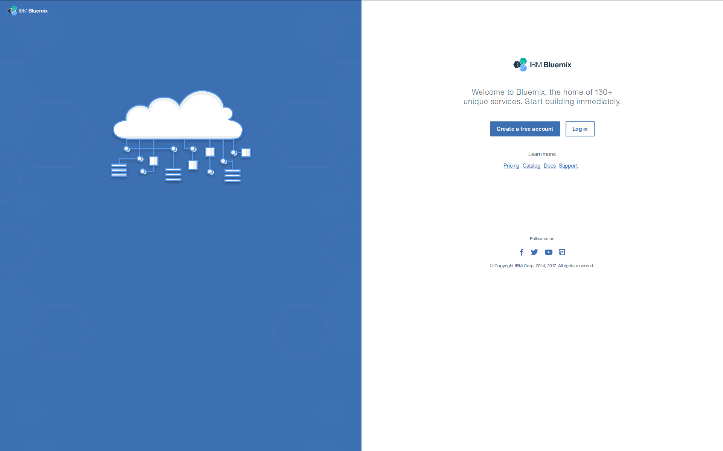
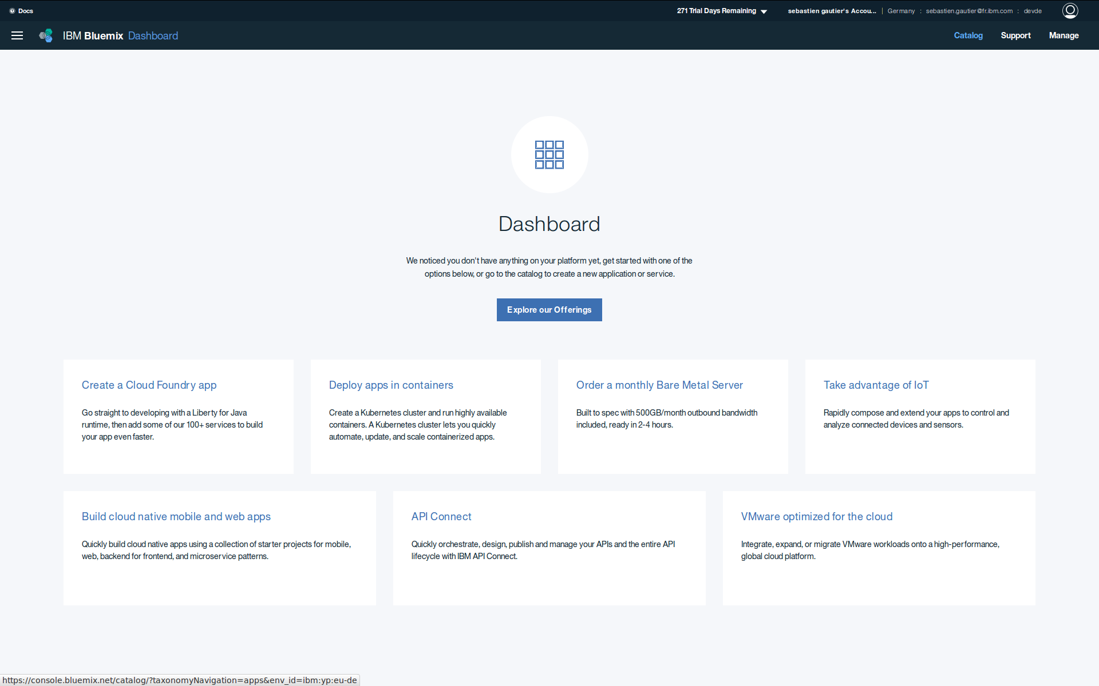
From Dashboard go to Catalog

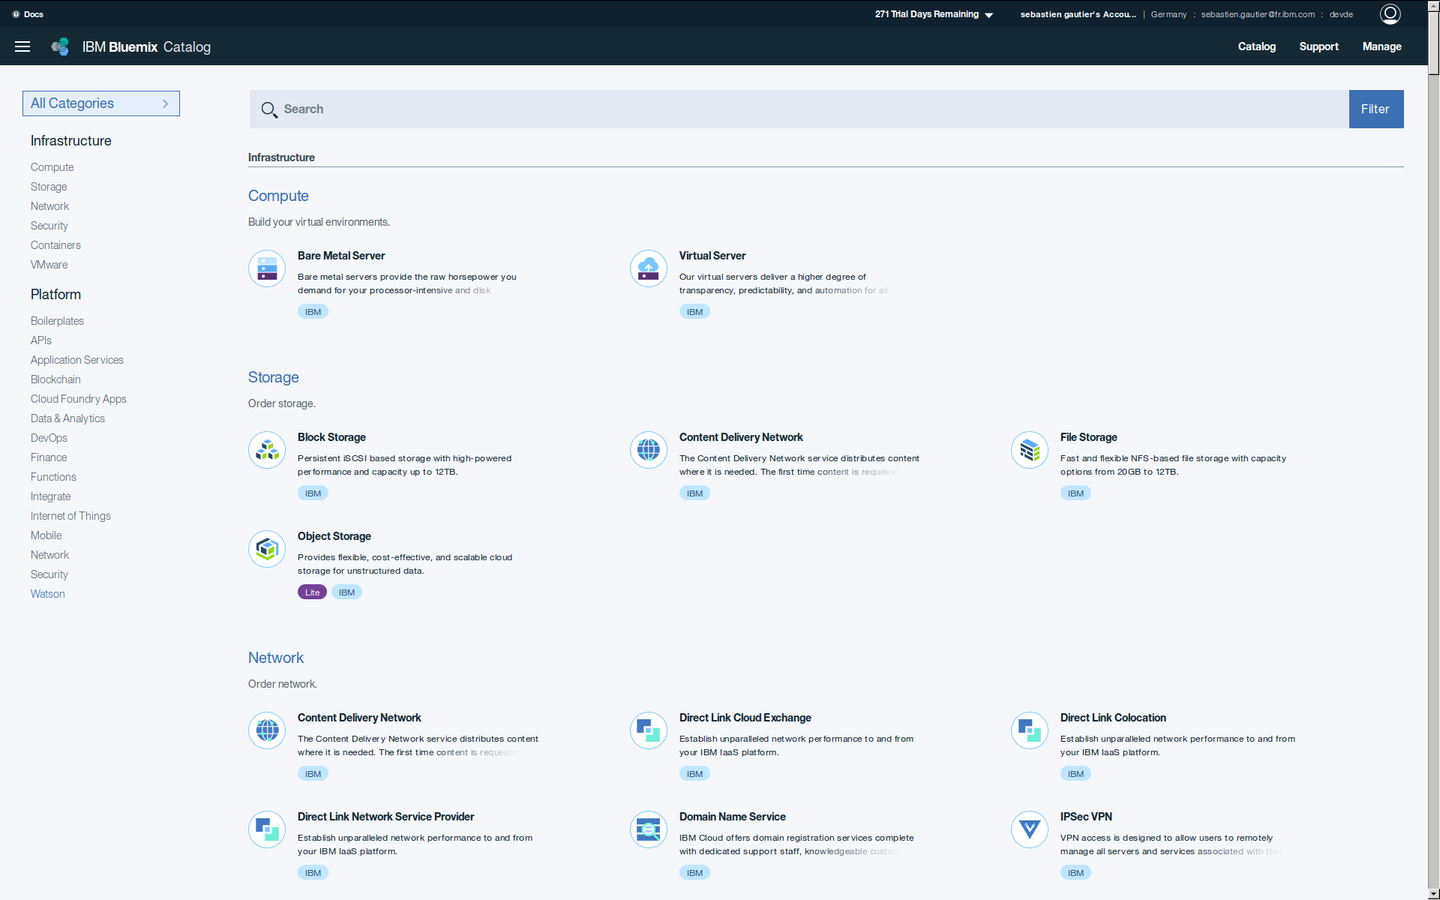
Reach Watson services

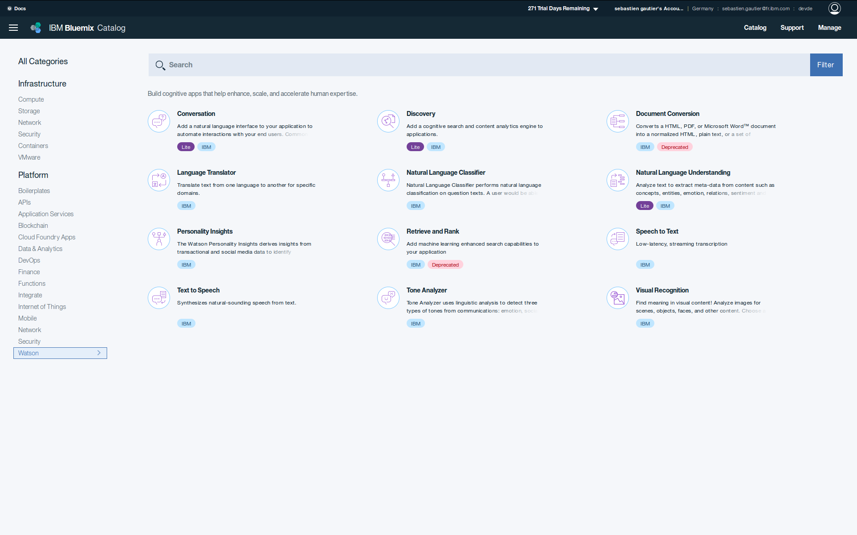
Create Tone Analyzer service ta0 and credential user0

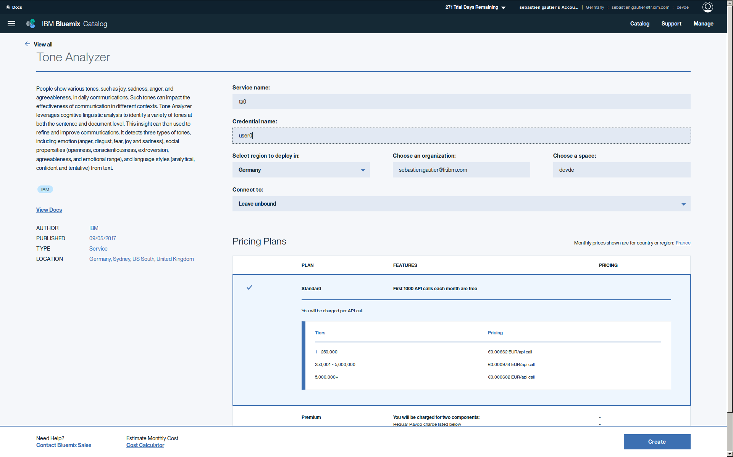
Get Tone Analyzer ta0 credential user0 and save it for future use.

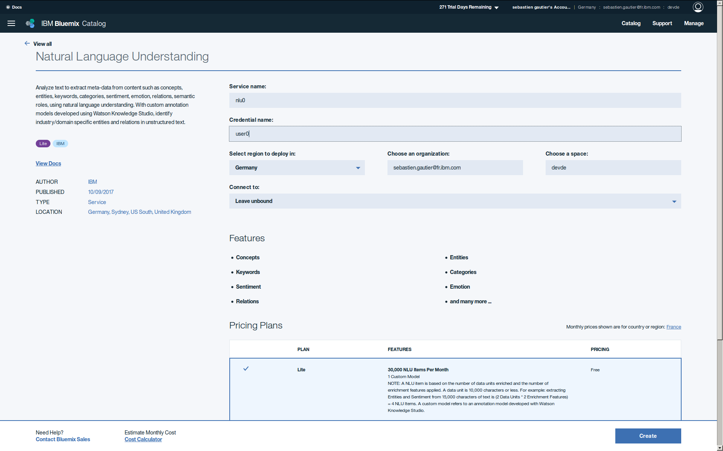
Create Natural Language understanding service nlu0 and credential user0.

Get Natural Language understanding nlu0 credential user0 and save it for future use.

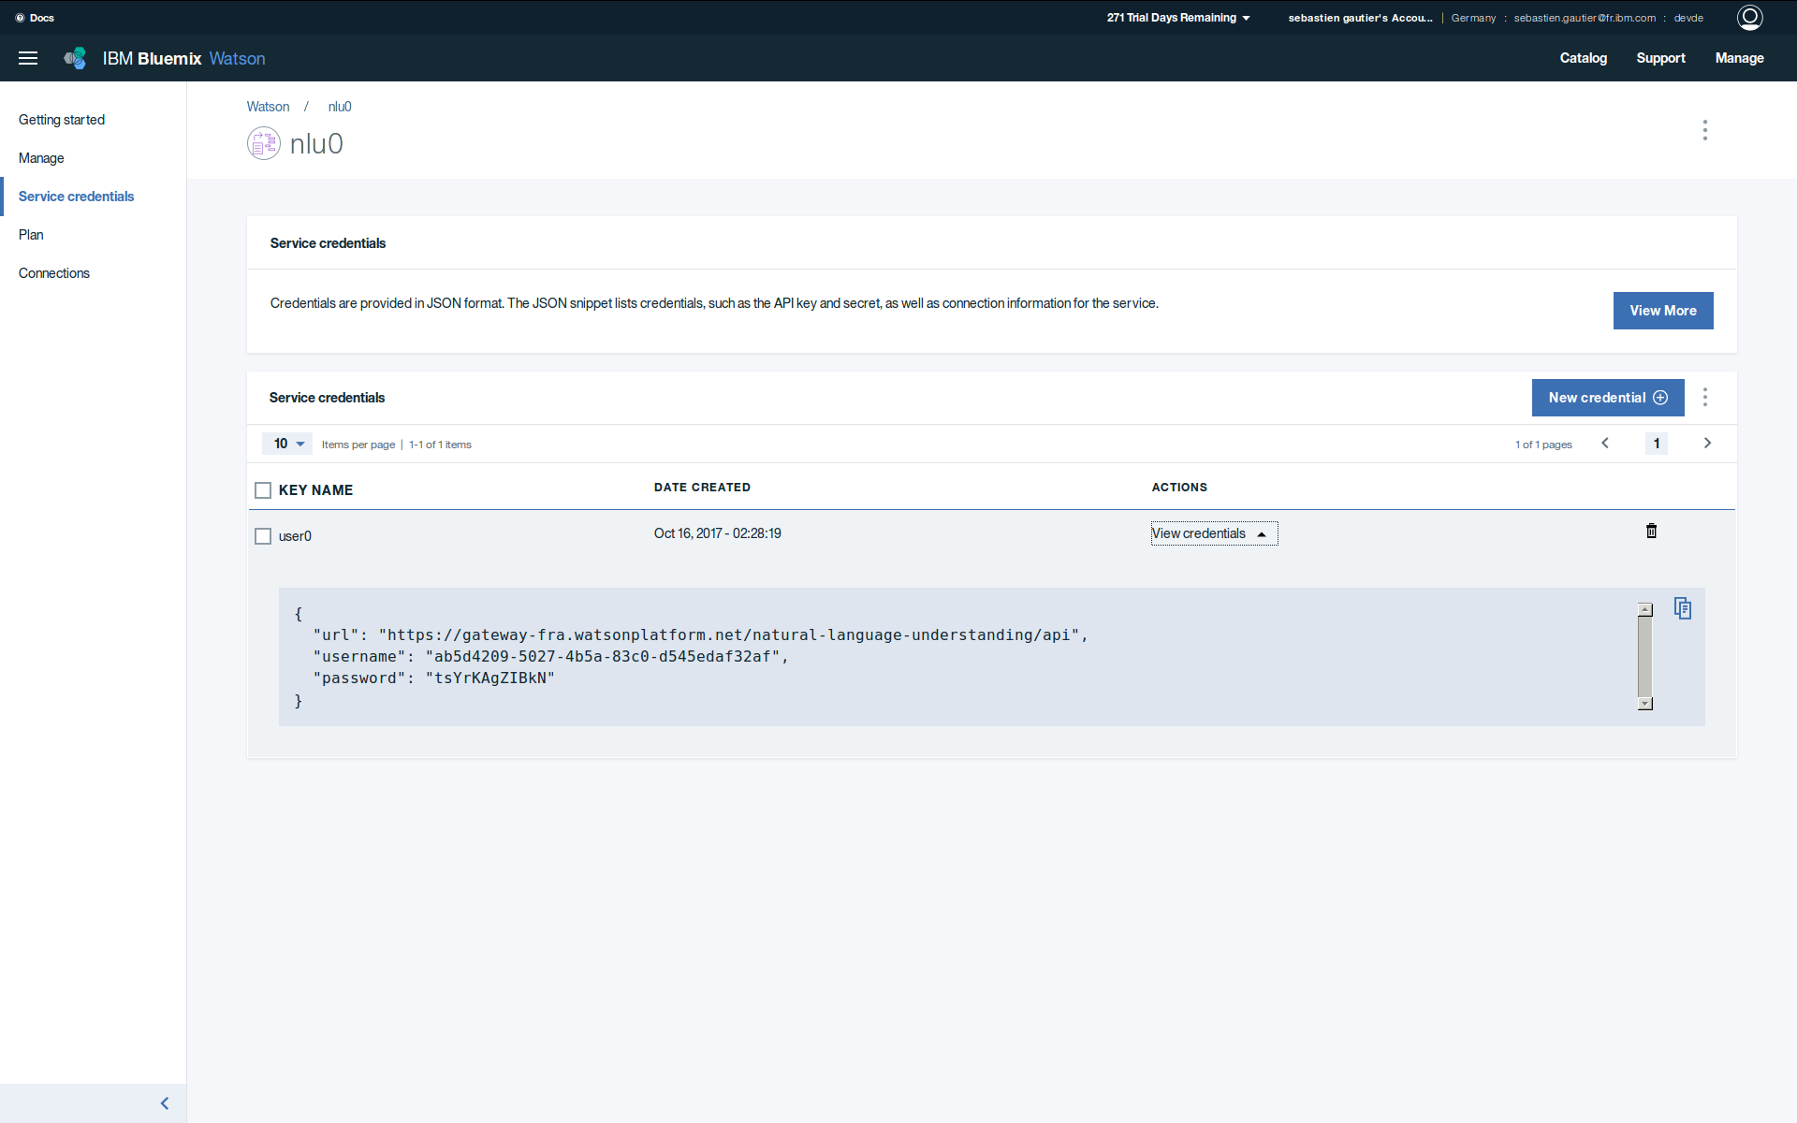
Create Discovery service dsc0

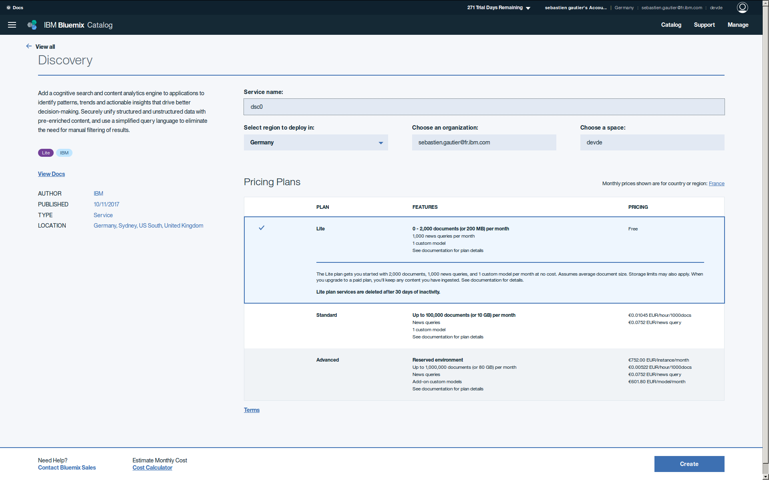
Create Discovery dsc0 credential user0.

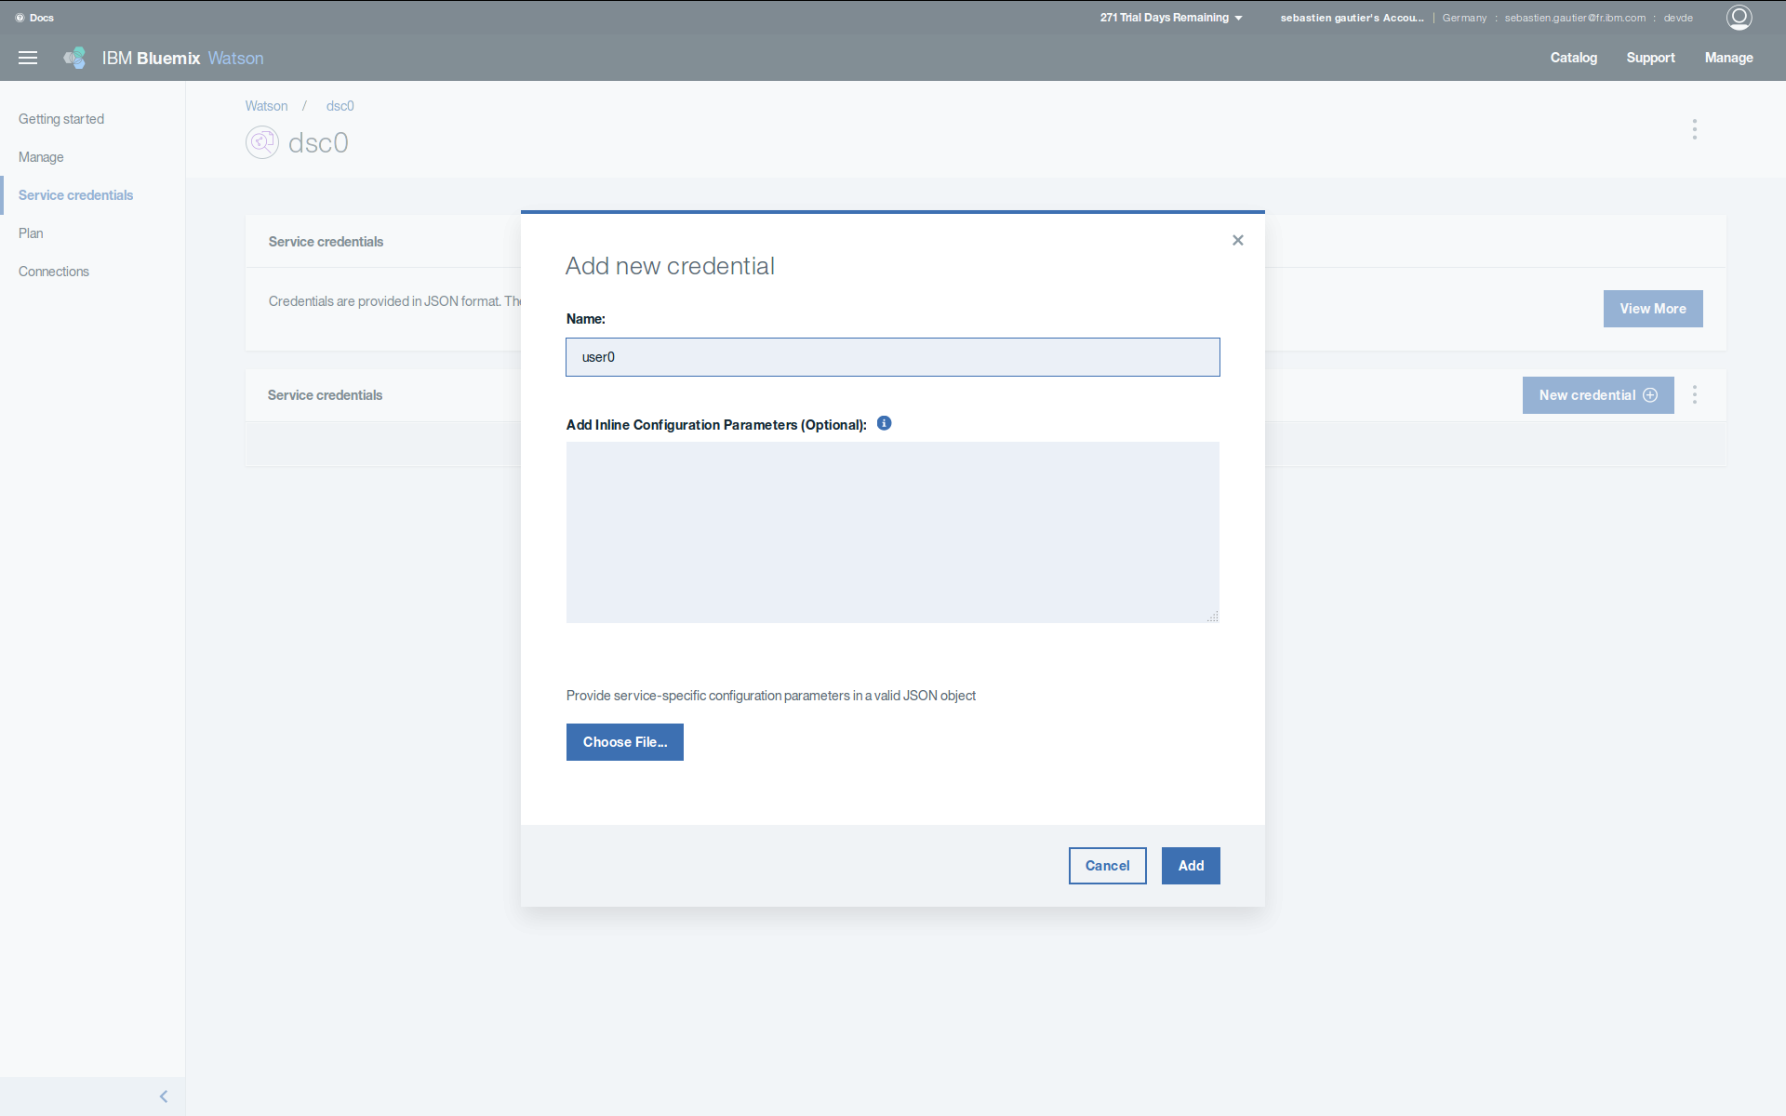

Get Discovery dsc0 credential user0 and save it for future use.

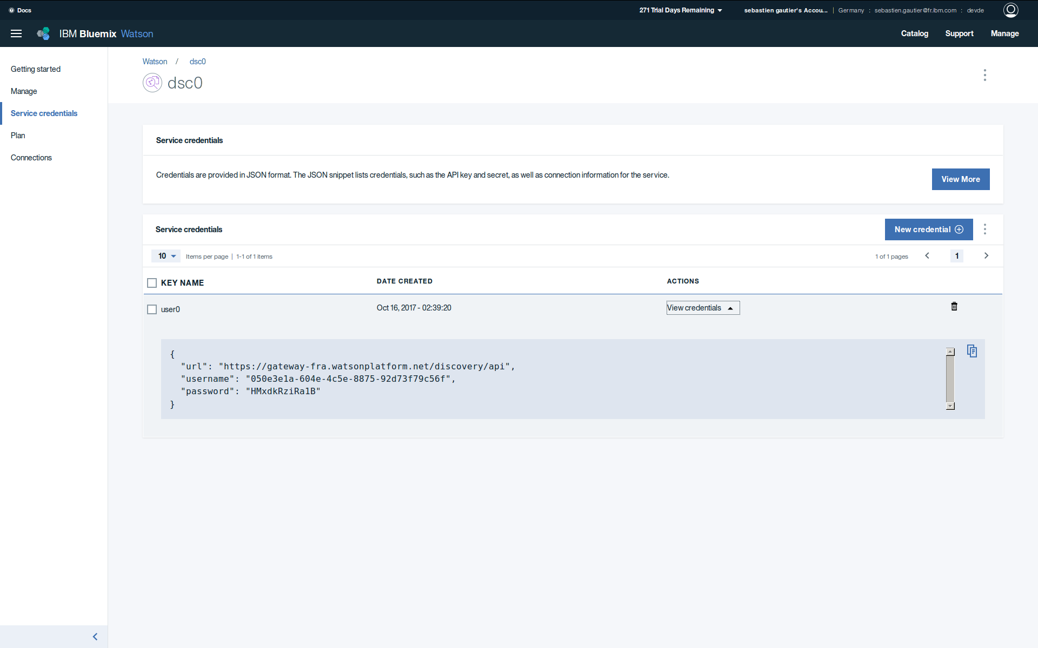
Launch Discovery Tools.

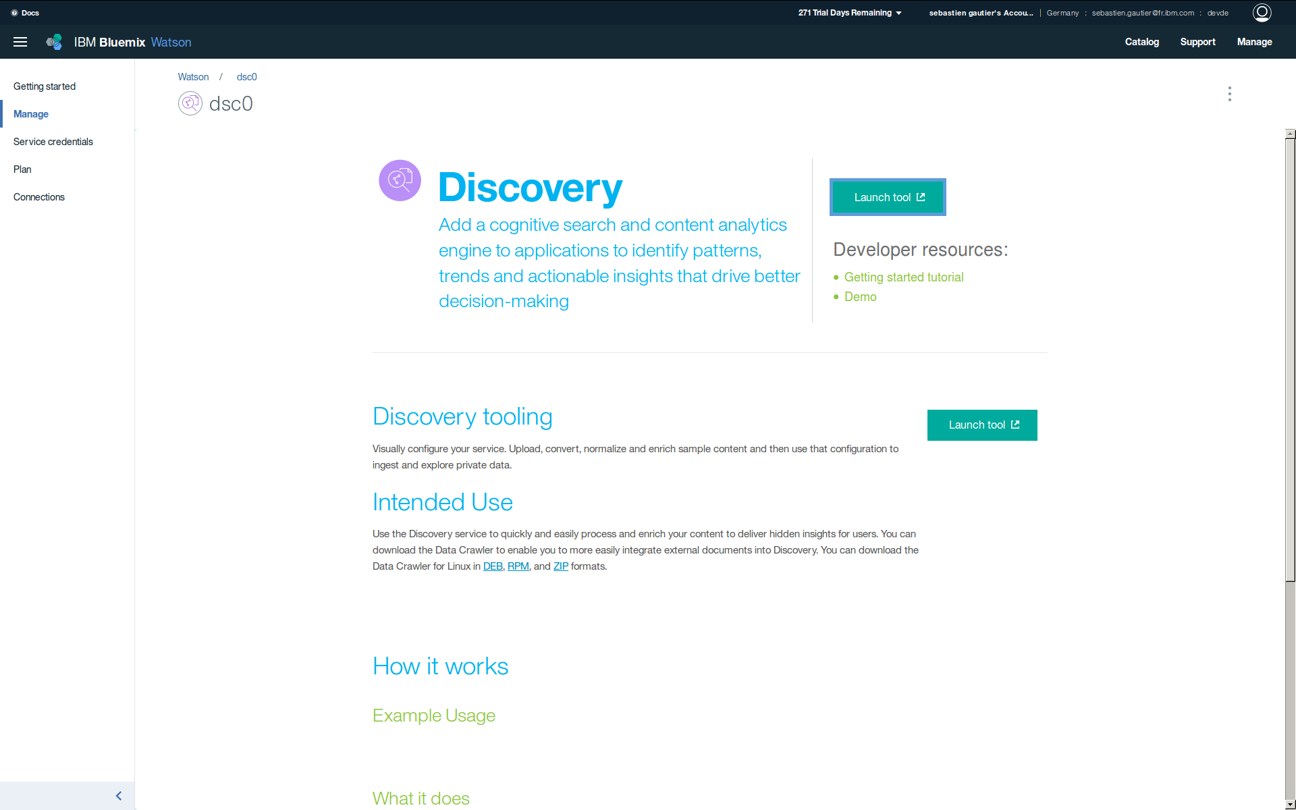
Create Discovery dsc0 collection coll0

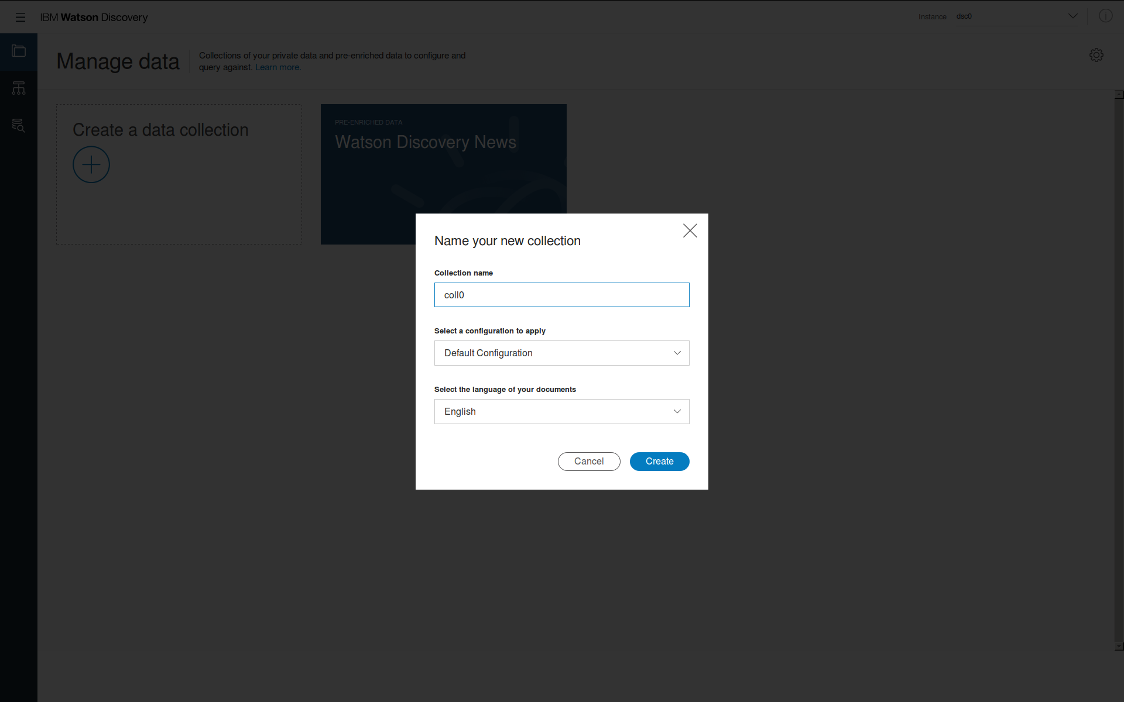
Check ta0, nlu0 and dsc0 services are created in dashboard.

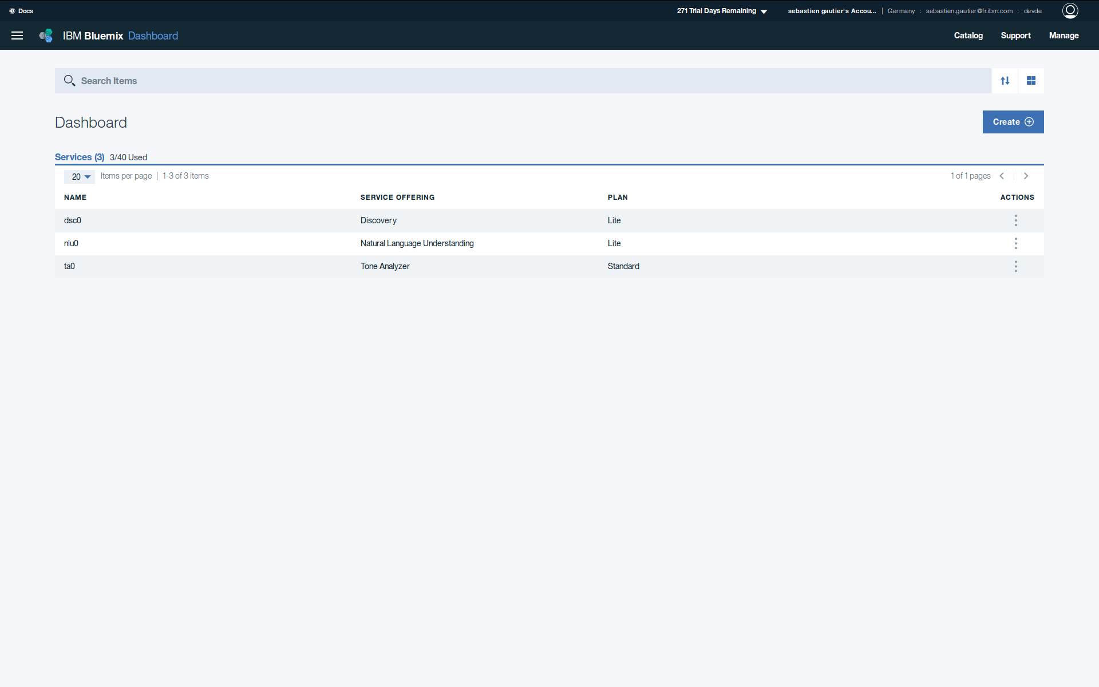
Create Visual Recognition vr0 service and credential user0.

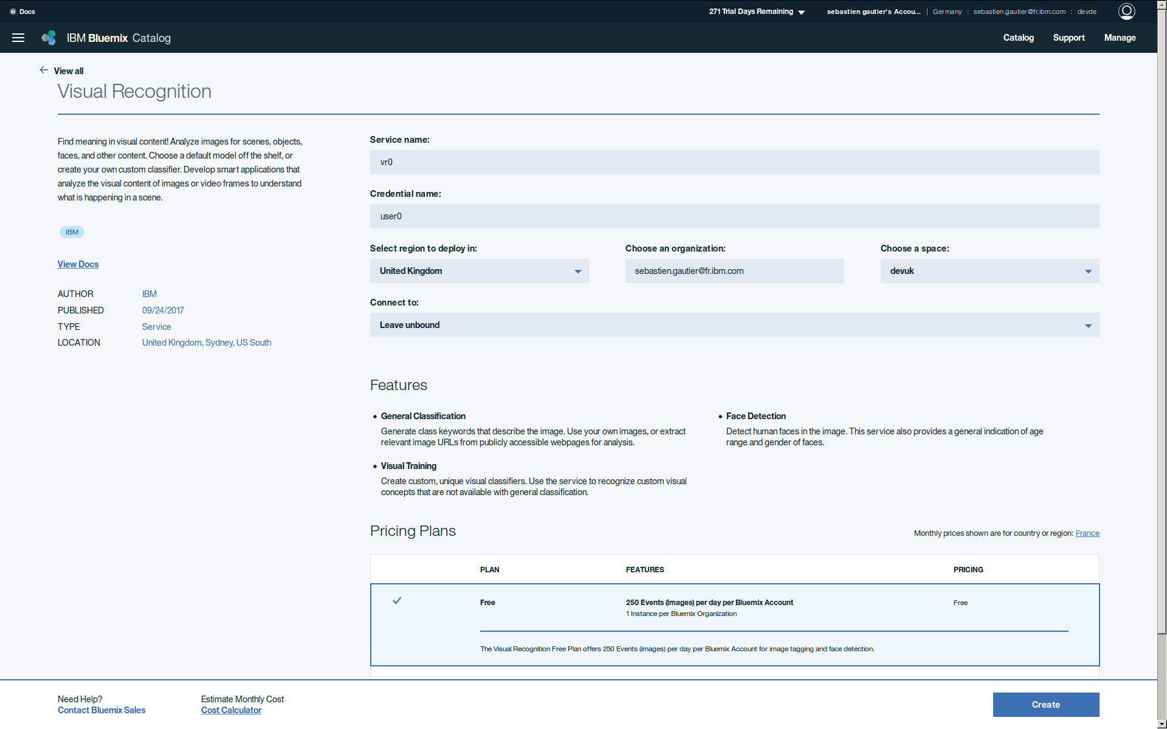
Get Visual Recognition vr0 credential user0 and save it for future use.

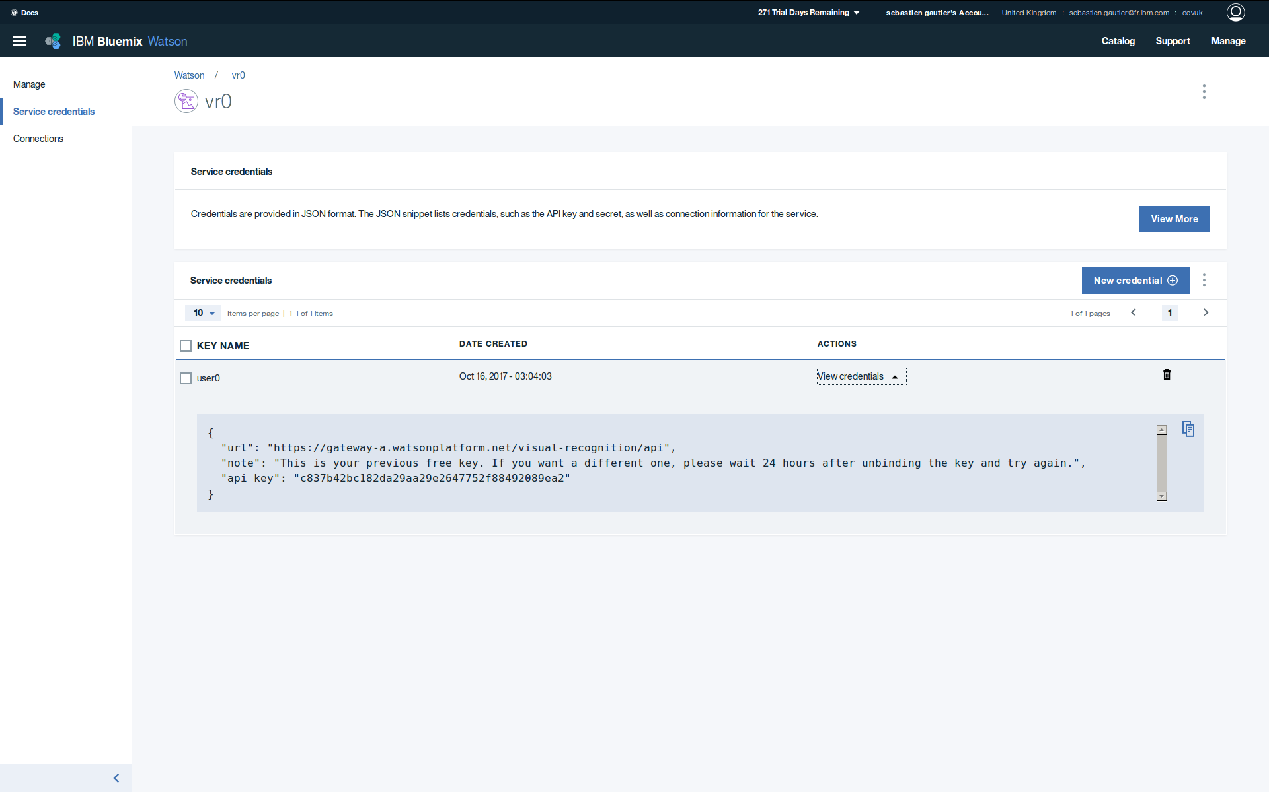
Check Visual Recognition vr0 service is created in dashboard.

