Minimum Noise Fraction with Multi-Directional Noise Estimation for denoising Hyperspectral Imagery

ABSTRACT

The Minimum Noise Fraction (MNF) transform is a widely used method for noise reduction in hyperspectral imaging; conventional one-dimensional noise estimation techniques fail to consider correlation among neighboring pixels, reducing their ability to model noise effectively. Additionally, the standard MNF approach often struggles with low-variance spectral bands due to singular covariance matrices. To address these challenges, this work presents a new Python-based MNF library that introduces a “Three-Pixel” noise estimation method that captures noise in multiple spatial directions and incorporates an adaptive regularization scheme for stable covariance inversion. The experimental results on hyperspectral imagery demonstrate that the proposed strategy consistently improved noise suppression in more that 95% of spectral bands.

Keywords: MNF, Denoising, Hyperspectral Imaging, Multi-Directional Noise, Remote Sensing, SNR

1. INTRODUCTION

Principal Components (PC) [1] transformation has long been used for compression, visualization, and enhancement of multispectral remote sensing data. However, as highlighted by Green [2] in their seminal work, PC transformation did not always produce components ordered by image quality, particularly when noise levels varied across spectral bands. To address this limitation, Green et al. introduced the Minimum Noise Fraction (MNF) transform, which ordered components based on their signal-to-noise ratio (SNR) rather than variance. Due to this property, MNF became a widely used technique for noise reduction and dimensionality reduction [3] in hyperspectral image analysis [4].

Despite its effectiveness, conventional MNF implementations exhibited certain practical limitations. One key issue lay in noise estimation, where noise was typically estimated using only next-pixel (horizontal) differences. This approach did not consider noise variations present in other spatial directions and ignored neighboring pixels. As a result, the estimated noise covariance matrix did not fully capture the true spatial noise characteristics of the hyperspectral images. In addition, when the spectral bands exhibited strong correlation or were nearly homogeneous, the data covariance matrix became ill-conditioned or even singular. Under such circumstances, the standard MNF eigen-decomposition could fail to converge or produce unreliable results, thereby limiting its applicability in practical hyperspectral processing workflows.

In this work, this limitation was addressed by incorporating a neighbor-pixel-based noise estimation approach, in which spatial neighbors were taken into account during noise matrix calculation. In addition, regularization strategies were integrated to mitigate ill-conditioning and numerical instability arising from highly correlated or nearly homogeneous spectral bands. This improved noise estimation and stabilization framework led to a more reliable noise covariance matrix and enhanced the stability and performance of the MNF transform, particularly in line-scanning-based imaging.

To validate the proposed noise estimation technique, a comparative analysis was carried out with the conventional next-pixel method under both Global MNF and Line-by-Line (LBL) [5] [6] processing architectures. The results showed that the LBL approach consistently improved a larger number of spectral bands when a limited number of leading eigenvectors were used, while achieving comparable or better numerical improvement than the conventional MNF approach. These findings demonstrated the effectiveness of the proposed neighbor-pixel noise estimation method for hyperspectral image denoising in both batch and real-time processing [7] frameworks.

2. BACKGROUND

Hyperspectral imaging is a powerful technique that captures information across a large number of spectral bands, enabling detailed analysis of material properties. It has been applied in diverse areas such as remote sensing, food quality inspection, material identification, and biomedical analysis. The high spectral resolution of hyperspectral data, however, makes it highly sensitive to noise, which can arise from sensor electronics, illumination variations, and rapid data acquisition processes.

In many practical systems, particularly push-broom scanners, hyperspectral images are acquired line by line. This acquisition mode introduces additional challenges for noise reduction, especially in real-time processing scenarios such as medical imaging [8], industrial inspection, environmental monitoring, precision agriculture. Further, military applications such as target [9], terrain analysis, and battlefield monitoring [10], where rapid and reliable hyperspectral analysis is critical.

To address these challenges, the Minimum Noise Fraction (MNF) transform has been widely used. MNF separates signal-dominated components from noise-dominated components by leveraging both image and noise covariance matrices. By discarding or smoothing components with low signal-to-noise ratio (SNR), MNF effectively reduces noise while preserving essential spectral information.

Two main MNF processing approaches are commonly employed. Firstly, global MNF processes the entire hyperspectral cube at once, providing accurate noise-signal separation but requiring full access to the image data and significant computational resources. On the other hand, in the line-by-line (LBL) processing approach, MNF [5] performs the transformation per line, allowing real-time or streaming processing but often relying on simplified noise estimation methods, such as next-pixel (horizontal) differences, which may not fully capture spatial noise characteristics.

Conventional MNF methods also face numerical challenges. In datasets with highly correlated or nearly homogeneous spectral bands, the covariance matrix [11] [12] can become ill-conditioned or singular, causing the eigen-decomposition to fail or produce unreliable results. Moreover, traditional noise estimation approaches that consider only horizontal differences often underestimate noise contributions from neighbors, limiting the effectiveness of the transform in line-scanning applications.

This work has addressed these limitations by developing neighbor-pixel-based noise estimation techniques, which incorporate information from surrounding pixels to compute more accurate noise covariance matrices. Regularization methods have also been applied to stabilize eigen-decomposition in cases of ill-conditioned data, improving both the reliability and performance of MNF transformations in both global and line-by-line processing scenarios.

3. THEORY

The Minimum Noise Fraction (MNF) transform is a widely used linear technique for separating signal and noise in hyperspectral images. Let the hyperspectral dataset be represented as a matrix Y ∈ ℝᴮˣᴽ, where B denotes the number of spectral bands and P is the total number of pixels. The observed image is assumed to consist of the true signal S with additive noise N, expressed as

$Y=S+N.$ (1)

For MNF processing, the data are first mean-centered to obtain the zero-mean matrix Z. The transformation matrix is then derived by solving the generalized eigenvalue problem

$Σ_{N}\overline{a}=λΣ\overline{a},$ (2)

where Σ and Σₙ denote the image covariance matrix and noise covariance matrix, respectively. The resulting eigenvectors form the MNF basis, and the components are automatically ordered from high to low signal-to-noise ratio (SNR). Thus, the first few components generally contain most of the useful spectral information, whereas the later components are dominated by noise.

A denoised reconstruction is obtained by retaining only the first r high-SNR components. The corresponding inverse transform can be written as

$Z^{∗}={\left(A^{−1}\right)}^{T}RAZ,$ (3)

where A is the forward MNF transform matrix and R is a diagonal matrix that preserves only the selected components. In practice, the noise covariance Σₙ is estimated using simple pixel differences under the assumption that neighboring pixels are spatially correlated. This is given by

$n_{b,p}=\left(y_{b,p}−y_{b,p+1}\right),$ (4)

This is referred as next pixel noise estimation (NPNE) in this paper.

4. THREE-PIXEL NOISE ESTIMATION

In conventional MNF implementations, noise was typically estimated using only horizontal differences between neighboring pixels, which did not fully capture the spatial variability in hyperspectral images. Noise can arise from multiple sources, including sensor electronics, illumination variations, sensor or scene motion, fast data acquisition, and environmental factors, often causing variations in multiple spatial directions.

To address this, a three-pixel noise estimation (TPNE) method is proposed, incorporating horizontal, vertical, and diagonal differences. Consecutive lines in push-broom scanners naturally provide vertical neighbors, which are used to improve noise estimation accuracy. By combining differences along three directions, the estimated noise better represents true spatial variability and produces a more stable noise covariance matrix, which is critical for regularized MNF transformations, especially in datasets with highly correlated or nearly homogeneous spectral bands.

In the Line-by-Line (LBL) processing architecture, future lines are unavailable during processing. The method therefore uses the previously acquired line to compute vertical and diagonal differences, enabling integration into the LBL framework while maintaining real-time processing capabilities and providing more accurate noise estimation than horizontal-only approaches.

4.1 Three Pixel Noise Estimation Method

The proposed TPNE method follows the same MNF theoretical framework described above in the theory section. The signal model, generalized eigenvalue formulation, and reconstruction process remain unchanged and are governed by Eqs. (1)–(3). The only modification introduced by the proposed approach lies in the estimation of the noise matrix, which directly influences the noise covariance matrix used in the MNF transform. The estimation of the noise covariance matrix is presented in Algorithm 1.

Algorithm 1 Three-Pixel Noise Estimation (TPNE) for Hyperspectral Data
Require: Image Y, where Y[l] ∈ ℝᴮˣˢ for l = 0, …, L − 1
Ensure: Noise matrices N[l] ∈ ℝᴮˣ⁻¹
1: for l=0 to L−2 do
2: h ← Y[l][:, 0:S−1] − Y[l][:, 1:S]
3: v ← Y[l][:, 0:S−1] − Y[l+1][:, 0:S−1]
4: d ← Y[l][:, 0:S−1] − Y[l+1][:, 1:S]
5: N[l] ← 1/3 (h + v + d)
6: end for
7: return N

5. PERFORMANCE METRICS

In the present study, the quantitative metrics employed to assess the quality of individual spectral bands include band variance and signal-to-noise ratio (SNR). These matrices are utilized as no ground truth data is required for analysis.

Let B denote the total number of spectral bands and N denote the number of spatial samples (pixels) in each of the bands. Let xᵇ(i) represent the reference signal value of the i-th pixel in band b, and x̂ᵇ(i) represent the corresponding reconstructed or estimated value.

5.1 Band Variance

The variance of band b is defined as

$σ_{b}^{2}=\frac{1}{N}\sum_{i=1}^{N}{{\left(\hat{x_{b}}\left(i\right)−μ_{b}\right)}^{2}},$ (5)

and the corresponding standard deviation is

$σ_{b}=\sqrt{σ_{b}^{2}}.$ (6)

Under the additive noise assumption Eq. (1) the observed band variance satisfies

$Var\left(Y_{b}\right)=Var\left(X_{b}\right)+Var\left(N_{b}\right).$ (7)

After noise removal, the variance of the denoised band decreases due to suppression of the noise component, while the underlying signal variance is largely preserved.

5.2 Signal-to-Noise Ratio (SNR)

The band-wise Signal-to-Noise Ratio (SNR) is defined as the ratio of the mean value of the band to its standard deviation:

${SNR}_{b}=\frac{μ_{b}}{σ_{b}}.$ (8)

6. EXPERIMENTAL SETUP

6.1 Dataset

The experiments were conducted on a high-resolution hyperspectral dataset comprising 40 contiguous spectral bands. The imagery was provided on a spatial grid with a pixel size of 15 cm (0.15 m × 0.15 m).

6.2 Hardware Configuration

All experiments were conducted on a system equipped with an Intel® Core™ i5-9300H processor operating at 2.40 GHz and 8 GB of RAM. Computation and visualization tasks were supported by an NVIDIA GeForce GTX 1050 GPU (cuBLAS) [13]. The system ran a 64-bit Ubuntu 22.04 LTS operating system.

7. RESULTS AND ANALYSIS

To validate the effectiveness of the proposed noise estimation technique, a detailed comparative analysis was performed between the TPNE method and the conventional next-pixel approach (NPNE). This comparison was carried out by varying the number of inverse bands that correspond to the leading eigenvectors obtained from the MNF transformation. Both noise calculation methods were evaluated using two different processing architectures. The first was the global MNF (MNF) approach, in which the entire image was processed simultaneously using global statistics. The second was the line-by-line (LBL) approach, in which statistical parameters were updated incrementally as each line of the image was processed, making it suitable for real-time or streaming applications.

Performance comparison was first analyzed on the basis of the number of bands that showed improvement. When the first two eigenvectors were used as inverse bands, the LBL approach demonstrated improvements in 35 spectral bands. When the number of inverse bands was increased to three, the performance of the LBL approach improved further, with enhancements observed in 39 bands. In this configuration, the LBL approach slightly outperformed the global MNF approach, which showed improvements in 37 bands. When the first four eigenvectors were employed, the LBL approach maintained consistent performance, continuing to improve 39 bands. In contrast, the global MNF approach exhibited stable behavior, with improvements observed in 38 bands.

In addition to the number of improved bands, the numerical improvement values were also examined and found to follow a similar trend. As depicted in Figure 1, for Band 30, when the first two eigenvectors were used, the LBL approach achieved an improvement of 7.53%, which was higher than the improvement of 5.97% obtained using the global MNF approach. When the first three eigenvectors were considered, the improvement produced by the LBL approach decreased to 4.66%, while the improvement obtained using the global MNF approach remained nearly unchanged at 5.95%. Similarly, as presented in Figure 2, for Band 33, using the first two eigenvectors, the LBL approach resulted in an improvement of 5.53%, whereas the global MNF approach achieved a substantially lower improvement of 1.80%.

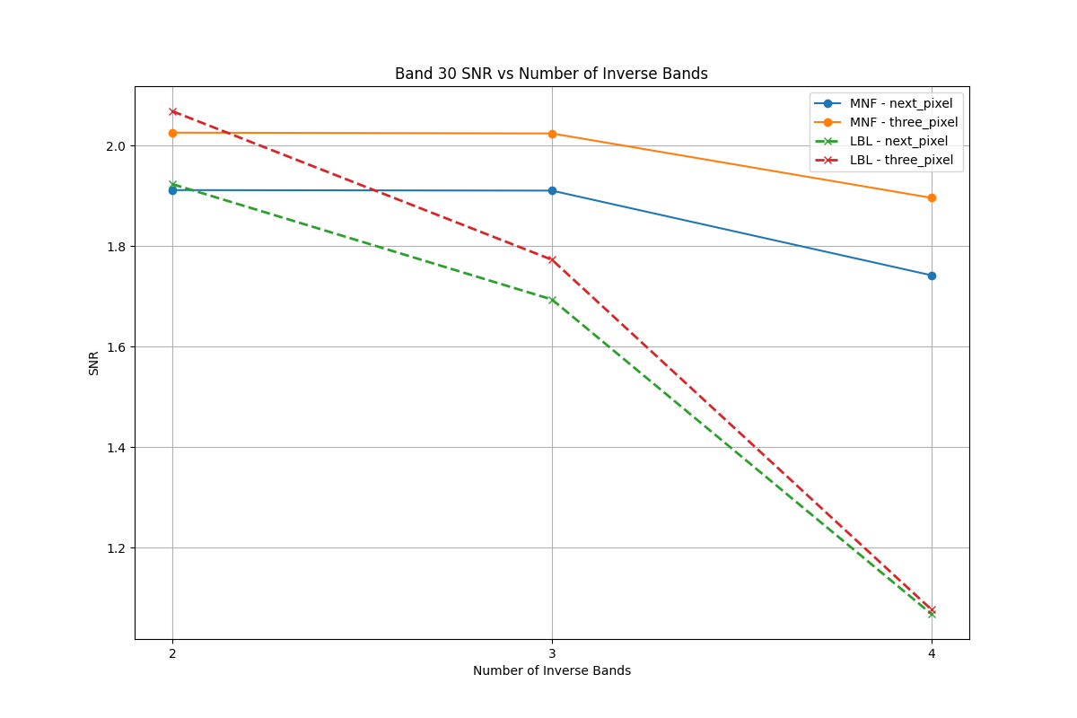

Figure 1: SNR comparison of Band 30
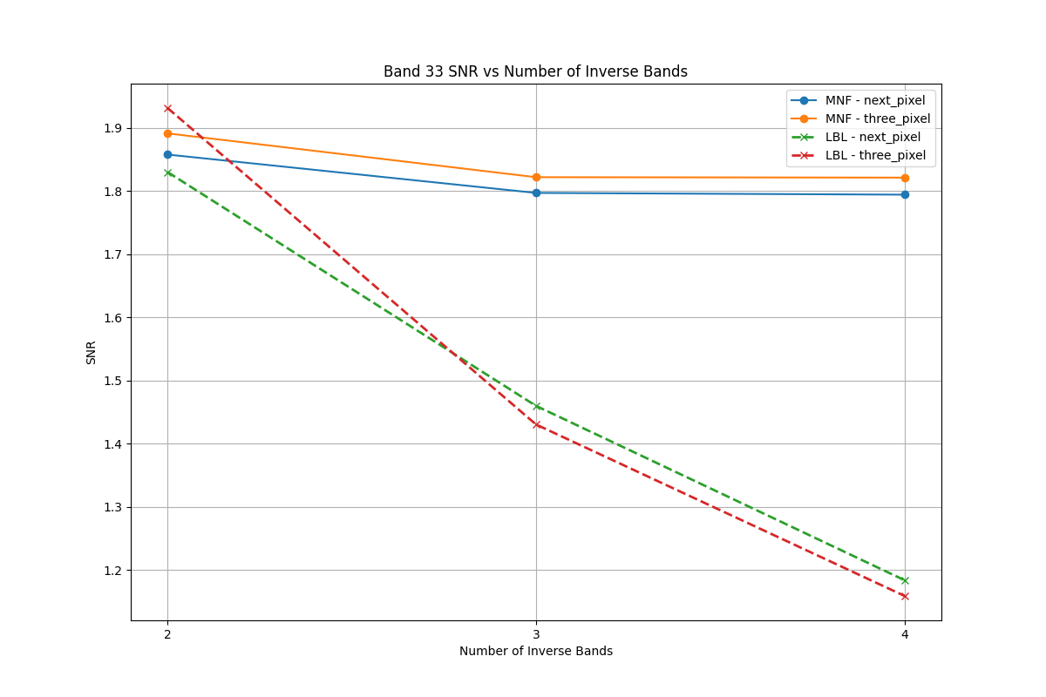

Figure 2: SNR comparison of Band 33

Table 1: Noise estimation variance using the LBL.
Band | Inv. Bands | NPNE | TPNE
30 | 2 | 0.0088 | 0.0077
 | 3 | 0.0119 | 0.0105
 | 4 | 0.0256 | 0.0252
33 | 2 | 0.5571 | 0.4723
 | 3 | 0.8488 | 0.8641
 | 4 | 1.1874 | 1.2349

Table 2: Noise estimation variance using the Global MNF.
Band | Inv. Bands | NPNE | TPNE
30 | 2 | 0.0127 | 0.0113
 | 3 | 0.0128 | 0.0114
 | 4 | 0.0153 | 0.0130
33 | 2 | 0.5655 | 0.5457
 | 3 | 0.6044 | 0.5880
 | 4 | 0.6063 | 0.5884

From Tables 1 and 2, it is observed that the TPNE method consistently produces lower noise variance than the conventional next-pixel method across all bands and inverse band configurations. This reduction is evident for both Line-by-Line (LBL) and Global MNF processing, indicating that the TPNE approach provides a more reliable and stable noise estimate by better suppressing spatially correlated signal components.

Figure 3 to 6 presents the output spectral information for Band 30 and Band 33 in grayscale for the conventional next-pixel noise estimation method, and the proposed TPNE method. The TPNE approach exhibits visibly improved noise suppression and enhanced structural clarity compared to the next-pixel method, while better preserving spatial details in both the bands.

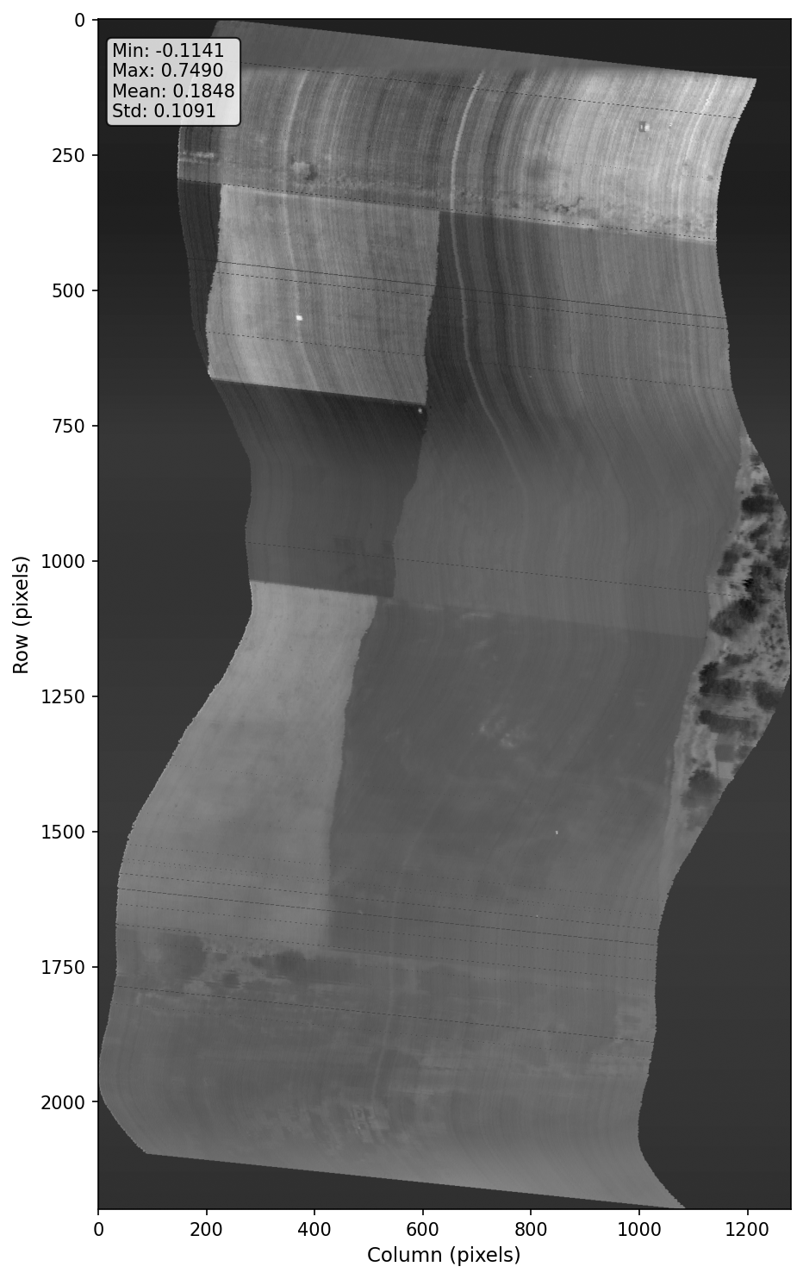

Figure 3: NPNE Band 30
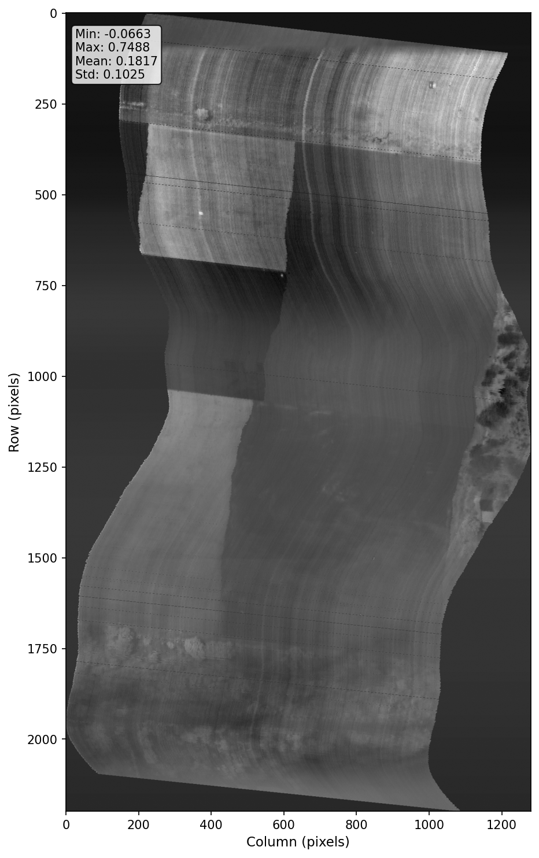

Figure 4: TPNE of Band 30

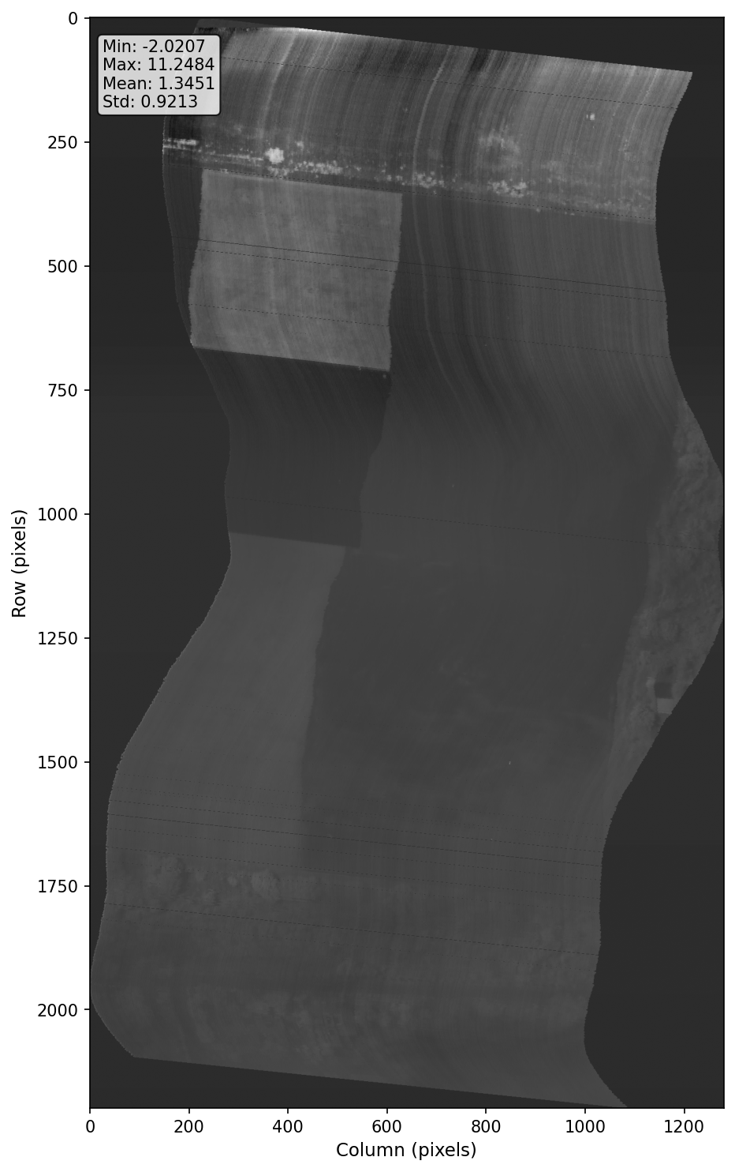

Figure 5: NPNE Band 33
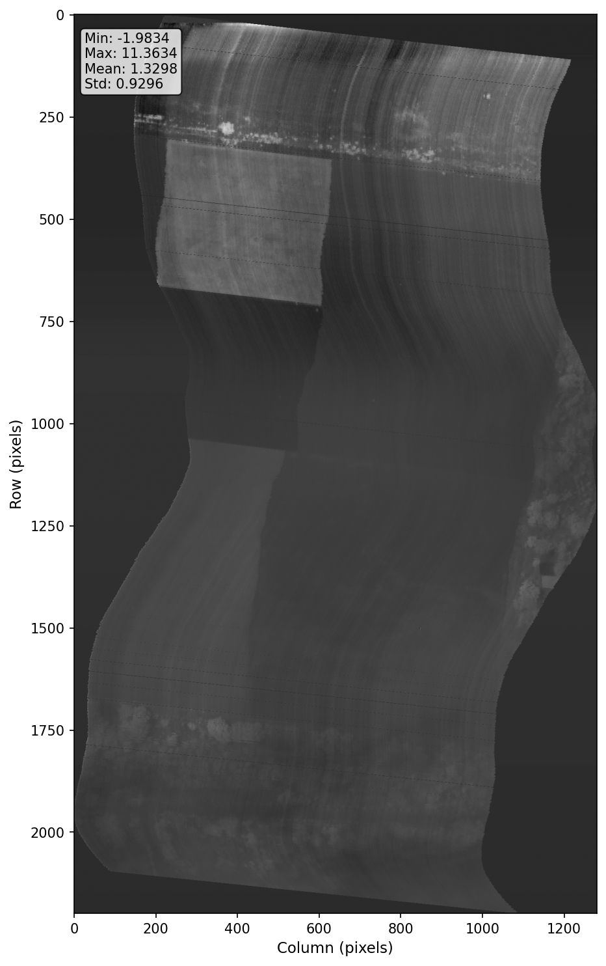

Figure 6: TPNE of Band 33

8. CONCLUSIONS

The present study proposes a improved minimum noise fraction transform technique for hyperspectral image denoising. Although Global MNF and Line-by-Line (LBL) architectures were already well established, the main contribution in present work is the introduction of a three pixel based noise estimation which enhanced the performance in reducing noise significantly while maintaining the spectral information. Unlike traditional approaches that considered only horizontally adjacent pixels, this method also included vertical and diagonal pixel relationships, which helped capture the spatial noise structure more accurately and reduce noise more effectively. The proposed noise estimation method was validated by integrating it into both Global MNF and LBL architectures. Experimental results demonstrate that the suggested method reduces the estimated noise while improving the signal quality, with more noticeable performance improvements observed in the LBL framework, where accurate noise estimation was important for real-time processing.

9. ACKNOWLEDGEMENT

Authors would like to express their gratitude to Dr. Manvendra Singh, IRDE, DRDO, Dehradun and his team for providing the hyperspectral dataset. Further, the reviewers’ insightful comments are greatly appreciated, and the authors would like to express their gratitude. Furthermore, authors acknowledge the fair and responsible use of OpenAI’s ChatGPT for language refinement and grammar checking.

REFERENCES

1. Chang CI, Du Q. Interference and noise-adjusted principal components analysis. IEEE Trans Geosci Remote Sens. 1999;37(5):2387-2396.
2. Green AA, Berman M, Switzer P, Craig MD. A transformation for ordering multispectral data in terms of image quality with implications for noise removal. IEEE Trans Geosci Remote Sens. 1988;26(1):65-74.
3. Renard N, Bourennane S, Blanc-Talon J. Denoising and dimensionality reduction using multilinear tools for hyperspectral images. IEEE Geosci Remote Sens Lett. 2008.
4. Chang CI. Hyperspectral data exploitation: Theory and applications. 2007.
5. Bjorgan A, Randeberg LL. Real-time noise removal for line-scanning hyperspectral devices using a minimum noise fraction-based approach. Sensors. 2015;15(2):3362-3378.
6. Bjorgan A, Randeberg LL. Mnf-lbl source code [Internet]. 2015 [cited 2026 Apr 19]. Available from: https://github.com/ntnu-bioopt/mnf
7. Yang W, Gao L, Chen D. Real-time target detection in hyperspectral images based on spatial-spectral information extraction. EURASIP J Adv Signal Process. 2012.
8. Lu G, Fei B. Medical hyperspectral imaging: a review. J Biomed Opt. 2014.
9. Nasrabadi NM. Hyperspectral target detection: An overview of current and future challenges. IEEE Signal Process Mag. 2014;31(1):34-44.
10. Uzkent B, Rangnekar A, Hoffman MJ. Aerial vehicle tracking by adaptive fusion of hyperspectral likelihood maps. In: 2017 IEEE Conference on Computer Vision and Pattern Recognition Workshops (CVPRW); 2017. p. 233-242.
11. Chan TF, Golub GH, LeVeque RJ. Algorithms for computing the sample variance: Analysis and recommendations. Am Stat. 1983.
12. Pebay PP. Formulas for robust, one-pass parallel computation of covariances and arbitrary-order statistical moments. Technical Report SAND2008-6212. Sandia National Laboratories; 2008.
13. NVIDIA Corporation. cublas library [Internet]. [cited 2026 Apr 19]. Available from: https://developer.nvidia.com/cublas

