**VIRTUAL CLOAK**

PROJECT SYNOPSIS

OF PROJECT – II

**BACHELOR OF ENGINEERING**

Computer Science & Engineering

Submitted By: -

Siddharth Baudh



**SUPERVISOR**

ER. ADITI AJEET KUMAR GUPTA

**DEPARTMENT OF COMPUTER SCIENCE**

**AND ENGINEERING, IET, KHANDARI,**

**AGRA (U.P.) - 282005**

**INDEX**

|  |  |  |
| --- | --- | --- |
| **S.NO** | **TOPIC** | **PAGE NO** |
| 1 | Abstract | 3 |
| 2 | Motivation | 4 |
| 3 | Problem Definition | 5 |
| 4 | Methodology | 6 |
| 5 | System Architecture | 7 |
| 6 | Software Requirement | 8 |
| 7 | References | 9 |

**ABSTRACT**

Have you ever thought of making visible things invisible, Have you ever thought how does one supersede backgrounds and add effects in a movie? The cloak was magical and invisible in the movies. As we know there is no magic and no virtual cloak which exists in the world. It’s all about the graphics tricks.The concept of an invisibility cloak is a mixture of science, fantasy, and the collective imagination. This paper helps to createone’s own ‘Virtual Cloak’. It will make use of Python and OpenCV module specifically targeting Image Processing and Image Segmentation to create a false sense of invisibility in theframe. It will explore how an object of a specific color or texture can be manipulated using the OpenCV library of python.To achieve this, initially we’ll be capturing and storing the backdrop frame . Thereafter we’ll be identifying the red coloured fabric by making use of the above mentioned algorithms. Then we’ll segment out the red colored fabric by generating a mask and then finally , we’ll generate the final augmented(magical)output to create virtual cloak.

**MOTIVATION**

We live in the era of video calls. Conducted over the internet and using whatever camera that comes with your laptop or computer, we broadcast our lives to our classmates, coworkers, and families.

Sometimes, though, we don’t want to broadcast our space. My office, like many others, has a few perennial pieces of clutter. I also have a guitar on the wall behind me, which doesn’t always scream professionalism.

As a result, Zoom and other video calling software includes a feature to hide your background, usually behind an image of your choice. While most don’t think of it much, the actual task of de-termining what determines the foreground and the background in an image is hardly trivial.

**PROBLEM DEFINITION**

Zoom and other video calling software includes a feature to hide your background, but we are trying to remove specific area from image or videos and then replace that area with the background to after doing this we can hide all the are which is surrounded or covered by red cloth . After then we redirect that image or video to the camera api so that when ever a person opens a camera he will see visual effect.

For this we are going to use OpenCV an image processing library present in python and written

in C++ which provides vast verity of functionality which make our task easy to implement.

**METHODOLOGY**

The working is opposite to the concept of green screening. As in the case of green screening background is removed but in this application we remove the foreground. Red colored cloth is used as a cloak for this application. We can use any colour with a little bit of changes in the code.

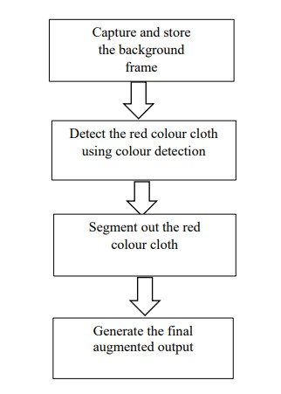

Figure 1 : System Flow

**SYSTEM ARCHITECTURE**

First, we’ll take the image and convert it to black and white. Next, edge detection will be applied and the contours in the image will be found. Any contours that are too either too big or too small to be the foreground will be removed.

The remaining contours will be considered the foreground. This makes some intuitive sense, as especially small details in a busy background will generate very small contours. By contrast, very large contours which take up most the screen probably aren’t the foreground, but some visual artefact of the background.

Finally a mask is generated from the remaining contours and is blended into the original image.

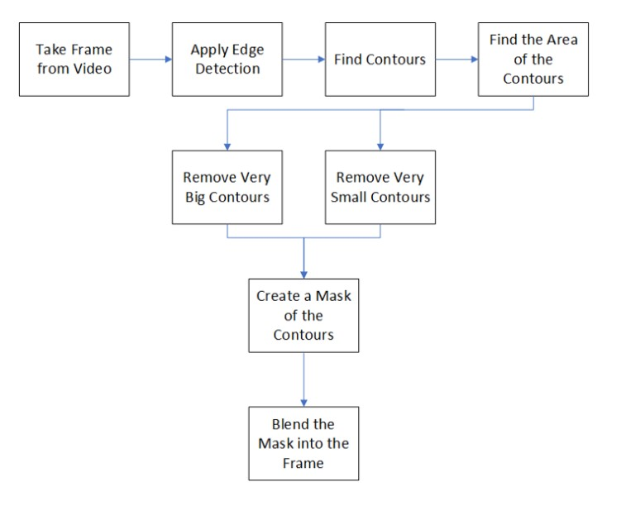

**Software Requirement**

* **Operating System:**
  + - Windows 7 or above
    - Linux 14 or above
* **Programming Language**:
  + - Python 3.7+
* **IDE**
  + - Jupyter Notebook
* **Library**
  + - OpenCV
    - NumPy
    - Time Module

**Hardware Requirements**

* **Processor:**
  + - Intel Pentium Processor or above
* **RAM:**
  + - At least 1GB
* **Storage:**
  + - At least 100 MB
* **Web Camera**
* **Red Colour cloth**

**REFERENCES**

[1] (PDF) Introduction to Computer Vision in Python. (2021, November 1). Retrieved

Available : https://www.researchgate.net/publication/228378315_Introduction_to_Computer_Vision_in_Python

[2] “Image Processing using OpenCV and Python in windows”

Available: https://www.researchgate.net/publication/274634881_Image_Processing_using_OpenCV_and_Python_in_windows

[3] Computer vision. (2001, October 25).

Available : https://en.wikipedia.org/wiki/Computer_vision

[4] A detail video about opencv module & his functions

Available : https://youtu.be/WQeoO7MI0Bs/