JNDI
Java Naming Directory Interface (JNDI) is the standard Java API for directory and naming services.

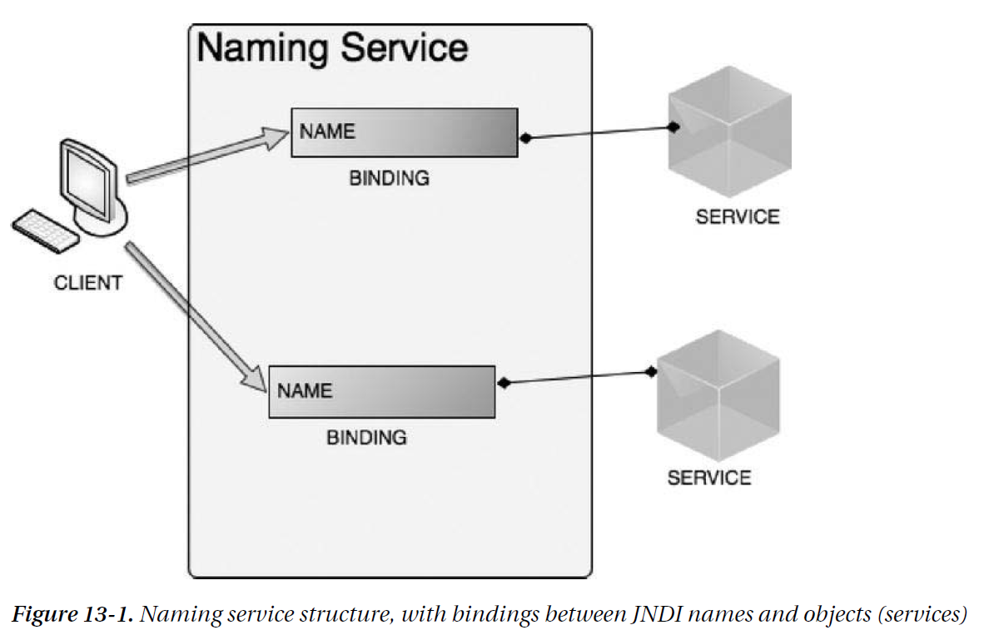

The main interface in the JNDI API is javax.naming.Context, which represents the abstraction of the naming context in Java. It define method to create, update, and examine the bindings stored in the naming context by their name. The main implementation of the Context interface is the javax.naming.InitialContext class, which is instantiated based on the environment configuration of the naming service, and is used as a starting point for any resource lookup.
JNDI resources are organized in a hierarchical tree, where lookup is performed relative to the current context.

Naming server = ???

