JUnit

As we said in the introduction, a unit test is just a piece of code. It's a piece of code you write that happens to excercise another piece of code, and determines whether the other piece of code is behaving as expected or not.

When writing test code, there are some naming convetions you need to follow. If you have a method named createAccount that you want to test, then your first test method might be named testCreateAccount. The method testCreateAccount will call createAccount with the necessary parameters and verify that createAccount works as advertised. You can, of course, have many test methods that excercise createAccount.

The test code must be written to do a few things:
- Set up all conditions needed for testing (create any required objects, allocate any needed resources, etc.);
- Call the method to be tested;
- Verify that the method to be tested functioned as expected;
- Clean up after itself.

Asserts
Asserts are the fundamental building block for unit tests; the Junit library provides a number of different forms of assert.
- AssertEquals.
Note: equals method for native arrays does not compare the contents of the arrays, just the array reference itself, which is probably not what you want.
Note2: Due to floating-point representation, if you are using an assert to compare floating point numbers (floats or doubles in Java), you need to specify one additional piece of information, the tolerance.
- AssertNull, AssertNotNull.
- AssertSame.
- AssertTrue, assertFalse.
- Fail.

In Junit all methods starting with test and suite methods will be run automatically by Junit. For creating suite see 3.4 Junit Test Composition of Pragmatic Unit Testing in Java with Junit.

Per-test Setup and Tear-down
protected void setUp();
protected void tearDown();

The methods above are called before and after each methods execution.

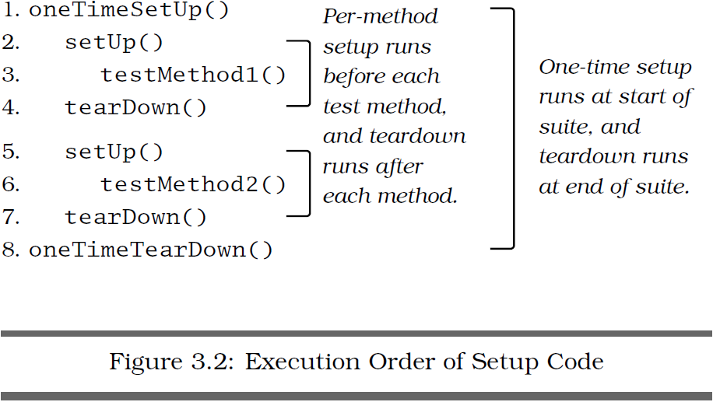

TO DO FOR CONTINUING THIS NOTE: To finish cap. 3 book Pragmatic Unit Testing in Java with Junit.

