Spring

Spring container
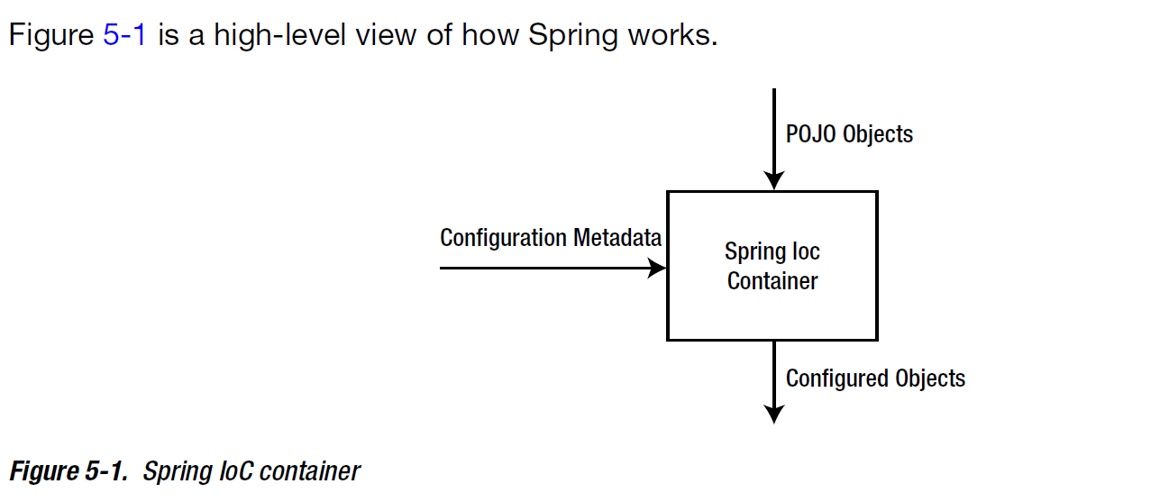

Containing your beans
In a Spring-based application, your application objects will live within the Spring container. As illustrated in figure the container will create the objects, wire them together, configure them, and manage their complete lifecycle from cradle to grave (or new to finalize(), as the case may be).

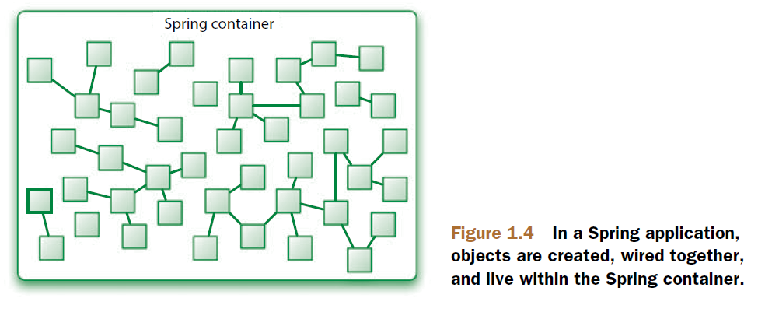

Understand the container helps you grasp how your objects will be managed.
The container is at the core of the Spring Framework. Spring's container uses dependency injection (DI) to manage components that make up an application. This includes creating associations between collaborationg components. As such, these objects are cleaner and easier to understand, support reuse, and are easy to unit test.
Spring comes with serveral container implementation that can be categorized into two types:
- Bean factories (org.springframework.beans.factory.beanfactory interface): are the simplest of containers, providing basic support for DI.
- Application contexts (org.springframework.context.ApplicationContext interface): build on the notion of a bean factory by providing application framework service.
  - ClassPathXmlApplicationContext
  - FileSystemXmlApplicationContext
  - XmlWebApplicationContext
  - AnnotationConfigApplicationContext

Dependency Injection
Pratically, DI is a specialized form of IoC, although you will often find that the two terms are used interchangeably.

- Constructor Injection: dependencies are provided by constructor.
- Setter Injection: dependencies are provided by “setDependency” method.
- Method Injection

Minimizing XML configuration in Spring
Spring offers a few tricks to help cut down on the amount of XML configuration required:
- Autowiring helps reduce or even eliminate the need for <property> and <contructor-arg> elements by letting Spring automatically figure out how to wire bean dependencies.
- Autodiscovery takes autowiring a step further by letting Spring figure out which classes should be configured as Spring beans, reducing the need for the <bean> element.

Spring provides four flavors of autowiring:
- byName
- byType

- constructor
- autodetect

Wiring with annotations
Remember to turn on annotation wiring in the Spring configuration file (see myNote spring configuration file.odt).

Spring 3 supports a few different annotations for autowiring:
- @Autowired
performs a byType autowiring but there must be exactly one bean that's applicable for wiring its job done. If there are no applicable beans or if multiple beans could be autowired, then @Autowired will fail with a nasty NoSuchBeanDefinitionException. We can use @Autowired(required=false) to accept null value.

- @Inject
- @Resource

Pro Spring Integration
Spring is a container and component model. Everything else is built on top of this container and component model. Object managed in the container do not have to know about Spring or the container because of Inversion of Control (IoC).
Within the Spring framework are two packages: org.springframework.beans and org.springframework.context that expose the core functionality of the IoC container.

Bean life cycle
To gain better awareness of Spring lifecycle management, the following list shows each step of the process in which the IoC container engages your beans.
- Create the bean via constructor of factory method
- Set the values and bean references to bean properties
- Call initialization callback methods
- Bean is ready for use
- Upon container shutdown, call destruction callback methods

Spring Expression Language
Spring Expression Language (SpEL) provides easy-to-use infrastructure that can be leveraged outside of the Spring container. Within the container, it can be used to make configuration mush easier in a lot of cases.
Today, there are many different types of expression languages in the enterprise space (OGNL, EL of Jsp and so on. Interesting!!!).
Some of these expression languages are very powerful, bodering on being scripting languages in their own right. The SpEL is no different. It is available almost everywhere you can imagine needing it – from annotations to XML configuration. The SpringSource Tool Suite also provides robust support for the expression language in the way of auto-completition and lookup.

The expression language supports a long list of features: see pag. 98 book Pro Spring Integration.

The ultimate goal of a SpEL expression is to arrive at some value after evaluation.

The #{} makers are a clue to Spring that the content that they contain is a SpEL expression. They could be mixed with non-SpEL values as well:
<property name=”count” value=”The value is #{5}” />

Number
#{5}, #{5.25}, etc.

String
#{“chunk”}, #{'chunk'}

boolean
#{true}, #{false}

Release Numbering
It is useful to understand how Spring Security release numbers work, as it will help you identify the effort (or lack thereof) involved in migrating to future releases of the project. Each release uses a standard triplet of integers: MAJOR.MINOR.PATCH. The intent is that MAJOR versions are incompatible, large-scale upgrades of the API. MINOR versions should largely retain source and binary compatibility with older minor versions, thought there may be some design changes and incompatible updates. PATCH level should be perfectly compatible, forwards and backwards, with the possible exception of changes which are to fix bugs and defects.
The extent to which you are affected by changes will depend on how tightly integrated your code is. If you are doing a lot of customization you are more likely to be affected than if you are using a simple namespace configuration.
You should always test your application thoroughly before rolling out a new version.

