OSGi

Open Service Gateway initiative.

Definitions:

OSGi is a framework (or a specification?) that defines a dynamic module system for java.

OSGi service platform is an industry standard defined by the OSGi Alliance to specifically address the lack of support for modularity in the java platform.

OSGi is a layer for the java platform.

OSGi is the module system for java. It defines a way to create true modules and a way for those modules to interact at runtime.

Key concepts:

Module (bundle): is a jar file with additional metadata;

Lifecycle: how to manage lifecycle of a bundle without re-start jvm;

Service: how bundle collaborate each other;

Specific technical information:

REPOSITORY

OBR: OSGi Bundle Repository. OBR is a specification from the OSGi Alliance for a service that allow downloading bundles from a remote repository (like a maven repository!!).

There are a few OSGi repository: felix, sling, paremus.

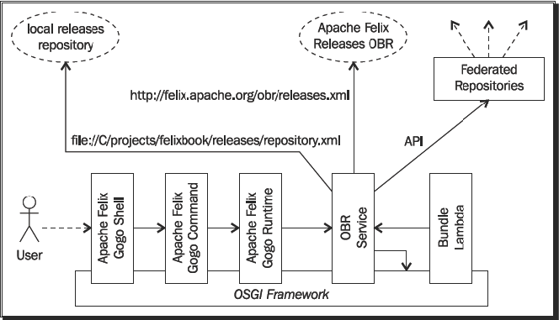

BundleActivator

A bundle may optionally declare an Activator class implementing the org.osgi.framework.BundleActivator interface. This class must be referenced in the bundle manifest file via the BundleActivator header. Implementing the activator allows the bundle developer to specify actions to be performed upon starting or stopping a bundle. Generally, such operations include gaining access to or freeing resources, and registering and unregistering services.

Some information:

OSGi uses an interface-based development model.

OSGi jar bundles can be used everywhere we can use a jar file. The extra metadata inside MANIFEST.MF is simply ignored by any application that does not understand it.

OSGi class loader system is like a graph (not a tree!) where links between bundles are based on imported and exported packages.

In OSGi all packages are “bundle private” by default.

The OSGi Alliace’s role is to define the specification for new releases of the platform, and to certify implementations of the current release of the specification.

The OSGi Alliance’s technical work is done by Expert Gourps: EG, CPEG (Core Platform), MEG, VEG, EEG.

OSGi implementations: Equinox, Knopflerfish, Felix, Concierge.

OSGi environments: Apache Karaf, Eclipse Virgo.

See also:

JSR 277 (Java Module System)

TO DO

Whiteboard and extender patterns.