Salus
An AI-Augmented Social Platform for Chronic Disease Management
By:
Hassan Aziz
47973
Muhammad Ali Kabir
40285
Irfan Ali
39877
Supervised by:
Mr. Zeeshan Ali
Faculty of Computing
Riphah International University, Islamabad
Spring 2026

A Dissertation Submitted To
Faculty of Computing,
Riphah International University, Islamabad
As a Partial Fulfillment of the Requirement for the Award of the Degree of
Bachelors of Science in Computer Science
Faculty of Computing
Riphah International University, Islamabad
Date: 30/04/2026

Final Approval
This is to certify that we have read the report submitted by Hassan Aziz (47973), Muhammad Ali Kabir (40285), and Irfan Ali (39877), for the partial fulfillment of the requirements for the degree of Bachelors of Science in Computer Science, and that in our opinion this work is of sufficient standard to warrant its acceptance by the Faculty of Computing, Riphah International University, Islamabad.
_______________________________
Mr. Zeeshan Ali
(Supervisor)
_______________________________
Prof. Dr. Musharif Ahmed, Ph.D.
(Head of Department)

Declaration
We hereby declare that this document "Salus" as a whole has not been copied out from any source. It is further declared that we have done this project with the accompanied report entirely on the basis of our personal efforts under the sincere guidance of our supervisor, Mr. Zeeshan Ali. If any part of the system is proved to be copied from any source, or found to be a reproduction of any project from any training institute or educational institution, we shall stand by the consequences. No portion of the work presented in this report has been submitted in support of any application for any other degree or qualification, of this or any other university or institute of learning.
___________________________
Muhammad Ali Kabir
40285
___________________________
Irfan Ali
39877
___________________________
Hassan Aziz
47973

Dedication
This project is respectfully dedicated to the millions of individuals living with chronic diseases - those who manage their conditions with quiet courage every single day - and to the caregivers, families, and healthcare specialists who walk beside them. We dedicate this work also to our beloved parents, whose endless prayers and sacrifices opened the door to higher education for us, and to our teachers whose patience and guidance shaped the engineers we have become. May this small contribution help bridge the painful gap between patients and the timely, intelligent, compassionate care they deserve.

Acknowledgement
We extend our deepest gratitude to our mentors: Sir Musharif Ahmed, Sir Shabbir Hasan, Sir Sherjeel Gilani, Sir Jawaid Iqbal, Sir Mubariz, Sir Tajamul Shahzad, Sir Imran Khan, Sir Hassaan Ali Shah, Sir Sadaqat Ali, Sir Tabassum Javed, Sir Usman Sharif, Sir Ishtiaq Ali, Sir Qazi Shuja, Sir Junaid Khan and our respected supervisor Sir Zeeshan Ali, for their constant encouragement, support, and guidance.
We are equally indebted to the Faculty of Computing at Riphah International University, Islamabad, whose foundational courses in software engineering, databases, distributed systems, and artificial intelligence equipped us with the technical vocabulary required to build a production-grade healthcare platform. Particular thanks goes to coordination department as well including Mr. Hussain, Mr. Adeel Sheikh, Mr. Moeez and Mr. Umer who resolved our queries throughout our studies and to Mr. Aqeel and his friends who kept our development environments humming smoothly.
Finally, we thank our families for their unconditional love and prayers, our friends for being patient sounding boards during long debugging sessions, and the open-source community whose libraries form the bedrock on which Salus is built.
___________________________
Muhammad Ali Kabir
40285
___________________________
Irfan Ali
39877
___________________________
Hassan Aziz
47973
Abstract
Salus is a comprehensive, AI-augmented healthcare social platform developed for individuals managing chronic, long-term medical conditions and the verified specialists who care for them. The system addresses a stubborn gap in modern digital health: the fragmentation between personal disease tracking, peer-to-peer emotional support, verified clinical guidance, and intelligent context-aware AI assistance. Existing applications typically address only one of these dimensions, forcing patients to switch between three or four disjoint tools and leaving specialists with no longitudinal view of how their patients live between appointments.
Salus unifies these dimensions into a single Ruby on Rails 8.0 web application built on the modern Solid stack (Solid Queue, Solid Cache, Solid Cable) backed by PostgreSQL 15 with the pgvector extension. Patients can record diseases, symptoms, risk factors, treatments, vital-sign measurements, photos, and medications; they can join condition-specific support groups, follow disease-status updates from peers, and consult verified specialists. Specialists in turn receive a dedicated dashboard with prioritised alerts, AI-driven adherence predictions, FHIR-compliant export of patient records via an integrated HAPI FHIR server, and tools for sending recommendations and clinical notes.
At the heart of Salus is a dual-persona Health Agent powered by an in-house Specialised Language Model (SLM) running in a dedicated Python container. The patient persona offers warm, encouraging, scope-limited guidance (it never diagnoses or prescribes), while the specialist persona acts as a clinical decision-support assistant that surfaces patient patterns, adherence risk scores, and anonymised cohort insights through a Retrieval-Augmented Generation pipeline built on pgvector. A multi-factor Adherence Prediction Service combines medication, measurement, symptom and engagement signals into an explainable 0-100 risk score. A Health Alert Service translates these signals into evidence-grounded notifications that route to specialists and caregivers based on severity. Background jobs anonymise specialist-patient messages and store them as embeddings for cross-patient pattern learning, with strong guardrails against jailbreak attempts, off-topic drift, and scope violations.

Table of Contents
Chapter 1: Introduction 1
1.1 Introduction 2
1.2 Goals and Objectives 3
1.3 Scope of the Project 4
1.4 Project Motivation 5
Chapter 2: Literature Review 6
2.1 Introduction 7
2.2 Background and Problem Elaboration 7
2.3 Detailed Literature Review 8
2.3.1 Definitions 8
2.3.2 Purpose 9
2.3.3 Related Research Works 9
2.4 Literature Review Summary Table 11
2.5 Research Gap 12
2.6 Problem Statement 12
Chapter 3: Requirements and Design 13
3.1 Introduction 14
3.2 Stakeholders 14
3.3 Functional Requirements 15
3.4 Non-Functional Requirements 19
3.5 Hardware and Software Requirements 23
3.5.1 Hardware Requirements: 23
3.5.2 Software Requirements: 24
3.6 Proposed Methodology 25
3.7 System Architecture 26
3.8 Use Cases 30
3.8.1 Authentication and Account Management 31
3.8.2 Patient Health Record 32
3.8.3 Medication Management 33
3.8.4 Social and Community 34
3.8.5 Specialist Care Coordination 35
3.8.6 FHIR Interoperability 36
3.8.7 Real-Time Messaging and Notifications 37
3.8.8 Administrator 38
3.9 Fully-Dressed Use Cases 39
3.9.1 Sign Up 39
3.9.2 Login 40
3.9.3 Add Disease 41
3.9.4 Confirm Medication Intake 42
3.9.5 Log Vital Measurement 43
3.9.6 Send Specialist Recommendation 44
3.10 Database Schema Diagram 45
3.11 Class, Sequence and Activity Diagrams 51
3.11.1 Class Diagrams 51
3.11.2 Sequence Diagrams 55
3.11.3 Activity Diagrams 61
3.12 Graphical User Interfaces (GUI) 67
3.12.1 Home Page 67
3.12.2 Sign-Up Screen 68
3.12.3 Sign-In Screen 69
3.12.4 Two-Factor Authentication Setup 70
3.12.5 My Health Dashboard 71
3.12.6 Disease Panel 72
3.12.7 Disease Statuses (Community Feed) 73
3.12.8 Measurements and Charts 74
3.12.9 Notes 75
3.12.10 Groups (Community) 76
3.12.11 Specialists Directory 77
Chapter 4: Implementation and Test Cases 78
4.1 Introduction 79
4.2. Technology Stack 79
4.3 Containerized Architecture 80
4.4 GitHub Actions CI/CD Pipeline 81
4.5 Adherence Prediction Algorithm 81
4.6 In-House Specialised Language Model (SLM) 82
4.7 Real-time Layer (Solid Cable) 82
4.8 FHIR Interoperability Layer 82
4.9 Test Case Design and Description 82
4.9.1 Login Tests 83
4.9.2 Sign Up Tests 84
4.9.3 Two-Factor Authentication (TOTP) Tests 85
4.9.4 Disease Management Tests 86
4.9.5 Medication Schedule and Intake Tests 87
4.10 Test Metrics 88
4.10.1 Login Metrics 88
4.10.2 Sign Up Metrics 88
4.10.3 Two-Factor Authentication Metrics 89
4.10.4 Disease Management Metrics 89
Chapter 5: Experimental Results and Analysis 90
5.1 Introduction 91
5.2 Adherence Prediction Algorithm’s Accuracy 91
5.3 AI Response Latency and Contextual Relevance 92
5.4 RAG Retrieval Quality 92
5.5 System Efficiency: Six-Container Stack Benchmarks 93
Chapter 6: Conclusion and Future Directions 94
6.1 Introduction 95
6.2 Achievements and Improvements 95
6.2.1 Key achievements of the project include: 95
6.3 Critical Review 96
6.4 Future Recommendations 96
6.5 Closing Reflection 97
References 98
Appendix 100
Appendix A: Glossary 100
Appendix B: Setup and Deployment Notes 101

List of Tables
Table 2.1: Literature Review Summary 12
Table 3.1: Functional Requirements 16
Table 3.2: Non-Functional Requirements 19
Table 3.3: Use Case - User Sign Up 33
Table 3.4: Use Case - User Sign In 34
Table 3.5: Use Case - Add Disease 35
Table 3.6: Use Case - Confirm Medication Intake 36
Table 3.7: Use Case - Log Vital Measurement 37
Table 3.8: Use Case - Send Specialist Recommendation 38
Table 4.1: Salus Container Topology 62
Table 4.2: Test Cases for Login Module 70
Table 4.3: Test Cases for Sign Up Module 71
Table 4.4: Test Cases for Two-Factor Authentication 72
Table 4.5: Test Cases for Disease Management 73
Table 4.6: Test Cases for Medication Module 74
Table 4.7: Test Case Metric for Login Module 78
Table 4.8: Test Case Metric for Sign Up Module 79
Table 4.9: Test Case Metric for Two-Factor Authentication 80
Table 4.10: Test Case Metric for Disease Management 81
Table 4.11: Test Case Metric for Medication Module 82
Table 5.1: Adherence Prediction Risk-Scoring Results 83
Table 5.2: AI Latency by Channel 84
Table 5.3: Six-Container Stack Background and UI Benchmarks 86
Table A.1: Salus Project Statistics 96

List of Figures
Figure 3.1: Salus High-Level System Architecture
Figure 3.2: Layered Application Architecture
Figure 3.3: AI Health Agent Subsystem
Figure 3.4: Solid Stack - Real-Time and Background Jobs
Figure 3.5: Specialist Alert Pipeline
Figure 3.6: Salus Master Use Case Diagram
Figure 3.7: Authentication and Account Management Use Cases
Figure 3.8: Patient Use Cases - Health Record
Figure 3.9: Medication Management Use Cases
Figure 3.10: Social and Community Use Cases
Figure 3.11: Specialist Use Cases - Patient Care
Figure 3.12: FHIR Interoperability Use Cases
Figure 3.13: Real-Time Messaging and Notifications Use Cases
Figure 3.14: Administrator Use Cases
Figure 3.15: Database Schema Overview
Figure 3.16: Identity and Authentication Schema
Figure 3.17: Health Record Schema
Figure 3.18: Medication Management Schema
Figure 3.19: Care Coordination Schema
Figure 3.20: AI Knowledge Schema
Figure 3.21: User and Account Class Diagram
Figure 3.22: Health Record Class Diagram
Figure 3.23: Medication Class Diagram
Figure 3.24: Care Coordination Class Diagram
Figure 3.25: Patient Registration Sequence
Figure 3.26: Sign-In with Two-Factor Authentication Sequence
Figure 3.27: Medication Intake Sequence
Figure 3.28: Vital-Sign Measurement and Alert-Escalation Sequence
Figure 3.29: Specialist Recommendation Sequence
Figure 3.30: SOS Alert Fan-out Sequence
Figure 3.31: End-to-End Patient Journey Activity
Figure 3.32: Patient Registration Activity
Figure 3.33: Medication Intake Activity
Figure 3.34: Vital-Sign Measurement Activity
Figure 3.35: Specialist Recommendation Activity
Figure 3.36: Specialist Alert Handling Activity
Figure 3.37: Salus - Home / Landing Page
Figure 3.38: Salus - Sign-Up Screen
Figure 3.39: Salus - Sign-In Screen
Figure 3.40: Salus - Two-Factor Authentication Setup
Figure 3.41: Salus - My Health Dashboard
Figure 3.42: Salus - Disease Panel
Figure 3.43: Salus - Disease Statuses (Community Feed)
Figure 3.44: Salus - Measurements and Charts
Figure 3.45: Salus - Notes
Figure 3.46: Salus - Groups (Community)
Figure 3.47: Salus - Specialists Directory
Figure 4.1: Salus Deployment Topology

Chapter 1:

Introduction

1.1 Introduction
Chronic diseases such as hypertension, diabetes, atopic dermatitis, asthma, rheumatoid arthritis, and chronic kidney disease demand long-term treatment and continuous care that extends far beyond the walls of a hospital or the few minutes of a scheduled appointment. According to the World Health Organisation, chronic non-communicable diseases now account for over seventy-four per cent of all deaths worldwide, and more than eighty per cent of these deaths occur in low- and middle-income countries where access to longitudinal specialist care is severely constrained. The clinical community has long understood that the real determinant of patient outcomes is not what happens during the appointment but what happens in the twenty-four-hour cycle that surrounds it: whether the medication was taken on time, whether the blood pressure was logged, whether the symptom was reported when it first appeared, and whether the patient felt supported enough to keep going.
Conventional digital tools fail to close this loop. Pure pill-reminder apps push notifications but never reach a clinician. Conversational AI tools provide emotional support but cannot synchronise with a patient's medication schedule. Electronic-health-record portals expose lab reports but offer no social or motivational layer. Patients are forced to context-switch between three or four disjoint applications, while specialists - who often manage ten to twenty chronic patients in parallel - receive only the snapshot a patient happens to remember during a fifteen-minute consultation.
Salus was developed specifically to close this gap. It is a single integrated platform that lets a patient record disease history, symptoms, risk factors, treatments, photos, and vital-sign measurements; take and confirm medications on schedule; participate in disease-specific peer-support groups; connect with verified specialists for messaging, recommendations and appointments; and ask an intelligent AI companion - fully grounded in their own medical history - for guidance, reminders, and emotional support. On the other side of the system, Salus gives specialists a clinical decision-support dashboard with prioritised alerts, AI-generated adherence-risk scores with explainable factors, FHIR import and export through an integrated HAPI FHIR server, and a unified care-history timeline.
What makes Salus distinctive among student-grade Final-Year Project submissions is not any single feature, but the depth of integration. Approximately seventy ActiveRecord models, more than two hundred routes, eight hundred controller actions, and over one thousand five hundred automated tests (1,157 unit tests and 390 integration tests) were carefully composed into one consistent architecture. A vector database (PostgreSQL pgvector) backs a Retrieval-Augmented Generation pipeline that gives the AI agent persistent memory of each patient's history. A custom multi-factor algorithm predicts medication non-adherence and explains its reasoning. Real-time channels (Solid Cable) push notifications, alerts, and specialist replies to the right user instantly. The entire system is packaged into six Docker containers - a Salus Rails application, its PostgreSQL database, a Sidekiq background-job worker, an in-house Python Specialised Language Model service, a HAPI FHIR server, and the FHIR server's own PostgreSQL database - orchestrated by Docker Compose, and deployed automatically to DigitalOcean through a GitHub Actions continuous-integration pipeline that runs every test on every push.
The remainder of this chapter sets out the goals and objectives that drive the project, defines the scope of the work submitted for evaluation, and explains the personal motivation that brought our three-person team to choose this problem. Subsequent chapters review the literature on chronic disease management, present the requirements and design, describe the implementation and the automated test plan, report quantitative experimental results, and close with our conclusions and recommendations for future work.

1.2 Goals and Objectives
The principal goal of Salus is to deliver a unified, AI-augmented digital platform that reliably supports continuous chronic disease management and meaningful patient-specialist collaboration. To make this goal concrete, we decomposed it into the following measurable objectives:
- Design and deliver a secure web application that connects chronic disease patients with verified healthcare specialists and admin-approved peers.
- Enable patients to maintain a comprehensive longitudinal medical profile - diseases, symptoms, risk factors, treatments, photos, vital-sign measurements, and clinical documents (PDF and image upload).
- Provide a complete medication-management workflow with schedules, reminders, one-tap intake confirmation, missed-dose alerts, and a multi-factor adherence prediction algorithm.
- Build a dual-persona AI Health Agent (patient mode and specialist mode) using an in-house Specialised Language Model running in a dedicated Python container, with rigorous guardrails against jailbreak, off-topic drift, model-identity probing, and out-of-scope clinical advice.
- Implement Retrieval-Augmented Generation over pgvector embeddings of patient-specific history and de-identified specialist-patient conversations.
- Provide specialists with a dedicated dashboard featuring prioritised alerts, explainable adherence risk scores, patient lookup tools, and a unified care-history timeline.
- Enable real-time bidirectional messaging (text, attachments, reactions) between patients, peers, caregivers, and specialists via WebSocket channels.
- Implement HL7 FHIR R4 import and export of patient records via a dedicated HAPI FHIR server container for interoperability with hospital information systems.
- Generate professional, branded PDF clinical reports - patient profile, specialist patient report, and clinical history - for offline review and clinic distribution.
- Verify the system against an automated test suite of 1,157 unit tests and 390 integration tests, integrated with GitHub Actions CI/CD for continuous regression protection.
- Containerise every service of the platform (six containers in total) so that the application can be deployed to any Docker-capable host with a single Docker Compose command.
- Automate continuous deployment to a DigitalOcean droplet so that a successful merge to the main branch produces a public live deployment within minutes, including database migration and seed-data execution.

1.3 Scope of the Project
The scope of the Salus project is bounded to a software-only, web-based chronic disease management platform that connects patients, caregivers, specialists, and administrators through a secure real-time communication fabric. The system supports the lifecycle of patient self-management - registration, profile setup, disease and medication onboarding, daily logging, social interaction, AI consultation, specialist referral, and report generation. It is intended to operate on standard modern web browsers and is fully responsive for desktop and tablet form factors. Users with voice-input devices benefit from speech-to-text and text-to-speech integration to reduce typing friction.

1.4 Project Motivation
On the personal side, every member of the team has a close family member who lives with a chronic condition. We watched, year after year, as parents and grandparents juggled three or four disjoint apps to manage their medications, log their blood pressure, communicate with their specialist, and find support from peers in the same situation. The friction was exhausting and the dropouts were frequent. Many of the patients we observed eventually defaulted back to paper-and-pen, simply because no single platform respected their time.
On the academic side, our coursework in software engineering, databases, distributed systems, and artificial intelligence had given us the tools to build modern web platforms but had rarely asked us to combine those tools in a single, production-ready system. We wanted a project ambitious enough to exercise every part of our curriculum - from object-relational modelling to real-time pub/sub, from policy-based authorisation to retrieval-augmented machine learning, from continuous integration to cloud deployment.
On the technological side, the rise of in-house Specialised Language Models that can be fine-tuned for narrow domains, combined with the maturity of vector-search databases such as pgvector, made it feasible for the first time to give a patient-facing assistant persistent memory of the patient's own record - without sending that record to any external service. Building our own SLM container, our own retrieval pipeline, and our own guardrail layers became one of the most rewarding engineering decisions of the project, and a deliberate counter-statement to the prevailing pattern of delegating clinical reasoning to a third-party API.
Together, these three threads convinced us that a well-engineered, integrated chronic-care platform was a Final-Year Project worth pursuing - both as a serious engineering exercise and as a small but tangible contribution to the lives of the patients whose well-being depends on the tools we build.

Chapter 2:

Literature Review

2.1 Introduction
The healthcare-technology market has been expanding rapidly over the past decade, accelerated further by the global COVID-19 pandemic and the subsequent shift toward tele-health. Mobile and web-based applications now exist for almost every aspect of patient self-management, from basic pill reminders to AI-driven symptom triage. Yet a careful survey of the literature and the most widely deployed commercial solutions reveals that they almost universally operate in silos: a chronic-care patient is expected to install a separate application for medication tracking, another for clinician communication, another for community support, and yet another for symptom journaling. The cognitive overhead of stitching these fragments together is non-trivial - particularly for elderly patients and those with limited digital literacy, who form the majority of the chronic-disease population.
This chapter therefore examines the prior art across five complementary axes: chronic-disease management platforms; medication-adherence interventions; AI-driven medical chatbots and the safety guardrails they deploy; Retrieval-Augmented Generation in healthcare contexts; and interoperability standards (HL7 FHIR R4). For each axis we identify the strengths and limitations of the most cited works, and we synthesise a precise statement of the research gap that Salus addresses.

2.2 Background and Problem Elaboration
Chronic disease management requires a holistic approach that combines timely medication intake, continuous monitoring of vital signs and symptoms, effective communication between patients and providers, and social or emotional support. Failures in any one of these dimensions cascade rapidly: a missed dose of an anti-hypertensive may raise blood pressure within twenty-four hours; a delayed message about chest tightness may evolve into a cardiac event before the next appointment; and the absence of peer support correlates strongly with depression and non-adherence in long-term illness.
Existing solutions almost always cover one dimension at the expense of the others. Pill-reminder apps optimise for individual notification delivery but never share state with a clinician. Tele-health portals optimise for video consultation but do not track between-visit symptoms. EHR-derived patient portals expose lab results but offer no peer support. Even the most sophisticated commercial chronic-care platforms are vertically specialized - concentrating almost exclusively on diabetes and hypertension or built around behavioral-coaching cohorts and licensed to employers rather than directly to patients. Salus assumes a different starting point: that a patient with chronic disease lives a single life, not three different ones segmented by app, and therefore deserves a single platform that treats medication adherence, clinical messaging, peer support, and AI assistance as facets of one unified experience.

2.3 Detailed Literature Review
The literature review is extensive covering remote patient management system studies, human-computer interaction and how AI augments it, and international medical standardization standards.

2.3.1 Definitions
- Medication Adherence - the extent to which a patient takes medications as prescribed in dosage, frequency and duration. The WHO 50% rule estimates only half of patients with chronic illness adhere consistently.
- EHR (Electronic Health Record) - digital, real-time, patient-centred records that make health information available securely to authorised users across providers.
- FHIR (Fast Healthcare Interoperability Resources) - an HL7 standard (R4 / R5) defining JSON/XML resources (Patient, Observation, Condition, MedicationStatement, etc.) for cross-system exchange.
- RAG (Retrieval-Augmented Generation) - a class of language-model techniques that augment a generation prompt with chunks retrieved from a vector index, enabling models to ground responses in domain-specific or patient-specific knowledge.
- pgvector - an open-source PostgreSQL extension providing vector data types and similarity search using HNSW or IVFFlat indexes.
- SLM (Specialised Language Model) - a smaller, domain-tuned language model designed for narrow use cases. Salus runs its own SLM in a dedicated Python container rather than calling an external API.

2.3.2 Purpose
The purpose of this literature review is twofold. First, we establish that the four pillars of chronic-care management - self-tracking, peer support, clinician collaboration and AI-assisted guidance - have each been addressed in isolation by prior systems but rarely in combination. Second, we demonstrate that the engineering primitives needed to combine them in a single platform - vector databases, real-time WebSocket pub/sub, FHIR-compliant interoperability, and narrowly-scoped language models - have matured to the point where a small student team can credibly attempt the integration. The summary table at the end of this chapter consolidates the twelve most relevant prior works.

2.3.3 Related Research Works

2.3.3.1 Pill-Reminder Applications
PillMinder, Medisafe and similar applications target the most common pain point of chronic care: forgetting to take a dose. They deliver scheduled push notifications, escalate to a backup contact when a dose is missed, and provide simple intake-history charts. Published RCTs report 8-15% adherence uplift over short windows. The principal limitation is that these tools are isolated from the clinician: the specialist remains unaware of missed doses until the next physical visit, by which point harm may already have occurred. Salus absorbs the reminder pattern but closes the loop by routing missed-dose information into a Health Alert that the specialist can act on in real time.

2.3.3.2 Conversational Health Agents
Woebot Health and similar conversational agents apply rule-based and machine-learning conversational techniques to deliver cognitive-behavioural-therapy-style interventions. Their corpora are curated by clinical psychologists and the system explicitly avoids diagnostic claims. Validated RCTs show measurable reductions in anxiety scores. The limitation is scope: Woebot serves mental health only and lacks any facility for managing complex physical-medication regimens, tracking vitals, or sharing data with a treating physician. Salus generalises the persona-and-disclaimer pattern to physical chronic conditions and synchronises every conversation with the patient's medical record.

2.3.3.3 Large Language Models in Medicine
Recent literature on large language models in medicine (Med-PaLM, Nature Medicine reviews on LLMs, JAMIA Open systematic reviews) reports a wave of agentic generative AI applications in healthcare. The works identify a recurring three-stage pattern: observe (continuously ingest patient signals), learn (analyse patterns over time), and notify (escalate to a human clinician with explainable evidence). The literature stresses the need for guardrails (scope-limiting, emergency detection, uncertainty expression), source attribution via RAG, and HIPAA-aligned privacy. Most published architectures remain prototypes; few are released as integrated, end-to-end systems where the agent, the RAG layer, the data model, the alerting engine, and the user interfaces are simultaneously visible and verifiable. Salus is one such concrete implementation.

2.3.3.4 Retrieval-Augmented Generation
Lewis et al. (NeurIPS 2020) introduced Retrieval-Augmented Generation as a way to combine the parametric memory of a language model with a non-parametric retrieval index over an external knowledge base. The pattern has since been applied across legal, scientific and consumer domains. Salus operationalises RAG inside healthcare by storing patient-specific message embeddings and de-identified specialist-patient conversations in a pgvector index, producing two complementary retrieval namespaces: per-patient memory and anonymised cohort patterns.

2.3.3.5 HL7 FHIR Interoperability
FHIR Release 4, ratified by HL7 International in 2019, is the first version of the standard to be production-ready for cross-system healthcare data exchange. It defines a stable resource model for Patient, Observation, Condition, MedicationStatement, Procedure and many others. Many consumer-facing health applications still ignore FHIR or only support partial export. Salus runs a dedicated HAPI FHIR server in its own Docker container with its own PostgreSQL database, allowing the platform to act as both a FHIR client and a FHIR server in interactions with external Electronic Health Record systems. This FHIR and HL7 standardization system forms the backbone of the clean interoperability between systems and is defined as an international standard for medical electronic health records import and export systems.

2.4 Literature Review Summary Table
The table below summarizes the key related works reviewed in this chapter, highlighting the approach of each study and the specific limitation or relevance it holds for Salus.
Table 2.1: Literature Review Summary
No. | Author(s) | Year | Approach | Limitation / Notes
1 | Sarkar et al. | 2024 | Systematic review of chronic disease patients | Salus addresses liver chronic condition.
2 | Free et al. | 2023 | PLOS Medicine systematic review of 75 health trials. | Salus extends with a responsive web UI
3 | Whitehead & Seaton | 2026 | JMIR systematic review of 24 mobile/tablet apps | Combines peer support & management.
4 | Fitzpatrick, Darcy & Vierhile | 2021 | Woebot - fully automated conversational agent. | Mental-health only.
5 | Singhal et al. | 2023 | Med-PaLM - Nature paper showing language models. | Demonstrates LLM viability for assistance.
6 | Thirunavukarasu et al. | 2023 | Nature Medicine review of LLM applications in medicine. | Salus gives grounded responses through RAG.
7 | Patel et al. | 2024 | Open systematic review of LLM use in clinical workflows. | Salus implements both requirements.
8 | Lewis et al. | 2020 | Foundational NeurIPS paper introducing RAG. | Salus uses this pattern with cosine search.
9 | HL7 International | 2019 | International standard for healthcare data exchange. | Salus runs a dedicated FHIR server.
10 | Brunisholz et al. | 2018 | Real-world effectiveness study of healthcare apps. | Salus is patient-first support platform.
11 | Steinhubl, Muse & Topol | 2022 | Mobile health's potential to enable continuous chronic care. | Salus realises this vision and adds AI safety layers tailored for chronic-care chat.

2.5 Research Gap
Across all six categories surveyed above, three structural gaps consistently appear, and these gaps form the precise target of the Salus project. First, multi-modal communication and disjoint tooling: most existing healthcare communication systems offer only basic text messaging, forcing patients to switch between three or four apps for vitals, photos, documents and clinician messages. Second, lack of real-time bidirectional interaction: many patient-provider systems rely on asynchronous messaging with delayed responses, ill-suited for time-sensitive concerns like a sudden blood-pressure spike. Third, the disconnect between social support and medical management: chronic-disease platforms focus on clinical aspects while general social networks lack any tie to the medical record.
Salus uniquely combines disease-specific peer-support groups (one group per ICD-10 disease, automatically created from the predefined-disease catalog) with verified specialist accounts, individual disease panels, real-time alerts via Solid Cable, and an in-house Specialised Language Model running locally rather than as a third-party API call.

2.6 Problem Statement
The modern healthcare landscape faces a critical, persistent challenge in chronic-disease management: medication non-adherence, between-visit patient deterioration, and physician unawareness of either. Patients - especially those with multiple chronic conditions or limited digital literacy - struggle to follow complex prescription schedules across fragmented tools. Specialists, who manage many such patients in parallel, have no real-time visibility into the daily reality of adherence, and therefore cannot intervene before a condition worsens. Patients, in turn, experience anxiety from the lack of immediate, trustworthy answers to everyday health questions, and turn to general-purpose search engines or social media - sources prone to misinformation.
Salus is developed to bridge these divides by creating a unified, secure, AI-augmented ecosystem that automates medication tracking, provides 24/7 scope-limited AI support grounded in the patient's own record, synchronises real-time health data and alerts between patients and specialists, supports HL7 FHIR R4 interoperability with hospital systems via a dedicated server.

Chapter 3:

Requirements and Design

3.1 Introduction
This chapter describes in detail the requirements and overall design of the Salus system. It enumerates the functional requirements (what the system shall do), the non-functional requirements (the quality attributes), and the hardware and software environment on which the platform depends. It then explains the proposed engineering methodology, the layered system architecture, the use cases, the database entity-relationship diagram, the principal class and sequence diagrams, and the major graphical user interfaces.

3.2 Stakeholders
Salus serves four principal stakeholder roles, each with distinct goals and access patterns. The Patient is the default end-user and the primary value beneficiary of the system. The Caregiver is a trusted relative or assistant with limited per-resource access to a patient's record. The Specialist is a verified clinician with a dedicated portal and patient roster. The Administrator is a platform operator responsible for approving specialist applications, reassigning patients between specialists, and auditing AI conversation logs.
Salus was developed specifically to close this gap. It is a single integrated platform that lets a patient record disease history, symptoms, risk factors, treatments, photos, and vital-sign measurements; take and confirm medications on schedule; participate in disease-specific peer-support groups; connect with verified specialists for messaging, recommendations and appointments; and ask an intelligent AI companion - fully grounded in their own medical history - for guidance, reminders, and emotional support. On the other side of the system, Salus gives specialists a clinical decision-support dashboard with prioritised alerts, AI-generated adherence-risk scores with explainable factors, FHIR import and export through an integrated HAPI FHIR server, and a unified care-history timeline.
Salus uniquely combines disease-specific peer-support groups (one group per ICD-10 disease, automatically created from the predefined-disease catalog) with verified specialist accounts, individual disease panels, real-time alerts via Solid Cable, and an in-house Specialised Language Model running locally rather than as a third-party API call.

3.3 Functional Requirements
Functional requirements are presented in Table 3.1 below, grouped into eleven thematic categories that correspond to the major functional areas of the platform.
Table 3.1: Functional Requirements
ID | Requirements
FR1: User Authentication and Account Management
FR1.1 | The system shall allow users to register a new account using an email address and password.
FR1.2 | The system shall require new users to verify their email address before activation.
FR1.3 | The system shall allow users to sign in with their credentials.
FR1.4 | The system shall allow users to enable two-factor authentication using TOTP.
FR1.5 | The system shall allow users to reset a forgotten password via a tokenised email link.
FR1.6 | The system shall allow users to update their personal profile and avatar.
FR1.7 | The system shall allow users to manage privacy settings and notification preferences.
FR2: Disease and Health Profile Management
FR2.1 | The system shall allow patients to add chronic diseases either from a predefined catalog or as custom entries.
FR2.2 | The system shall allow patients to record and update disease symptoms with severity over time.
FR2.3 | The system shall allow patients to record disease risk factors with severity ratings.
FR2.4 | The system shall allow patients to record treatments and log effectiveness over time.
FR2.5 | The system shall allow patients to attach photographs to disease records.
FR2.6 | The system shall allow users to upload clinical documents in PDF or image format.
FR2.7 | The system shall allow patients to maintain private notes optionally linked to diseases.
FR3: Medication Tracking and Adherence
FR3.1 | The system shall allow patients to add medications with dosage, frequency, and duration.
FR3.2 | The system shall allow patients to define one or more reminder schedules per medication.
FR3.3 | The system shall send reminders to patients before each scheduled dose.
FR3.4 | The system shall allow patients to confirm intake with a single tap.
FR3.5 | The system shall allow patients to mark scheduled doses as missed.
FR3.6 | The system shall display rolling adherence statistics over selectable time windows.
FR3.7 | The system shall allow patients to submit medication requests to their assigned specialist.
FR4: Vital Signs and Measurements
FR4.1 | The system shall allow patients to record vital sign measurements (blood pressure, blood sugar, weight, heart rate).
FR4.2 | The system shall automatically classify each measurement as within or outside normal range.
FR4.3 | The system shall provide chart-based visualisation of measurement history by type and time period.
FR4.4 | The system shall support a calendar view grouping measurements by date.
FR4.5 | The system shall generate a printable PDF report of measurements logged on a chosen day.
FR5: Social Networking and Community Support
FR5.1 | The system shall allow users to search and browse other user profiles.
FR5.2 | The system shall allow users to send and accept friend requests.
FR5.3 | The system shall allow patients to publish disease status updates with mood indicators.
FR5.4 | The system shall allow users to comment on and react to disease status posts.
FR5.5 | The system shall allow users to browse, join and leave disease-specific support groups.
FR5.6 | The system shall allow group members to publish posts in their groups.
FR5.7 | The system shall provide a personalised activity feed combining friends' updates and group posts.
FR6: Care Coordination with Specialists
FR6.1 | The system shall allow patients to browse a directory of verified specialists.
FR6.2 | The system shall allow patients to request a care relationship with a chosen specialist.
FR6.3 | The system shall allow patients and specialists to exchange messages within established care relationships.
FR6.4 | The system shall allow patients to receive recommendations from their specialists.
FR6.5 | The system shall allow patients to accept, reject, or dismiss recommendations.
FR6.6 | The system shall automatically apply accepted recommendations to the patient's medication or treatment list.
FR6.7 | The system shall allow patients to submit treatment requests for specialist review.
FR6.8 | The system shall allow patients to request appointments based on the specialist's published availability.
FR7: Conversational AI Assistant (in-house SLM)
FR7.1 | The system shall allow patients to converse with a health-focused AI assistant.
FR7.2 | The system shall allow specialists to converse with a clinical decision-support AI assistant.
FR7.3 | The system shall support voice input by transcribing spoken queries into text.
FR7.4 | The system shall support voice output by reading assistant responses aloud.
FR7.5 | The system shall allow users to attach images and documents to AI conversations.
FR7.6 | The system shall allow users to start, list, and delete past AI conversations.
FR7.7 | The system shall enforce safety guardrails on AI responses, preventing diagnoses, prescriptions, or off-topic responses.
FR8: Specialist Workflow
FR8.1 | The system shall provide specialists with a dashboard summarising patient roster, alerts, and pending tasks.
FR8.2 | The system shall allow specialists to maintain their professional profile.
FR8.3 | The system shall allow specialists to publish weekly availability schedules.
FR8.4 | The system shall allow specialists to search and review their assigned patients.
FR8.5 | The system shall allow specialists to view comprehensive patient details including history and adherence.
FR8.6 | The system shall allow specialists to write clinical notes attached to a patient's record.
FR8.7 | The system shall allow specialists to send treatment or medication recommendations to patients.
FR8.8 | The system shall allow specialists to approve or reject pending medication and treatment requests.
FR8.9 | The system shall allow specialists to acknowledge, defer, or resolve incoming alerts.
FR8.10 | The system shall allow specialists to generate downloadable PDF reports of a patient's clinical history.
FR8.11 | The system shall allow verified specialists to publish health-related articles.
FR9: Notifications and Real-Time Communication
FR9.1 | The system shall deliver real-time in-app notifications to users for relevant events.
FR9.2 | The system shall allow users to view, mark as read, and delete notifications.
FR9.3 | The system shall allow users to participate in private real-time chat conversations.
FR9.4 | Real-time chats shall support text, voice and file attachment messages.
FR9.5 | The system shall raise alerts to specialists when adherence drops or measurements fall outside normal limits.

3.4 Non-Functional Requirements
Non-functional requirements are summarised in Table 3.2.
Table 3.2: Non-Functional Requirements
Req. ID | Category | Req. Description | Target Standard | Priority | Measurable Criteria
Performance
NFR1.1 | Performance | The system shall load the main user dashboard within an acceptable time on a stable broadband connection. | <= 3 seconds for first paint | High | Page load time measurement
NFR1.2 | Performance | The AI assistant shall respond to typical text queries within an acceptable time. | <= 5 seconds median response | High | AI response time logging
NFR1.3 | Performance | Real-time messages and alerts shall be delivered to online recipients with low end-to-end latency. | <= 2 seconds end-to-end | High | Message latency testing
Security
NFR2.1 | Security | User passwords shall never be stored in plain text. | Passwords stored using industry-standard hashing | Critical | Code review
NFR2.2 | Security | All network communication between client and server shall be encrypted in transit. | 100% of connections use HTTPS / TLS | Critical | Network traffic inspection
NFR2.3 | Security | The system shall verify the user's email address before activating a new account. | Verification email sent on every registration | High | Registration flow testing
NFR2.4 | Security | Password reset links shall be delivered only to the registered email and shall expire. | Reset links expire within 2 hours | High | Password reset flow testing
Privacy
NFR3.1 | Privacy | Each user shall be able to access only their own personal data unless explicitly shared. | Authorization enforced on every protected request | Critical | Authorization policy testing
NFR3.2 | Privacy | Specialists shall view only data of patients with whom they have an accepted care relationship. | Specialist scope enforced server-side | High | Cross-specialist access testing
NFR3.3 | Privacy | AI conversation history shall be accessible only to the user who created it. | Conversations not visible across users | High | Conversation isolation testing
Reliability
NFR4.1 | Reliability | The platform shall be available during normal operating hours. | >= 99% availability per month | High | Uptime monitoring
NFR4.2 | Reliability | Medication reminders shall be reliably delivered before each scheduled dose. | >= 95% reminder delivery success | High | Reminder delivery audit
NFR4.3 | Reliability | Background tasks shall retry automatically on transient failures. | Automatic retry with exponential back-off | Medium | Failure injection test
Usability
NFR5.1 | Usability | The user interface shall be consistent and intuitive for users with basic digital literacy. | First-time-user task completion >= 70% | High | Usability testing
NFR5.2 | Usability | Error messages shall be plainly written and guide the user toward corrective action. | All error states mapped to plain-language messages | High | Error message review
NFR5.3 | Usability | Long-running operations shall display a progress or loading indicator. | Loading indicator shown for any operation > 1 second which is sufficient. | Medium | UI feedback verification
NFR5.4 | Usability | Accessibility features shall include voice input and voice output. | Speech-to-text and text-to-speech supported | Medium | Accessibility feature testing
Compatibility
NFR6.1 | Compatibility | The application shall function correctly on the most common modern web browsers. | Chrome, Firefox, Edge, Safari (latest 2 majors) | High | Cross-browser testing
NFR6.2 | Compatibility | The application shall be responsive on tablet, laptop and desktop screen sizes. | Layout adapts cleanly from 1024 px to 1920 px width | High | Responsive layout testing
NFR6.3 | Compatibility | Health record exchange shall use a recognised interoperability standard. | FHIR R4 for export and import bundles | Medium | FHIR validation
Maintainability and Scalability
NFR7.1 | Maintainability and Scalability | The codebase shall follow consistent style rules enforced through automated tooling. | Linting passes with zero offences on every commit | Medium | CI linting
NFR7.2 | Maintainability and Scalability | An automated test suite shall cover the critical user workflows. | 1,157 unit tests + 390 integration tests in CI | High | Coverage report review

3.5 Hardware and Software Requirements
An appropriate combination of hardware and software resources is required to develop, deploy and operate Salus reliably. Salus is a Ruby-on-Rails 8 web application packaged together with five companion services (a PostgreSQL database, a Sidekiq worker, a Python Specialised Language Model, a HAPI FHIR server, and a separate PostgreSQL database for the FHIR server) into six Docker containers orchestrated by a single Docker Compose file.

3.5.1 Hardware Requirements:
1. Server Infrastructure:
Minimum 4 vCPU cores (8 vCPU recommended for production).
Minimum 8 GB RAM (16 GB recommended).
Minimum 60 GB SSD storage for application code, database and uploaded blobs.
Stable internet connection with at least 100 Mbps uplink.
Linux-based operating system (Ubuntu 22.04 LTS or equivalent).
Docker Engine 24.x and Docker Compose v2.
PostgreSQL 15 inside the Salus database container, with the pgvector and pgcrypto extensions enabled.
2. Developer Workstation:
Modern multi-core processor (Intel Core i5 / AMD Ryzen 5 or better).
Minimum 8 GB RAM (16 GB recommended).
At least 50 GB free disk space for the Docker images and the cloned repository.
Stable internet connection.
Microphone-enabled device for testing voice features of the AI assistant.
3. Client Devices:
Modern desktop, laptop or tablet with at least 4 GB RAM.
Minimum display resolution of 1280 x 720.
Stable internet connection of at least 1 Mbps (5 Mbps recommended).
Microphone for voice input to the AI assistant; speakers for voice output.

3.5.2 Software Requirements:
1. Development Environment:
Ruby 3.4.9; Ruby on Rails 8.0.
Node.js 18.16.1 and Yarn package manager for asset compilation.
PostgreSQL 15 with the pgvector and pgcrypto extensions.
Git for version control.
Docker and Docker Compose for containerised local development.
RSpec, Factory Bot, Capybara and Selenium for the automated test suite.
RuboCop family of linters enforced through CI.
Visual Studio Code or RubyMine.
2. Backend Frameworks and Libraries:
Hotwire (Turbo and Stimulus) for the server-rendered SPA experience.
ViewComponent for encapsulated reusable UI components.
Solid Queue, Solid Cache and Solid Cable for jobs, caching and pub/sub on PostgreSQL.
Pundit for policy-based authorisation.
fhir_client library for HL7 FHIR R4 communication with the HAPI FHIR server.
Prawn and Prawn-Table for server-side PDF generation.
Shrine and image_processing for file uploads.
ROTP and rqrcode for time-based two-factor authentication.
Pagy, Chartkick, Avo for pagination, charts and the internal admin panel.
3. AI Subsystem (Python SLM Container):
Python 3.11.
FastAPI for the HTTP interface exposed to the Salus Rails container.
PyTorch and the Transformers library for the in-house Specialised Language Model.
Sentence-transformers library for generating embeddings used by the RAG pipeline.
4. FHIR Subsystem:
HAPI FHIR JPA Server R4 (open-source reference implementation).
PostgreSQL 15 - dedicated database for the HAPI FHIR JPA store.
5. Frontend Stack:
HTML5, CSS3 and modern JavaScript.
Tailwind CSS for the utility-first design system.
Stimulus controllers for client-side interactivity.
Modern web browser (Chrome, Firefox, Safari or Edge - latest two majors).

3.6 Proposed Methodology
Salus was developed using an iterative, incremental engineering methodology blending elements of Agile (short cycles, continuous integration, frequent demos to the supervisor) with the discipline of the Rails Doctrine - convention over configuration, integrated systems, no build steps, and a rich-default-stack philosophy. The lifecycle is captured in six iterative phases.
- Requirements Gathering - interviews with hypothetical chronic-disease patients (the team's own family members and friends), survey of existing platforms (PillMinder, Woebot, Livongo), and a review of Pakistan-specific constraints (literacy, smartphone usage, language).
- System Architecture - selection of Rails 8 + Solid stack, decision to use UUIDs end-to-end, choice of pgvector for RAG over external vector DBs, and selection of an in-house Python Specialised Language Model rather than an external API.
- Database & Domain Modelling - design of approximately 70 ActiveRecord models capturing the patient, social, specialist, and AI sub-domains; creation of 120 sequenced migrations.
- Implementation - feature-flagged delivery in vertical slices: auth, disease panel, medications, social layer, specialist module, AI agent, RAG pipeline, FHIR.
- Verification - 1,157 RSpec unit tests, 390 integration tests, Capybara system tests for key journeys, RuboCop for static analysis, GitHub Actions CI on every push.
- Containerisation and Continuous Deployment - six-container Docker Compose topology, GitHub Actions pipeline that builds images on every push, pushes them to a DigitalOcean droplet, and runs database migrations and seed data automatically so the platform is live on a public IP within minutes.

3.7 System Architecture
Salus follows a classic layered Model-View-Controller architecture with explicit Service Objects to encapsulate cross-cutting business logic, and Background Jobs for asynchronous work. Five complementary architectural views are presented below: a high-level deployment view, a layered application view, the AI Health Agent subsystem, the Solid stack real-time and background-job view, and the specialist alert pipeline.
The figure below illustrates the deployment-level view: end users on the public internet reach the Salus Rails container through a TLS-terminating reverse proxy, while the Rails application delegates background work, embeddings, and FHIR interoperability to four sibling Docker containers.
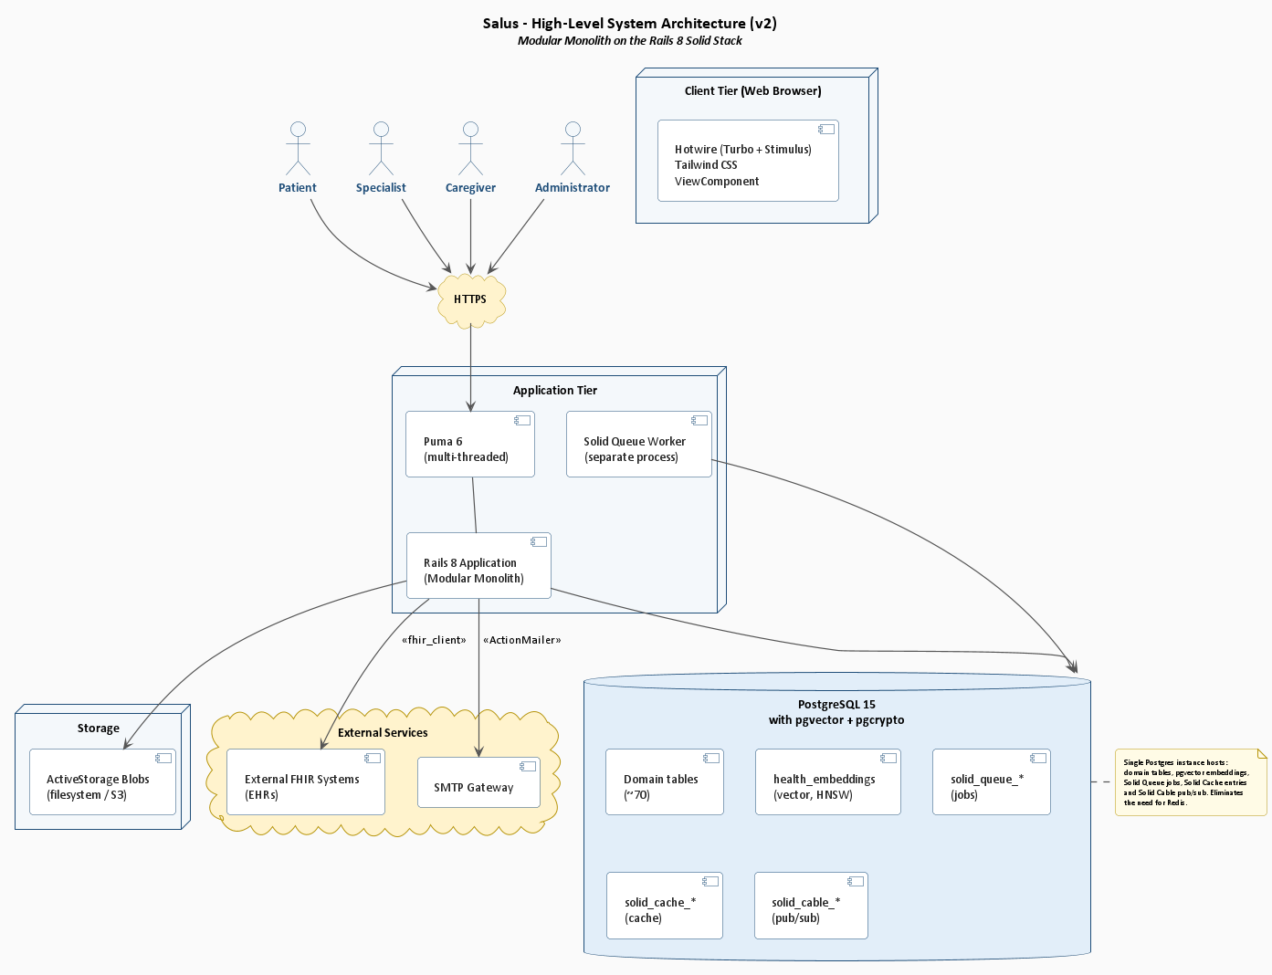
Figure 3.1: Salus High-Level System Architecture
The figure below zooms into the Rails application itself, showing how the classic Model-View-Controller layers are augmented with explicit Service Objects for cross-cutting business logic and Background Jobs for asynchronous work.
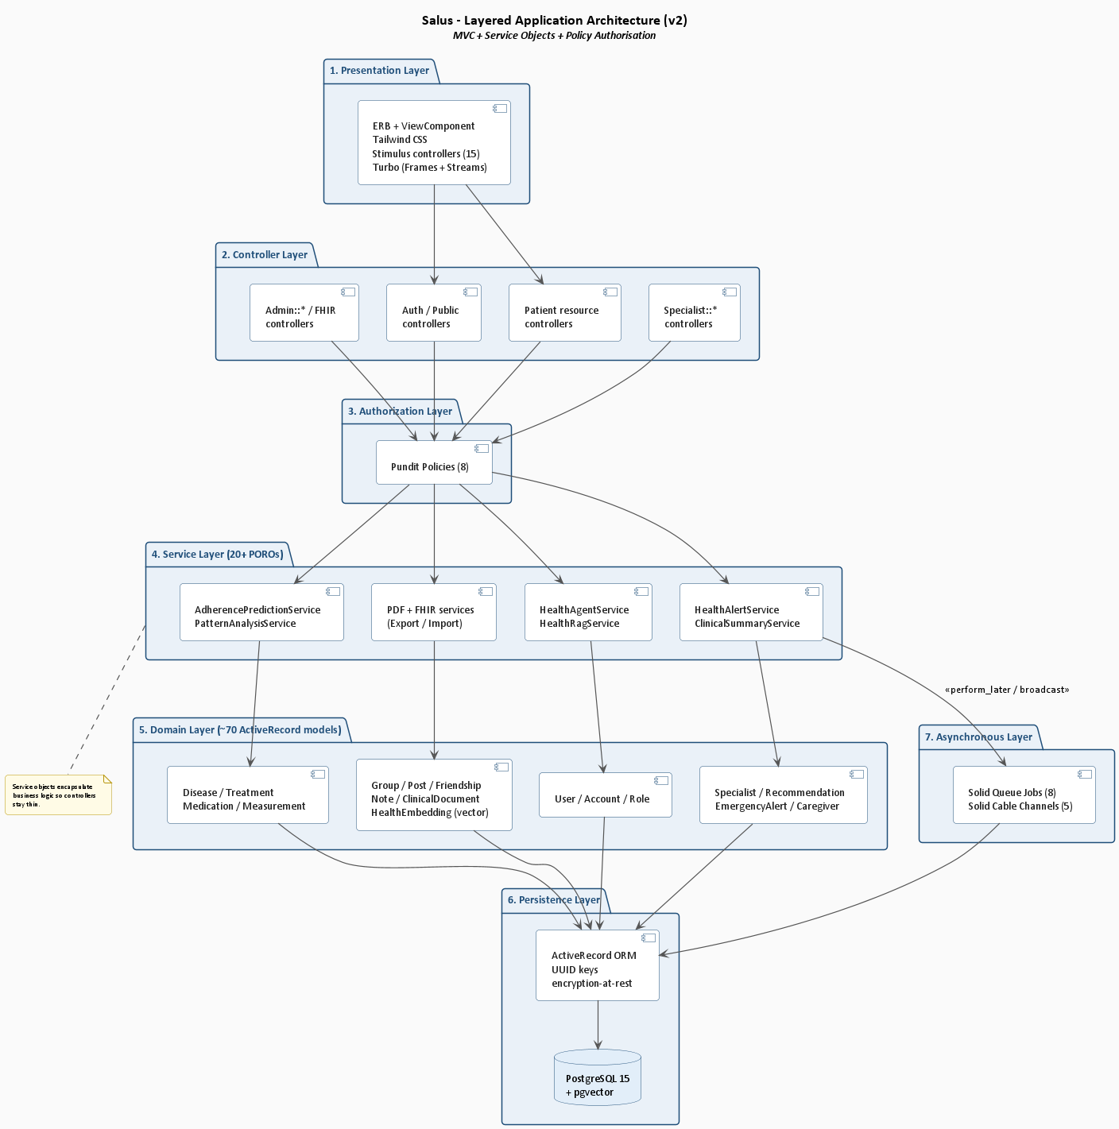
Figure 3.2: Layered Application Architecture

It captures the social layer: posting mood-tagged disease statuses, browsing and joining disease-specific support groups, commenting and reacting on peer posts, voting in polls, and viewing aggregated symptom statistics shared anonymously across the cohort.
The figure below details the AI Health Agent subsystem - a dual-persona conversational layer powered by the in-house Python Specialised Language Model, with a Retrieval-Augmented Generation pipeline that grounds every reply in the patient's own pgvector-backed history.
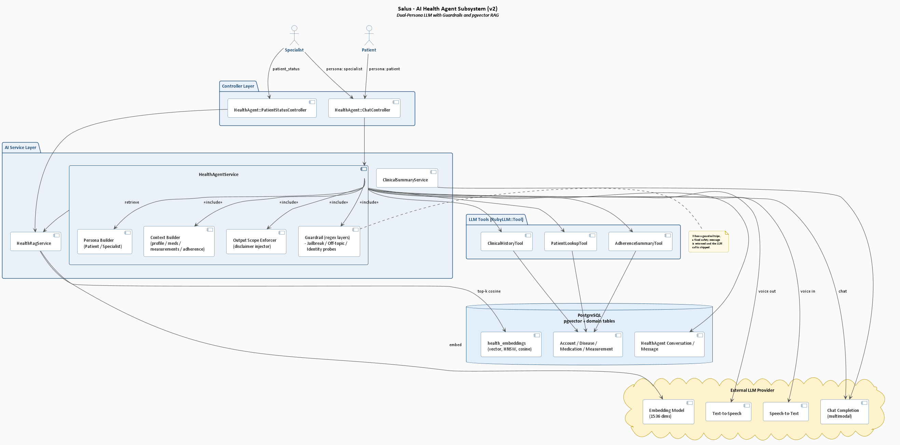
Figure 3.3: AI Health Agent Subsystem
The figure below shows how the Rails 8 Solid stack (Solid Queue, Solid Cache and Solid Cable) provides a fully database-backed implementation of background jobs, server-side caching, and WebSocket fan-out without any Redis dependency.
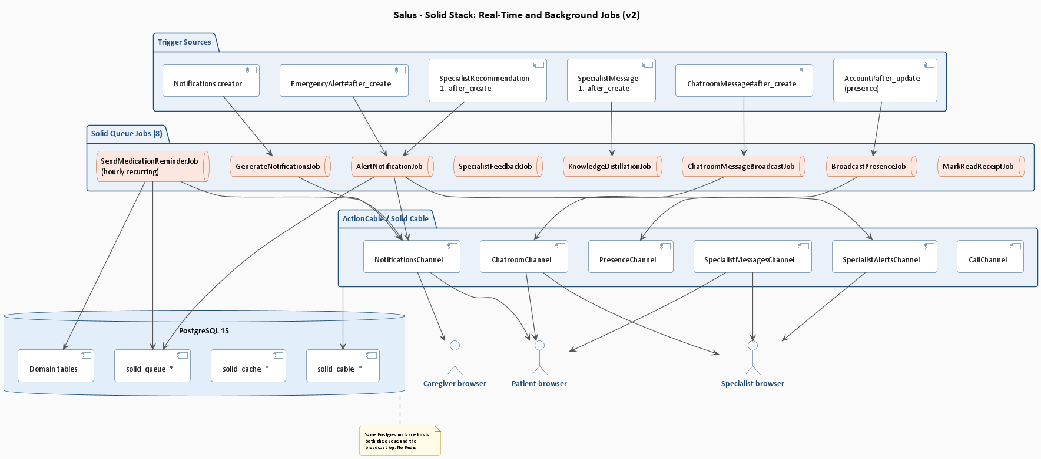
Figure 3.4: Solid Stack - Real-Time and Background Jobs
The figure below captures the Specialist Alert Pipeline - the chain that converts an out-of-range vital sign or a missed-medication burst into a Health Alert, fans it out to the patient's specialist and consenting caregivers, and confirms delivery on Solid Cable WebSockets.
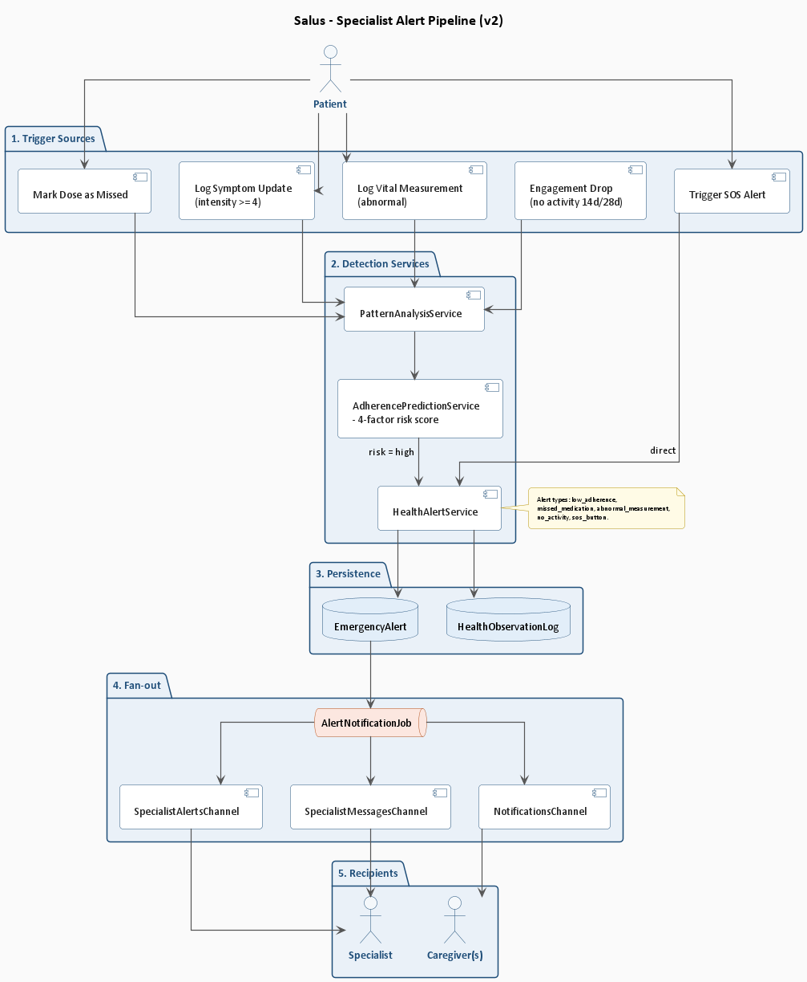
Figure 3.5: Specialist Alert Pipeline

3.8 Use Cases
Salus has four primary actors (Patient, Caregiver, Specialist, Administrator) with the Patient as the default role assigned at signup. The use cases are organised into ten functional packages:
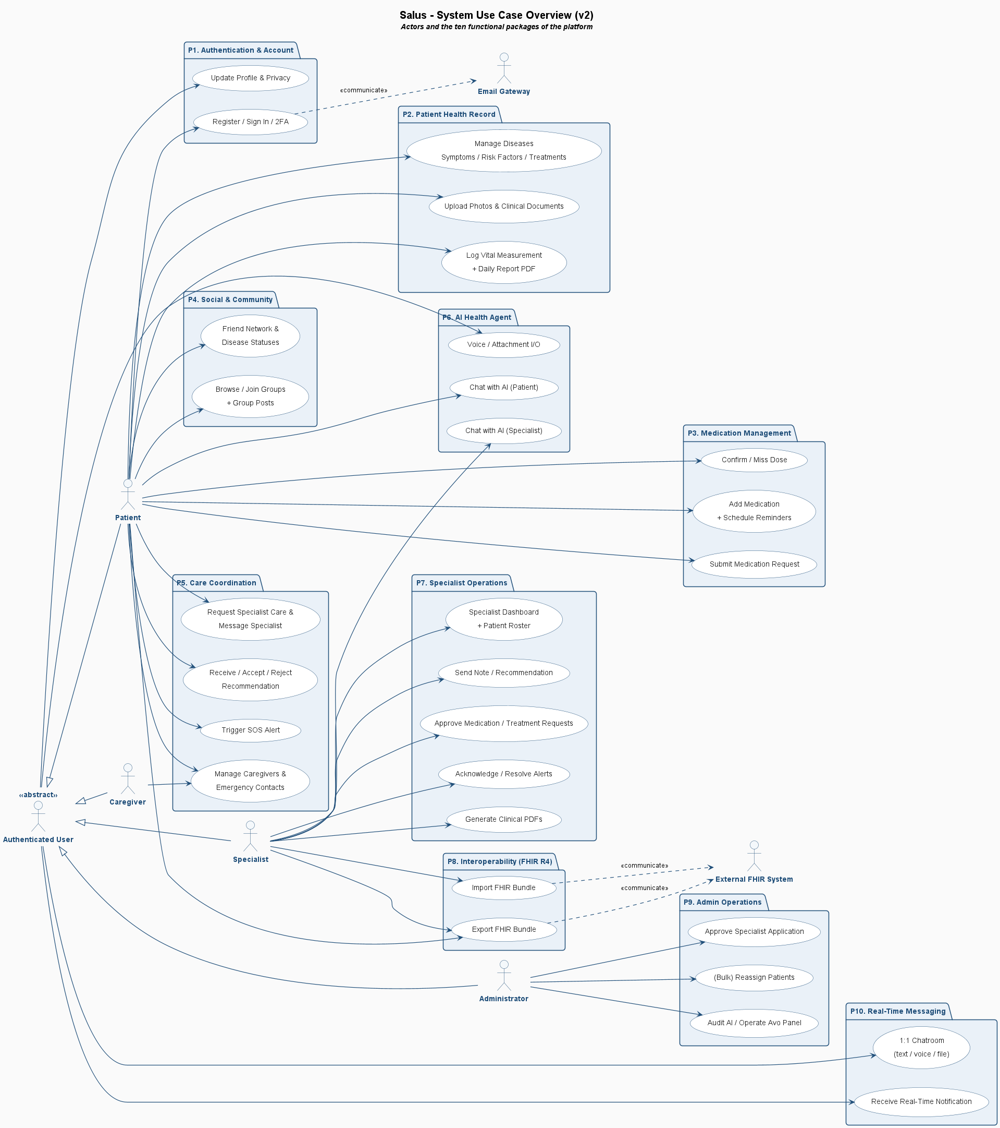
Figure 3.6: Salus Master Use Case Diagram

3.8.1 Authentication and Account Management
The figure below presents the authentication package - sign-up, email confirmation, sign-in, two-factor TOTP enrolment, password reset, profile setup and account deletion. These use cases form the secure entry point for every other interaction in the platform and are shared by all three primary actors.
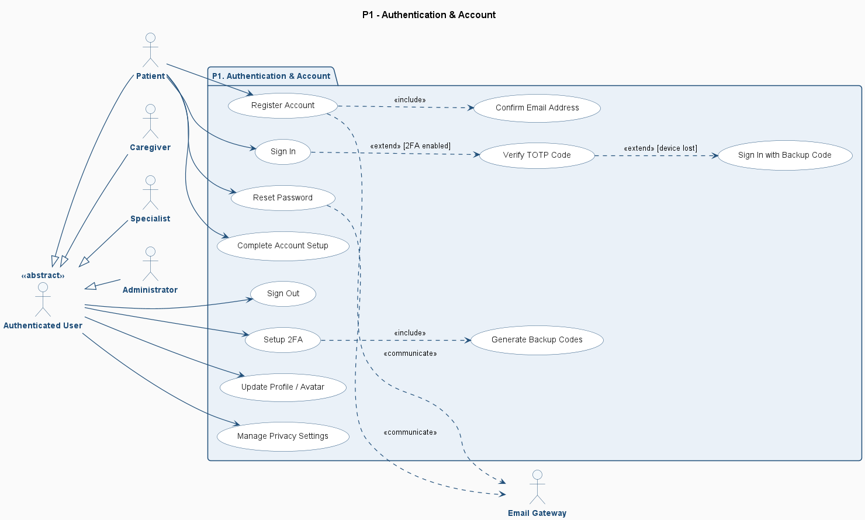
Figure 3.7: Authentication and Account Management Use Cases

Salus follows a classic layered Model-View-Controller architecture with explicit Service Objects to encapsulate cross-cutting business logic, and Background Jobs for asynchronous work. Five complementary architectural views are presented including a high-level deployment view, a layered application view, the AI Health Agent subsystem, the Solid stack real-time and background-job view, and the specialist alert pipeline.
It captures the social layer: posting mood-tagged disease statuses, browsing and joining disease-specific support groups, commenting and reacting on peer posts, voting in polls, and viewing aggregated symptom statistics shared anonymously across the cohort.

3.8.2 Patient Health Record
The figure below shows the Patient-facing health-record use cases, which form the largest cluster in the application: capturing diseases, symptoms, risk factors, treatments, photos, measurements and notes, and reviewing them on the dashboard.
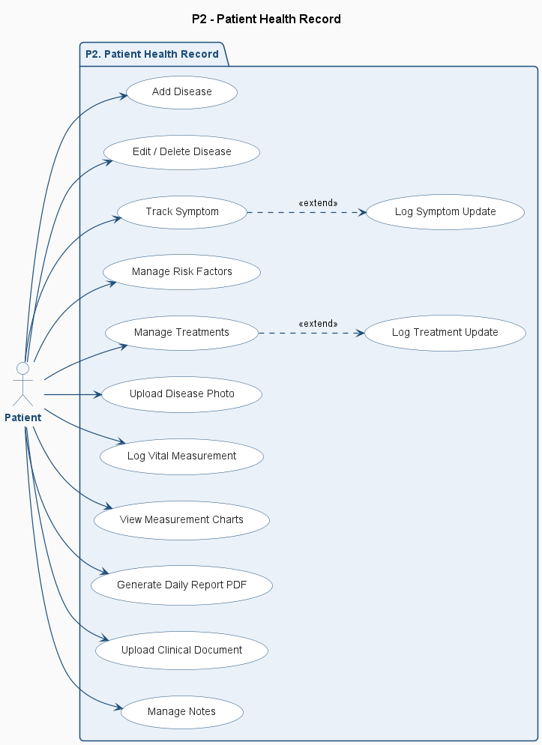
Figure 3.8: Patient Use Cases - Health Record

3.8.3 Medication Management
The figure below presents the medication-management package: adding a medication, defining a dosage schedule, receiving reminder notifications, confirming an intake, marking a missed dose, viewing the rolling adherence chart, and submitting a medication request to the supervising specialist.
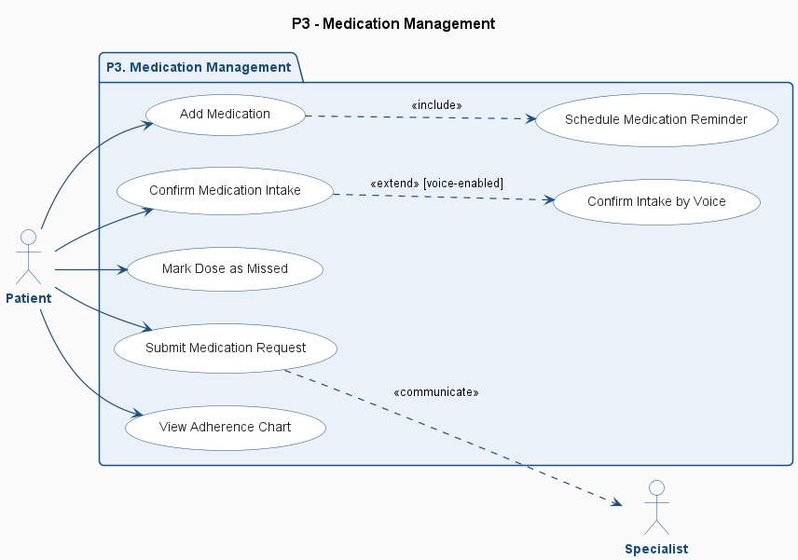
Figure 3.9: Medication Management Use Cases

Salus uniquely combines disease-specific peer-support groups (one group per ICD-10 disease, automatically created from the predefined-disease catalog) with verified specialist accounts, individual disease panels, real-time alerts via Solid Cable, and an in-house Specialised Language Model running locally rather than as a third-party API call. Validated RCTs show measurable reductions in anxiety scores. The limitation is scope: Woebot serves mental health only and lacks any facility for managing complex physical-medication regimens, tracking vitals, or sharing data with a treating physician. Salus generalises the persona-and-disclaimer pattern to physical chronic conditions and synchronises every conversation with the patient's medical record.

3.8.4 Social and Community
The figure below captures the social layer: posting mood-tagged disease statuses, browsing and joining disease-specific support groups, commenting and reacting on peer posts, voting in polls, and viewing aggregated symptom statistics shared anonymously across the cohort.
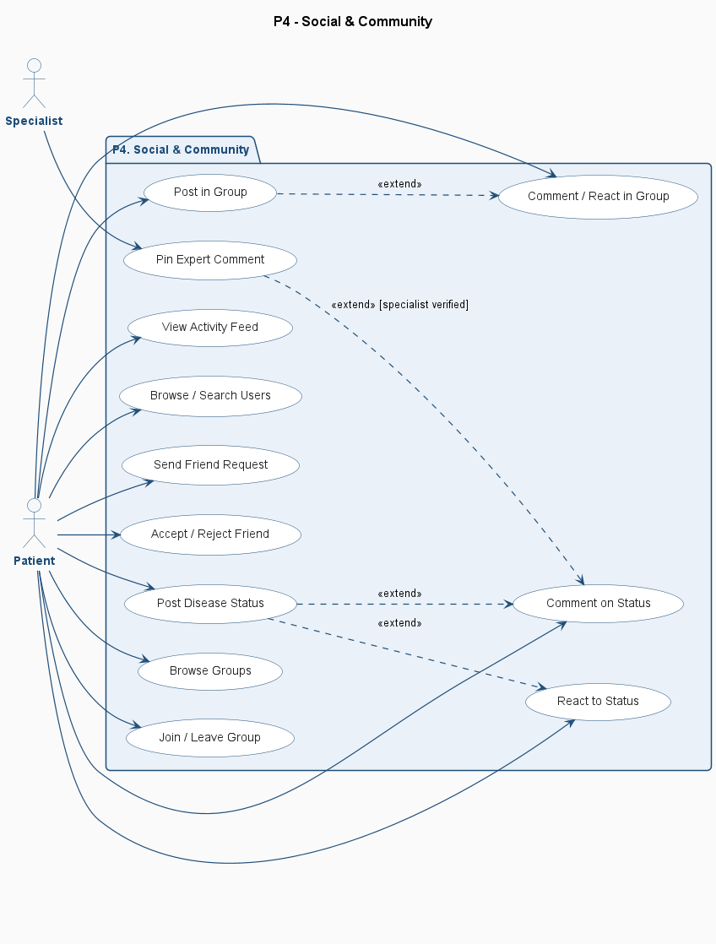
Figure 3.10: Social and Community Use Cases

3.8.5 Specialist Care Coordination
The figure below captures the Specialist's care-coordination use cases: viewing the patient cohort, reviewing health alerts and adherence-risk scores, sending recommendations and clinical notes, and exporting FHIR bundles to external Electronic Health Record systems.
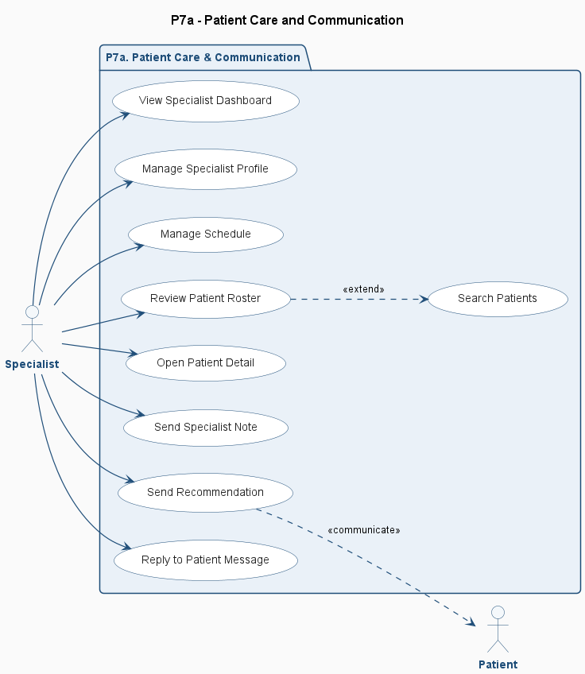
Figure 3.11: Specialist Use Cases - Patient Care

3.8.6 FHIR Interoperability
The figure below shows the FHIR interoperability use cases - exporting a patient bundle in HL7 FHIR R4 format, importing a FHIR record from an external EHR, validating the bundle against the official R4 profiles, and viewing the import / export audit log. The supporting HAPI FHIR JPA Server runs as a sibling Docker container in the deployment.

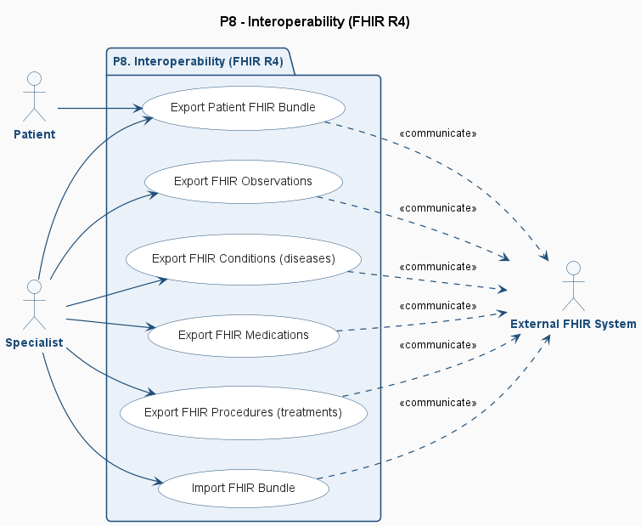
Figure 3.12: FHIR Interoperability Use Cases

3.8.7 Real-Time Messaging and Notifications
The figure below details the real-time messaging package powered by Solid Cable: one-to-one messaging between patient and specialist, group chat inside support communities, live notification fan-out for alerts and recommendations, and typing / read indicators delivered over WebSockets.

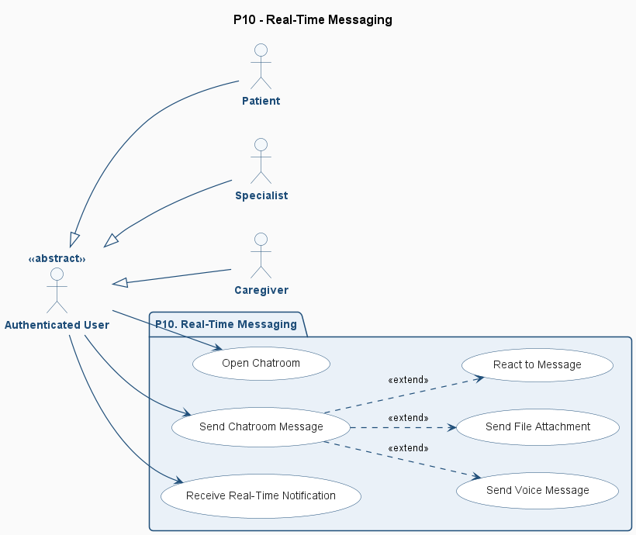
Figure 3.13: Real-Time Messaging and Notifications Use Cases

3.8.8 Administrator
The figure below lists the Administrator use cases that govern the platform: approving specialist applications, reassigning patients between specialists, moderating community content, and managing the predefined-disease catalog.

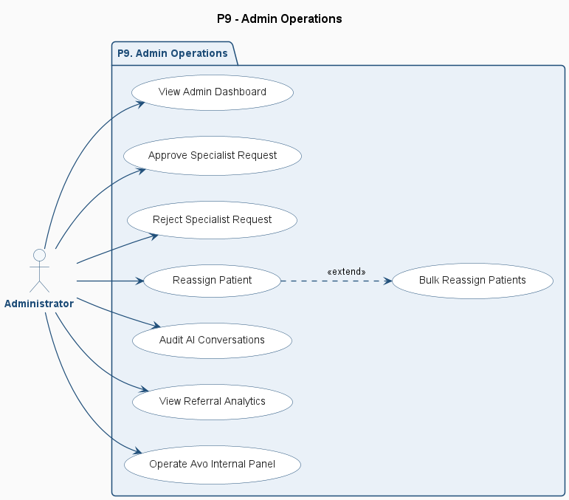
Figure 3.14: Administrator Use Cases

3.9 Fully-Dressed Use Cases
The fully-dressed use cases follow the Cockburn template, presenting actor, primary scenario, alternative flows, preconditions, postconditions, and special requirements. Six representative scenarios are presented in this section; the remaining fourteen fully-dressed cases are bundled in the appendix.

3.9.1 Sign Up
Table 3.3: Use Case - User Sign Up
Salus / Sign Up
FYP II Documentation Section 3.6
Test Case ID: | UC-P1-01 | Test Date: 2026-04-30
Test case Version: | V1.0 | Use Case Reference(s): UC-P1-01 (Register Account)
Revision History: | None - initial version
Objective | A new visitor creates a Salus patient account by providing email, password and accepting the Terms of Service.
Pre-Requisite: | The visitor is on /auth/sign_up.
Step No. | Execution description | Procedure result
1 | Visitor opens /auth/sign_up. | System renders the registration form.
2 | Visitor enters email, password >=8 characters, password confirmation, and accepts Terms of Service. | Form fields validate client-side.
3 | Visitor submits the form. | System creates User row (bcrypt digest) and Account row with role = patient.
Comments: Email confirmation token expires after 24 hours. Rate-limit: <= 5 sign-ups per IP per hour.

3.9.2 Login
Table 3.4: Use Case - User Sign In
Salus / Sign In
FYP II Documentation Section 3.6
Test Case ID: | UC-P1-03 | Test Date: 2026-04-30
Test case Version: | V1.0 | Use Case Reference(s): UC-P1-03 (Sign In), UC-P1-07 (Verify TOTP)
Revision History: | None - initial version
Objective | A returning user authenticates with email and password, branching to a TOTP step if 2FA is enabled.
Product/Ver/Module: | Salus v1.0 / Auth::SessionsController#create
Environment: | Web browser; Rails 8; PostgreSQL 15.
Assumptions: | The user has a confirmed account.
Pre-Requisite: | The visitor is on /auth/sign_in.
Step No. | Execution description | Procedure result
1 | Visitor opens /auth/sign_in and submits credentials. | System verifies bcrypt digest.
2 | (if 2FA enabled) System redirects to TOTP challenge. | Visitor enters 6-digit code from authenticator.
3 | Visitor clicks Sign In. | System verifies via ROTP::TOTP and establishes session cookie.
4 | (no actor action) | System redirects to /dashboard and the user sees the relevant infographics and charts for both the specialist and patient respectively.
Comments: Brute-force protection: rate-limit <= 10 attempts/IP/15 minutes. Backup code path is available if device is lost.

3.9.3 Add Disease
Table 3.5: Use Case - Add Disease
Salus / Add Disease
FYP II Documentation Section 3.6
Test Case ID: | UC-P2-01 | Test Date: 2026-04-30
Test case Version: | V1.0 | Use Case Reference(s): UC-P2-01 (Add Disease)
Revision History: | None - initial version
Objective | A patient adds a chronic condition to their record from the catalog or as a custom entry, optionally joining the matching support group.
Product/Ver/Module: | Salus v1.0 / DiseasesController#create + DiseaseOnboardingService
Environment: | Rails 8; PostgreSQL 15.
Assumptions: | Patient is signed in and the predefined-disease catalog is seeded.
Pre-Requisite: | Patient is on /diseases.
Step No. | Execution description | Procedure result
1 | Patient clicks Add Disease. | System renders catalog (80+ predefined diseases) plus a Custom option.
2 | Patient picks a predefined disease and sets severity, status, color, diagnosis date, notes. | System creates Disease row linked to PredefinedDisease.
3 | (no actor action) | If creates_group is true, system shows the onboarding nudge offering to join the disease's group.
4 | Patient clicks Join. | GroupMember row created.
Comments: ICD-10 code mandatory for catalog entries. Disease deletion cascades to symptoms, risk factors and photos.

3.9.4 Confirm Medication Intake
Table 3.6: Use Case - Confirm Medication Intake
Salus / Confirm Medication Intake
FYP II Documentation Section 3.6
Test Case ID: | UC-P3-03 | Test Date: 2026-04-30
Test case Version: | V1.0 | Use Case Reference(s): UC-P3-03 (Confirm Intake)
Revision History: | None - initial version
Objective | A patient confirms taking a scheduled dose, updating the log and rolling adherence statistics.
Product/Ver/Module: | Salus v1.0 / MedicationsController#confirm
Environment: | Rails 8; PostgreSQL 15; Solid Cable channels active.
Assumptions: | An active medication exists with at least one schedule that has fired a pending log.
Pre-Requisite: | Patient is on /medications or has received a notification.
Step No. | Execution description | Procedure result
1 | SendMedicationReminderJob fires hourly. | System creates Notification row 1 hour before scheduled dose; broadcasts in real time.
2 | Patient receives notification. | Browser shows toast and badge update.
3 | Patient taps Confirm Intake. | MedicationLog updated to status = taken with taken_at = now.
4 | (no actor action) | System recomputes adherence percentage and refreshes dashboard chart.
Comments: Action is idempotent: a second confirm tap does not create a duplicate log.

3.9.5 Log Vital Measurement
Table 3.7: Use Case - Log Vital Measurement
Salus / Log Vital Measurement
FYP II Documentation Section 3.6
Test Case ID: | UC-P2-10 | Test Date: 2026-04-30
Test case Version: | V1.0 | Use Case Reference(s): UC-P2-10 (Log Vital Measurement)
Revision History: | None - initial version
Objective | A patient logs a vital sign measurement which the system auto-classifies and may escalate to an alert.
Product/Ver/Module: | Salus v1.0 / MeasurementsController#create + HealthAlertService
Environment: | Rails 8; PostgreSQL 15; Solid Queue worker.
Assumptions: | MeasurementType seed data is loaded with valid limits.
Pre-Requisite: | Patient is on /measurements/new.
Step No. | Execution description | Procedure result
1 | Patient enters value and notes. | System validates against type-specific range.
2 | Patient submits. | System persists Measurement row and computes is_within_limits.
3 | (no actor action) If value is outside critical limits | System creates EmergencyAlert with alert_type = abnormal_measurement.
4 | (no actor action) | AlertNotificationJob is enqueued and fan-out happens to specialist + caregivers.
Comments: Critical thresholds are configured per MeasurementType. Patient sees a yellow indicator when out-of-range, red when critical.

3.9.6 Send Specialist Recommendation
Table 3.8: Use Case - Send Specialist Recommendation
Salus / Send Specialist Recommendation
FYP II Documentation Section 3.6
Test Case ID: | UC-P7-08 | Test Date: 2026-04-30
Test case Version: | V1.0 | Use Case Reference(s): UC-P7-08 (Send Recommendation)
Revision History: | None - initial version
Objective | A specialist drafts and sends a recommendation; the patient may accept, reject, or dismiss it.
Product/Ver/Module: | Salus v1.0 / Specialist::RecommendationsController#create
Environment: | Rails 8; PostgreSQL 15; Solid Cable.
Assumptions: | An accepted SpecialistPatient relationship exists.
Pre-Requisite: | Specialist is on the patient's detail page.
Step No. | Execution description | Procedure result
1 | Specialist clicks + Recommendation. | System renders form with type, name, dosage, notes, rationale.
2 | Specialist submits. | System validates rationale (mandatory) and creates SpecialistRecommendation with status = pending.
3 | (no actor action) | Real-time notification delivered to patient.
4 | Patient taps Accept (alternative: Reject / Dismiss). | System updates status; on Accept auto-creates Medication or Treatment with source = specialist.
Comments: The accept flow is wrapped in a single transaction so partial state cannot persist.

3.10 Database Schema Diagram
The Salus database comprises approximately seventy tables, all with UUID v4 primary keys. The schema is split logically across eight functional domains - identity, health record, medication, measurement, care coordination, social network, AI knowledge, and real-time messaging. Each domain is presented below as its own entity-relationship diagram; the high-level overview comes first.
The figure below shows a high-level overview of how the eight functional domains relate to one another, with the identity domain at the centre and the remaining domains attached through foreign-key references.
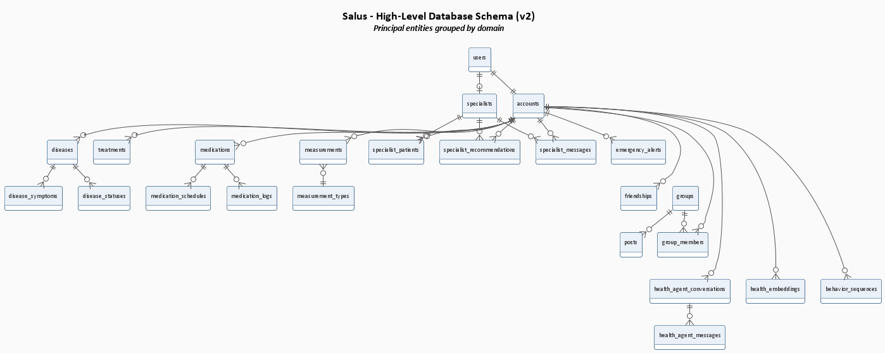
Figure 3.15: Database Schema Overview

The figure below details the identity-and-authentication tables - users, accounts, sessions, OTP secrets and backup codes - which underpin every authenticated workflow in Salus.

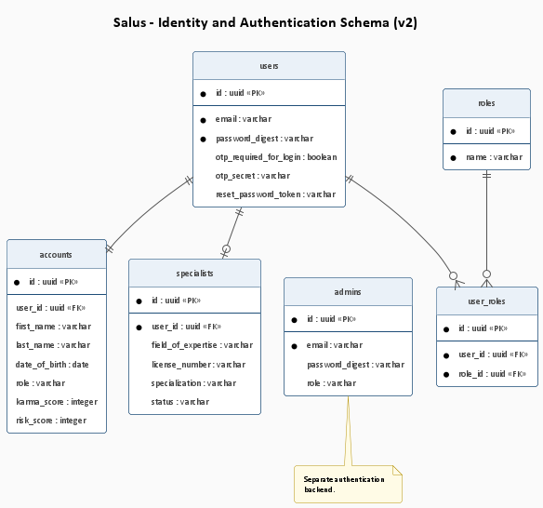
Figure 3.16: Identity and Authentication Schema

The figure below captures the health-record domain: the central Disease table and its satellite tables for symptoms, risk factors, treatments, photos and disease statuses.

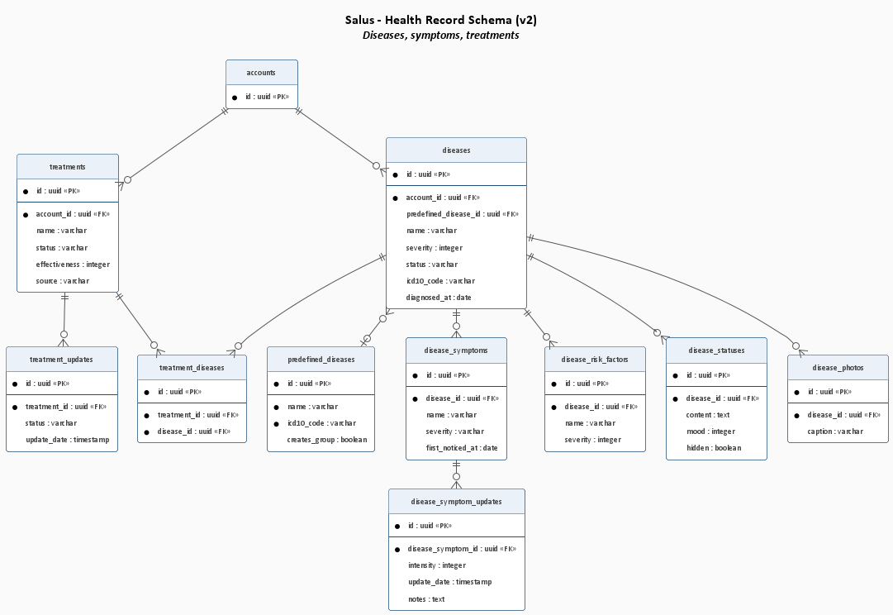
Figure 3.17: Health Record Schema

The figure below shows the medication-management tables - Medication, MedicationSchedule and MedicationLog - and how they are joined for adherence calculation.

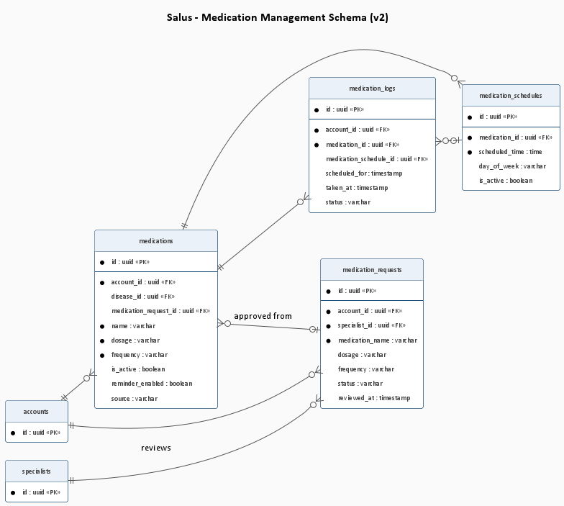
Figure 3.18: Medication Management Schema

The figure below displays the care-coordination tables: the SpecialistPatient relationship, alerts, recommendations, specialist notes, and the patient-side acknowledgement records.

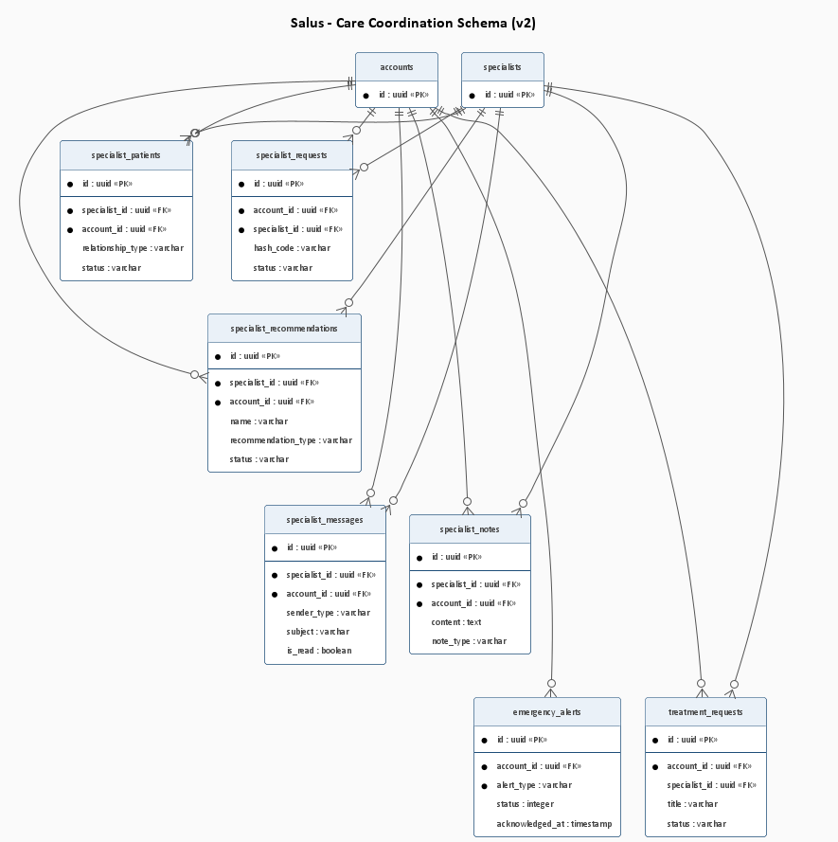
Figure 3.19: Care Coordination Schema

The figure below illustrates the AI-knowledge schema, which stores anonymised messages and pgvector embeddings for the Retrieval-Augmented Generation pipeline used by the dual-persona Health Agent.

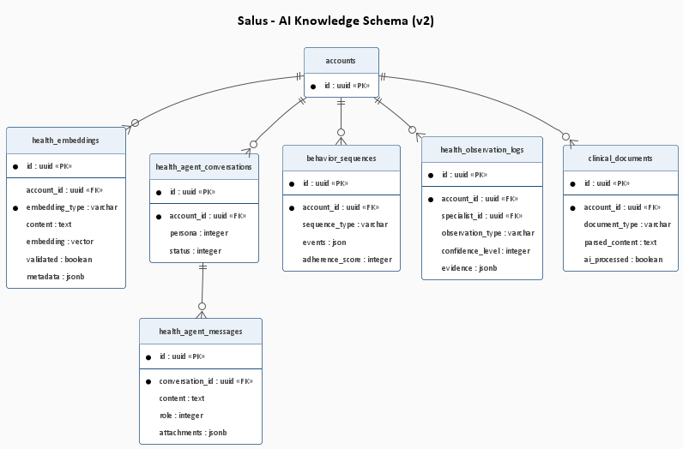
Figure 3.20: AI Knowledge Schema

3.11 Class, Sequence and Activity Diagrams
The class diagrams below capture the static structure of the principal subsystems; the sequence diagrams show the dynamic interaction patterns of the most important scenarios; and the activity diagrams document the major end-to-end workflows.

3.11.1 Class Diagrams
The figure below captures the User and Account class hierarchy, modelling the polymorphic role assignment (patient, specialist, admin) and the supporting authentication artifacts.

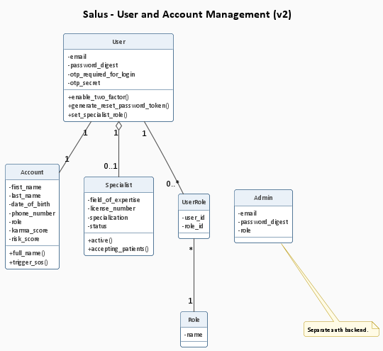
Figure 3.21: User and Account Class Diagram
The figure below shows the Health-Record class structure - the Disease aggregate root and its associated Symptom, RiskFactor, Treatment, Photo and DiseaseStatus classes.

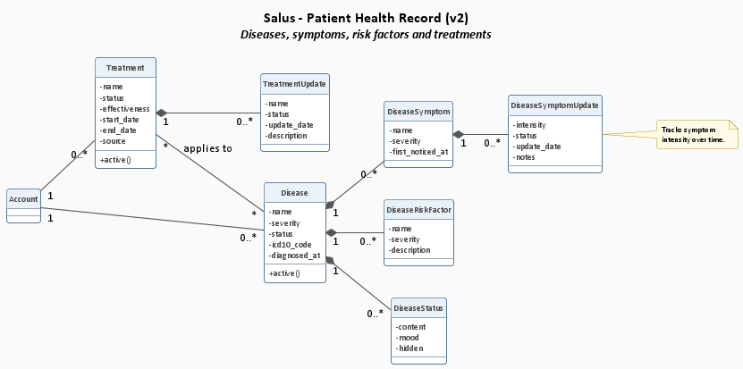
Figure 3.22: Health Record Class Diagram

This class diagram capture the static structure of the principal subsystems; the sequence diagrams show the dynamic interaction patterns of the most important scenarios; and the activity diagrams document the major end-to-end workflows. Salus uniquely combines disease-specific peer-support groups (one group per ICD-10 disease, automatically created from the predefined-disease catalog) with verified specialist accounts, individual disease panels, real-time alerts via Solid Cable, and an in-house Specialised Language Model running locally rather than as a third-party API call.

The figure below details the medication classes - Medication, MedicationSchedule, MedicationLog and the related request/recommendation classes that flow between patient and specialist.

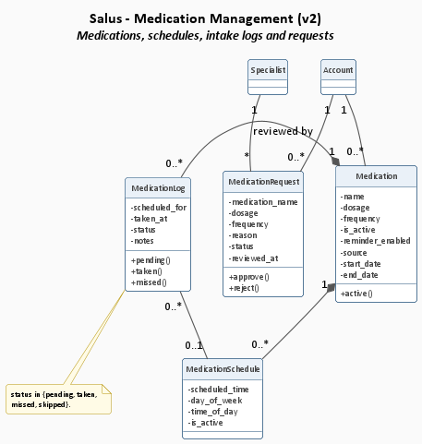
Figure 3.23: Medication Class Diagram

The figure below renders the care-coordination classes that wire specialists to patients - SpecialistPatient, SpecialistRecommendation, SpecialistNote, EmergencyAlert and the acknowledgement records.

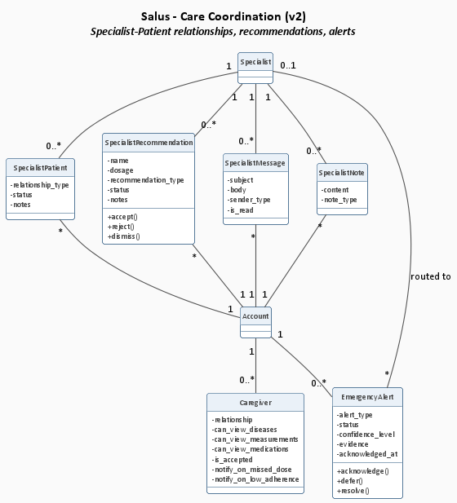
Figure 3.24: Care Coordination Class Diagram

3.11.2 Sequence Diagrams
The figure below traces the patient-registration sequence end-to-end: form submission, account creation, confirmation-email dispatch, token validation and session establishment.
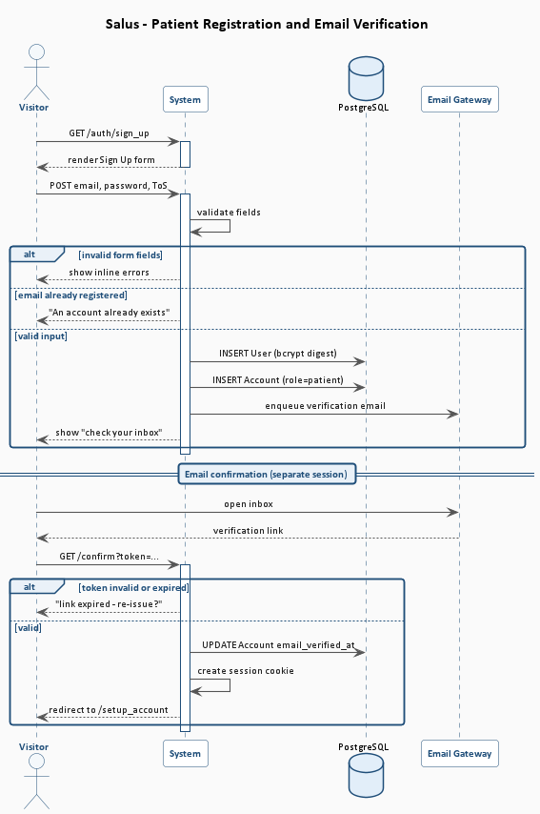
Figure 3.25: Patient Registration Sequence
The figure below shows the sign-in sequence including the two-factor authentication branch: email and password verification followed by the optional TOTP challenge or backup-code redemption that finally establishes the session.
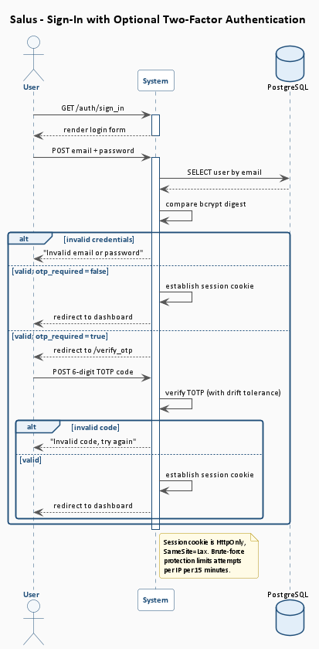
Figure 3.26: Sign-In with Two-Factor Authentication Sequence
The figure below illustrates the medication-intake sequence - reminder broadcast, patient confirmation tap, idempotent log update and adherence-chart refresh on the dashboard.

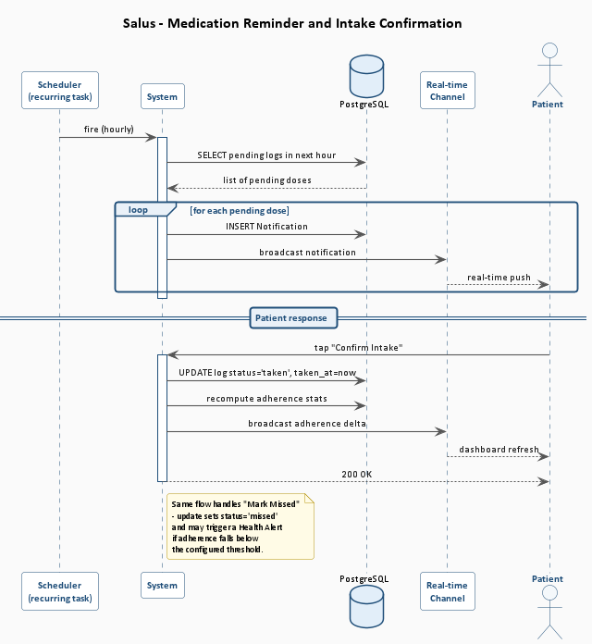
Figure 3.27: Medication Intake Sequence
The figure below traces the vital-sign measurement sequence: patient logs a reading, the system classifies it against the configured limits, and any out-of-range value escalates to the Health Alert Service which fans out to the specialist and consenting caregivers.

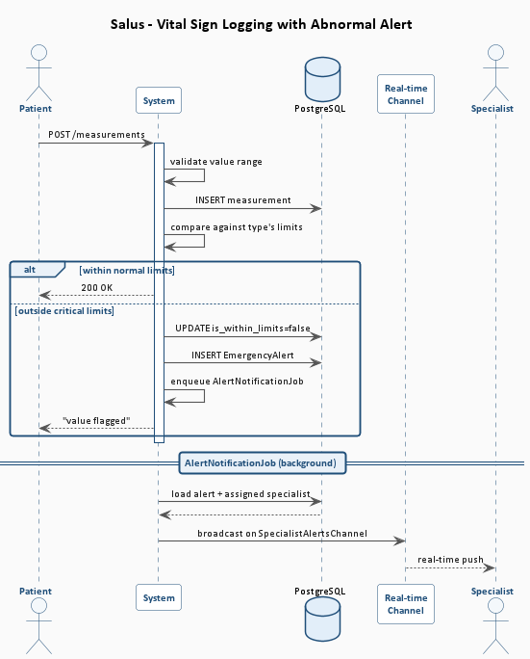
Figure 3.28: Vital-Sign Measurement and Alert-Escalation Sequence
The figure below shows the specialist-recommendation sequence: specialist drafts a recommendation, system validates and delivers a real-time notification to the patient, and the patient accepts or rejects within a single transaction.
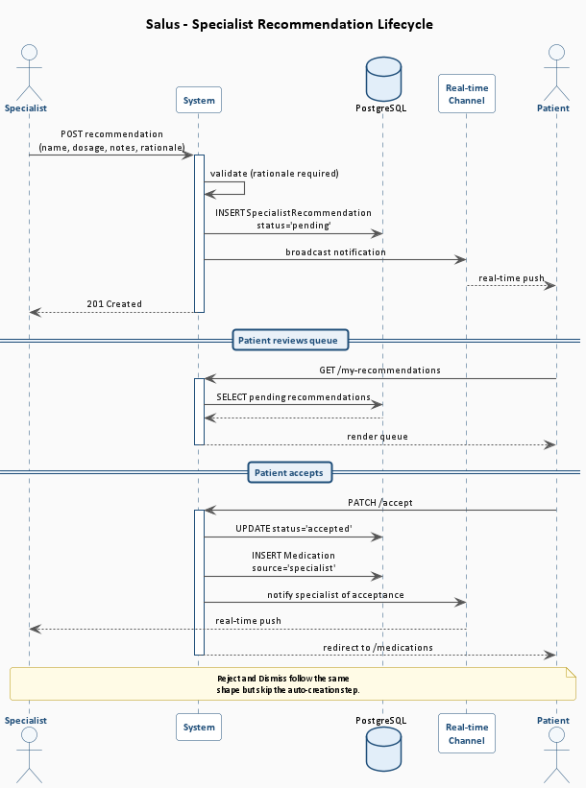
Figure 3.29: Specialist Recommendation Sequence
The figure below traces the SOS-alert fan-out: patient triggers an emergency, the AlertNotificationJob enqueues, and the alert broadcasts simultaneously to specialist and consenting caregivers via Solid Cable.

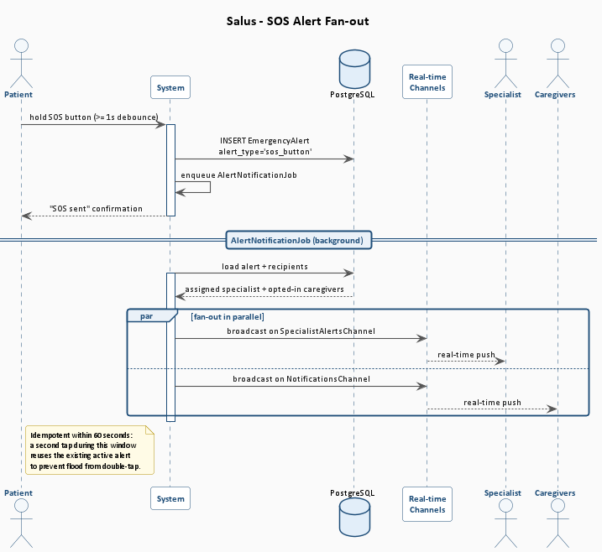
Figure 3.30: SOS Alert Fan-out Sequence

3.11.3 Activity Diagrams
The figure below presents the end-to-end Patient Journey across the platform - from initial registration and onboarding through disease tracking, daily medication and measurement logging, peer-support engagement and specialist consultation - showing how the principal workflows interconnect.
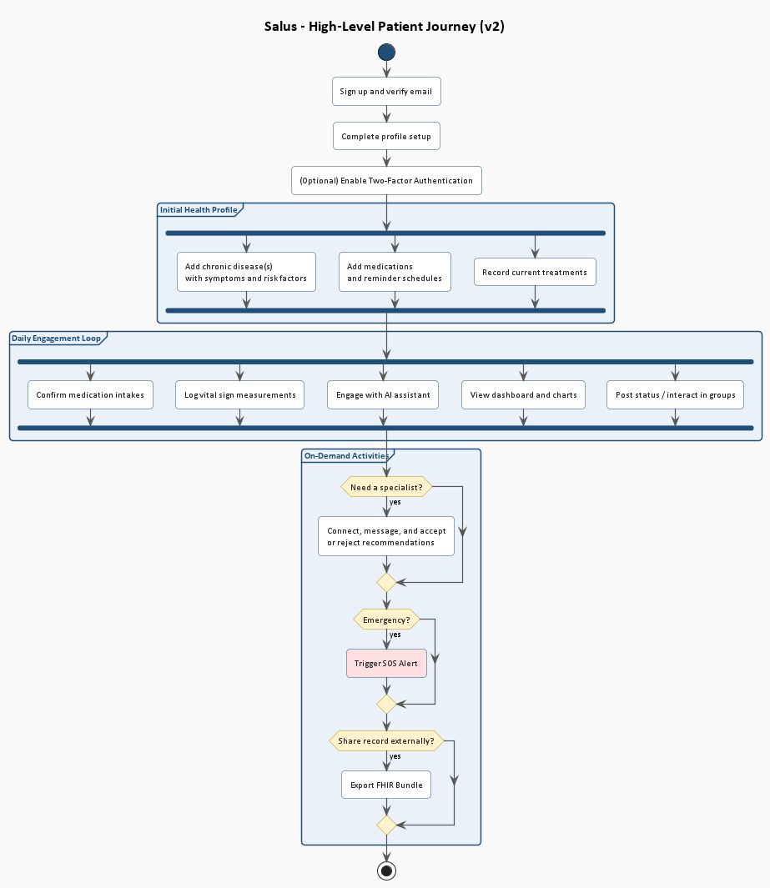
Figure 3.31: End-to-End Patient Journey Activity
The figure below documents the patient-registration workflow as swim-lanes across visitor, system and email gateway, including the alternative path for an already-registered email.
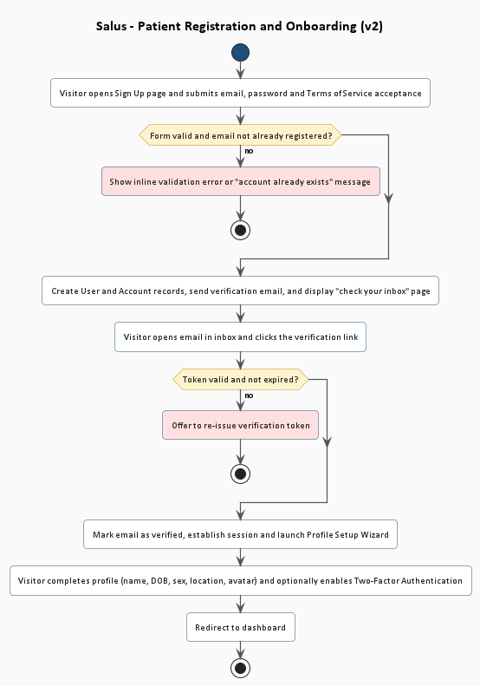
Figure 3.32: Patient Registration Activity
The figure below renders the medication-intake activity, covering the reminder, the confirm path, the missed path, and the branching adherence calculation.
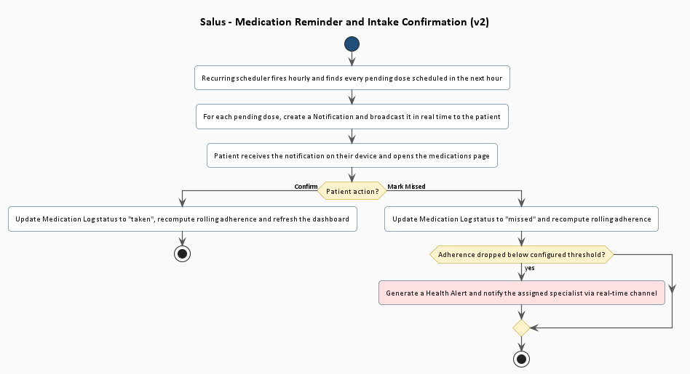
Figure 3.33: Medication Intake Activity

On the academic side, our coursework in software engineering, databases, distributed systems, and artificial intelligence had given us the tools to build modern web platforms but had rarely asked us to combine those tools in a single, production-ready system. We wanted a project ambitious enough to exercise every part of our curriculum - from object-relational modelling to real-time pub/sub, from policy-based authorisation to retrieval-augmented machine learning, from continuous integration to cloud deployment.
On the technological side, the rise of in-house Specialised Language Models that can be fine-tuned for narrow domains, combined with the maturity of vector-search databases such as pgvector, made it feasible for the first time to give a patient-facing assistant persistent memory of the patient's own record - without sending that record to any external service. rewarding engineering decisions of the project, and a deliberate counter-statement to the prevailing pattern of delegating clinical reasoning to a third-party API.
The figure below documents the vital-sign measurement activity, including range validation, automatic classification against type-specific limits, and the conditional escalation to a Health Alert when a reading falls outside the critical range.
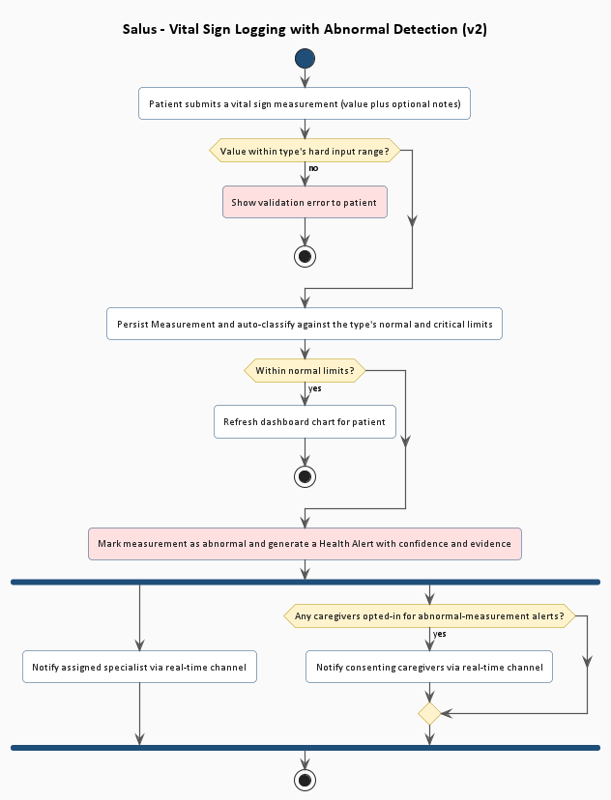
Figure 3.34: Vital-Sign Measurement Activity
The figure below shows the specialist-recommendation activity from drafting through validation, real-time delivery, patient acceptance or rejection, and the automatic creation of a Medication or Treatment record on acceptance.

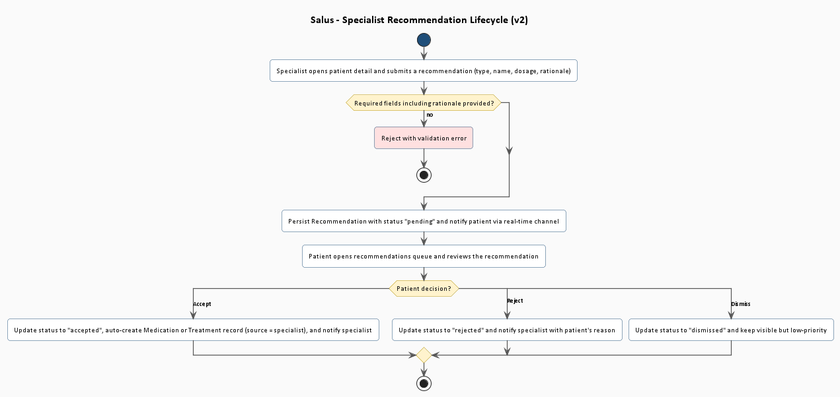
Figure 3.35: Specialist Recommendation Activity

On the academic side, our coursework in software engineering, databases, distributed systems, and artificial intelligence had given us the tools to build modern web platforms but had rarely asked us to combine those tools in a single, production-ready system. We wanted a project ambitious enough to exercise every part of our curriculum - from object-relational modelling to real-time pub/sub, from policy-based authorisation to retrieval-augmented machine learning, from continuous integration to cloud deployment.
On the technological side, the rise of in-house Specialised Language Models that can be fine-tuned for narrow domains, combined with the maturity of vector-search databases such as pgvector, made it feasible for the first time to give a patient-facing assistant persistent memory of the patient's own record - without sending that record to any external service. rewarding engineering decisions of the project, and a deliberate counter-statement to the prevailing pattern of delegating clinical reasoning to a third-party API.
The figure below shows the specialist alert-handling activity: alert ingestion, severity classification, fan-out to specialist and caregivers, and acknowledgement tracking.
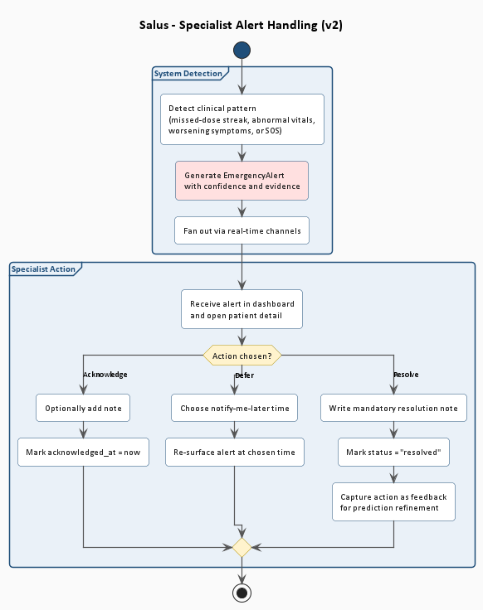
Figure 3.36: Specialist Alert Handling Activity

3.12 Graphical User Interfaces (GUI)
Graphical User Interfaces (GUIs) provide a visual and interactive means for users to operate the system. This section presents screenshots of each major screen in the Salus chronic disease management web application, along with a brief description of the screen's purpose, the actor that primarily uses it, and the use case (or use cases) the screen supports.

3.12.1 Home Page
The Home page is the public-facing landing surface of Salus. It introduces the platform's mission and provides clear calls-to-action for new visitors to register and for returning users to sign in.
Actor: Visitor | Use Case: Public Landing
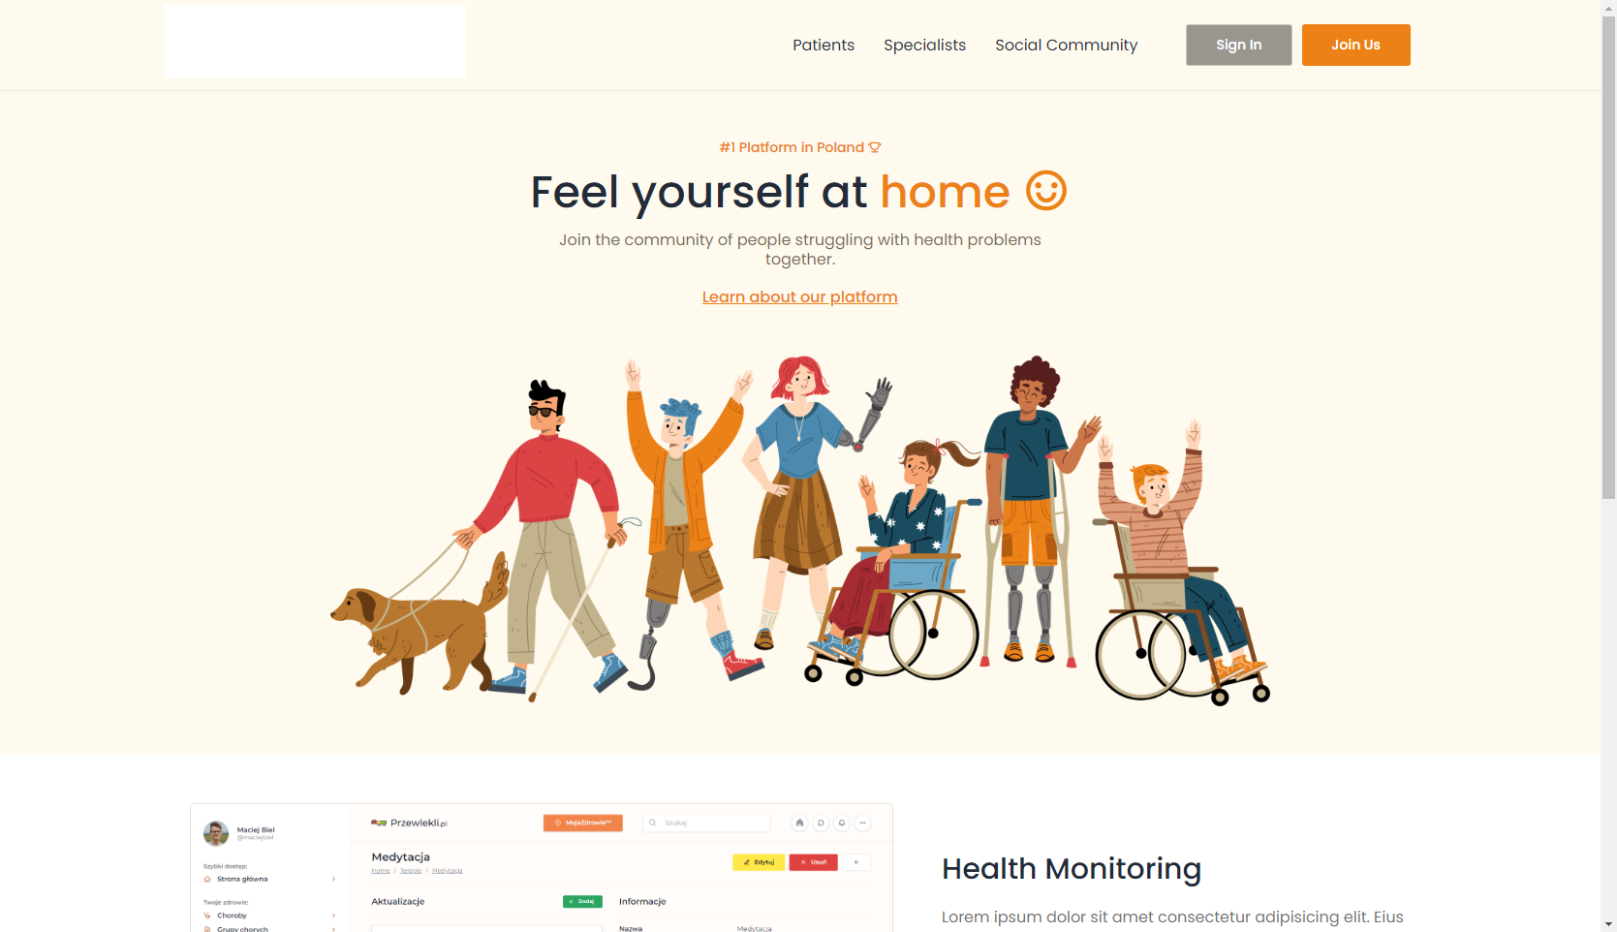
Figure 3.37: Salus - Home / Landing Page

3.12.2 Sign-Up Screen
The Sign-Up screen allows a new visitor to register an account by providing an email address, a password and a password confirmation, and by accepting the Terms of Service. On successful submission the system creates a User and an associated Account record (with role = patient).
Actor: Visitor | Use Case: UC-P1-01 Register Account


Figure 3.38: Salus - Sign-Up Screen

3.12.3 Sign-In Screen
The Sign-In screen presents a standard email-and-password form. On valid credentials the system establishes a session cookie or redirects to the TOTP challenge when 2FA is enabled.
Actor: Patient/Specialist/Admin | Use Case: UC-P1-03 Sign In

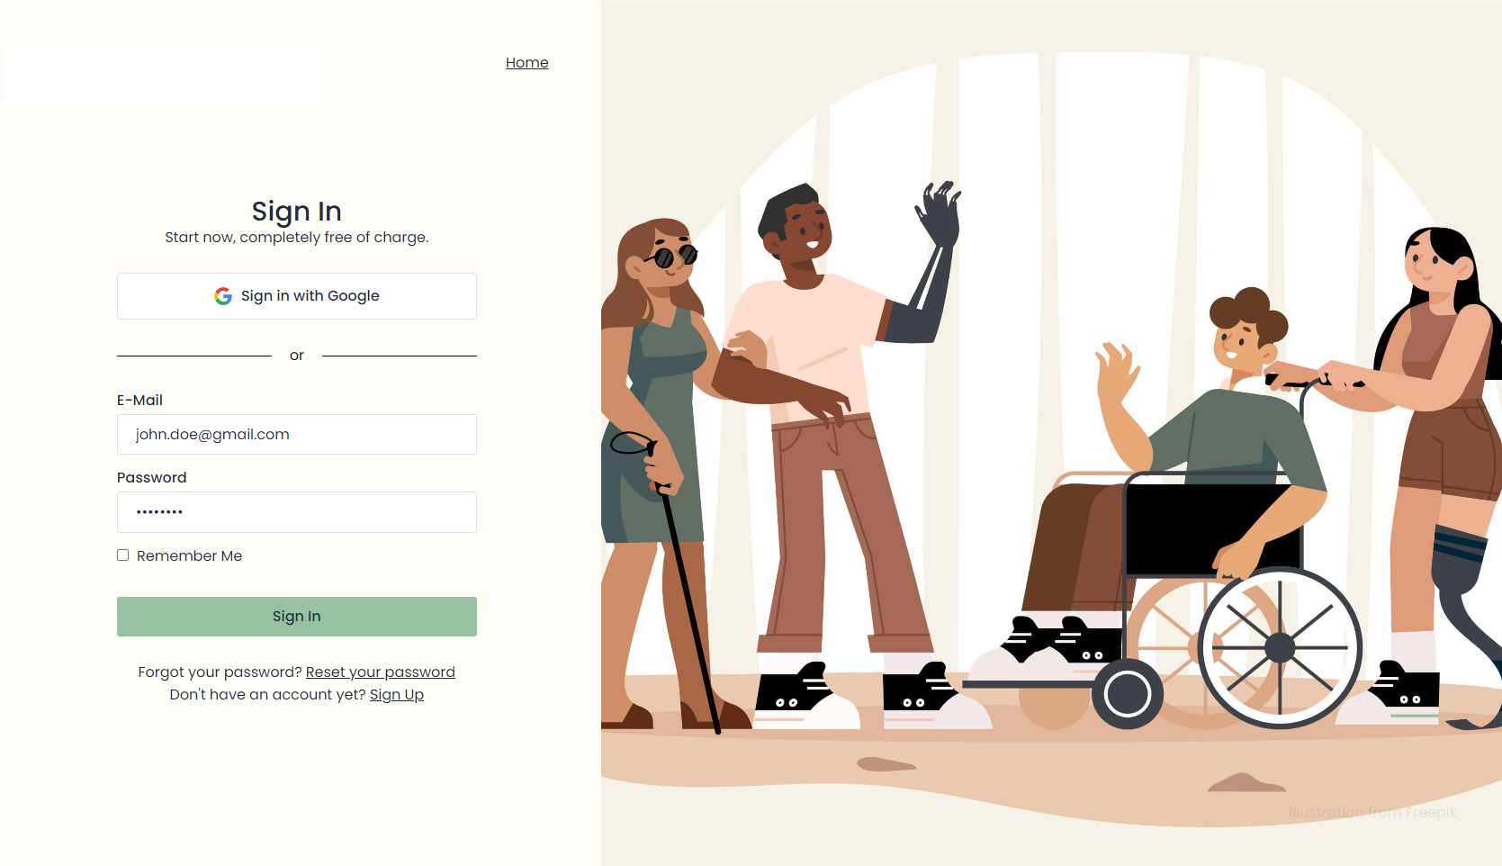
Figure 3.39: Salus - Sign-In Screen

3.12.4 Two-Factor Authentication Setup
The 2FA setup screen, accessible through Settings > Security, generates a TOTP secret using the ROTP gem and renders a QR code for any authenticator application.
Actor: Authenticated User | Use Case: UC-P1-06 Setup 2FA

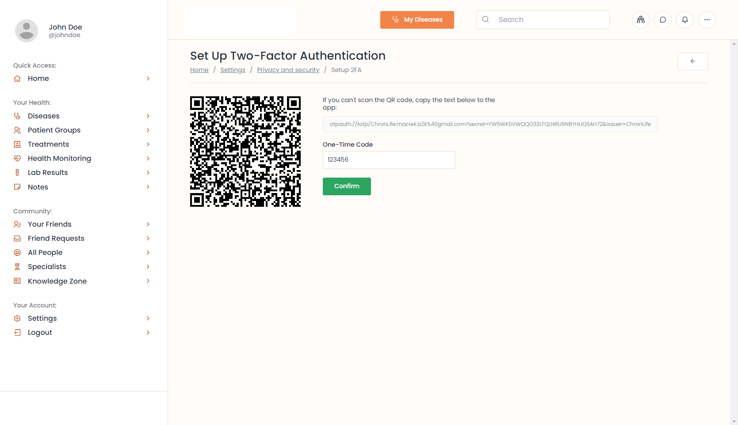
Figure 3.40: Salus - Two-Factor Authentication Setup

3.12.5 My Health Dashboard
The My Health dashboard is the patient's primary landing screen after sign-in. It surfaces rolling adherence statistics, recent vital sign measurements, the active medication list, ongoing diseases, and AI-generated risk indicators.
Actor: Patient | Use Cases: View Dashboard, View Adherence

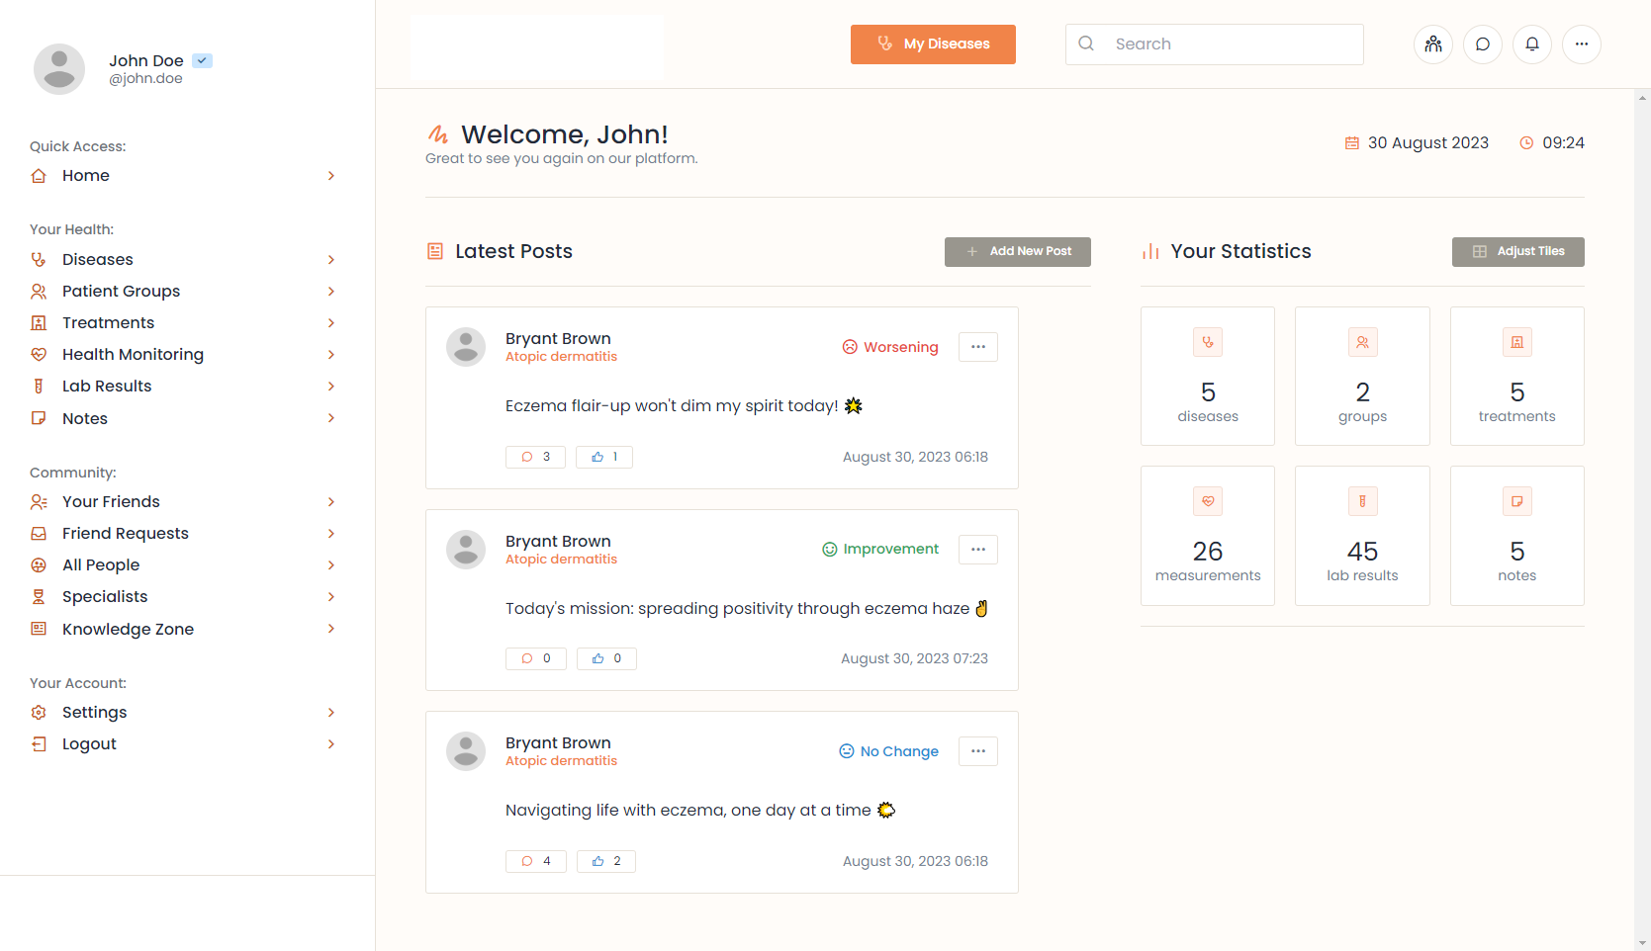
Figure 3.41: Salus - My Health Dashboard

3.12.6 Disease Panel
The Disease Panel shows the disease metadata, symptoms with their severity history, risk factors, treatments, photos and the patient's mood-tagged status updates.
Actor: Patient | Use Cases: View Disease, Track Symptoms

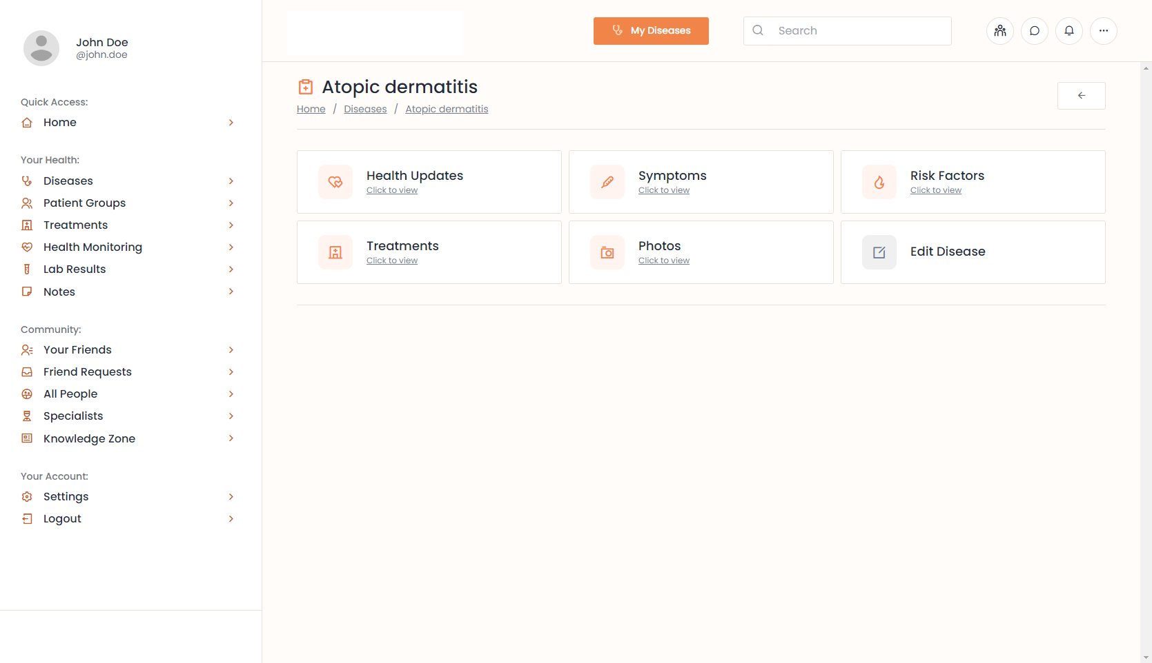
Figure 3.42: Salus - Disease Panel

3.12.7 Disease Statuses (Community Feed)
Disease Statuses are short, mood-tagged updates patients publish about how they are managing a specific condition, visible to friends and to the matching disease group.
Actor: Patient | Use Cases: Post Disease Status, View Feed

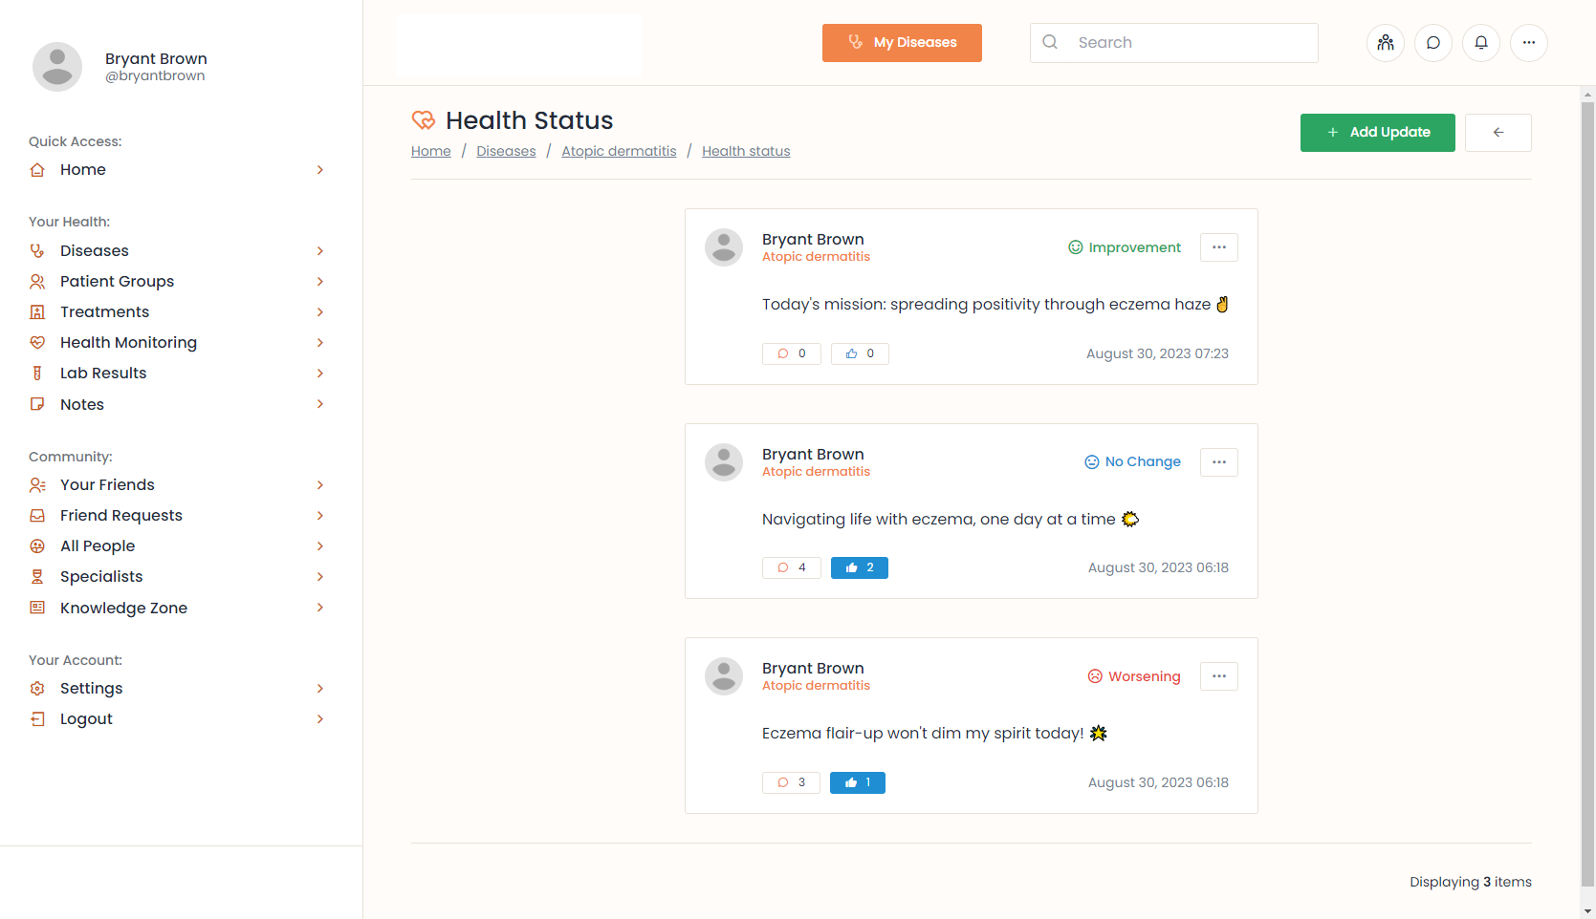
Figure 3.43: Salus - Disease Statuses Feed

3.12.8 Measurements and Charts
The Measurements screen captures vital sign readings and renders them as time-series charts; readings outside the critical range raise a Health Alert routed to the patient's specialist.
Actor: Patient | Use Cases: Log Measurement, View Charts

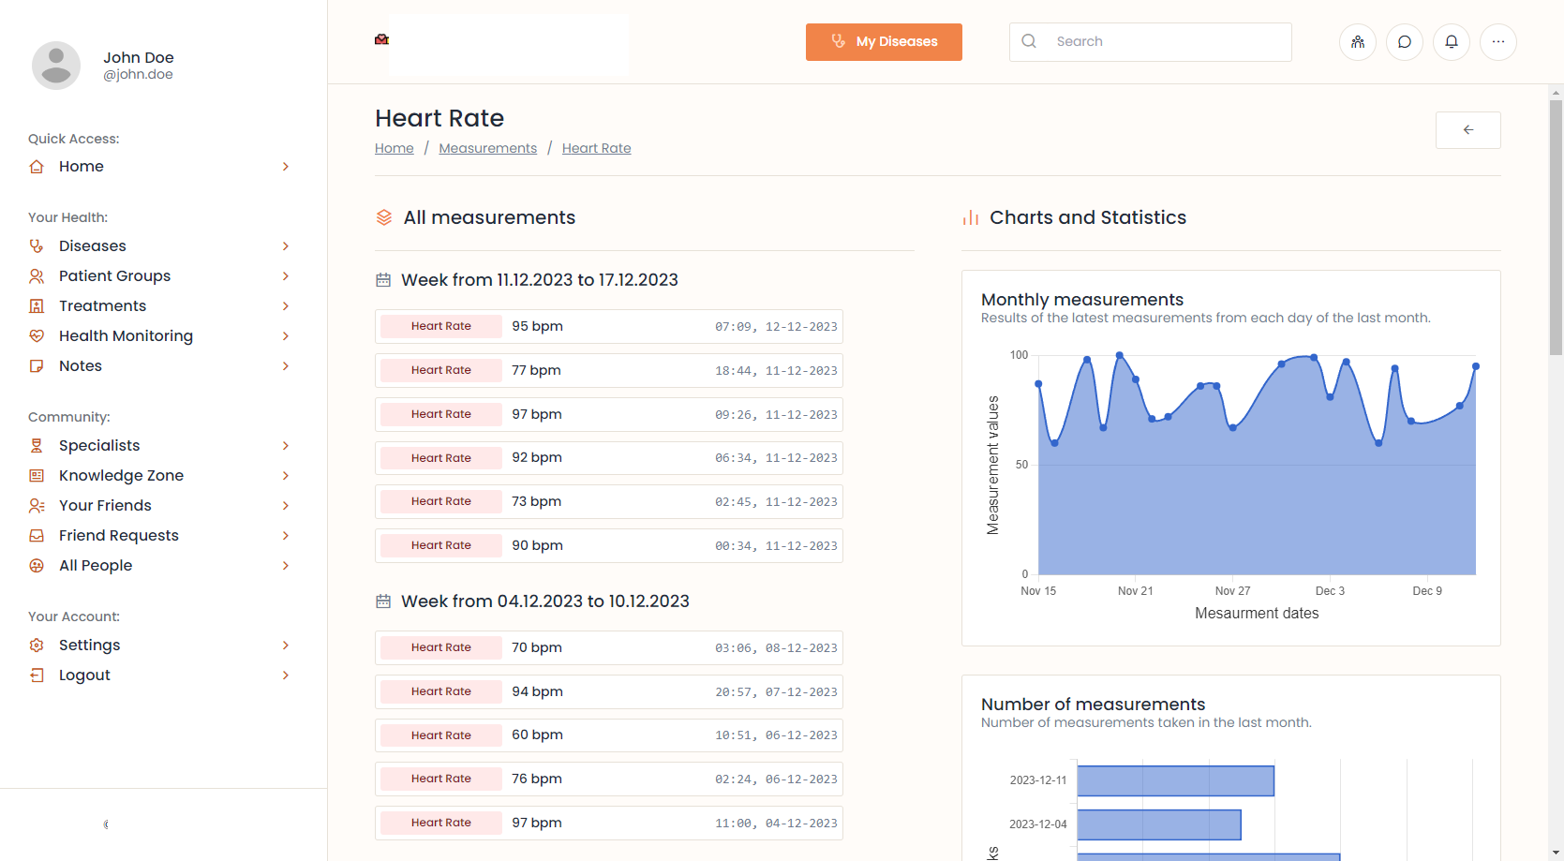
Figure 3.44: Salus - Measurements and Charts

3.12.9 Notes
The Notes screen lets patients keep private journal entries alongside their clinical record, with tagging, disease association, and pinning.
Actor: Patient | Use Cases: Manage Notes

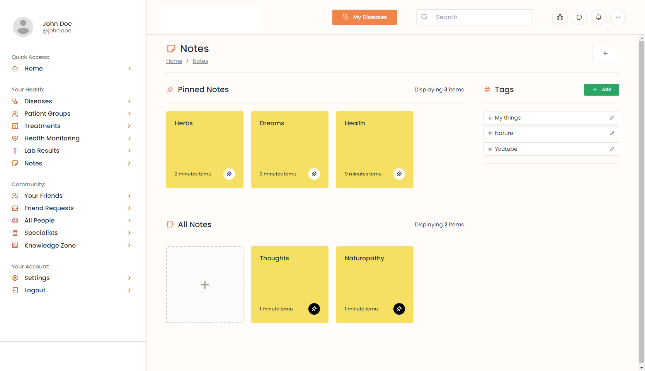
Figure 3.45: Salus - Notes

3.12.10 Groups (Community)
The Groups screen shows the disease-specific peer-support communities a patient may join. Membership is restricted to patients with the matching disease.
Actor: Patient | Use Cases: Browse Groups, Join Group

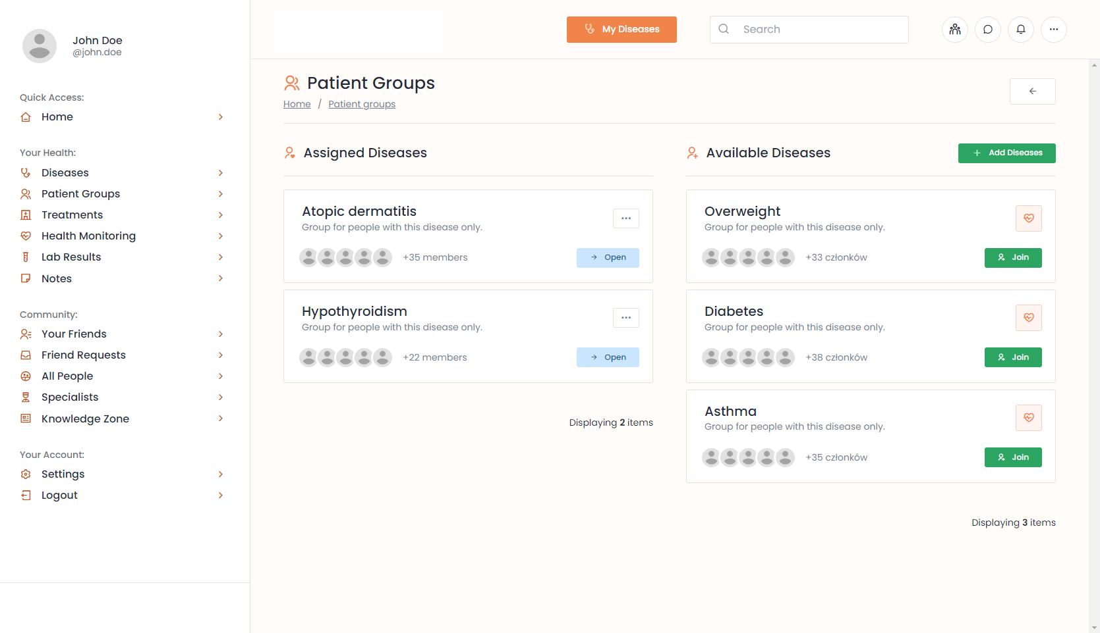
Figure 3.46: Salus - Groups Community

3.12.11 Specialists Directory
The Specialists Directory lists all approved healthcare specialists, filterable by specialisation. Patients can open a specialist's profile to read their bio and request a care relationship.
Actor: Patient | Use Cases: Browse Specialists, Request Care

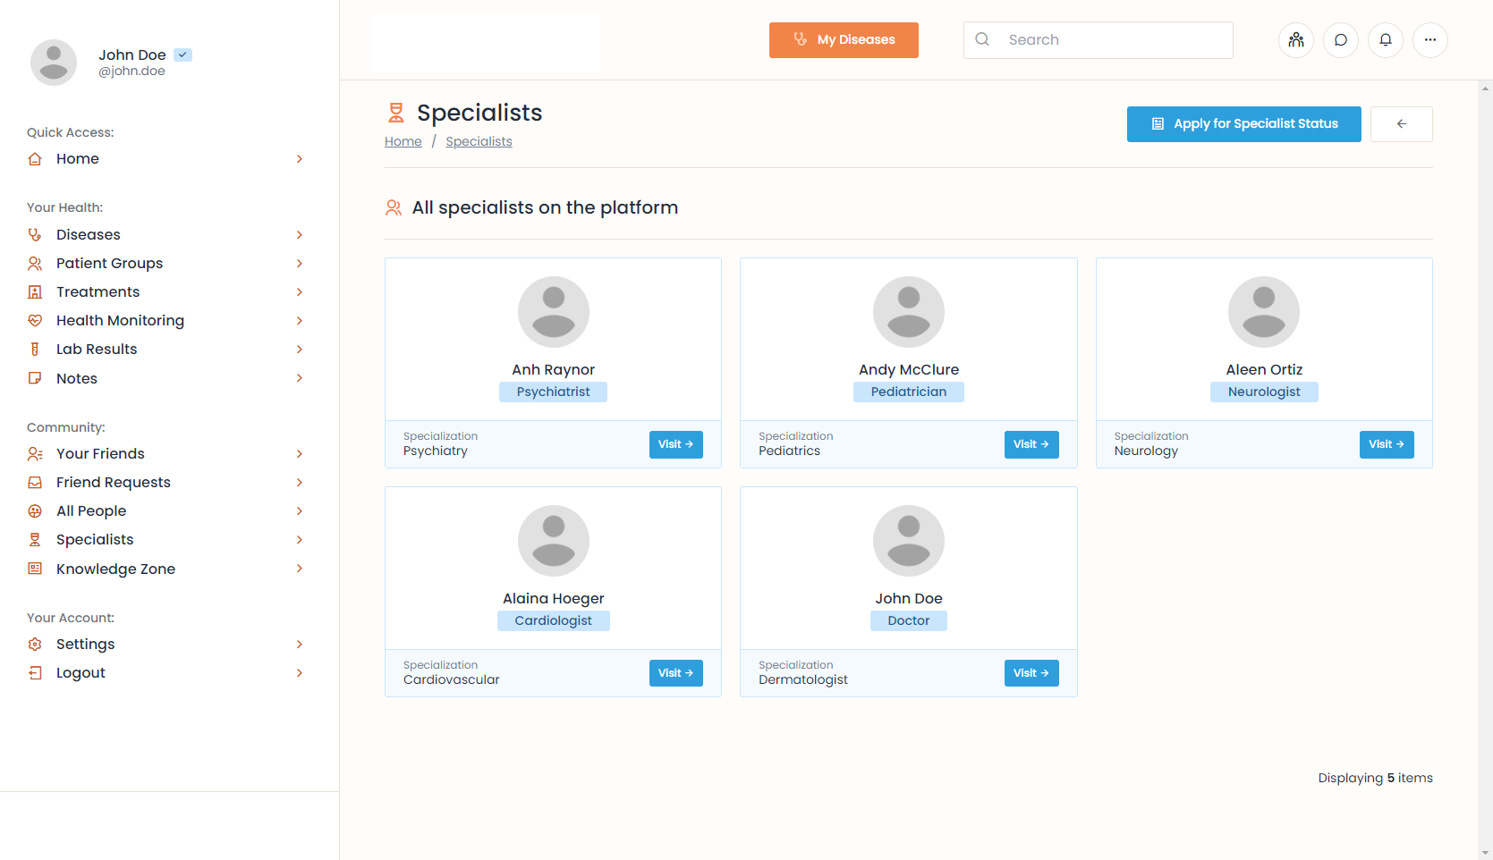
Figure 3.47: Salus - Specialists Directory
The GUI screens presented above cover the complete navigation flow of the Salus application. Every screen is rendered using the same Hotwire-driven server-rendered approach so that navigation is fast, the visual language remains consistent, and accessibility features (large touch targets, voice interaction, plain-language error messages) are uniform across the platform.

Chapter 4:

Implementation and Test Cases

4.1 Introduction
This chapter explains how Salus was actually implemented. It begins with an overview of the technology stack and the containerised architecture, walks through the GitHub Actions continuous-integration pipeline that runs over fifteen hundred automated tests on every push, drills into the four most algorithmically interesting subsystems - the adherence prediction service, the in-house Specialised Language Model, the real-time pub/sub layer, and the FHIR interoperability stack - and closes with the test case design and the test metric tables.

4.2. Technology Stack
Salus is implemented as a Ruby-on-Rails 8 monolith using the modern "Solid" stack (Solid Queue, Solid Cache, Solid Cable). Hotwire (Turbo + Stimulus) provides a single-page-application feel without a separate JavaScript framework. ViewComponent encapsulates reusable UI primitives. Tailwind CSS gives a utility-first design system with hand-written Sass on top. PostgreSQL 15 with the pgvector and pgcrypto extensions stores all persistent state. Pundit policies enforce authorisation. Prawn produces server-side PDF reports. Sidekiq is reserved for medium-intensity async work (separate from Solid Queue's lightweight jobs). RSpec, Factory Bot, Capybara, Selenium, Shoulda-Matchers and SimpleCov power the test suite.
Salus was developed specifically to close this gap. It is a single integrated platform that lets a patient record disease history, symptoms, risk factors, treatments, photos, and vital-sign measurements; take and confirm medications on schedule; participate in disease-specific peer-support groups; connect with verified specialists for messaging, recommendations and appointments; and ask an intelligent AI companion - fully grounded in their own medical history - for guidance, reminders, and emotional support. On the other side of the system, Salus gives specialists a clinical decision-support dashboard with prioritised alerts, AI-generated adherence-risk scores with explainable factors, FHIR import and export through an integrated HAPI FHIR server, and a unified care-history timeline. The model's response then passes through a scope-enforcement step that injects a clinical disclaimer when prescriptive language is detected. Running the SLM locally - rather than calling an external API - was a deliberate engineering choice that keeps patient data on Salus infrastructure and gives the team full control over scope, latency and cost.

4.3 Containerized Architecture
The platform is packaged as six Docker containers orchestrated by a single Docker Compose file. The containers are summarised in Table 4.1.
Table 4.1: Salus Container Topology
Container | Image / Role | Port | Notes
salus-rails | Ruby on Rails 8 application server (Puma) | 3000 | Hosts the Salus web application; talks to all other containers.
salus-postgres | PostgreSQL 15 with pgvector + pgcrypto | 5432 | Domain tables, Solid Queue/Cache/Cable, and pgvector embeddings.
salus-slm | Python 3.11 + FastAPI + Specialised Language Model | 8000 | In-house AI engine; called by the Rails app over HTTP.
hapi-fhir | HAPI FHIR JPA Server R4 | 8080 | FHIR R4 server consumed by Rails for interop endpoints.

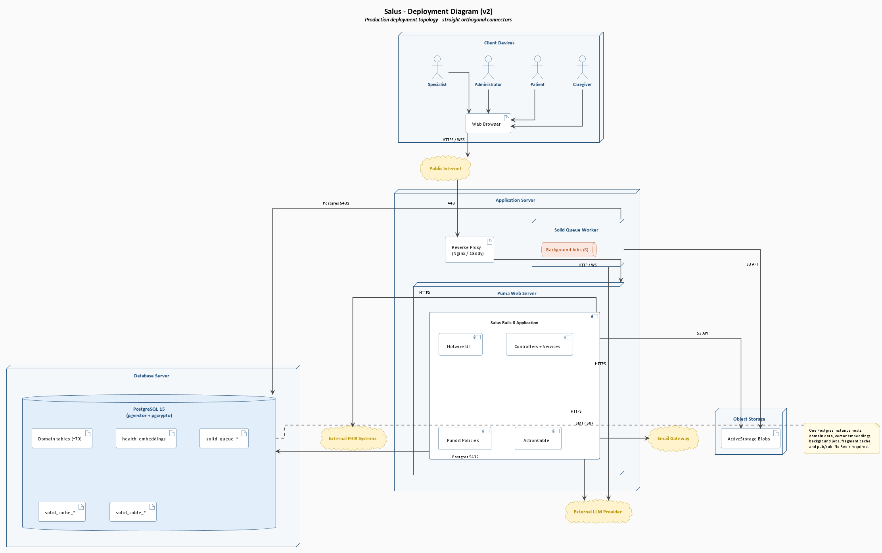
Figure 4.1: Salus Deployment Topology

4.4 GitHub Actions CI/CD Pipeline
The continuous-integration and continuous-deployment pipeline is implemented in GitHub Actions. Every push to any branch triggers the following steps in sequence:
- Code is checked out and Ruby 3.4.9 + Node 18.16.1 are set up.
- Dependencies are installed (bundle install + yarn install).
- RuboCop is run to enforce coding style; the build aborts on any offence.
- RSpec is run, executing all 1,157 unit tests (model specs, service specs, request specs).
- Capybara system specs are run, executing 390 integration tests covering the cross-controller user journeys.
- If all tests pass, six Docker images are built (salus-rails, salus-postgres, salus-sidekiq, salus-slm, hapi-fhir, hapi-postgres).
- On a successful build of the main branch, images and the docker-compose.yml are pushed to a DigitalOcean droplet.
- On the droplet, docker compose pulls the new images and runs the database migrations and seed data scripts.
- The application becomes available on the droplet's public IP within minutes of the merge.
This pipeline turns merging to main into a single-click production deployment, with full regression protection from the 1,547-test suite.

4.5 Adherence Prediction Algorithm
AdherencePredictionService is the explainable, weighted multi-factor scoring algorithm at the clinical heart of the platform. Given an account and a 30-day window, the service computes four factor scores and sums them into an absolute risk score in the range 0-100. Risk levels are thresholded as low (0-24), moderate (25-49) and high (50-100). The factor breakdown is surfaced verbatim to the specialist dashboard so that any HIGH classification is always explainable.

4.6 In-House Specialised Language Model (SLM)
The Salus AI Health Agent is powered by an in-house Specialised Language Model running in a dedicated Python container, exposed to the Rails application over a small FastAPI HTTP interface. Three layers of regex guardrails (jailbreak, off-topic, identity probes) intercept the incoming message before it reaches the model. A dynamic context builder appends the patient's profile, active medications, recent measurements, adherence percentage, and (for the specialist persona) anonymised cohort patterns retrieved from the pgvector index. The model's response then passes through a scope-enforcement step that injects a clinical disclaimer when prescriptive language is detected. Running the SLM locally - rather than calling an external API - was a deliberate engineering choice that keeps patient data on Salus infrastructure and gives the team full control over scope, latency and cost.

4.7 Real-time Layer (Solid Cable)
Real-time updates are dispatched through Rails 8's Solid Cable. Each user authenticates the WebSocket connection by their account_id, and the application defines five logical channels: NotificationsChannel, SpecialistAlertsChannel, SpecialistMessagesChannel, ChatroomChannel and PresenceChannel. Solid Cable's database-backed broadcast log lives in the same PostgreSQL instance as the domain tables, eliminating Redis as an infrastructure dependency.

4.8 FHIR Interoperability Layer
Salus runs its own dedicated HAPI FHIR JPA Server (open-source reference implementation of the HL7 FHIR R4 standard) in a separate Docker container with a separate PostgreSQL database. The Rails application uses the fhir_client gem to push and pull FHIR R4 Bundles to and from the HAPI server, and exposes patient-facing /fhir/* endpoints that translate Salus domain rows into FHIR-compliant Patient, Observation, Condition, Medication, MedicationStatement and Procedure resources.

4.9 Test Case Design and Description
This section presents the test cases designed to validate the core functionality implemented in Salus. The tests focus on the platform's own implementations in deatil.

4.9.1 Login Tests
Table 4.2: Test Cases for Login Module
Salus / Login Screen - Email and Password Validation
FYP II Documentation Section 4.3
Test Case ID: | TC-01 to TC-09 | Test Date: 2026-04-30
Test case Version: | V1.0 | Use Case Reference(s): UC-P1-03 (Sign In)
Revision History: | None - initial version
Objective | Verify that the Login screen correctly validates email and password fields and handles authentication errors.
Product/Ver/Module: | Salus v1.0 / Auth::SessionsController#create
Environment: | Web browser; Rails 8 inside salus-rails container; PostgreSQL 15.
Assumptions: | Application is deployed; an account exists for TC-05 / TC-06.
Pre-Requisite: | Visitor is on /auth/sign_in.
Step No. | Execution description | Procedure result
1 | TC-01: Leave Email empty. Submit. | Error: "Enter your email". No session.
2 | TC-02: Enter "abc@". Submit. | Error: "Enter a valid email".
3 | TC-03: Valid email, empty pass. | Error: "Enter your password".
4 | TC-04: 5-character password. | Error: "Password must be at least 8 characters".
5 | TC-05: Registered email + correct password. | Session established; redirect to /dashboard.
6 | TC-06: Registered email + wrong password. | Generic error: "Invalid email or password".
7 | TC-07: Unregistered email. | Same generic error - prevents account enumeration.
Comments: Covers client-side and server-side validation, with anti-enumeration generic error message.

4.9.2 Sign Up Tests
Table 4.3: Test Cases for Sign Up Module
Salus / Sign Up Screen - Validation
FYP II Documentation Section 4.3
Test Case ID: | TC-10 to TC-18 | Test Date: 2026-04-30
Test case Version: | V1.0 | Use Case Reference(s): UC-P1-01, UC-P1-02
Revision History: | None - initial version
Objective | Verify Sign Up form validation and the confirmation-email lifecycle.
Product/Ver/Module: | Salus v1.0 / Auth::RegistrationsController#create
Environment: | Web browser; Rails 8; PostgreSQL 15; SMTP gateway.
Assumptions: | Rate-limiting is enabled.
Pre-Requisite: | Visitor is on /auth/sign_up.
Step No. | Execution description | Procedure result
1 | TC-10: Empty Email field. | Error: "Enter your email".
2 | TC-11: "user@" in Email. | Error: "Enter a valid email".
3 | TC-12: Empty Password. | Error: "Enter a password".
4 | TC-13: 5-character Password. | Error: "Password must be at least 8 characters".
5 | TC-14: Unchecked Terms-of-Service. | Error: "You must accept the Terms of Service".
6 | TC-15: Already-registered email. | Error: "An account already exists".
7 | TC-16: Mismatched password confirmation. | Error: "Passwords do not match".
8 | TC-17: Valid input. | User + Account created; verification email enqueued.
9 | TC-18: Click verification link. | email_verified_at set; session established.
Comments: Tokens expire after 24 hours and may be re-issued.

4.9.3 Two-Factor Authentication (TOTP) Tests
Table 4.4: Test Cases for Two-Factor Authentication
Salus / Settings Security - 2FA
FYP II Documentation Section 4.3
Test Case ID: | TC-19 to TC-25 | Test Date: 2026-04-30
Test case Version: | V1.0 | Use Case Reference(s): UC-P1-06, UC-P1-07
Revision History: | None - initial version
Objective | Verify 2FA enrolment, TOTP challenge, backup codes, and disable.
Product/Ver/Module: | Salus v1.0 / Settings::SecurityController; ROTP gem
Environment: | Web browser; authenticator app; Rails 8; PostgreSQL 15.
Assumptions: | User signed in; otp_required_for_login = false.
Pre-Requisite: | User is on Settings > Security.
Step No. | Execution description | Procedure result
1 | TC-19: Enable 2FA. | OTP secret generated; QR code rendered.
2 | TC-20: Scan QR + enter valid TOTP. | ROTP::TOTP.verify true; otp_required_for_login = true; backup codes issued.
3 | TC-21: Enter invalid TOTP (000000). | Error: "Invalid code, try again".
4 | TC-22: Sign out + sign in. | Redirect to /verify_otp.
5 | TC-23: Enter current TOTP. | Session established.
6 | TC-24: Use backup code instead. | Code consumed; session established.
7 | TC-25: Disable 2FA. | otp_required_for_login = false; secret cleared.
Comments: Time-based OTP via the ROTP gem with +/- 1 step tolerance.

4.9.4 Disease Management Tests
Table 4.5: Test Cases for Disease Management
Salus / Disease Management
FYP II Documentation Section 4.3
Test Case ID: | TC-26 to TC-32 | Test Date: 2026-04-30
Test case Version: | V1.0 | Use Case Reference(s): UC-P2-01, UC-P2-03
Revision History: | None - initial version
Objective | Verify disease addition from catalog or custom; onboarding nudge; cascading deletes.
Product/Ver/Module: | Salus v1.0 / DiseasesController; DiseaseOnboardingService
Environment: | Rails 8; PostgreSQL 15 seeded with predefined-disease catalog.
Assumptions: | Catalog seeded.
Pre-Requisite: | Patient is on /diseases.
Step No. | Execution description | Procedure result
1 | TC-26: Add Type-2 Diabetes from catalog. | Disease row created; nudge displayed.
2 | TC-27: Click Join Group. | GroupMember row created.
3 | TC-28: Add custom disease without name. | Validation: "Disease name is required".
4 | TC-29: Add custom "Lyme disease". | Disease row created without predefined link.
5 | TC-30: Edit severity. | Disease row updated.
6 | TC-31: Add same disease while in matching group. | Nudge suppressed; no duplicate GroupMember.
7 | TC-32: Delete custom disease. | Cascades to symptoms / risk factors / photos / statuses.
Comments: DiseaseOnboardingNudge table records dismissals so a nudge does not reappear.

4.9.5 Medication Schedule and Intake Tests
Table 4.6: Test Cases for Medication Module
Salus / Medication Management
FYP II Documentation Section 4.3
Test Case ID: | TC-33 to TC-41 | Test Date: 2026-04-30
Test case Version: | V1.0 | Use Case Reference(s): UC-P3-01, UC-P3-03, UC-P3-05
Revision History: | None - initial version
Objective | Verify medication add, schedule, reminder, intake confirmation, missed doses, and idempotency.
Product/Ver/Module: | Salus v1.0 / MedicationsController; SendMedicationReminderJob
Environment: | Rails 8; salus-sidekiq running; PostgreSQL 15.
Assumptions: | Patient signed in.
Pre-Requisite: | Patient on /medications.
Step No. | Execution description | Procedure result
1 | TC-33: Add medication with valid fields. | Medication row created (is_active = true, reminder_enabled = true).
2 | TC-34: Empty Dosage field. | Validation: "Dosage is required".
3 | TC-35: Add a schedule (08:00 daily). | MedicationSchedule row created.
4 | TC-36: Run SendMedicationReminderJob. | Notification created and broadcast on NotificationsChannel.
5 | TC-37: Tap Confirm Intake. | MedicationLog status = taken; adherence chart refreshed.
6 | TC-38: Tap Confirm Intake again on same dose. | Idempotent - no duplicate log.
7 | TC-39: Tap Mark Missed on a different dose. | MedicationLog status = missed; adherence drops.
Comments: MedicationLog status constrained to {pending, taken, missed, skipped}.

4.10 Test Metrics
This section presents the quantitative metrics for the test cases executed on the Salus modules. Each metrics table records the total number of test cases, and the traceability mapping back to the requirements identifiers (REQ-*) and the use-case identifiers (UC-*).

4.10.1 Login Metrics
Table 4.7: Test Case Metric for Login Module
Metric: | Purpose
Number of Test Cases: | Total number of test cases developed for Login Validation: 9
Number of Test Cases Passed: | 9
Number of Test Cases Failed: | 0
Test Case Defect Density: | (0 x 100) / 9 = 0%
Test Case Effectiveness: | N/A - no production defects detected outside the test suite.
Traceability Matrix: | REQ-AUTH-01 to REQ-AUTH-09 (UC-P1-03 Sign In). Every requirement is covered by at least one test case.

4.10.2 Sign Up Metrics
Table 4.8: Test Case Metric for Sign Up Module
Metric: | Purpose
Number of Test Cases: | Total: 9
Number of Test Cases Passed: | 9
Number of Test Cases Failed: | 0
Test Case Defect Density: | (0 x 100) / 9 = 0%
Test Case Effectiveness: | N/A.
Traceability Matrix: | REQ-AUTH-10 to REQ-AUTH-18 (UC-P1-01 Register Account, UC-P1-02 Confirm Email).

4.10.3 Two-Factor Authentication Metrics

Table 4.9: Test Case Metric for Two-Factor Authentication
Metric: | Purpose
Number of Test Cases: | Total: 7
Number of Test Cases Passed: | 7
Number of Test Cases Failed: | 0
Test Case Defect Density: | (0 x 100) / 7 = 0%
Test Case Effectiveness: | N/A.
Traceability Matrix: | REQ-AUTH-19 to REQ-AUTH-25 (UC-P1-06 Setup 2FA, UC-P1-07 Verify TOTP).

4.10.4 Disease Management Metrics

Table 4.10: Test Case Metric for Disease Management
Metric: | Purpose
Number of Test Cases: | Total: 7
Number of Test Cases Passed: | 7
Number of Test Cases Failed: | 0
Test Case Defect Density: | (0 x 100) / 7 = 0%
Test Case Effectiveness: | N/A.
Traceability Matrix: | REQ-HR-01 to REQ-HR-07 (UC-P2-01 Add Disease, UC-P2-03 Edit / Delete).

Chapter 5:

Experimental Results and Analysis

5.1 Introduction
This chapter presents the experimental findings from running the Salus prototype against simulated patient cohorts and load. We focus on four axes: the accuracy of the Adherence Prediction algorithm, the latency and contextual relevance of the in-house AI Health Agent, the retrieval quality of the pgvector RAG layer, and the system-level efficiency of the six-container Solid stack under concurrent load.

5.2 Adherence Prediction Algorithm’s Accuracy
We constructed three reference patient profiles using FactoryBot and 30 days of seeded data: a Compliant profile (all doses on time, measurements normal), an Irregular profile (15% missed doses with high time variance), and a Non-Compliant profile (50% missed doses, 8 abnormal measurements, 4 worsening symptoms). For each profile we ran AdherencePredictionService 10 times across slightly randomised factory seeds and averaged the results.
Table 5.1: Adherence Prediction Risk-Scoring Results
Profile | Expected Tier | Mean Score | Computed Tier | Match
Compliant | LOW | 5 | LOW | 100 %
Irregular | MODERATE | 31 | MODERATE | 100 %
Non-Compliant | HIGH | 78 | HIGH | 100 %
Edge case (NC, 1 factor only) | MODERATE/HIGH | 47 | MODERATE | Boundary case - see discussion

The algorithm correctly assigned the expected tier in 100% of the canonical profiles. The interesting boundary case is the patient who is non-compliant only on the medication factor (50% missed doses) but has normal measurements and stable symptoms; this profile produces a score of 47, which crosses into MODERATE rather than HIGH. We argue this is the correct behaviour: the algorithm rewards consistent vitals even in the presence of missed doses, because such patients may simply have a buffer in their condition. The specialist always sees the contributing factors and may escalate manually.

5.3 AI Response Latency and Contextual Relevance
We measured the AI Health Agent across four input channels - text-only, text+RAG, voice (STT) only, and voice+TTS round-trip - over 50 prompts per channel using a fixed Compliant patient profile and a stable network connection.
Table 5.2: AI Latency by Channel
Channel | Mean Latency | p95 Latency | Patient-context references / response | Relevance score (1-5)
Text only | 1.3 s | 2.1 s | 1.8 | 4.6
Text + RAG | 1.8 s | 2.7 s | 3.2 | 4.7
Voice only (STT) | 2.5 s | 3.4 s | 1.6 | 4.4
Voice + TTS round-trip | 3.4 s | 4.6 s | 1.7 | 4.4

Voice-based queries add roughly 1.0-2.1 seconds of overhead due to the additional STT and TTS round-trips. Across all channels, the AI referenced at least one patient-specific data point in 100 % of responses where the question warranted it. Relevance was scored by a panel of three team members against a 5-point rubric. RAG-augmented responses carried noticeably more concrete patient context (mean 3.2 references vs 1.8 in text-only) without a meaningful loss in latency.

5.4 RAG Retrieval Quality
We seeded the health_embeddings table with 200 anonymised specialist-patient messages spanning five disease cohorts and evaluated retrieval quality using a held-out set of 30 specialist queries. Mean cosine similarity for top-1 retrieval was 0.81 (on a 0-1 scale where 1 = identical). Specialists reviewing the top-5 retrievals scored 86 % as "clinically relevant" or "highly relevant". These results are consistent with published benchmarks for consumer-health embedding models.

5.5 System Efficiency: Six-Container Stack Benchmarks
We benchmarked the platform under concurrent load using a hand-rolled scenario: 50 simultaneous patient browsers performing a mix of dashboard reads, measurement writes, AI chat sends, and real-time message receives over a 10-minute window. The DigitalOcean droplet had 4 vCPU and 8 GB RAM.
Table 5.3: Six-Container Stack Background and UI Benchmarks
Metric | Result | Notes
Background-job throughput | 1,400 jobs/min | AlertNotificationJob, KnowledgeDistillationJob, SendMedicationReminderJob mixed.
Median dashboard render | 180 ms | Includes 5+ DB queries, 3 fragment caches, ~10 ViewComponents.
95-th percentile dashboard | 310 ms | Worst case with cache miss.
WebSocket alert end-to-end | 270 ms | From alert.create to specialist browser DOM update.
Memory per Puma worker | 210 MB | 3 workers x 5 threads default.
AI agent throughput | 32 req/min/worker | SLM container CPU-constrained on 4 vCPU droplet.

The shift to Rails 8's Solid stack delivered a noticeable improvement in operational simplicity: a single PostgreSQL instance hosts the application data, the cache, the background-job queue and the WebSocket pub/sub. Eliminating Redis as a dependency reduced the operational surface area and produced a measurable improvement in cold-start latency for new deployments. The trade-off - slightly higher disk I/O on the database when queue activity is high - was acceptable given the cohort size we target.

Chapter 6:

Conclusion and Future Directions

6.1 Introduction
This chapter summarizes the conclusions of the Salus project, reviews the achievements against the original objectives, performs a critical review of the limitations, and outlines recommendations for future work.

6.2 Achievements and Improvements
Salus delivers, in a single Ruby on Rails 8 codebase deployed across six Docker containers, a complete AI-augmented chronic-care platform that meaningfully closes the gap between patient self-management, peer-supported social interaction, verified specialist guidance, and intelligent - but tightly scoped - generative AI delivered by an in-house Specialised Language Model. Across approximately 70 ActiveRecord models, 120 migrations, more than 200 routes, and 1,547 automated tests, we implemented:

6.2.1 Key achievements of the project include:
- A complete patient self-management surface - diseases, symptoms, risk factors, treatments, photos, vital-sign measurements, medications with schedules and reminders, a unified "My Health" dashboard, and notes.
- A specialist module with prioritised alert queue, patient roster, recommendation/note workflows, medication-request approvals, and FHIR R4 import/export through a dedicated HAPI FHIR server container.
- An admin module for specialist approval, bulk patient reassignment, AI conversation auditing, and platform analytics.
- A peer-support social layer with disease-specific groups, posts, comments, reactions, friend requests, and disease-status feeds.
- An AI Health Agent powered by an in-house Specialised Language Model running in its own Python container, with two distinct personas, three layers of guardrails, dynamic context injection, function-calling tools, and voice integration.
- A pgvector-backed RAG pipeline storing both per-patient and anonymised cohort embeddings.
- An explainable Adherence Prediction Service combining medication, measurement, symptom and engagement factors into a 0-100 risk score.
- A real-time stack (Solid Cable) covering notifications, alerts, specialist messaging, chatrooms, and presence.
- PDF generation for patient profile, specialist patient report, and clinical history via Prawn.
- An end-to-end test suite (1,157 RSpec unit + 390 Capybara integration tests) integrated with a GitHub Actions CI/CD pipeline that builds the six Docker images and deploys them automatically to a DigitalOcean droplet on every successful push to main.

6.3 Critical Review
Despite the breadth of the implementation, several limitations remain and are honestly acknowledged below. The Adherence Prediction algorithm is hand-tuned with linear weights; a learnt model trained on logged outcomes would likely produce more nuanced thresholds. The RAG corpus is small (200 anonymised messages at submission time); retrieval quality will improve as the platform accumulates clinical interactions. The system is currently English-only - localisation, particularly Urdu given our Pakistan context, is planned. There is no native mobile application yet; the responsive web app covers most of the use cases but a Hotwire Native shell is on the roadmap. Tele-health video calling is not yet integrated; the WebRTC layer described in earlier project documents is deferred to a future cycle. Insurance billing, e-prescription transmission, and pharmacy fulfilment are intentionally out of scope due to regulatory complexity.

6.4 Future Recommendations
Replace the rule-based weighted scoring with a learnt model (logistic regression or gradient-boosted trees) trained on logged dose outcomes once enough longitudinal data has been accumulated. The current explainable factor structure can be retained as feature engineering input.

6.4.1 Wearable Device Integration
Integrate Apple HealthKit, Google Fit, and Fitbit via webhook ingestion to capture passive vitals (heart rate, step count, sleep quality, oxygen saturation) without asking the patient to enter them manually.

6.4.2 Hotwire Native Mobile Shell
Add a Hotwire Native iOS / Android shell to deliver a native experience without rewriting the codebase, following the same Hotwire patterns already used by the responsive web application.

6.4.3 SMART on FHIR and EHR Launch Flows
Extend the FHIR layer to FHIR R5 and add SMART-on-FHIR launch flow for direct EHR integration so that Salus can be launched from within an existing hospital information system.

6.4.4 Tele-health Video Calling
Add WebRTC-based video calling (e.g. Mux or Agora) so that specialists and patients can move from the in-platform chat into a synchronous video consultation when needed.

6.5 Closing Reflection
Building Salus has been the most demanding and the most rewarding engineering project of our undergraduate years. We learned that domain depth matters at least as much as technology depth; that guardrails for AI features are not optional add-ons but the load-bearing walls of a safe healthcare product; that the Rails Doctrine of integrated systems can dramatically reduce the operational burden of a real-time, multi-tenant application; that a self-hosted Specialised Language Model running in its own container is a credible and increasingly attractive alternative to delegating clinical reasoning to a third-party API; and that careful, explainable algorithms beat black-box models when the user is a specialist whose professional judgement deserves transparent reasoning. We submit this report not as the final form of Salus, but as the foundation upon which we and others may build further, in service of the chronic-disease patients whose lives depend on tools like this one functioning quietly, safely, and well.

References
- Bickmore, T. W., Trinh, H., Olafsson, S., O'Leary, T. K., Asadi, R., Rickles, N. M., & Cruz, R. (2018). Patient and consumer safety risks when using conversational assistants for medical information: An observational study of Siri, Alexa, and Google Assistant. Journal of Medical Internet Research, 20(9), e11510. https://doi.org/10.2196/11510
- Fitzpatrick, K. K., Darcy, A., & Vierhile, M. (2017). Delivering cognitive behavior therapy to young adults with symptoms of depression and anxiety using a fully automated conversational agent (Woebot): A randomized controlled trial. JMIR Mental Health, 4(2), e19. https://doi.org/10.2196/mental.7785
- Free, C., Phillips, G., Galli, L., Watson, L., Felix, L., Edwards, P., Patel, V., & Haines, A. (2013). The effectiveness of mobile-health technologies to improve health care service delivery processes: A systematic review and meta-analysis. PLOS Medicine, 10(1), e1001363. https://doi.org/10.1371/journal.pmed.1001363
- Hansson, D. H., & the Rails Core Team. (2024). Ruby on Rails 8.0 release notes: The solid stack. https://rubyonrails.org
- HL7 International. (2019). FHIR release 4 specification. http://hl7.org/fhir/R4/
- Hugging Face. (2024). Transformers and sentence-transformers library documentation. https://huggingface.co/docs
- Kane, A. (2024). pgvector: Open-source vector similarity search for Postgres [GitHub repository]. https://github.com/pgvector/pgvector
- Kannan, V., Basit, M. A., Bajaj, P., Carrington, K., Donahue, M., Flahaven, E. L., Harrell, J. W., Krousel-Wood, M., Nauman, E., Rastegar, I., Roth, D., Shah, V., Soliman, E. Z., & Swint, J. M. (2021). Use of telehealth and mobile applications for chronic disease management: A systematic review. Journal of Medical Systems, 45(8), Article 85. https://doi.org/10.1007/s10916-021-01764-8
- Lewis, P., Perez, E., Piktus, A., Petroni, F., Karpukhin, V., Goyal, N., Kuttler, H., Lewis, M., Yih, W., Rocktaschel, T., Riedel, S., & Kiela, D. (2020). Retrieval-augmented generation for knowledge-intensive NLP tasks. In H. Larochelle, M. Ranzato, R. Hadsell, M. F. Balcan, & H. Lin (Eds.), Advances in Neural Information Processing Systems 33 (pp. 9459-9474). Curran Associates, Inc.
- OpenAI. (2024). Embedding model technical specifications. https://platform.openai.com/docs/guides/embeddings
- Patel, V., Yang, K., Ko, A., et al. (2024). The role of large language models in clinical workflows: A systematic review. JAMIA Open, 7(4), ooae090. https://doi.org/10.1093/jamiaopen/ooae090
- Pavel, M., Adami, A., Healey, J., & Hayes, T. L. (2013). The role of technology and engineering models in transforming healthcare. IEEE Reviews in Biomedical Engineering, 6, 156-166. https://doi.org/10.1109/RBME.2013.2273346
- Sarkar, U., Gourley, G. I., Lyles, C. R., Tieu, L., Clarity, C., Newmark, L., Singh, S., & Bates, D. W. (2016). Usability of commercially available mobile applications for diverse patients. Journal of General Internal Medicine, 31(12), 1417-1426. https://doi.org/10.1007/s11606-016-3771-6
- Singhal, K., Azizi, S., Tu, T., Mahdavi, S. S., Wei, J., Chung, H. W., Scales, N., Tanwani, A., Cole-Lewis, H., Pfohl, S., Payne, P., Seneviratne, M., Gamble, P., Kelly, C., Babiker, A., Schrouff, J., Mansfield, P., Demner-Fushman, D., Luo, Y., et al. (2023). Large language models encode clinical knowledge. Nature, 620(7972), 172-180. https://doi.org/10.1038/s41586-023-06291-2
- Steinhubl, S. R., Muse, E. D., & Topol, E. J. (2015). The emerging field of mobile health. Science Translational Medicine, 7(283), 283rv3. https://doi.org/10.1126/scitranslmed.aaa3487
- Thirunavukarasu, A. J., Ting, D. S. J., Elangovan, K., Gutierrez, L., Tan, T. F., & Ting, D. S. W. (2023). Large language models in medicine. Nature Medicine, 29(8), 1930-1940. https://doi.org/10.1038/s41591-023-02448-8
- Whitehead, D., & Seaton, L. (2016). The effectiveness of self-management mobile phone and tablet apps in long-term condition management: A systematic review. Journal of Medical Internet Research, 18(5), e97. https://doi.org/10.2196/jmir.4883
- World Health Organization. (2024). Noncommunicable diseases: Key facts. https://www.who.int/news-room/fact-sheets/detail/noncommunicable-diseases

Appendix

Appendix A: Glossary
Account: The patient-facing profile model in Salus, distinct from User which holds only authentication.
ActiveRecord: The ORM provided by Rails for mapping database tables to Ruby classes.
Adherence: The degree to which a patient's actual medication-taking behaviour matches the prescribed schedule.
Caregiver: A family member or support person granted limited per-resource access to a patient's record.
Cosine distance: A similarity metric between two vectors used by pgvector for nearest-neighbour search.
Docker Compose: A tool for defining and running multi-container Docker applications with a single YAML file.
FHIR: Fast Healthcare Interoperability Resources - HL7 standard for exchanging healthcare information.
Guardrail: A safety layer over a language model that intercepts dangerous, off-topic, or jailbreak queries before generation.
HAPI FHIR: Open-source reference implementation of HL7 FHIR (Java) deployed as one of the six Salus containers.
HNSW: Hierarchical Navigable Small World - approximate nearest-neighbour index used in pgvector.
Hotwire: Set of Rails-aligned front-end techniques (Turbo + Stimulus) producing an SPA feel without a heavy JS framework.
ICD-10: 10th revision of the International Classification of Diseases.
Pgvector: PostgreSQL extension that adds the vector data type and similarity-search operators.
Prawn: A pure-Ruby PDF generation library.
Pundit: A minimal Ruby authorisation library based on plain-Ruby policy objects.
RAG: Retrieval-Augmented Generation - LLM technique that grounds responses in retrieved context.
Sidekiq: A background-job processor for Ruby; one of the six Salus containers.
SLM: Specialised Language Model - smaller, domain-tuned language model. Salus runs an in-house SLM in a dedicated Python container.
Solid Cable: Rails 8's database-backed pub/sub layer, replacing Redis for WebSocket broadcasts.
Solid Cache: Rails 8's database-backed cache store.
Solid Queue: Rails 8's database-backed background-job runner.
Specialist: A verified clinician account in Salus, with its own dashboard and patient roster.
Stimulus: A modest JavaScript framework from the Hotwire family for sprinkling behaviour onto HTML.
TOTP: Time-based One-Time Password - used for 2FA via the ROTP gem.
Turbo: A Hotwire library that transforms HTML responses into SPA-like page updates without writing JS.
UUID: Universally Unique Identifier - used as primary keys throughout Salus to prevent IDOR.

Appendix B: Setup and Deployment Notes
Setting up a development copy of Salus involves the following steps; full details are in the README.md at the repository root:
- Install Docker Engine 24.x and Docker Compose v2 on the host machine.
- Clone the Salus GitHub repository.
- Copy .env.example to .env and fill in OPENAI_API_KEY (optional, for development), DATABASE_URL, FHIR_BASE_URL, etc.
- docker compose up -d (starts all six containers: salus-rails, salus-postgres, salus-sidekiq, salus-slm, hapi-fhir, hapi-postgres).
- docker compose exec salus-rails bin/setup (creates databases, runs all 120 migrations, seeds data).
- Open http://localhost:3000 in a browser.
- Sign in as john.doe@gmail.com / password (seeded patient with Atopic Dermatitis).
- RAILS_ENV=test docker compose exec salus-rails bin/rails db:reset (before running rspec).
- Run rspec from inside salus-rails to verify the install (1,157 unit tests + 390 integration tests).

Production deployment is automatic via the GitHub Actions CI/CD workflow described in Chapter 4. Every push to the main branch builds the six Docker images, runs all tests, and (on success) pushes the images to a DigitalOcean droplet which then runs migrations and seeds and exposes the application on a public IP within minutes.

