//output from

Data

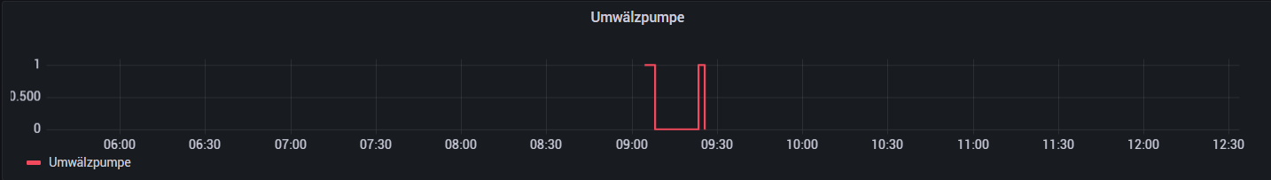

//output from

Table = union(tables: [FirstRow,Data])

  |> group()

  |> window(every:inf,timeColumn:"_time")

  |> sort(columns: ["_time"], desc: false)

Table

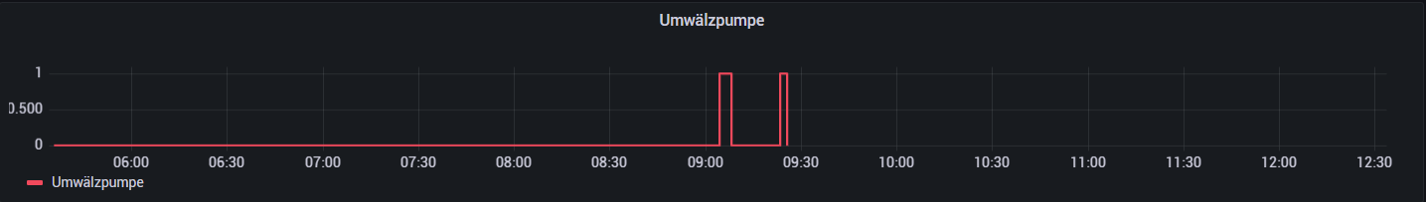

//output from

Table = union(tables: [FirstRow,Data,LastRow])

  |> group()

  |> window(every:inf,timeColumn:"_time")

  |> sort(columns: ["_time"], desc: false)

Table

