**Directions for running st_mona/geant4/mona_analysis**

**Compiling and preparing the codes:**

1) Compile st_mona code: go into ./st_mona/src and type “make”

2) Compile geant4 code: go into ./n2_geant and type “make”

3) Compile codes used to convert st_mona output to geant4 output: go into ./n2_geant/control and type “./Makefile”.

4) Setup directory for where your Sweeper maps are: go into ./st_mona/bin and open mk_maps_icc.sh. Modify all the directories to the directory that you keep your maps.

**Running the code:**

The entire program is run using a single script: MoNASim_Script_24O_HopeSchiller.sh.

Modifying the script (starting at the top of script):

I often have three lines shown (with 2 commented out) assuming you will want to simulate three different cases: (1) 24O beam with no reaction, (2) 24O(-n) to 23O(g.s.), and (3) 24O(-n) to 23O(excited state)->22O+n.

1) *FileName* is the prefix that will define all the files output from the simulation



2) *Arguments passed to st_mona*. This describes how the reaction is simulated. The “exp” input tells the code what experiment and the defining aspects of the experiment are then in st_mona.cc.

The “-geant” input implements the use of geant4. This should be used regardless of neutron emission since the code has been setup to expect this.

The “-reac” input defines the type of reaction/decay. “Glaub” is using glauber kick and then 1n decay. “Glaub_noDecay” is glauber kick and no neutron decay.

The “-e” input provides the energy distribution for the decay. As shown below, this is only used in the cases where we have a neutron decay. It is not used with “Glaub_noDecay”.

The “-n” input is the number of events to simulate

The “-strag” and “-glaub” define the strength of the straggling and glauber kick, respectively.

The “-nn” defines the number of neutrons to be stripped during the reaction. (Note that the last line shown below has –nn 0, so this simulated O24 beam with no reaction).



3) *FRAGname* tells the mona_analysis.cc code what fragment to use and then has some predefined information about the fragment/reaction. Set it according to the chosen reaction (defined above).

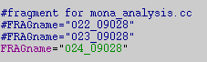

4) *MoNaDetFile* defines the file used to input the positioning of MoNA. These files are kept in ./n2_geant/ folder.



5) The MENATEG4XS variable needs to be set either in the script or in your .bashrc to define where to find the associated cross-sections. You should use the folder included in the .zip file as it is the most up-to-date. You will also need to change the 4 paths below to define where each code is run from and lastly, where to put the output files.

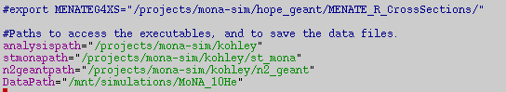

6) *Outputfiles* are given the suffix defined by the UniqueID. So, if you run one of the reactions with 5 different iterations than you can change the UniqueID for each iteration.

You do not need to change the last 4 lines. But they do define the naming convention I use for the output files. You will get the following 3 output files

a) *.root: is the output from st_mona, which contains the information about the reaction and charged fragment.

b) *-geant.root: is the output after geant4 has run. This contains information on the reaction, charged fragment and neutrons.

c) *-geant-anal.root: is the output after the final mona_analysis has completed. This contains calculated decay energies and Jacobi coordinates.

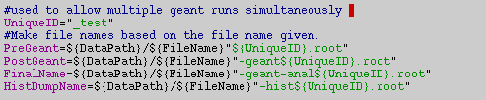

7) The following three sections (shown below) run the three different codes: (1) st_mona, (2) n2_geant, and (3) mona_analysis

