Figure S1. Bar plot of *Platygyra ryukyuensis* colonies, colored by Symbiodiniaceae genus. A) Divided by outcome – survived vs. did not survive event; B) divided by human disturbance category

A)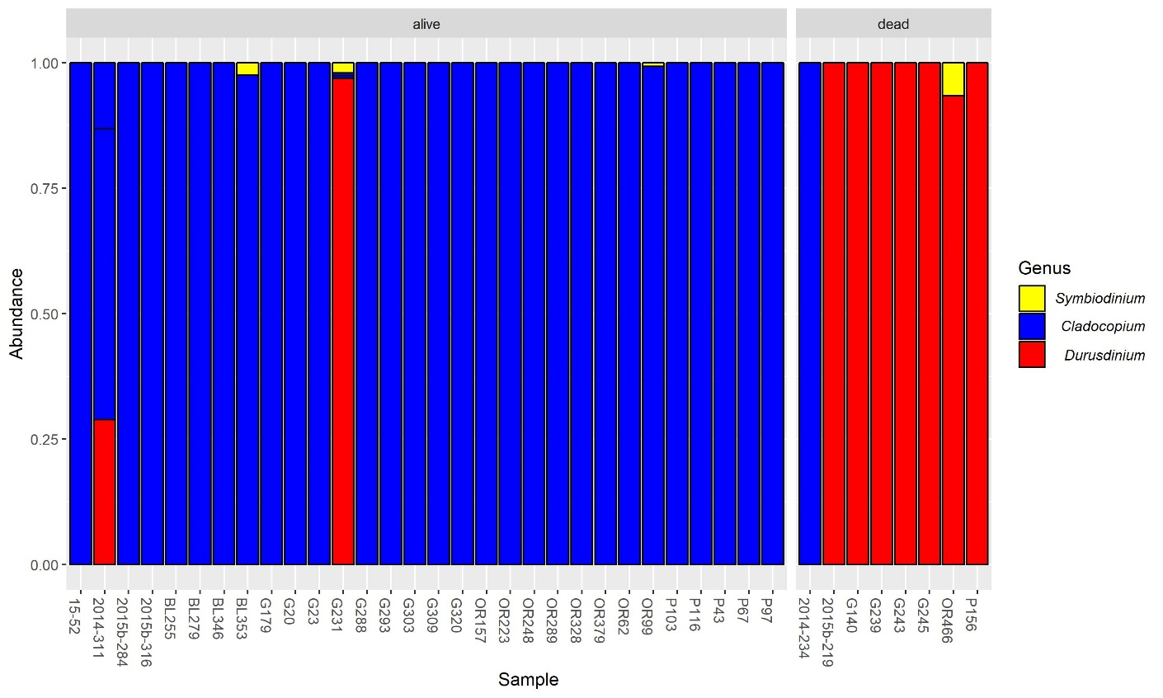

B)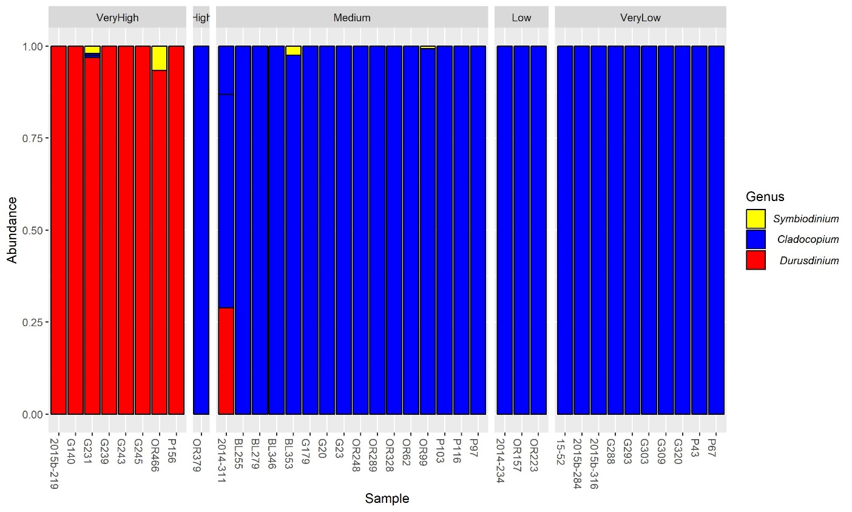

Figure S2. Bar plot of *Platygyra ryukyuensis* colonies, colored by the majority ITS2 sequence. A) Divided by outcome – survived vs. did not survive event; B) divided by human disturbance category

A)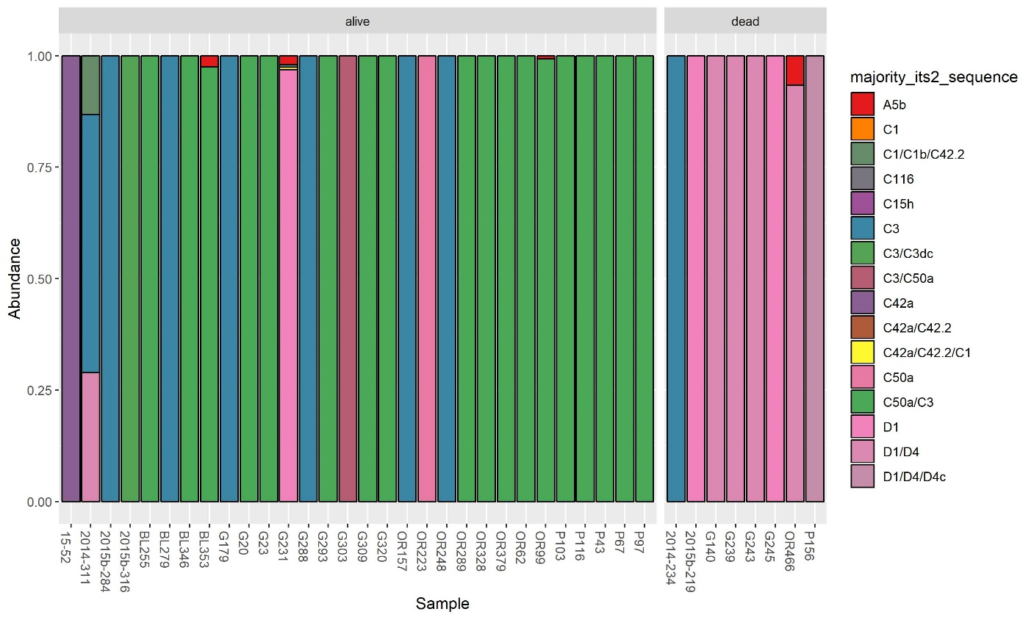

B)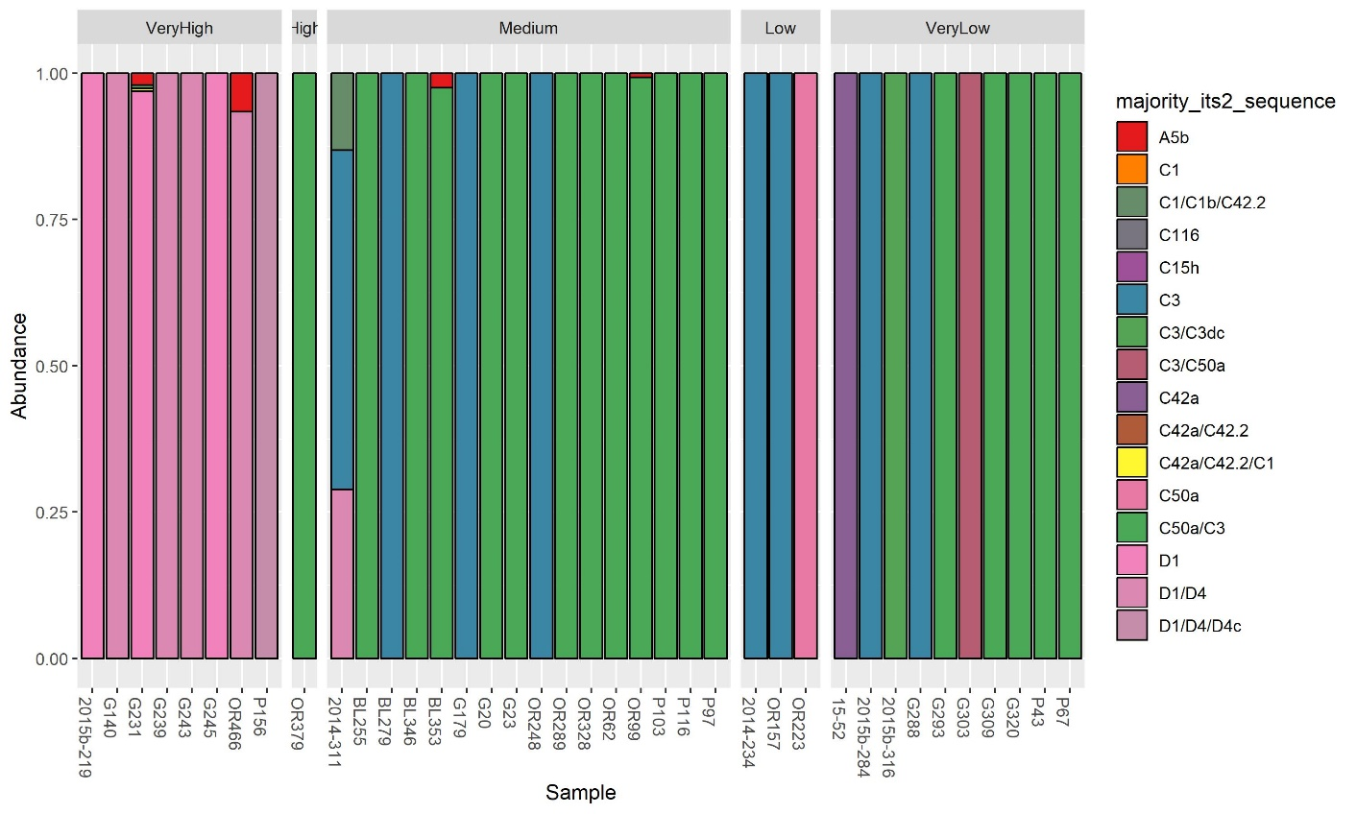

Figure S3. Bar plot of *Favites pentagona* colonies, colored by Symbiodiniaceae genus. A) Divided by outcome – survived vs. did not survive event; B) divided by human disturbance category

A)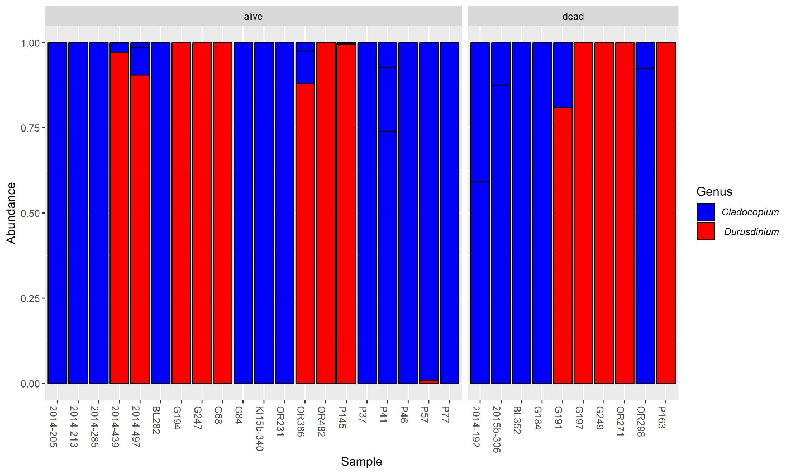

B)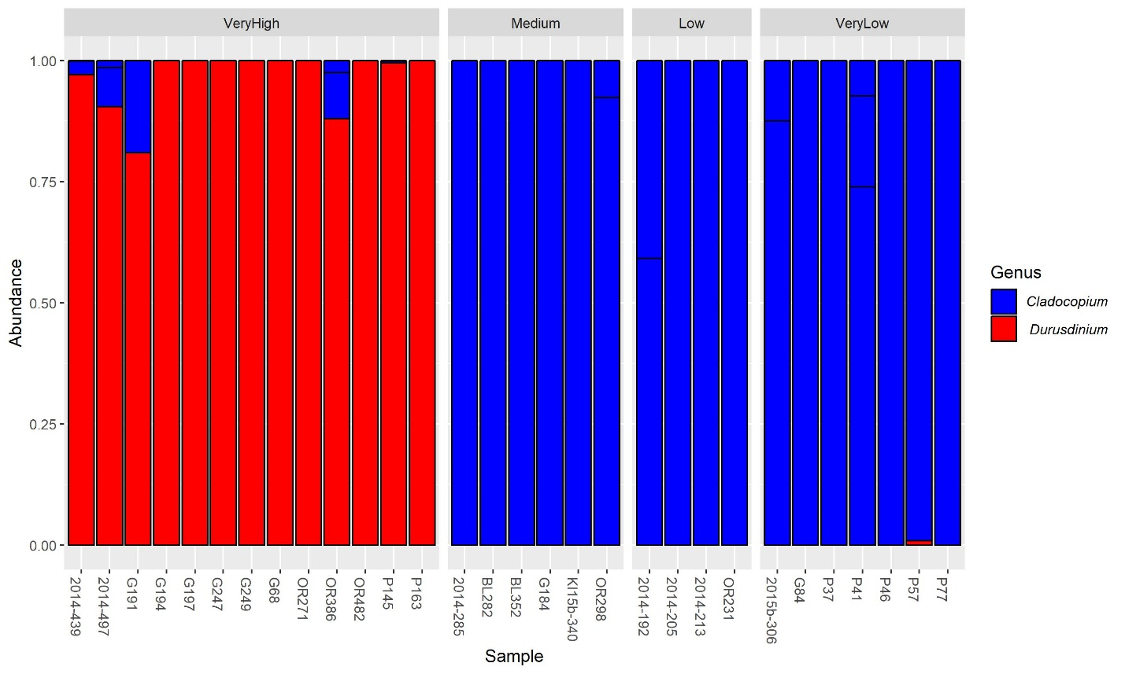

Figure S4. Bar plot of *Favites pentagona* colonies, colored by the majority ITS2 sequence. A) Divided by outcome – survived vs. did not survive event; B) divided by human disturbance category

A)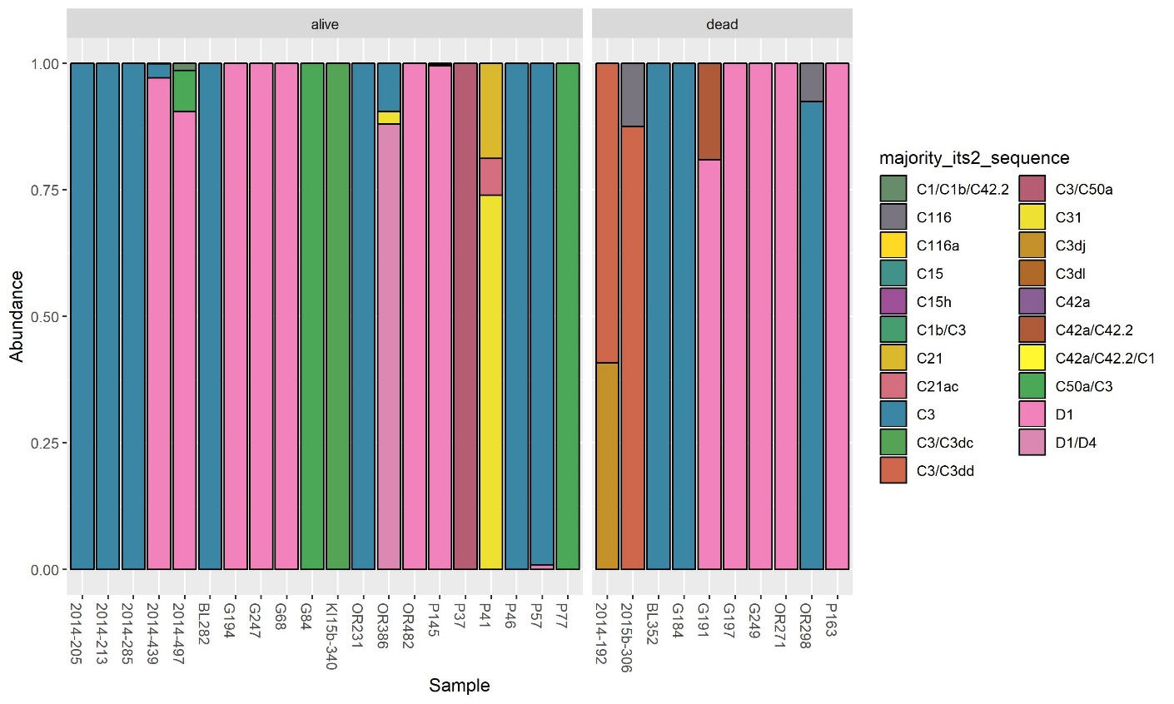

B)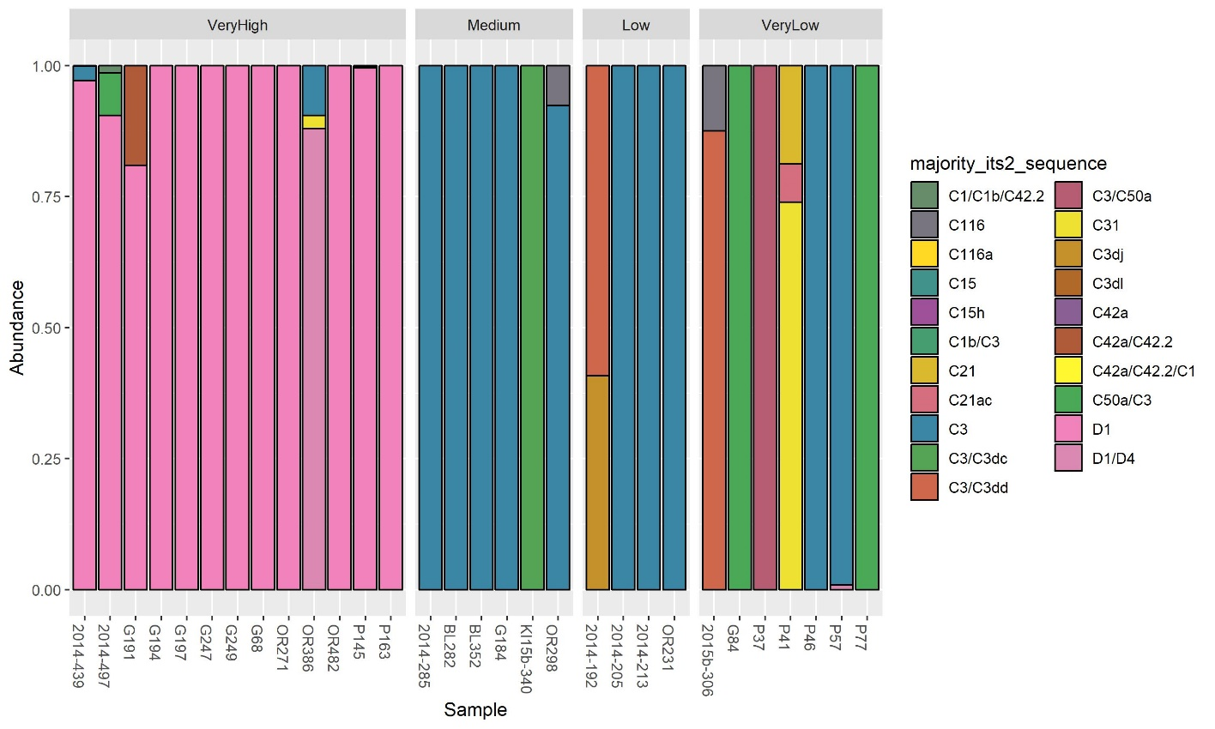

Figure S5. Bar plot of *Dipsastraea matthaii* colonies, colored by Symbiodiniaceae genus. A) Divided by outcome – survived vs. did not survive event; B) divided by human disturbance category

A)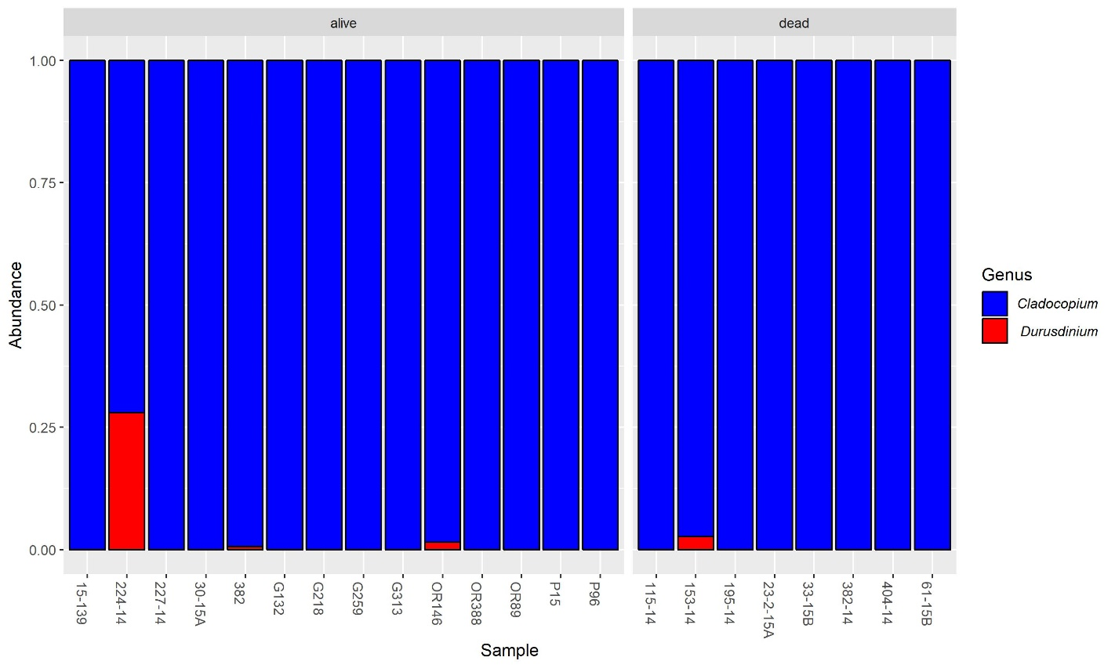

B)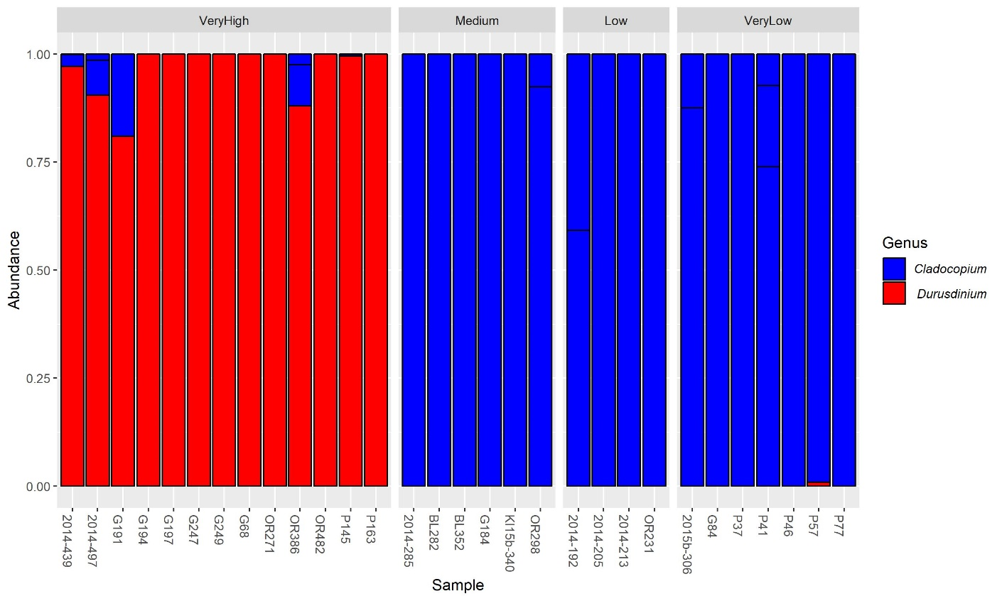

Figure S6. Bar plot of *Dipsastraea matthaii* colonies, colored by the majority ITS2 sequence. A) Divided by outcome – survived vs. did not survive event; B) divided by human disturbance category

A)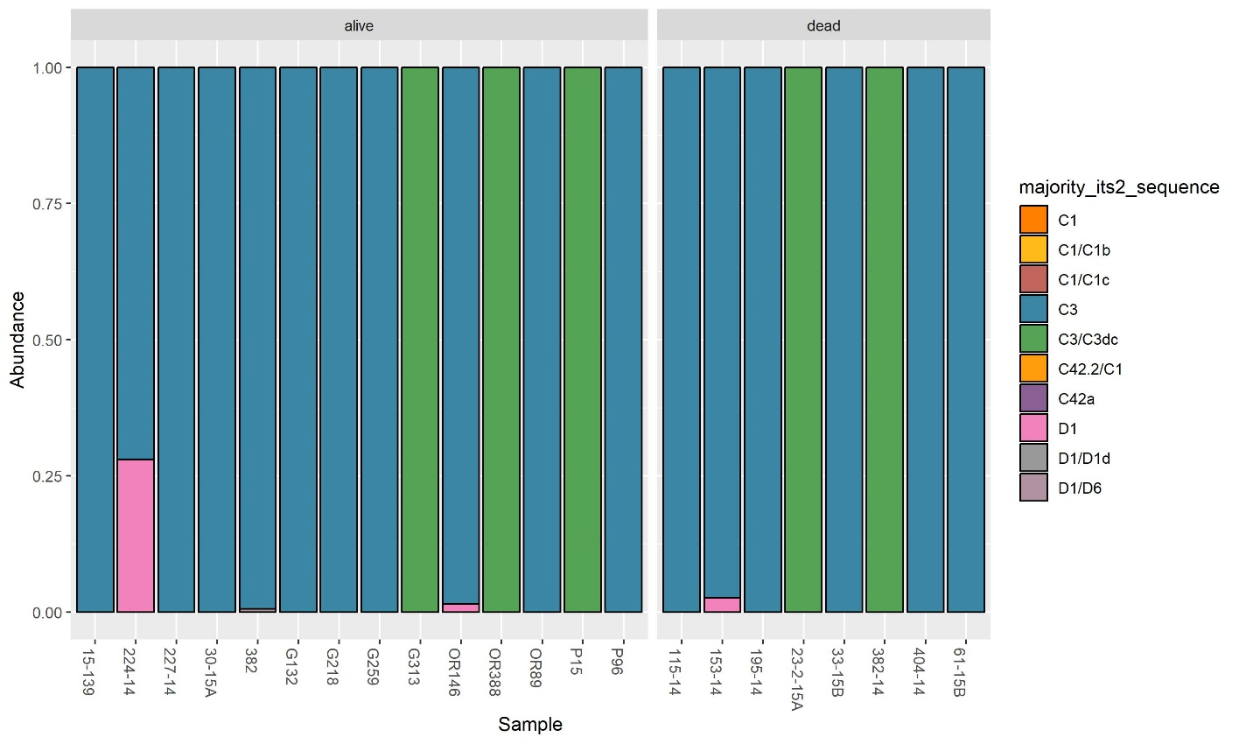

B)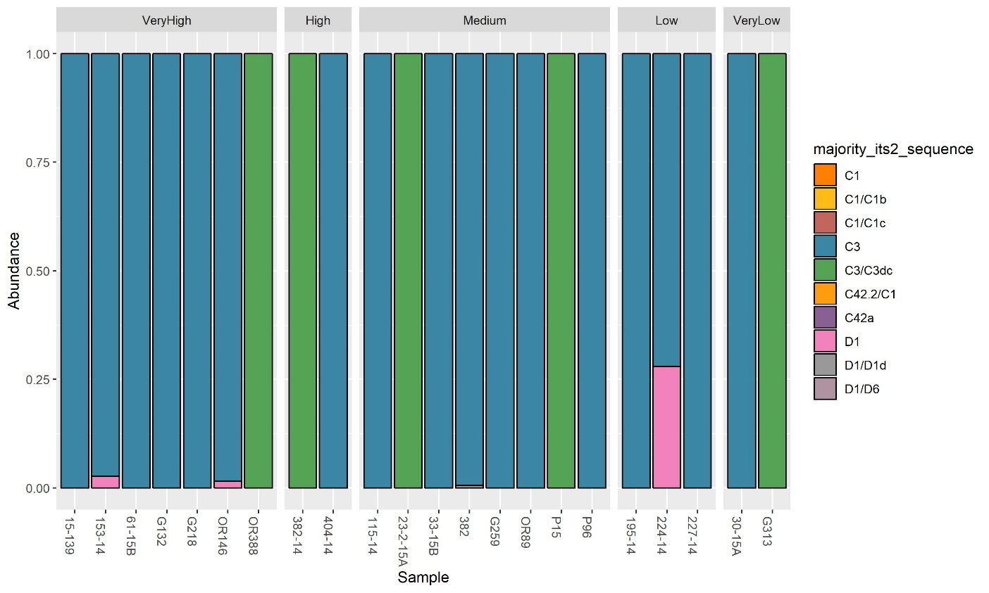

Figure S7. Bar plot of *Hydnophora microconos* colonies, colored by Symbiodiniaceae genus. A) Divided by outcome – survived vs. did not survive event; B) divided by human disturbance category

A)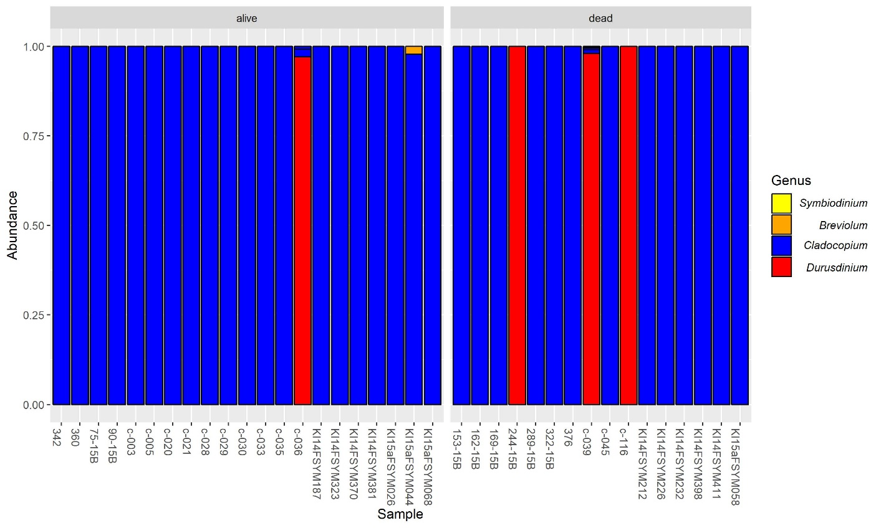

B)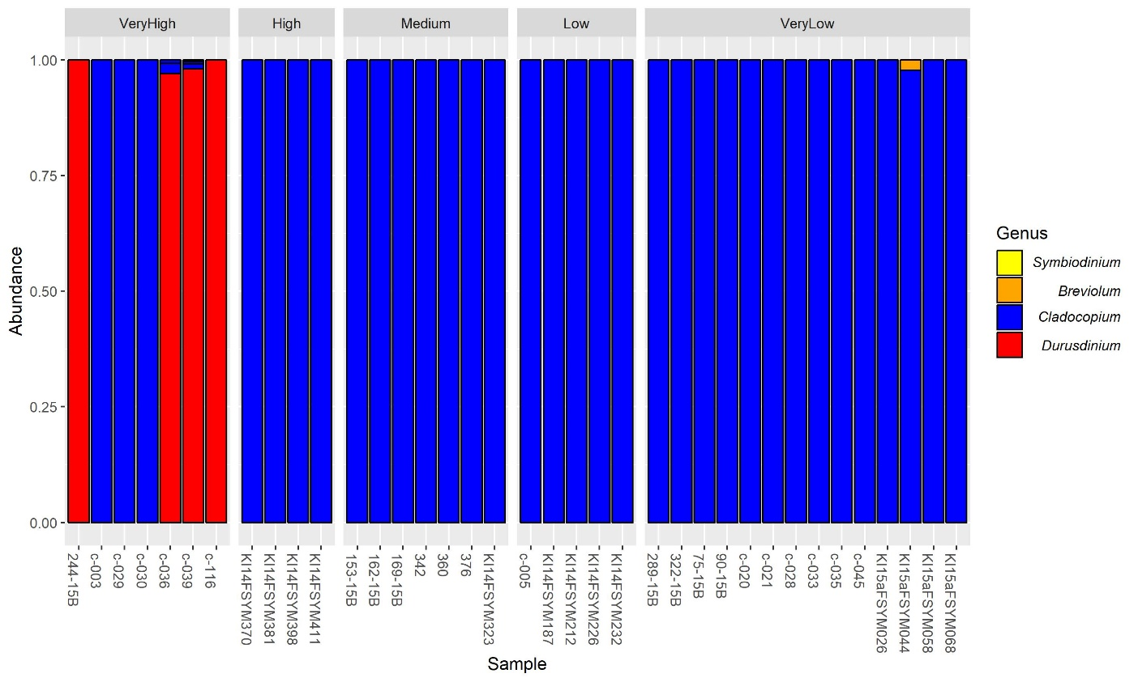

Figure S8. Bar plot of *Hydnophora microconos* colonies, colored by the majority ITS2 sequence. A) Divided by outcome – survived vs. did not survive event; B) divided by human disturbance category

A)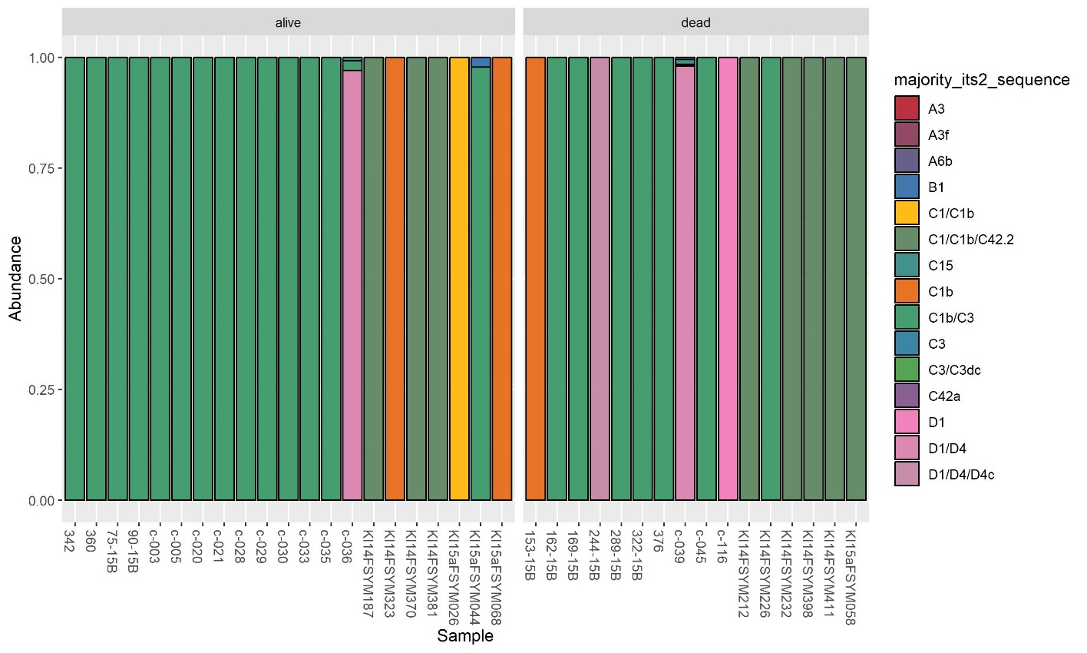

B)