GYA surveys

James Robinson; Kristina Tietjen

28 July 2016

Intro - explain the difference between applied, use inspired and fundamental research..... insert photo of Pasteur's quadrant - likely in the Intro chapter of the overall report.

**Methods** In addition the official data presented in earlier chapters, we also developed and ran a quantitative online survey to query Canadian researchers about their perceptions of, and experiences with, funding for fundamental research. The survey gathered information about gender, discipline, career stage and year PhD was obtained for each researcher, along with detailed information oabout.... An important aim of the survey was to provide an understanding "of trends and central issues relevant to careers in science in a glboal context"

The online survey was open from the end of May through early August 2016. To disseminate the survey to Canadian researchers, we gathered email addresses from university websites for as many faculty members as possible and emailed them directly. The survey was also shared broadly on social media, through the Global Young Academy network, on scientific list serves, and through personal connections.

**Results** In total, 1242 Canadian researchers completed the online survey. KT: INSERT SENTENCE ABOUT GENDER Eg. X per cent of survey respondents were male and X per cent female. Almost half of the responses came from either the natural or physical sciences (49%; Figure 2). The remaining responses were spread amongst the medical and life sciences (17%), engineering (11%), interdisciplinary science and social science or humanities). KT: THIS DOES NOT ADD UP TO 100% - did many people not list their discipline?? Over half of the respondents were early career academic researchers, defined as those researchers with less than ten years expereince applying for research grants since completion of their PhD. Another one quarter were senior academic researchers. KT: Again this does not add up to 100% - what is going on?

Overall, respondents reported that 70% of their

**NOTES ON FIGURES:** PLEASE REMOVE THE GLOBAL FIGURES THROUGHOUT - THIS IS ONLY THE CANADA REPORT. MOVE GLOBAL FIGURES INTO A DIFFERENT FILE. FIGURE 1. REMOVE. FIGURE 2. ADD CATEGORY FOR 'UNKNOWN' OR 'NOT STATED'. FIGURE 3. PLEASE ORDER IN ORDER OF CAREER I.E. POSTDOC THEN EARLY CAREER THEN SENIOR ACADEMIC, THEN PUT THE TWO NON-ACADEMICS TO THE RIGHT. FIGURE 4. I think this needs to be 3 frequency histogram plots since respondents reported percentages

### Summary statistics

As of Mon Sep 19 10:49:10 2016, 2092 surveys from 66 countries have been completed.

The majority of surveys were completed by researchers based in Canada (n = 1265), followed by Israel (n = 179) then by the UK (n = 167) and the USA (n = 116). 46 surveys did not identify their place of work.

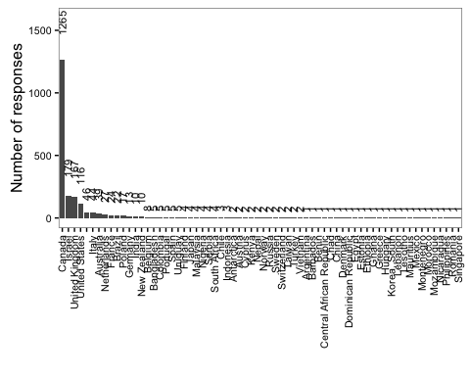

Survey responses by country

## Country_work gender  
## 1 Australia 39  
## 2 Austria 2  
## 3 Bangladesh 5  
## 4 Belgium 8  
## 5 Brazil 22  
## 6 Canada 1265  
## 7 Denmark 1  
## 8 Finland 4  
## 9 France 24  
## 10 Germany 13  
## 11 India 10  
## 12 Israel 179  
## 13 Italy 44  
## 14 Japan 4  
## 15 Korea, South 1  
## 16 Malaysia 4  
## 17 Netherlands 27  
## 18 New Zealand 10  
## 19 Norway 2  
## 20 Poland 17  
## 21 Russia 2  
## 22 Spain 5  
## 23 Sweden 2  
## 24 Switzerland 2  
## 25 Taiwan 2  
## 26 Turkey 2  
## 27 United Kingdom 167  
## 28 United States 116  
## 29 Uruguay 5

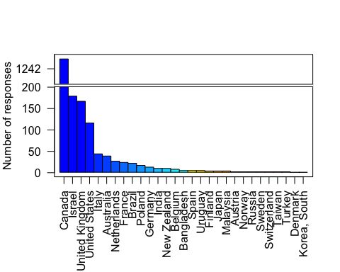

Survey responses of the top 20 responding countries, G8 countries, and the top spenders in R & D from OECD data

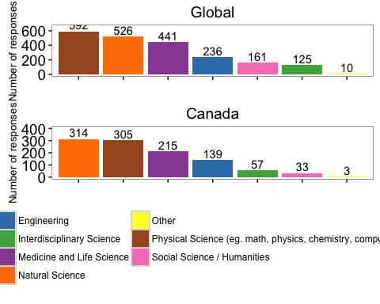

Survey responses by field of research (global and Canada)

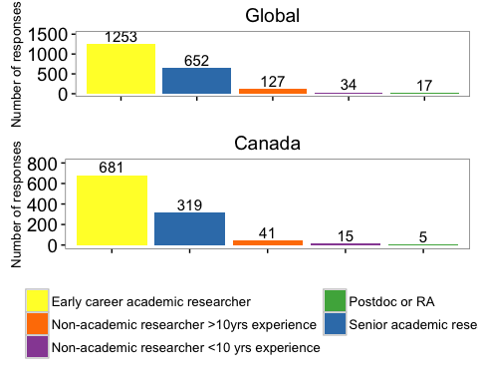

Survey responses by years of experience (global and Canada)

### GYA surveys: Canada

#### Part 1 - Type of Research Conducted

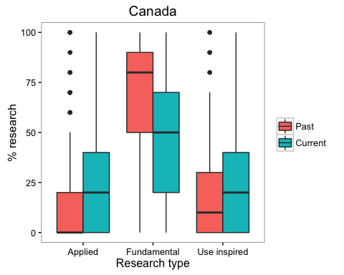

Current vs. past research type (Canada)

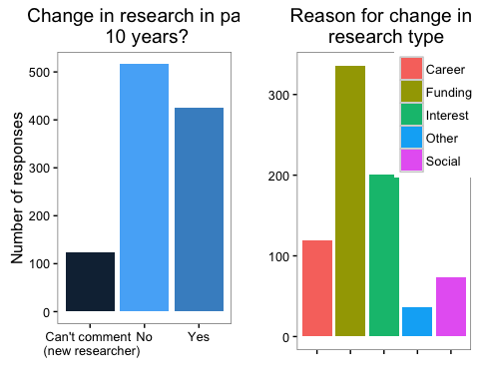

Reason for change in research over past 10 years (Canada)

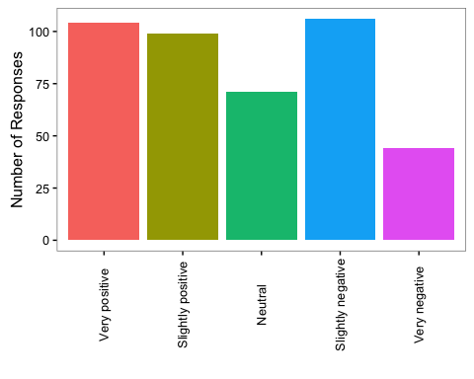

View of change in research over past 10 years (Canada)

#### Part 2 - External Partnerships

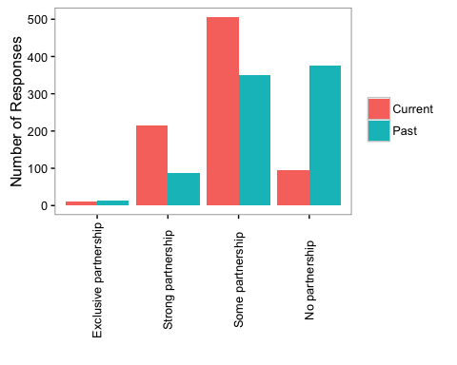

Current vs past level of partnership outside of academia (Canada)

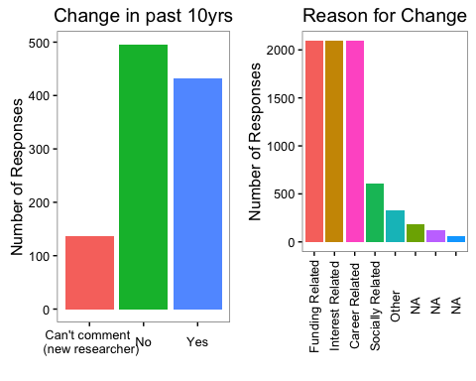

Reason for change over the past 10 years (Canada)

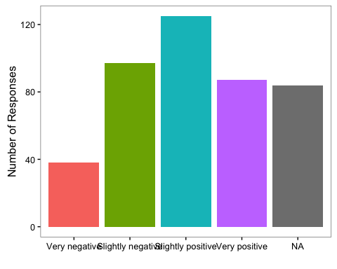

View of Change in partnership (Canada)

#### Part 3 - Grant Application History

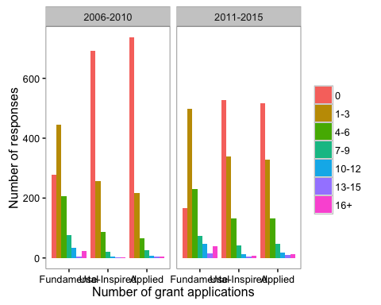

Number of external research grant applications (Canada)

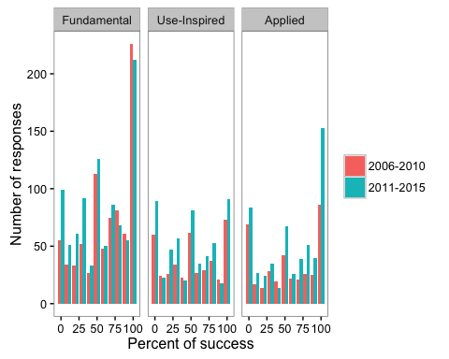

Percentage of research grant application success (Canada)

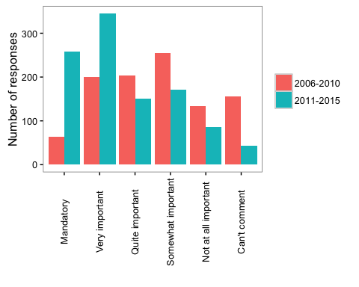

Importance of suggesting practical applications of the research for the grant to be successful (Canada)

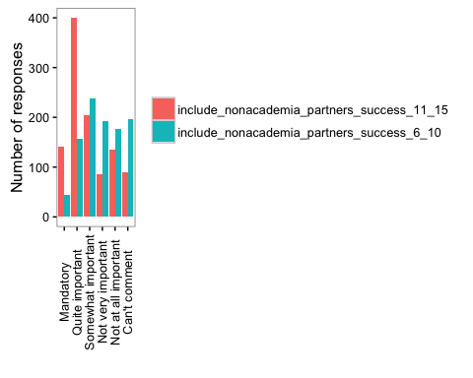

Importance of including partners from for-profit or non-governmental sectors in grant success (Canada)

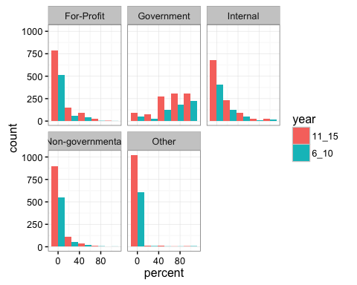

Distribution of research funding (Canada)

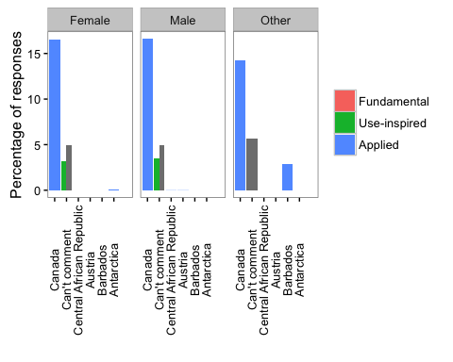

Grant success rates change over the past 10 years (Canada)

#### Part 4 - Funding Trends

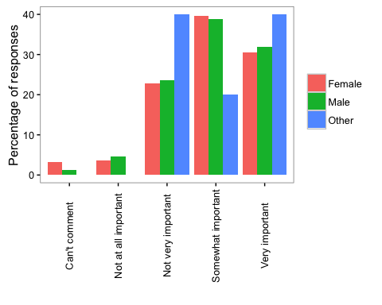

Perceived importance of fundamental research to Canada

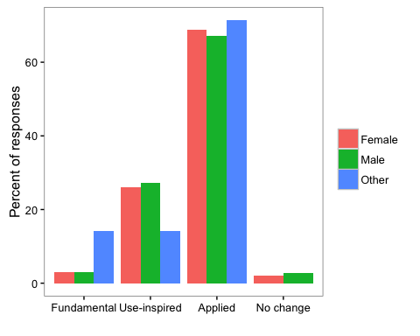

Perceived change in research priority by Canadian government

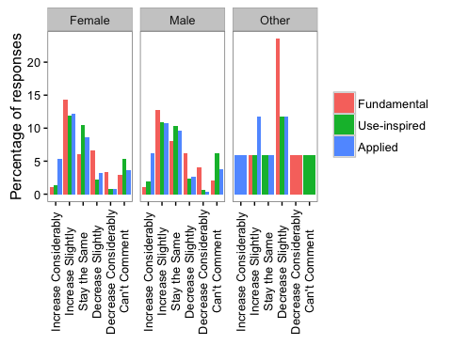

Anticipated change in research funding in next 5 years in Canada

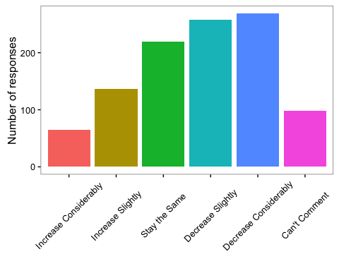

Effect of change in research funding on research careers of next generation (Canada)