Canadian online survey on fundamental research

16 September 2016

**Introduction** In addition to the official data presented in Chapters 2 and 3, we also developed and ran a quantitative online survey to query researchers about their perceptions of, and experiences with, funding for fundamental research. An important aim of the survey was to provide an understanding researcher's personal experiences and outlook on the research funding landscape in Canada. We had an excellent response to the survey, with over 1300 Canadian researchers completing it, suggesting that fundamental research funding is a high priority topic for Canadian researchers. Herein, we detail the survey questions and results.

**Methods**  
Online Survey  
The survey was open to researchers from all disciplines (e.g. science, social sciences, humanities, engineering, medicine) and career stages, with the proviso that they had some experience applying for research funding. The survey gathered detailed information in four major areas: 1) the types of research the scholars conduct (fundamental, use-inspired, applied), 2) the extent of external partnerships in their research, 3) their grant success rates, and 4) how important they perceive fundamental research is to the Canadian federal government and its future prospects in Canada. The survey also enquired how each of these factors have changed over time for the researchers. Finally, the survey gathered basic information from each respondent about gender, discipline, career stage and the year their PhD was obtained. The full survey is provided in Appendix 2.

The online survey was open from the end of May through early October 2016, and ran on the Fluid Surveys platform (fluidsurveys.com). Note that the survey was open to researchers from any country in the world because it is was run as part of a global survey through the Global Young Academy. To disseminate the survey to Canadian researchers, we gathered email addresses from Canadian university websites for as many faculty members as possible and emailed individual researchers directly. We also shared the survey broadly on social media, as well as through the Global Young Academy network, on scientific list serves, and through personal connections.

Survey Data Analysis  
To extract survey responses for Canadian researchers, we selected all respondents who reported 'Canada' as their country of work, as well as those respondents who did not report a country of work (i.e. field was blank) but whose location was within Canada. We conducted all statistical analyses in the open source software R (Version 3.3.1). **Note that numbers not all the same because respondents did not always answer every question**

**Results**  
In total, 1303 Canadian researchers completed the online survey. Of these, almost three quarters were male (74%) and one quarter were female (25%); a very small proportion either did not input their gender or selected other. Almost all of the survey respondents (94%) were either senior academics (65%), defined as those researchers with more than ten years experience applying for research grants since completion of their PhD, or early career academics (29%) (Figure 4.1). A small proportion of responses also came from post-doctoral researchers (4%), non-academic researchers (2%), or those who did not indicate their career stage (0.4%).

Researchers from many different disciplines were represented in the survey. Almost sixty per cent of responses came from either the natural or physical sciences (Figure 4.2). The remaining responses were spread amongst the medical and life sciences (20%), engineering (13%), interdisciplinary research (5%), and social sciences and humanities (3%).

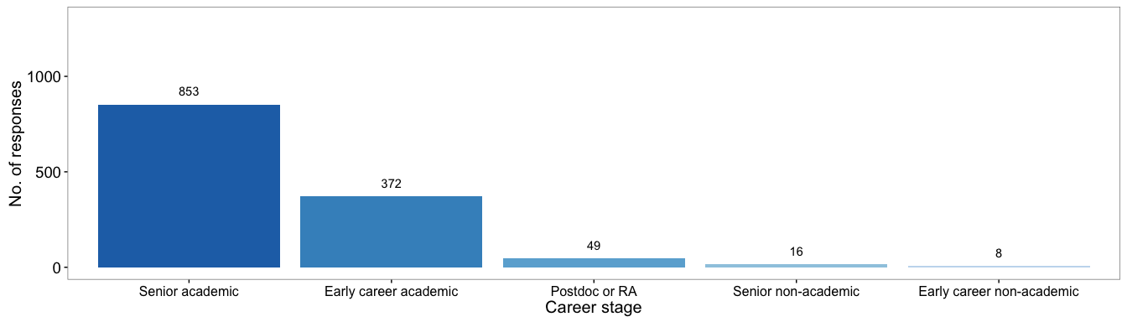

Figure 4.1 Number of Canadian survey respondents by career stage

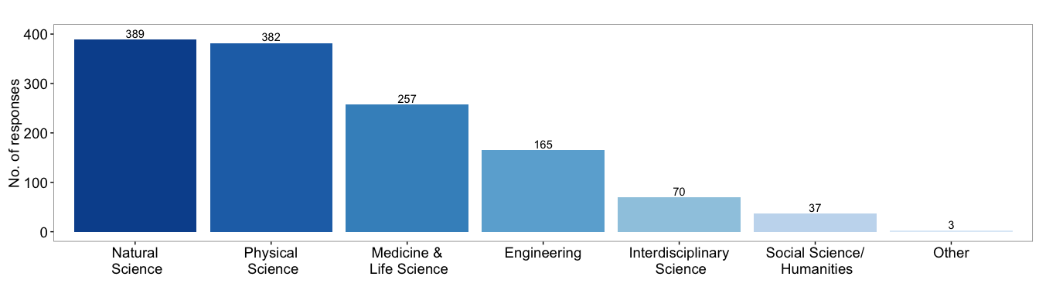

Figure 4.2 Survey responses by field of research

------ Rmd FILE IS FIXED DOWN TO HERE *4.1 Type of Research Conducted* Canadian survey respondents included researchers conducting all three types of research: fundamental, use-inspired, and applied. Very few researchers considered themselves to only do one type of research: insert %s of who think they do all of f, u, or a. X% of researchers consider that over half of their research program is in fundamental science......

SOMEHOW HAVE TO MAKE SENSE OF THE RESPONSES AND PLOT FOR THE % OF RESEARCH IN THE THREE CATEGORIES. Almost one third of researchers reported that the types of research they conduct has shifted over the past ten years (Figure 3). By far, the most reported reason for this change was funding (Figure 4). This suggests..... However, opinions about these changes were varible, with one quarter of respondents viewing them as slightly negative, one quarter slightly positive and one quarter very positive (Figure X).

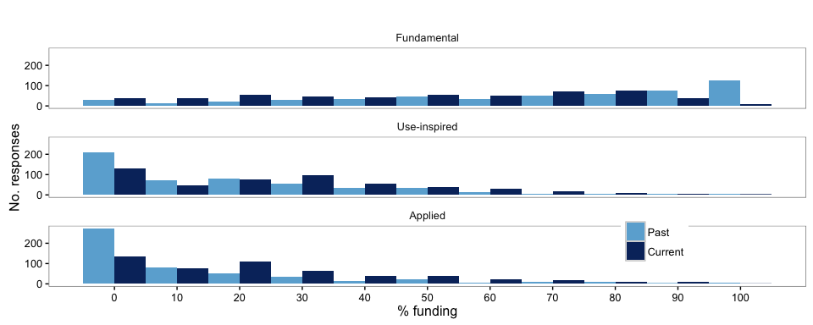

Figure 4.3 Funding allocation to fundamental, use-inspired and applied research categories. Reseachers were questioned about the percentage of funding allocated to Fundamental, Use-inspired or Applied research in the past and in their current research.- wrong caption

## $y  
## [1] "No. responses"  
##   
## attr(,"class")  
## [1] "labels"

## Var1 Var2 Freq  
## 1 Main_reason_change_Career_related 1 139  
## 2 Main_reason_change_Funding_related 1 410  
## 3 Main_reason_change_interest_related 1 244  
## 4 Main_reason_change_Other 1 44  
## 5 Main_reason_change_Socially_related 1 85

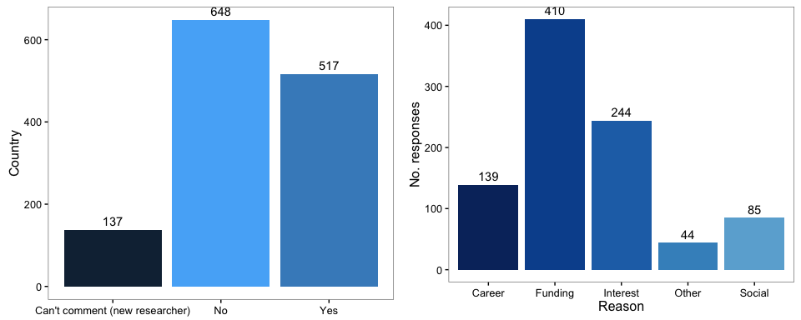

Figure 4.4 Change in research type proportions and the reasons. Researchers were asked to answer yes, no, or can't comment on if their type of research had changed in the last 10 years and to select what reasons for the change applied to them.

## view_change_of_type gender  
## 1 Neutral 84  
## 2 Slightly negative 128  
## 3 Slightly positive 119  
## 4 Very negative 54  
## 5 Very positive 130

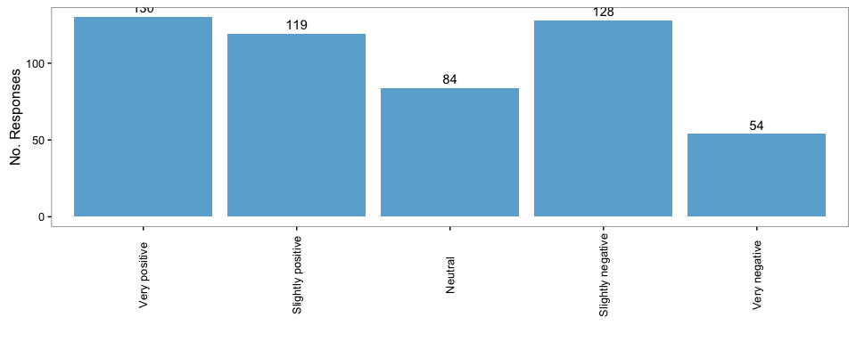

Figure 4.5 View of change in proportion of research. Researchers were asked how they viewed the change in the type of research they conduct/supervise.

#### Part 2 - External Partnerships

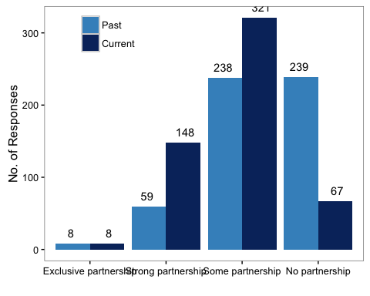

Figure 4.6 Current vs past level of partnership outside of academia. Researchers indicated the level of partnership that their current and past (10 years ago) research program had outside of academia.

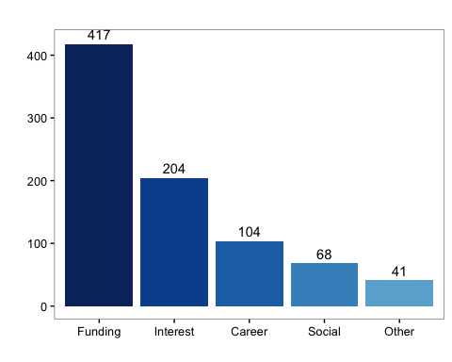

Reasons for change in level of external research partnerships over the past decade.

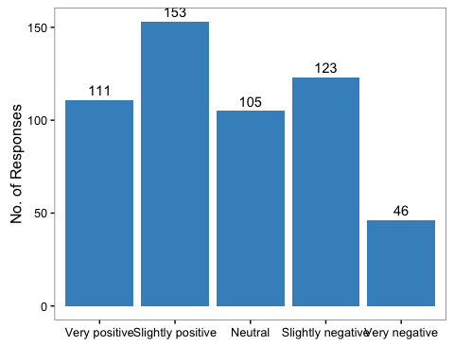

View of change in external partnerships. Researchers were asked how they viewed the change in the level of partnership with external groups.

*4.2 External Partnerships*  
The extent to which research is conducted with partners outside of academia, including in industry and non-governmental sectors, may also be considered as an indicator of use-inspired or applied research. Almost all respondents (88%) reported that their current research includes external partners to some degree: fifty-nine per cent reported some partnerships and a further quarter (27%) reported strong partnerships (Figure 4.6). Less than 1% reported conducting their research exclusively with partners outside of academia.

Over the past decade, there has been a sharp decline in the number of researchers with no external partnerships: only 12% of respondents reported having no partnerhips in their current research program, whereas almost half of respondents (44%) reported having no partnerships in the past (Figure 4.6). The number of strong external partnerships also has increased over time from 11% to 27% (Figure 4.6).

Funding was the driving force behind the shift towards external partnerhips. Half of Canadian respondents reported that they developed external partnerships in order to secure funding (Figure 4.7). The remaining half of respondents developed partnerships out of interest (24%), or for career (12%) or social reasons (<1%) (Figure 4.7).

Perspectives on these changes were mixed (Figure 4.8). Interestly, almost half of respondents (49%) viewed the change in external partnerships as slightly or very positive. Twenty per cent were indifferent to the change and thirty-one percent of respondents viewed them as slightly or very negative.

*Research Grants* [STILL TO COME]

The majority of respondents believe that it is now either mandatory or very important to suggest practical applications of their research in order for their grant applications to be successful. This has shifted over time, with researchers reporting that between 2006 and 2010 it was only somewhat important to do so (Figure X).

Similarly...... including partners from for-profit or non-governmental sectors in grants to be successful (Figure X).

*Perspectives on the State of Fundamental Research in Canada* Over half of Canadian researchers who responded said that fundamental research is either very important or somewhat important to our government. Differences by career stage, discipline,ggender....

At the same time, almost three-quarters of respondents said that applied research became a higher priority for our government over the past decade.

Summarize finding on how they think availabiltiy of research funding will change over the next five years:

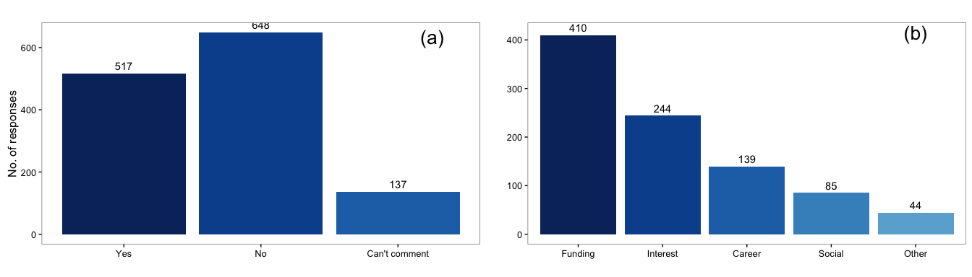

Reason for change in research over past 10 years. Researchers were asked if their funding proportions had changed in the past ten years (a), and what the main reason for a change in their research category (b).

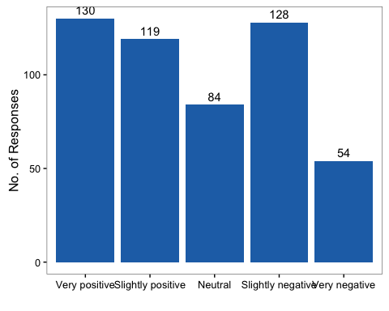

Opinion of change in research over past 10 years. Researchers were asked how they viewed the change in research type.

#### Part 3 - Grant Application History

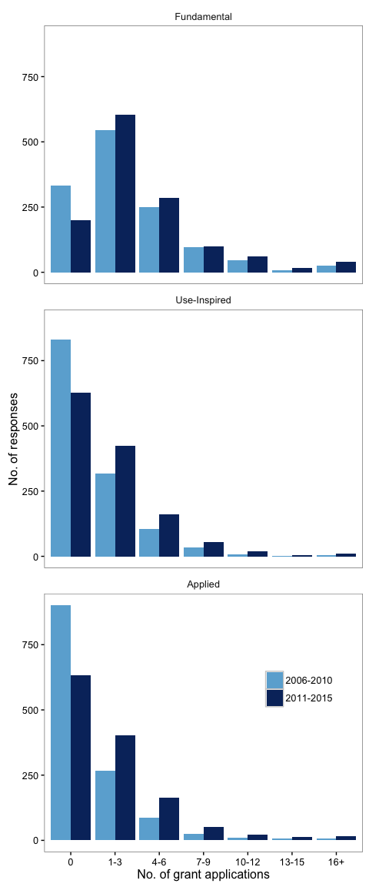

Number of research grant applications by research category in 2006-2010 and 2011-2015.

## [1] 4494 8

## [1] 4494 9

## [1] 66 4

## type percent time Freq  
## 1 Applied 0 2006-2010 80  
## 2 Fundamental 0 2006-2010 67  
## 3 Use-Inspired 0 2006-2010 74  
## 4 Applied 10 2006-2010 18  
## 5 Fundamental 10 2006-2010 37  
## 6 Use-Inspired 10 2006-2010 24  
## 7 Applied 20 2006-2010 16  
## 8 Fundamental 20 2006-2010 41  
## 9 Use-Inspired 20 2006-2010 30  
## 10 Applied 30 2006-2010 38  
## 11 Fundamental 30 2006-2010 58  
## 12 Use-Inspired 30 2006-2010 44  
## 13 Applied 40 2006-2010 22  
## 14 Fundamental 40 2006-2010 31  
## 15 Use-Inspired 40 2006-2010 32  
## 16 Applied 50 2006-2010 52  
## 17 Fundamental 50 2006-2010 133  
## 18 Use-Inspired 50 2006-2010 80  
## 19 Applied 60 2006-2010 25  
## 20 Fundamental 60 2006-2010 59  
## 21 Use-Inspired 60 2006-2010 28  
## 22 Applied 70 2006-2010 26  
## 23 Fundamental 70 2006-2010 94  
## 24 Use-Inspired 70 2006-2010 40  
## 25 Applied 80 2006-2010 37  
## 26 Fundamental 80 2006-2010 108  
## 27 Use-Inspired 80 2006-2010 49  
## 28 Applied 90 2006-2010 31  
## 29 Fundamental 90 2006-2010 73  
## 30 Use-Inspired 90 2006-2010 28  
## 31 Applied 100 2006-2010 106  
## 32 Fundamental 100 2006-2010 286  
## 33 Use-Inspired 100 2006-2010 94  
## 34 Applied 0 2011-2015 98  
## 35 Fundamental 0 2011-2015 124  
## 36 Use-Inspired 0 2011-2015 109  
## 37 Applied 10 2011-2015 30  
## 38 Fundamental 10 2011-2015 62  
## 39 Use-Inspired 10 2011-2015 29  
## 40 Applied 20 2011-2015 29  
## 41 Fundamental 20 2011-2015 69  
## 42 Use-Inspired 20 2011-2015 52  
## 43 Applied 30 2011-2015 43  
## 44 Fundamental 30 2011-2015 106  
## 45 Use-Inspired 30 2011-2015 68  
## 46 Applied 40 2011-2015 17  
## 47 Fundamental 40 2011-2015 44  
## 48 Use-Inspired 40 2011-2015 29  
## 49 Applied 50 2011-2015 80  
## 50 Fundamental 50 2011-2015 151  
## 51 Use-Inspired 50 2011-2015 94  
## 52 Applied 60 2011-2015 30  
## 53 Fundamental 60 2011-2015 68  
## 54 Use-Inspired 60 2011-2015 49  
## 55 Applied 70 2011-2015 51  
## 56 Fundamental 70 2011-2015 104  
## 57 Use-Inspired 70 2011-2015 52  
## 58 Applied 80 2011-2015 62  
## 59 Fundamental 80 2011-2015 88  
## 60 Use-Inspired 80 2011-2015 65  
## 61 Applied 90 2011-2015 51  
## 62 Fundamental 90 2011-2015 67  
## 63 Use-Inspired 90 2011-2015 25  
## 64 Applied 100 2011-2015 194  
## 65 Fundamental 100 2011-2015 261  
## 66 Use-Inspired 100 2011-2015 132

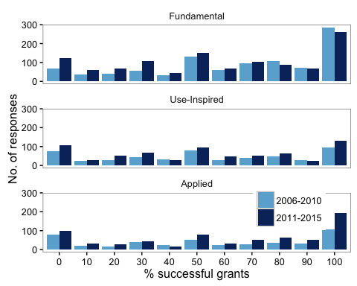

Research grant application success over the past 10 years. Researchers were asked to estimate the percentage of their research grant applications that were successful, in 2006-2010 and in 2011-2015.

## [1] Can't comment Can't comment Mandatory   
## [4] Mandatory Not at all important Not at all important  
## [7] Quite important Quite important Somewhat important   
## [10] Somewhat important Very important Very important   
## 6 Levels: Can't comment Mandatory ... Very important

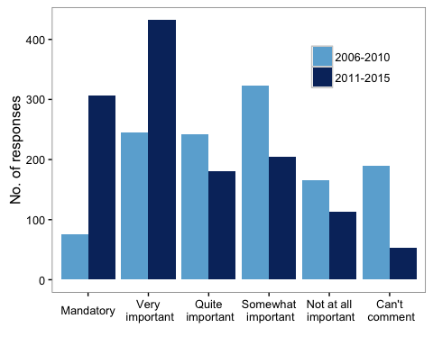

Importance of practical application of research over the past 10 years. Researchers were asked how important it was to suggest practical applications of their research to ensure that the grant was successful, in 2006-2010 and in 2011-2015.

## Var1 Var2 Freq   
## 2006-2010:6 Can't comment :2 Min. : 55.0   
## 2011-2015:6 Mandatory :2 1st Qu.:149.0   
## Not at all important:2 Median :196.0   
## Not very important :2 Mean :210.1   
## Quite important :2 3rd Qu.:250.5   
## Somewhat important :2 Max. :469.0

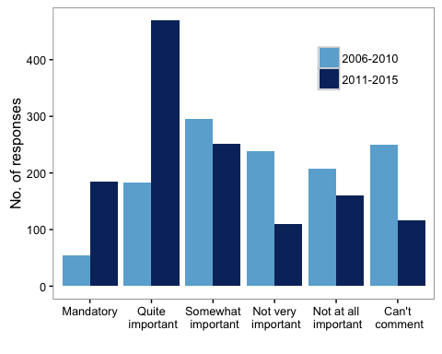

Importance of including partners from for-profit or non-governmental sectors in grant success. Researchers were asked how important it was to include external partnerships in their research to ensure that the grant was successful, in 2006-2010 and in 2011-2015.

## [1] 6_10 11_15  
## Levels: 11_15 6_10

## Factor w/ 2 levels "2011-2015","2006-2010": 2 2 2 2 2 2 2 2 2 2 ...

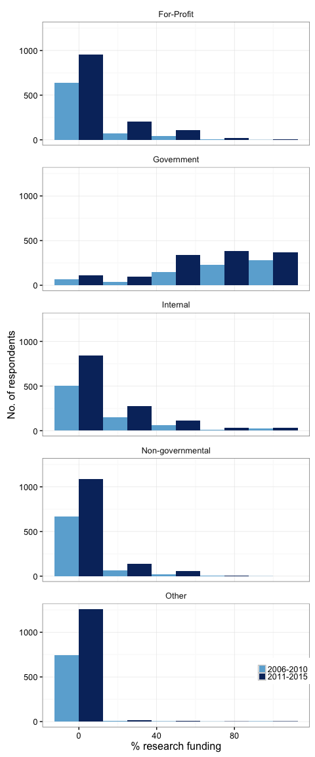

Distribution of research funding over the past 10 years. Researchers were asked to estimate the distribution of their research funding sources in 2006-2010 and 2011-2015.

## Country Country_work gender Location  
## 309 Canada Canada Male British Columbia  
## 310 Netherlands Canada Female Netherlands  
## 311 Netherlands Canada Female Netherlands  
## 312 Canada Canada Female Quebec  
## 313 Canada Canada Female Alberta  
## 314 Spain Canada Male Spain  
## what_participant_group  
## 309 Non-academic researcher conducting or managing research in industry or government with >10 years of experience  
## 310 Early career academic researcher with <10 years experience applying for research grants since completion of PhD  
## 311 Early career academic researcher with <10 years experience applying for research grants since completion of PhD  
## 312 Early career academic researcher with <10 years experience applying for research grants since completion of PhD  
## 313 Senior academic researcher with >10 years of experience applying for research grants  
## 314 Senior academic researcher with >10 years of experience applying for research grants  
## field_research success_change_10yrs_fundamental  
## 309 Engineering Decreased  
## 310 Engineering Can't comment  
## 311 Natural Science Decreased  
## 312 Social Science / Humanities Can't comment  
## 313 Social Science / Humanities Decreased considerably  
## 314 Interdisciplinary Science Decreased  
## success_change_10yrs_use success_change_10yrs_applied  
## 309 Increased Stayed the same  
## 310 Can't comment Increased  
## 311 Increased considerably Increased considerably  
## 312 Can't comment Can't comment  
## 313 Increased Increased considerably  
## 314 Decreased Increased

## Country Country_work gender Location  
## 1 Canada Canada Male British Columbia  
## 2 Netherlands Canada Female Netherlands  
## 3 Netherlands Canada Female Netherlands  
## 4 Canada Canada Female Quebec  
## 5 Canada Canada Female Alberta  
## 6 Spain Canada Male Spain  
## what_participant_group  
## 1 Non-academic researcher conducting or managing research in industry or government with >10 years of experience  
## 2 Early career academic researcher with <10 years experience applying for research grants since completion of PhD  
## 3 Early career academic researcher with <10 years experience applying for research grants since completion of PhD  
## 4 Early career academic researcher with <10 years experience applying for research grants since completion of PhD  
## 5 Senior academic researcher with >10 years of experience applying for research grants  
## 6 Senior academic researcher with >10 years of experience applying for research grants  
## field_research type  
## 1 Engineering success_change_10yrs_fundamental  
## 2 Engineering success_change_10yrs_fundamental  
## 3 Natural Science success_change_10yrs_fundamental  
## 4 Social Science / Humanities success_change_10yrs_fundamental  
## 5 Social Science / Humanities success_change_10yrs_fundamental  
## 6 Interdisciplinary Science success_change_10yrs_fundamental  
## level  
## 1 Decreased  
## 2 Can't comment  
## 3 Decreased  
## 4 Can't comment  
## 5 Decreased considerably  
## 6 Decreased

## type level Freq  
## 1 success_change_10yrs_applied 50  
## 2 success_change_10yrs_fundamental 12  
## 3 success_change_10yrs_use 83  
## 4 success_change_10yrs_applied Can't comment 265  
## 5 success_change_10yrs_fundamental Can't comment 126  
## 6 success_change_10yrs_use Can't comment 368  
## 7 success_change_10yrs_applied Decreased 91  
## 8 success_change_10yrs_fundamental Decreased 542  
## 9 success_change_10yrs_use Decreased 185  
## 10 success_change_10yrs_applied Decreased considerably 34  
## 11 success_change_10yrs_fundamental Decreased considerably 518  
## 12 success_change_10yrs_use Decreased considerably 57  
## 13 success_change_10yrs_applied Increased 345  
## 14 success_change_10yrs_fundamental Increased 13  
## 15 success_change_10yrs_use Increased 313  
## 16 success_change_10yrs_applied Increased considerably 395  
## 17 success_change_10yrs_fundamental Increased considerably 3  
## 18 success_change_10yrs_use Increased considerably 64  
## 19 success_change_10yrs_applied Stayed the same 123  
## 20 success_change_10yrs_fundamental Stayed the same 89  
## 21 success_change_10yrs_use Stayed the same 233

## Can't comment Decreased Decreased considerably   
## 3 3 3   
## Increased Increased considerably Stayed the same   
## 3 3 3

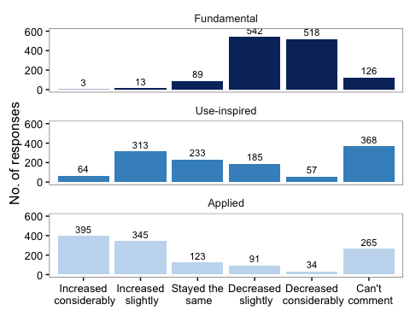

Change in grant success rates over the past 10 years. Researchers were asked if they thought that grant sucecss rates have changed in the past 10 years, for each research category.

#### Part 4 - Funding Trends

## [1] 1303 5

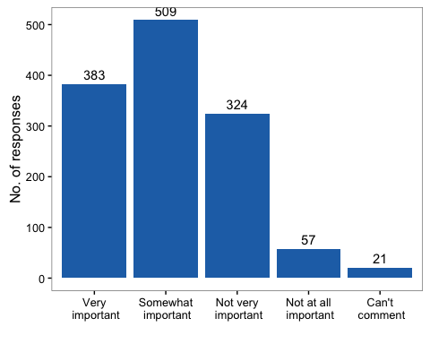

Perceived importance of fundamental research to Canadian government. Researchers were asked how important they thought fundamental research was to the Canadian government. Responses were/were not significantly different between genders.

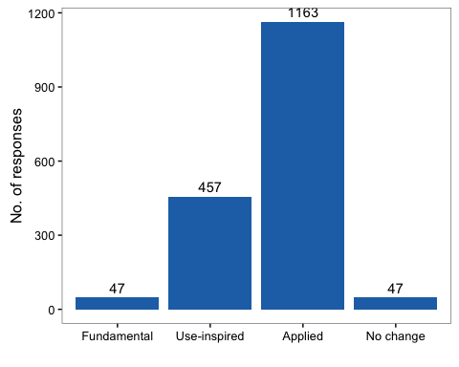

Perceived change in research priority by Canadian government. Researchers were asked whether any types of research had become higher priority for the Canadian government. Responses were/were not significantly different between genders.

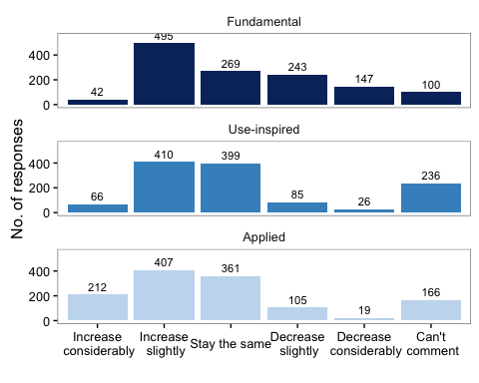

Anticipated change in research funding in next five years in Canada. Researchers were asked whether the availability of research funding would change in the next five years, for each research category. Responses were/were not significantly different between genders.

## Can't comment decrease considerably decrease slightly   
## 1 1 1   
## increase considerably increase slightly stay the same   
## 1 1 1

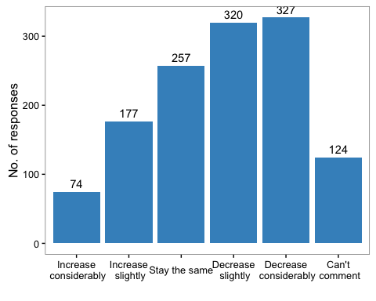

Effect of change in research funding on research careers of next generation in Canada. Researchers were asked if they though that changes in funding availability would influence the likelihood of the next generation pursuing careers in research. Responses were/were not significantly different between genders.