Developed countries online survey on fundamental research

4 Jan 2018

**Introduction**  
We developed and ran a quantitative online survey to query researchers about their perceptions of, and experiences with, funding for fundamental research. An important aim of the survey was to provide an understanding researcher's personal experiences and outlook on the research funding landscape. We had an excellent response to the survey, with over xxxx researchers completing it, suggesting that fundamental research funding is a high priority topic for researchers. Herein, we detail the survey questions and results.

**Methods**  
Online Survey  
The survey was open to researchers from all disciplines (e.g. science, social sciences, humanities, engineering, medicine) and career stages, with the proviso that they had some experience applying for research funding. The survey gathered detailed information in four major areas: 1) the types of research the scholars conduct (fundamental, use-inspired, applied), 2) the extent of external partnerships in their research, 3) their grant success rates, and 4) how important they perceive fundamental research is to the federal government and its future prospects in . The survey also enquired how each of these factors have changed over time for the researchers. Finally, the survey gathered basic information from each respondent about gender, discipline, career stage and the year their PhD was obtained. The full survey is provided in Appendix 2.

The online survey was open from the end of May through xxxxxxx , and ran on the Fluid Surveys platform (fluidsurveys.com). Note that the survey was open to researchers from any country in the world because it is was run as part of a global survey through the Global Young Academy. To disseminate the survey to researchers, we gathered email addresses from university websites for as many faculty members as possible and emailed individual researchers directly. We also shared the survey broadly on social media, as well as through the Global Young Academy network, on scientific list serves, and through personal connections.

Survey Data Analysis

**Note that numbers not all the same because respondents did not always answer every question**

**Results**  
In total, 2584 researchers from developed countries completed the online survey. Of these, almost xxxxx were male (72%) and xxxxx were female (28%); xxxx proportion either did not input their gender or selected other. xxxx of the survey respondents (92%) were either senior academics (63%), defined as those researchers with more than ten years experience applying for research grants since completion of their PhD, or early career academics (28%) (Figure 4.1). xxxxx also came from post-doctoral researchers (5%), non-academic researchers (2%), or those who did not indicate their career stage (0.4%).

Researchers from many different disciplines were represented in the survey. Almost xxxx percent of responses came from either the natural or physical sciences (Figure 4.2). The remaining responses were spread amongst the medical and life sciences (23%), engineering (10%), interdisciplinary research (6%), and social sciences and humanities (8%).

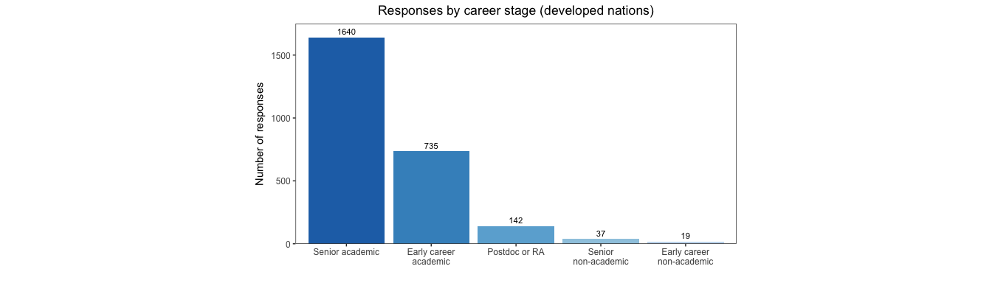

Figure 4.1 Number of survey respondents from developed nations by career stage

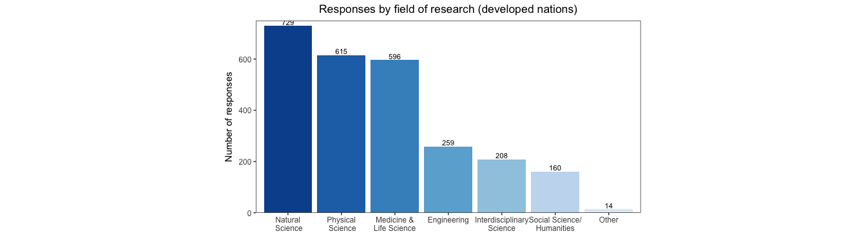

Figure 4.2 survey responses by field of research

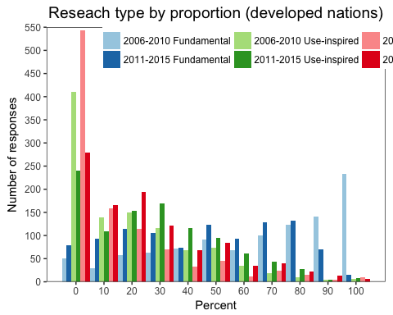

Figure 4.3 Respondents type of research describe in proportal amounts of fundamental, use-inspired and applied research. Reseachers were questioned about the percentage of funding allocated to Fundamental, Use-inspired or Applied research in the past and in their current research.

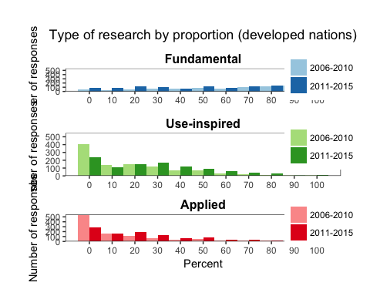

Figure 4.3 (different layout) Respondents type of research describe in proportal amounts of fundamental, use-inspired and applied research. Reseachers were questioned about the percentage of funding allocated to Fundamental, Use-inspired or Applied research in the past and in their current research.

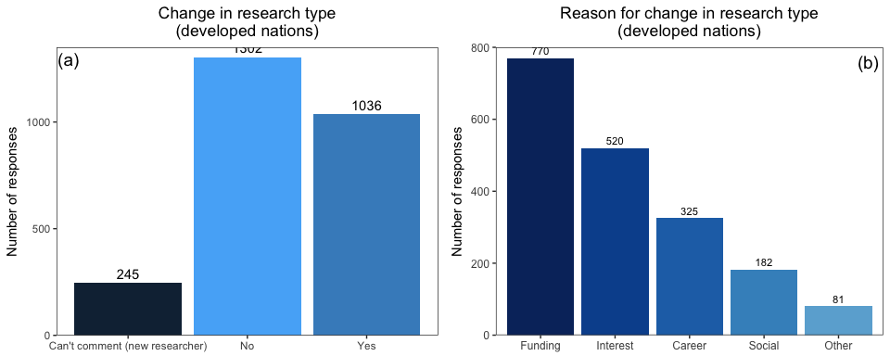

Figure 4.4a&b Change in research type proportions and the reasons. Researchers were asked to answer yes, no, or can't comment on if their type of research had changed in the last 10 years and to select what reasons for the change applied to them.

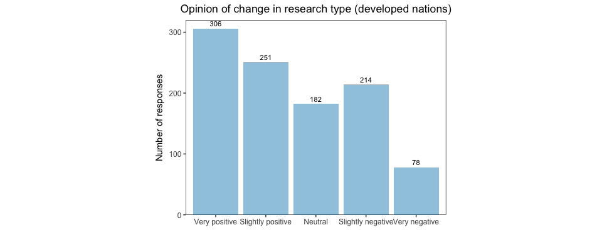

Figure 4.5 View of change in proportion of research. Researchers were asked how they viewed the change in the type of research they conduct/supervise.

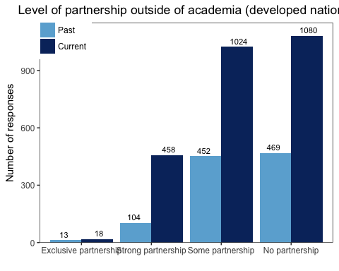

Figure 4.6 Current vs past level of partnership outside of academia. Researchers indicated the level of partnership that their current and past (10 years ago) research program had outside of academia).

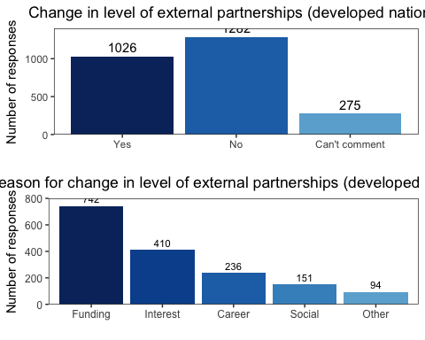

Figure 4.7a&b Did it change and reasons for change in level of external research partnerships over the past decade.

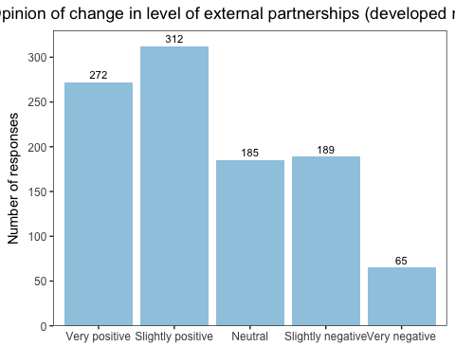

Figure 4.8 View of change in external partnerships. Researchers were asked how they viewed the change in the level of partnership with external groups.

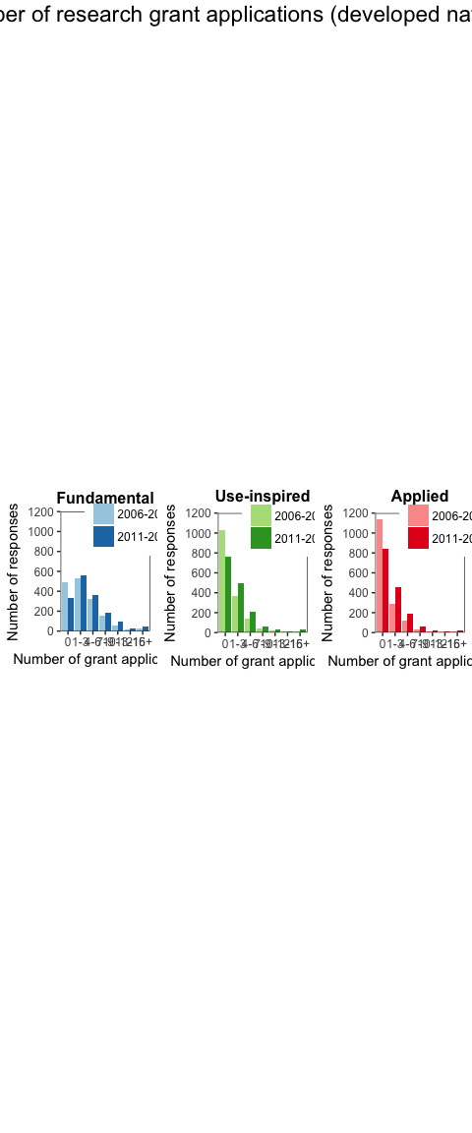

Fig. 4.9 Number of research grant applications by research category in 2006-2010 and 2011-2015.

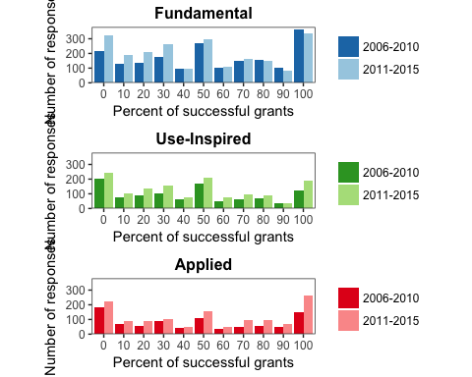

Fig 4.10 Research grant application success over the past 10 years. Researchers were asked to estimate the percentage of their research grant applications that were successful in 2006-2010 and in 2011-2015. Respondents also had the choice to answer No need for applications for this research type.

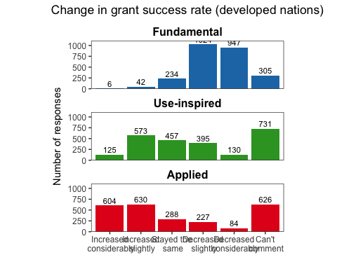

Fig 4.11 Change in grant success rates over the past 10 years. Researchers were asked if they thought that grant sucecss rates have changed in the past 10 years for each research category.

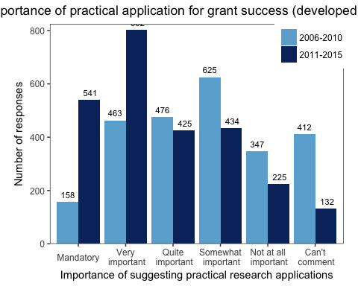

Fig 4.12 Importance of practical application of research over the past 10 years. Researchers were asked how important it was to suggest practical applications of their research to ensure that the grant was successful in 2006-2010 and in 2011-2015.

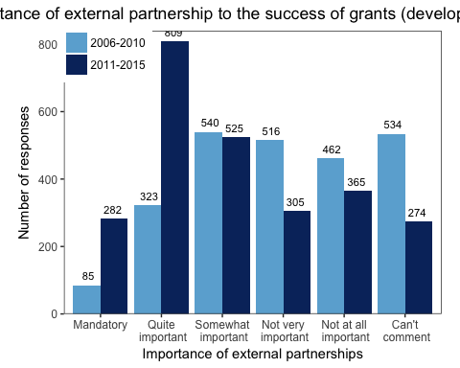

Fig 4.13 Importance of including partners from for-profit or non-governmental sectors in grant success. Researchers were asked how important it was to include external partnerships in their research to ensure that the grant was successful in 2006-2010 and in 2011-2015.

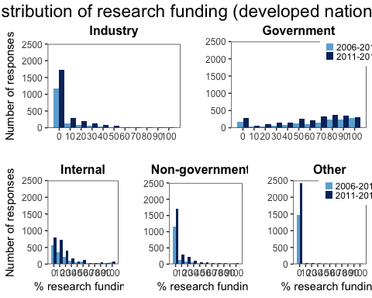

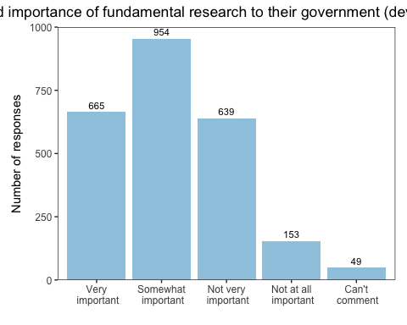

Fig 4.15 Perceived importance of fundamental research to their government. Researchers were asked how important they thought fundamental research was to the their government. Responses were/were not significantly different between genders.

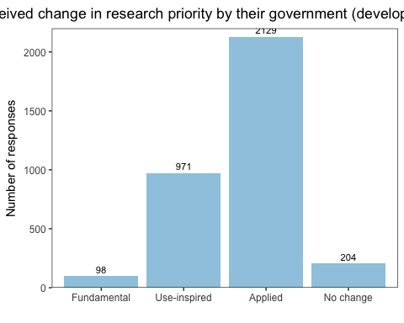

Fig 4.16 Perceived change in research priority by their government. Researchers were asked whether any types of research had become higher priority for the their government. Responses were/were not significantly different between genders.

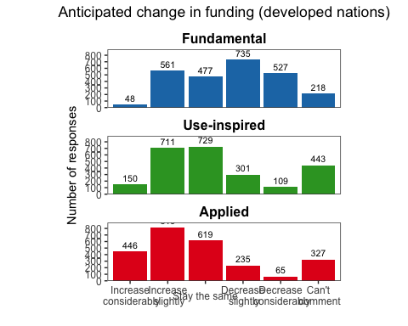

Fig 4.17 Anticipated change in research funding in next five years. Researchers were asked whether the availability of research funding would change in the next five years.

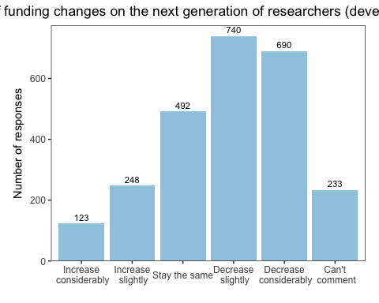

Fig 4.18 Effect of change in research funding on research careers of next generation. Researchers were asked if they though that changes in funding availability would influence the likelihood of the next generation pursuing careers in research. Responses were/were not significantly different between genders.