Canadian online survey on fundamental research

16 September 2016

**Introduction** In addition to the official data presented in Chapters 2 and 3, we also developed and ran a quantitative online survey to query researchers about their perceptions of, and experiences with, funding for fundamental research. An important aim of the survey was to provide an understanding researcher's personal experiences and outlook on the research funding landscape in Canada. We had an excellent response to the survey, with over 1300 Canadian researchers completing it, suggesting that fundamental research funding is a high priority topic for Canadian researchers. Herein, we detail the survey questions and results.

**Methods**  
Online Survey  
The survey was open to researchers from all disciplines (e.g. science, social sciences, humanities, engineering, medicine) and career stages, with the proviso that they had some experience applying for research funding. The survey gathered detailed information in four major areas: 1) the types of research the scholars conduct (fundamental, use-inspired, applied), 2) the extent of external partnerships in their research, 3) their grant success rates, and 4) how important they perceive fundamental research is to the Canadian federal government and its future prospects in Canada. The survey also enquired how each of these factors have changed over time for the researchers. Finally, the survey gathered basic information from each respondent about gender, discipline, career stage and the year their PhD was obtained. The full survey is provided in Appendix 2.

The online survey was open from the end of May through early October 2016, and ran on the Fluid Surveys platform (fluidsurveys.com). Note that the survey was open to researchers from any country in the world because it is was run as part of a global survey through the Global Young Academy. To disseminate the survey to Canadian researchers, we gathered email addresses from Canadian university websites for as many faculty members as possible and emailed individual researchers directly. We also shared the survey broadly on social media, as well as through the Global Young Academy network, on scientific list serves, and through personal connections.

Survey Data Analysis  
To extract survey responses for Canadian researchers, we selected all respondents who reported 'Canada' as their country of work, as well as those respondents who did not report a country of work (i.e. field was blank) but whose location was within Canada. We conducted all statistical analyses in the open source software R (Version 3.3.1). **Note that numbers not all the same because respondents did not always answer every question**

**Results**  
In total, 1303 Canadian researchers completed the online survey. Of these, almost three quarters were male (74%) and one quarter were female (25%); a very small proportion either did not input their gender or selected other. Almost all of the survey respondents (94%) were either senior academics (65%), defined as those researchers with more than ten years experience applying for research grants since completion of their PhD, or early career academics (29%) (Figure 4.1). A small proportion of responses also came from post-doctoral researchers (4%), non-academic researchers (2%), or those who did not indicate their career stage (0.4%).

Researchers from many different disciplines were represented in the survey. Almost sixty per cent of responses came from either the natural or physical sciences (Figure 4.2). The remaining responses were spread amongst the medical and life sciences (20%), engineering (13%), interdisciplinary research (5%), and social sciences and humanities (3%).

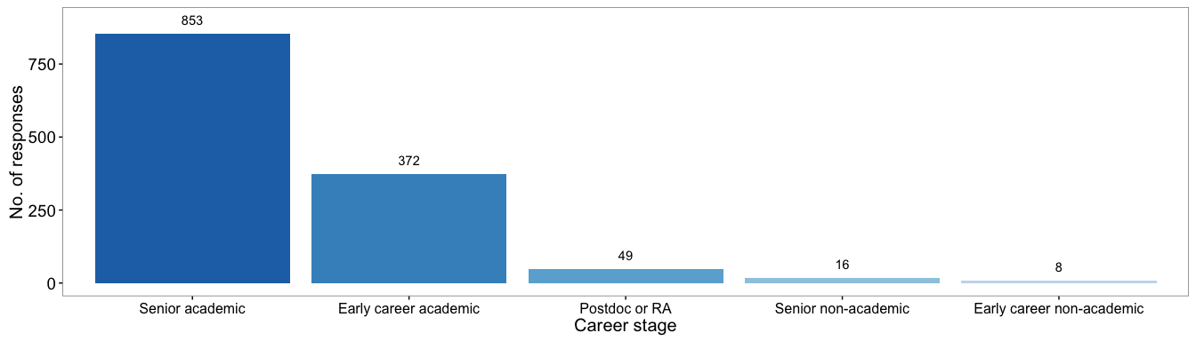

Figure 4.1 Number of Canadian survey respondents by career stage

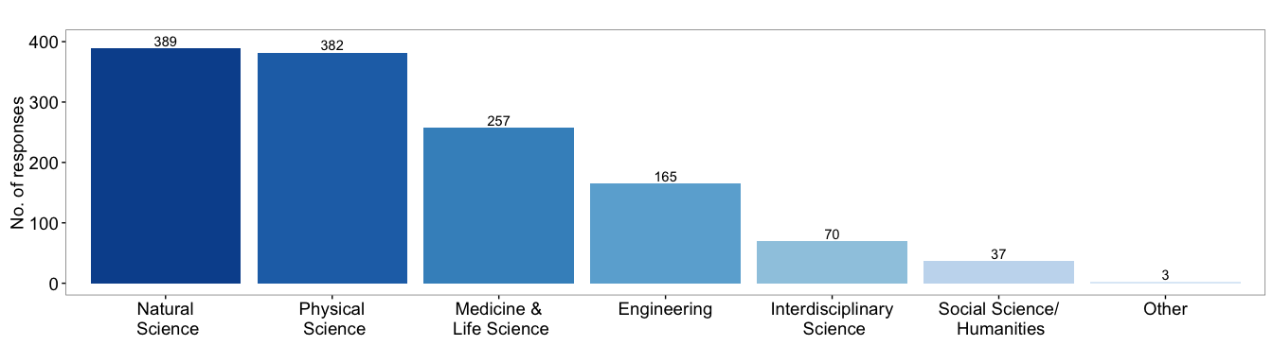

Figure 4.2 Survey responses by field of research

#### *4.1 Type of Research Conducted*

Canadian survey respondents included researchers conducting all three types of research: fundamental, use-inspired, and applied. Very few researchers (1.2%) considered themselves to currently only do one type of research: 0.1% applied, 0.3% use-inspired, 0.8% fundamental (Figure 4.3). There was a 11% drop in the number of researchers that only did fundamental research. This drop could have been caused by funding availability. Over one quarter (29%) of researchers consider that over half of their research program is in fundamental science currently. The number of researchers that consider over half of their research program is in applied science currently is 10% and in use-inspired only 9%. There should be proportionally more research funding for fundamental science than applied or use-inspired. Limited research funding was most likely the reason why there was a drop in fundamental research and an increase in both use-inspired and applied (researchers that considered 50% or more of their past research fundamental -38%, applied -6%, use-inspired - 6%).

Over one third of researchers (40%) reported that the types of research they conduct has shifted over the past ten years (Figure 4.4). By far, the most reported reason for this change was funding (45%) followed by interest (26%) (Figure 4.4). This suggests..... However, opinions about these changes were varible, with one quarter of respondents viewing them as slightly negative (25%), one quarter slightly positive (23%) and one quarter very positive (25%) (Figure 4.5). The positive feelings about these changes may be due to less stress about attaining funding.

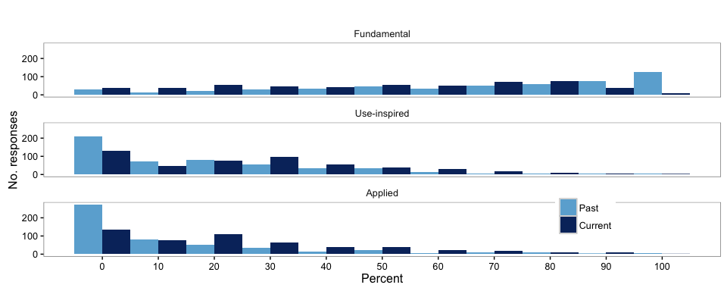

Figure 4.3 Respondents type of research describe in proportal amounts of fundamental, use-inspired and applied research. Reseachers were questioned about the percentage of funding allocated to Fundamental, Use-inspired or Applied research in the past and in their current research.

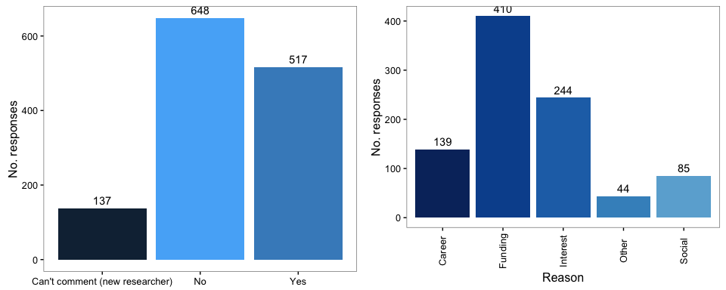

Figure 4.4 Change in research type proportions and the reasons. Researchers were asked to answer yes, no, or can't comment on if their type of research had changed in the last 10 years and to select what reasons for the change applied to them.

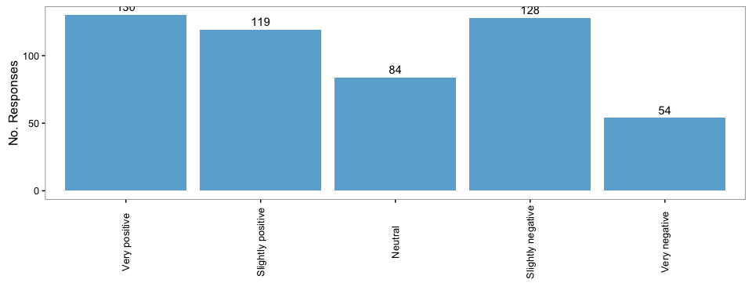

Figure 4.5 View of change in proportion of research. Researchers were asked how they viewed the change in the type of research they conduct/supervise.

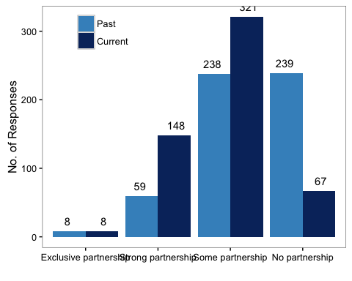

Figure 4.6 Current vs past level of partnership outside of academia. Researchers indicated the level of partnership that their current and past (10 years ago) research program had outside of academia).

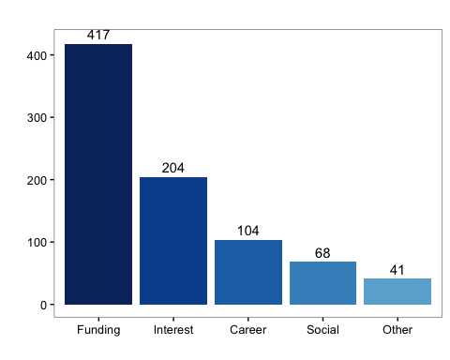

Figure 4.7 Reasons for change in level of external research partnerships over the past decade.

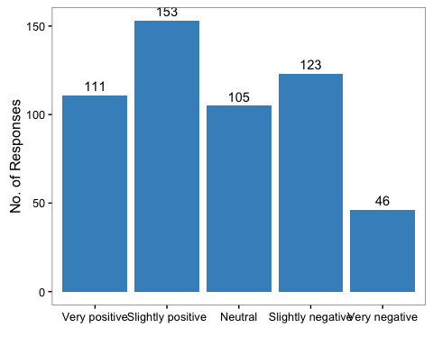

Figure 4.8 View of change in external partnerships. Researchers were asked how they viewed the change in the level of partnership with external groups.

#### *4.2 External Partnerships*

The extent to which research is conducted with partners outside of academia, including in industry and non-governmental sectors, may also be considered as an indicator of use-inspired or applied research. Almost all respondents (88%) reported that their current research includes external partners to some degree: fifty-nine per cent reported some partnerships and a further quarter (27%) reported strong partnerships (Figure 4.6). Less than 1% reported conducting their research exclusively with partners outside of academia.

Over the past decade, there has been a sharp decline in the number of researchers with no external partnerships: only 12% of respondents reported having no partnerhips in their current research program, whereas almost half of respondents (44%) reported having no partnerships in the past (Figure 4.6). The number of strong external partnerships also has increased over time from 11% to 27% (Figure 4.6).

Funding was the driving force behind the shift towards external partnerhips. Half of Canadian respondents reported that they developed external partnerships in order to secure funding (Figure 4.7). The remaining half of respondents developed partnerships out of interest (24%), or for career (12%) or social reasons (<1%) (Figure 4.7).

Perspectives on these changes were mixed (Figure 4.8). Interestly, almost half of respondents (49%) viewed the change in external partnerships as slightly or very positive. Twenty per cent were indifferent to the change and thirty-one percent of respondents viewed them as slightly or very negative.

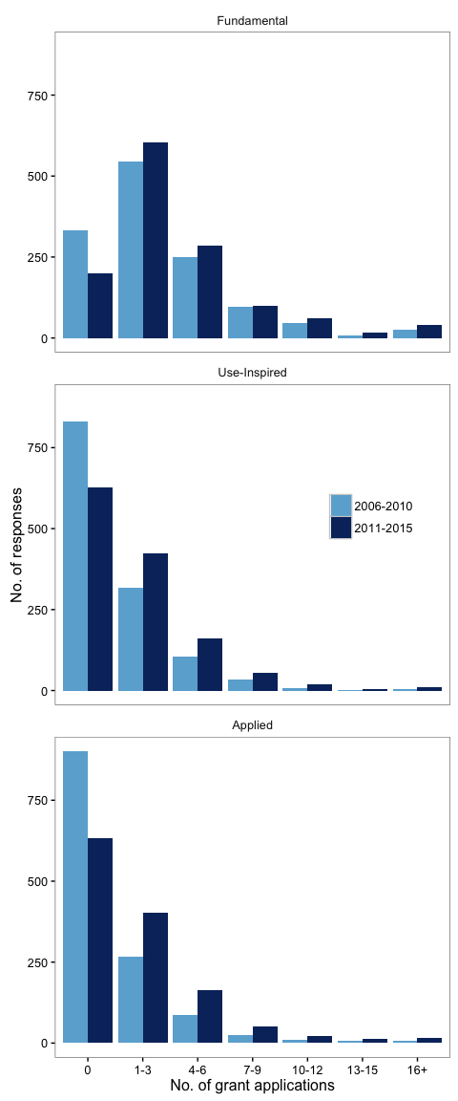

Fig. 4.9 Number of research grant applications by research category in 2006-2010 and 2011-2015.

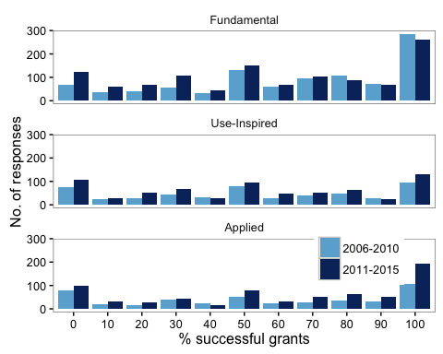

Fig 4.10 Research grant application success over the past 10 years. Researchers were asked to estimate the percentage of their research grant applications that were successful, in 2006-2010 and in 2011-2015. Respondents also had the choice to answer No need for applications for this research type.

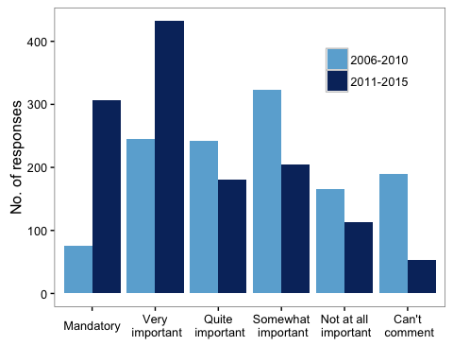

Fig 4.11 Importance of practical application of research over the past 10 years. Researchers were asked how important it was to suggest practical applications of their research to ensure that the grant was successful, in 2006-2010 and in 2011-2015.

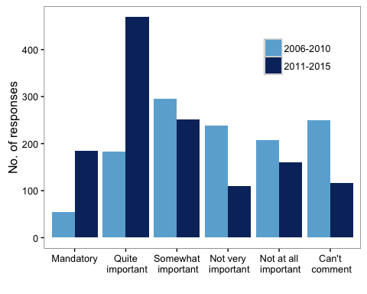

Fig 4.12 Importance of including partners from for-profit or non-governmental sectors in grant success. Researchers were asked how important it was to include external partnerships in their research to ensure that the grant was successful, in 2006-2010 and in 2011-2015.

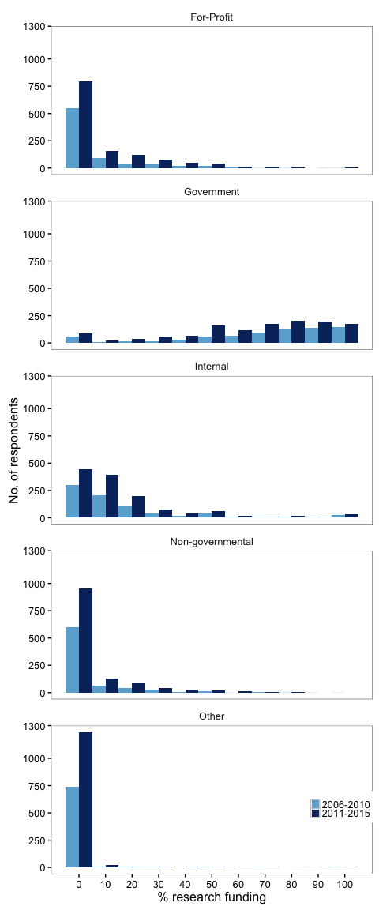

Fig 4.13 Distribution of research funding over the past 10 years. Researchers were asked to estimate the distribution of their research funding sources in 2006-2010 and 2011-2015.

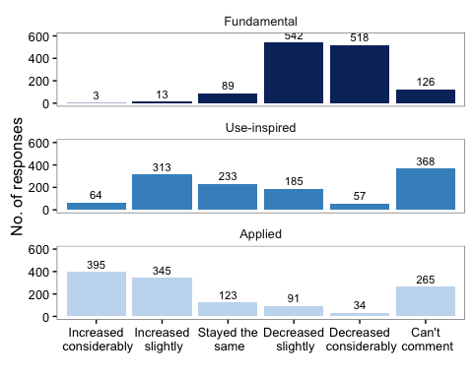

Fig 4.14 Change in grant success rates over the past 10 years. Researchers were asked if they thought that grant sucecss rates have changed in the past 10 years, for each research category.

#### *4.3 Research Grants*

There has been an overall increase in the number of grants applications (Figure 4.9). The biggest increase in number of researchers applying for one through nine applications was for Applied research grants, however the number of researchers that applied for 10+ Fundamental grants increased more than the other two. This may indicate either lower success rates and/or smaller grant values of Fundamental grants and therefore a need to apply more often for grants.  
*I have those numbers if we want to put them in*

With an increase in the number of grant applications one would expect that the success rates would decrease due to more scientists competing for the same money. This is demonstrated by a decrease in the 100% successfull (29% of total Fundamental responses to 23%) and increase in unsuccessful (7% to 11%) Fundamental grant applications (Figure 4.10). However, this is untrue for the Applied grants because there is a decrease in the unsuccessful (18% of total Applied responses to 14%) grant application and an increase for the successful grants (24% to 28%). This potentially shows an increase in available funding for this type of research compared to the funding availablity for Fundamental research. Proportionally there was no change in the responses for 0%, 50%, or 100% for the Use-Inspired grant applications.

The majority of the respondents believe that it is now either mandatory (24%) or very important (34%) to suggest practical applications of their research in order for their grant applications to be successful. This has shifted over time, with researchers reporting that between 2006 and 2010 it was only somewhat important (26%) to do so (Figure 4.11).

Similarly the shift was also seen in the belief of external partners being either mandatory (14%) or quite important (36%) for the grant application's success (Figure 4.12).

The government is the primary funding source for scientists thus the research priorities of the Canadian government can have a dramatic impact on research (Figure 4.13).

Over 80% of the respondents think that the success rate of fundamental research grant applications have decreased slightly or decreased considerably in the past ten years (Figure 4.14). Only 0.08% believe that the success rate has stayed the same or increased. The decrease in success could be due to in the increase in grant applications but there was only a 10% overall increase in Fundamental research grant applications. Applied research grant applications saw the reverse of the Fundamental research where 57% of respondents believe the success rate has improved. Use-Inspired research grant applications were in the middle but leaned more towards increased success.

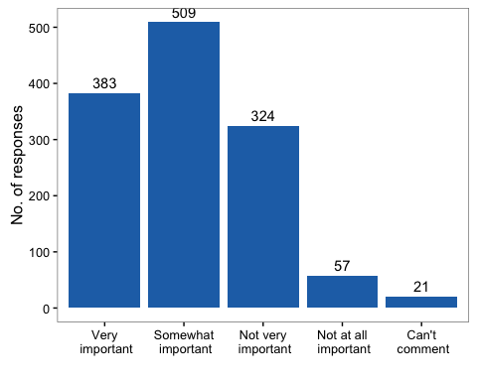

Fig 4.15 Perceived importance of fundamental research to Canadian government. Researchers were asked how important they thought fundamental research was to the Canadian government. Responses were/were not significantly different between genders.

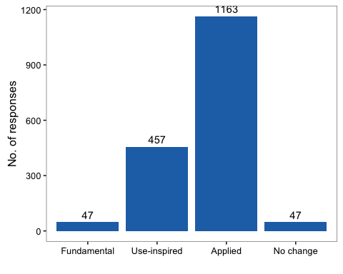

Fig 4.16 Perceived change in research priority by Canadian government. Researchers were asked whether any types of research had become higher priority for the Canadian government. Responses were/were not significantly different between genders.

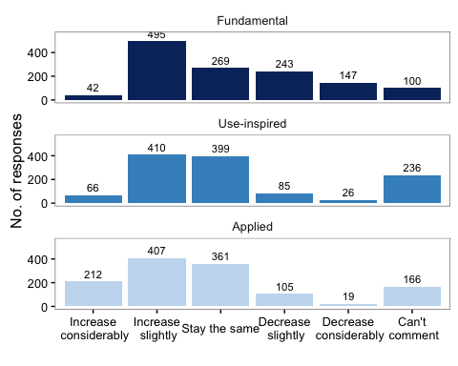

Fig 4.17 Anticipated change in research funding in next five years in Canada. Researchers were asked whether the availability of research funding would change in the next five years, for each research category. Responses were/were not significantly different between genders.

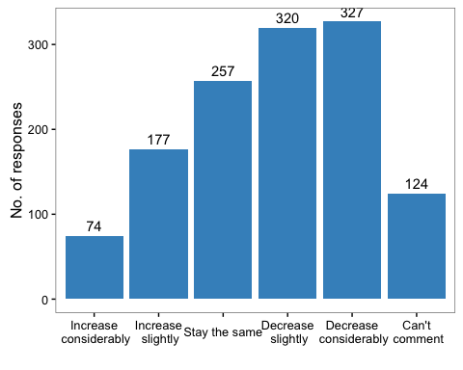

Fig 4.18 Effect of change in research funding on research careers of next generation in Canada. Researchers were asked if they though that changes in funding availability would influence the likelihood of the next generation pursuing careers in research. Responses were/were not significantly different between genders.

#### *4.4 Perspectives on the State of Fundamental Research in Canada*

Over half (69%) of Canadian researchers who responded said that fundamental research is either very important (30%) or somewhat important (39%) to our government (Figure 4.15).

At the same time, 68% of respondents said that applied research became a higher priority for our government over the past decade (Figure 4.16).

Canadians are not pessimistic about the future of research funding with the majority of respondents believing that funding will either stay the same or get better in the next five years (Figure 4.17). The change over of the government is probably encouraging this thinking. However, Applied funding still has the most optimistic outlooks. 17% of respondents think that funding for Applied research will increase considerably whereas less than 5% of respondents believe that for either Use-Inspired or Fundamental. Even with the majority of respondents thinking optimistic there was 30% of respondents that believe that funding for Fundamental research is going to decrease. This thinking may be lead by the belief that applied research has a higher priority in Canada.

Although respondents were generally optimistic about funding they are not so when it comes to thinking about the impact this will have on future generations. Half of Canadian researchers (51%) think that the likelihood of the next generation pursuing careers in research will either decrease slightly or decrease considerably (Fig 4.18).