Algoritmos
Rocio Gomez
2026-04-01

R Markdown
This is an R Markdown document. Markdown is a simple formatting syntax for authoring HTML, PDF, and MS Word documents. For more details on using R Markdown see http://rmarkdown.rstudio.com.
When you click the Knit button a document will be generated that includes both content as well as the output of any embedded R code chunks within the document. You can embed an R code chunk like this:

Primeros comandos de R
R es un lenguaje muy parecido a matlab y trabaja especialmente con variables que en general pueden ser matrices.
A=38
A=40
B=60
C=B-A
C
## [1] 20
##Uso de data sets o uso de bases de datos internos de R.
Si escribo en console data() se abre una serie de datos ya cargados en R que estan dados en tablas de las cuales podemos elegir columnas específicas si escribimos $ despues del comando de información específico.
summary(cars)
## speed dist
## Min. : 4.0 Min. : 2.00
## 1st Qu.:12.0 1st Qu.: 26.00
## Median :15.0 Median : 36.00
## Mean :15.4 Mean : 42.98
## 3rd Qu.:19.0 3rd Qu.: 56.00
## Max. :25.0 Max. :120.00

Including Plots
You can also embed plots, for example:
plot(pressure,main="presión del gas ideal", ylab="hPa",xlab="K")
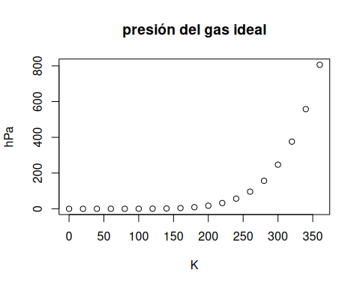
##Comando Plot Comando que permite graficar cualquier fuente de datos que le asignemos, teniendo tambien la posibiidad de asignar nombres a las variables o hacer cambios al gráfico. En caso de no saber para que sirve un comando podemos escribir ?plot en la consola y se abrirá una pestaña que nos explicará.
##Funciones estadísticas
z1<-rnorm(350,21,5)
z1
## [1] 20.141666 25.432135 22.190244 23.103608 19.172985 27.158289 20.289408
## [8] 20.797709 25.848747 25.904432 19.085933 15.041715 28.326159 24.028747
## [15] 7.976230 24.418296 26.248902 16.922774 18.589124 24.408550 34.801702
## [22] 18.045571 18.846993 10.896348 21.613088 24.276830 16.034490 23.063187
## [29] 19.031678 23.166153 34.000495 24.534237 18.099440 16.644721 18.024053
## [36] 24.162440 28.348350 12.467315 22.258861 27.043481 17.442074 15.312813
## [43] 22.226719 19.583497 10.311298 30.729678 15.050486 17.285358 14.752276
## [50] 19.439645 27.686185 13.511243 18.733526 28.891801 19.380698 26.782329
## [57] 24.525518 28.541615 14.050398 21.406751 21.995419 15.257264 17.411285
## [64] 14.666184 26.525596 23.522398 30.060279 21.431505 27.105296 14.300282
## [71] 23.830454 18.783397 29.252948 15.075693 22.767519 19.108629 19.513373
## [78] 21.667636 19.773804 15.528473 20.243921 29.668678 22.255461 20.490673
## [85] 23.206559 26.707324 13.212487 19.354635 21.439279 21.564592 13.470301
## [92] 14.827292 22.447631 32.937642 18.536729 20.327349 19.125526 28.425482
## [99] 18.264467 20.093654 29.158371 10.002844 19.516758 25.008006 17.378277
## [106] 22.553990 28.024975 22.741030 26.797809 17.836867 19.389333 30.750810
## [113] 19.670785 19.988387 19.908818 26.886282 25.283578 22.293665 21.378493
## [120] 14.399665 22.574736 20.406572 22.046243 28.351047 28.783605 12.294380
## [127] 25.193696 24.968418 18.268277 25.981791 25.528918 26.390159 14.906011
## [134] 20.349632 26.065857 14.927227 20.290810 29.890770 16.526596 10.962664
## [141] 11.184196 23.358026 25.440617 20.015457 21.844499 26.803325 15.267881
## [148] 18.783208 24.310698 19.837985 20.130953 18.949892 25.942589 8.856785
## [155] 23.995385 19.839726 20.245722 11.916772 13.384916 13.686888 17.050886
## [162] 25.330686 25.003165 21.295206 19.613277 22.063621 22.838457 19.199566
## [169] 21.528372 34.142342 15.131227 14.535692 24.961859 24.048920 26.544772
## [176] 13.919224 24.686771 25.103435 27.505398 35.846196 29.927862 18.092351
## [183] 21.335615 19.683869 22.044117 18.961212 25.998715 21.418433 11.121624
## [190] 18.879323 21.635612 22.029572 13.636531 30.175034 20.084218 25.101060
## [197] 19.045610 20.256379 27.448876 16.071651 23.127911 25.446522 19.614031
## [204] 21.309745 14.479572 18.280209 23.977099 20.382283 19.122154 31.254363
## [211] 26.486621 21.234823 19.799412 19.497949 15.467365 11.626986 16.845120
## [218] 24.445430 21.182967 20.014228 21.447690 25.237902 16.429999 21.211420
## [225] 15.493686 15.279690 20.558090 18.663109 18.486146 20.774999 24.675205
## [232] 29.029720 26.929987 23.237317 24.041253 26.378859 14.084622 21.193643
## [239] 24.566902 19.188039 24.303846 21.465196 29.140367 9.197805 23.347620
## [246] 15.097955 25.105192 14.930817 17.996124 15.734963 22.673819 15.555306
## [253] 16.975158 23.794599 22.235103 18.181697 21.145654 24.820637 32.033898
## [260] 22.176009 24.886866 21.531629 10.792329 23.914949 15.294052 22.002067
## [267] 22.296037 6.740764 24.357062 19.958647 25.074881 15.101725 21.171930
## [274] 18.446062 21.296589 16.589179 19.578673 24.091365 24.042512 26.722476
## [281] 23.548474 18.966061 19.726208 27.639227 19.375508 16.196874 20.929597
## [288] 20.288688 21.408814 22.648185 21.895390 16.268788 20.211956 22.293440
## [295] 15.883007 9.233409 16.312768 18.748309 22.369283 17.897140 35.010227
## [302] 15.678945 16.418165 15.383409 18.891808 22.221450 20.969724 24.442618
## [309] 24.548570 14.558922 18.899517 27.734400 22.996214 22.640750 19.365715
## [316] 17.598750 17.970262 21.825947 10.536314 29.021332 20.354394 30.845515
## [323] 21.064367 20.694488 27.658889 32.492848 16.551583 24.494329 17.284421
## [330] 21.941036 20.970022 16.275173 19.419120 29.246516 21.542713 22.139291
## [337] 28.464677 19.167699 25.211061 17.438339 17.929093 16.027999 18.857271
## [344] 17.731944 15.492168 21.102961 17.079325 23.483410 23.350472 20.692816
plot(z1)
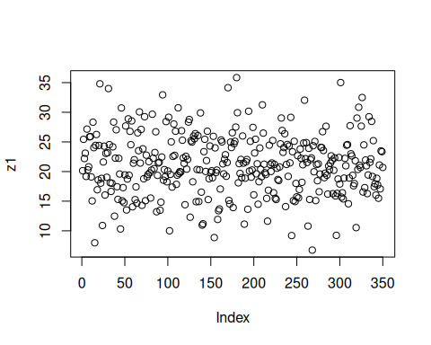
hist(z1)
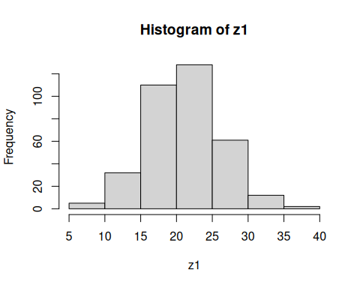
density(z1)
##
## Call:
## density.default(x = z1)
##
## Data: z1 (350 obs.); Bandwidth 'bw' = 1.339
##
## x y
## Min. : 2.724 Min. :9.933e-06
## 1st Qu.:12.009 1st Qu.:3.533e-03
## Median :21.293 Median :1.370e-02
## Mean :21.293 Mean :2.687e-02
## 3rd Qu.:30.578 3rd Qu.:4.836e-02
## Max. :39.863 Max. :8.452e-02
plot(density(z1))
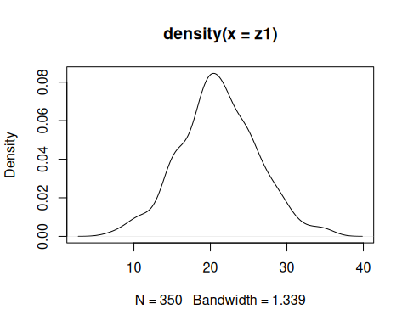
Note that the echo = FALSE parameter was added to the code chunk to prevent printing of the R code that generated the plot.

