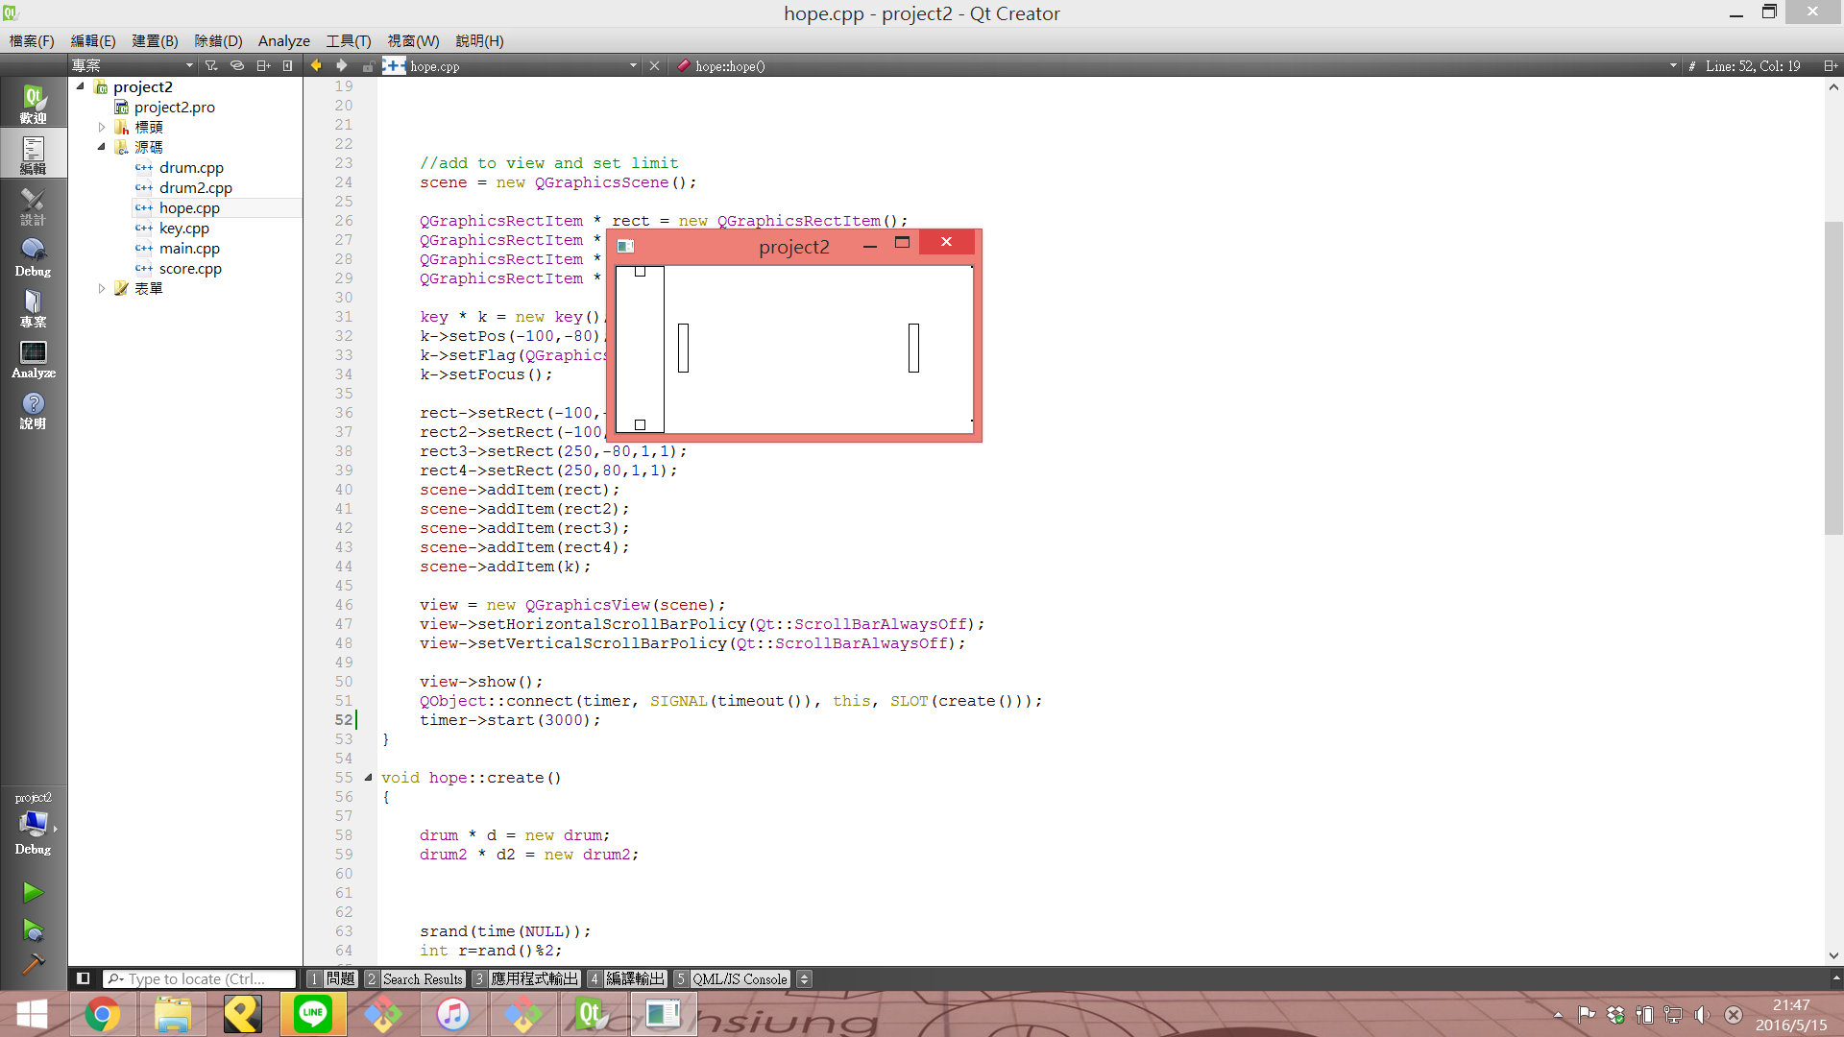

有兩種方塊

直的長方形按F消

橫的長方形按J消

|  |
| --- |
| Drum |
|  |
| +move():void  +drum() |

|  |
| --- |
| hope |
|  |
| +create():void  +hope() |

|  |
| --- |
| Drum2 |
|  |
| +move():void  +drum2() |

|  |
| --- |
| key |
|  |
| +key() |