**Group 20**



Employees Qualifications Management System

**Phase 1**

|  |  |
| --- | --- |
| ID | Name |
| 202059 | Mostafa Nassar |
| 206637 | Bavly Benyamin |
| 194233 | Farah Aymen |
| 201762 | Amro Sherif |
| 197032 | Yossuf Yasser Mohamed |

# Requirements Engineering

**Functional requirements:**

|  |  |
| --- | --- |
| Functional requirement | Description |
| Add Employee | The system shall allow adding employees. |
| Update Employee | The system shall allow updating employees’ information. |
| Remove Employee | The system shall remove employees. |
| Update Qualifications | The system must give each employee the ability to update their qualifications |
| Assign Courses | The system should assign appropriate courses to its employees on a need basis according to their skills. |
| View Profile | The system give the authority for the employees to view their own profiles and courses they are enrolled in. |

**Non-Functional requirements:**

|  |  |
| --- | --- |
| Non-functional requirement | Description |
| Reusability | The system shall work on the following operating systems: Windows 10, MacOS 10.0 and up, Arch-Linux-based systems, IOS 12.0 and up, Android 6.0 and up |
| Ease of use | Staff members shall be able to use all the system functions after 1 hours of training, the average number of errors shall not exceed 2 per hour of system use. |
| Reliability | The system must be available during normal working hours (Sun-Thu, 08:00 – 16:00), with a maximum of 20 minutes downtime/week |
| Robustness | The system shall take less than 2 minutes to restart after failure. Data must be backed up weekly to prevent data corruption following failure. |
| Speed | The system shall be able to 700 transactions per second and the response time will not exceed 0.5 second |
| Development | The system must be programmed using Java SE 16, and using MySQL as its database. |
| Legislative | Employees’ sensitive data (SSN, address, DoB, mobile number) shall be encrypted using AES to prevent the leaking of such data. |

# Context Diagram

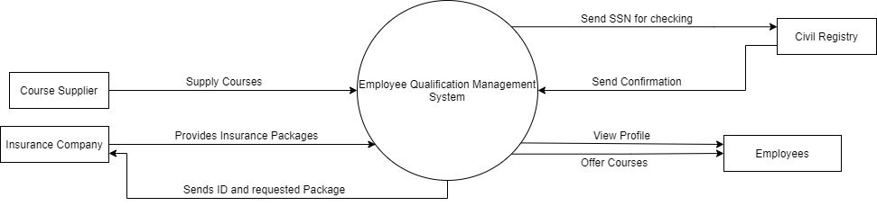

# Use case Diagram

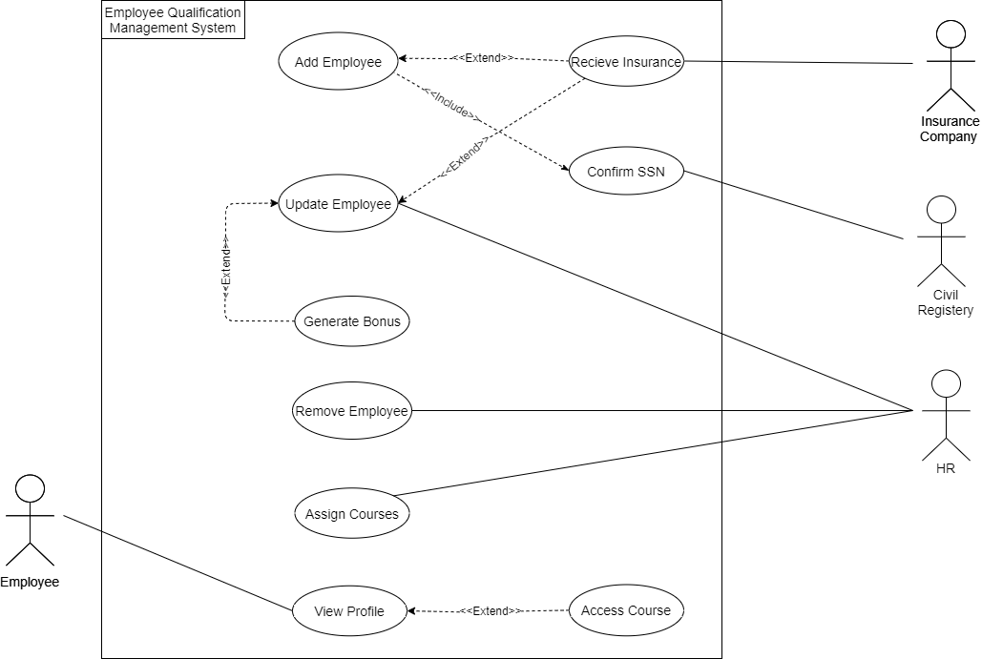

# Use case Scenarios

|  |  |
| --- | --- |
| **ID** | UC_01 |
| **Title** | Assign Courses |
| **Description** | A new skill is needed from employees in a specific department due to certain circumstances. For example, the employees have to work online instead of their offices. The system will provide courses for those who lack these skills. |
| **Priority** | Low |
| **Primary Actor** | HR |
| **Secondary Actor** | None |
| **Preconditions** | 1. HR is logged in. |
| **Post-conditions** | 1. Employees are notified by E-mail that new courses are unlocked for them. |
| **Main Success Scenario** | 1. HR enters the qualifications needed 2. HR chooses “List Employees” 3. The system goes through each employee, comparing their skills with the required ones, if the employee lacks any of them, their ID will be listed with the skills they lack. 4. The system checks the list and chooses the appropriate courses for these qualifications. 5. The HR Chooses specific course for each skill. 6. The HR Assigns Each course to Employee based on their lack for the skill. |
| **Extensions** | 6a. No employees lack the needed skills. So, the system will prompt the HR member to either try new departments, new skills, or go back to the main dashboard |

|  |  |
| --- | --- |
| **ID** | US_02 |
| **Title** | Add employee |
| **Description** | A new employee has joined the company, the HR wants to add the information of the employee to the system. |
| **Priority** | High |
| **Primary Actor** | HR |
| **Secondary Actor** | Civil Registry |
| **Preconditions** | * HR must be logged in. |
| **Post-Conditions** | * A new employee is added. |
| **Main Success Scenario** | 1. The HR select “add employee”.   2. A form is displayed asking for the name / Ssn/ date of birth/ address/ qualifications/ position/ mobile number/ department/ starting date.  3. The HR enter the information of the employee into the form.  4. The HR clicks on “Add employee” button. |
| **Extensions** | 3b. The HR enters invalid input for example, entering characters into Ssn field instead of numbers, the system notifies the HR that he entered an invalid input and prompt him to enter a valid input.  3c. the Ssn of the employee already exists, the system will notify him that the employee is already exists in the company. |

|  |  |
| --- | --- |
| **ID** | US_03 |
| **Title** | Remove Employee |
| **Description** | An employee has left the company, the HR wants to remove the record of this employee. |
| **S7Priority** | Medium |
| **Primary Actor** | HR |
| **Secondary Actor** | N/A |
| **Preconditions** | * HR must be logged in. * If the HR wants to remove employee, this employee must exist in the system. |
| **Post-Conditions** | * An existing employee is removed. |
| **Main Success Scenario** | 1. The HR select remove employee.   1. The HR enters the ID of the employee. 2. The HR clicks on “Delete employee” button. |
| **Extensions** | 2.a. The HR enters invalid ID for example, entering characters into ID field instead of numbers, the system notifies the HR that he entered an invalid ID. |

|  |  |
| --- | --- |
| **ID** | US_04 |
| **Title** | Update Employee |
| **Description** | There has been a change in one of the details of a specific employee for example, one of the employees changed his/her address or phone number, the HR wants to update his/her information. |
| **S7Priority** | High |
| **Primary Actor** | HR |
| **Secondary Actor** | N/A |
| **Preconditions** | * HR must be logged in. * If the HR wants to update employee, this employee must exist in the system. |
| **Post-Conditions** | * An existing employee is updated. |
| **Main Success Scenario** | 1. The HR select update employee. 2. The HR enters the ID of the employee. 3. The HR sees the information of the employee. 4. The HR selects a certain field that he wants to change. 5. The HR enters the new value to the field. 6. The HR clicks on “Submit” button. |
| **Extensions** | 2a. The HR enters invalid ID for example, entering characters into ID field instead of numbers, the system notifies the HR that he entered an invalid ID.  2b. The HR enters an ID which already exists, the system notifies the HR that he entered an invalid ID. |

# Activity Diagrams

-Assign Courses-

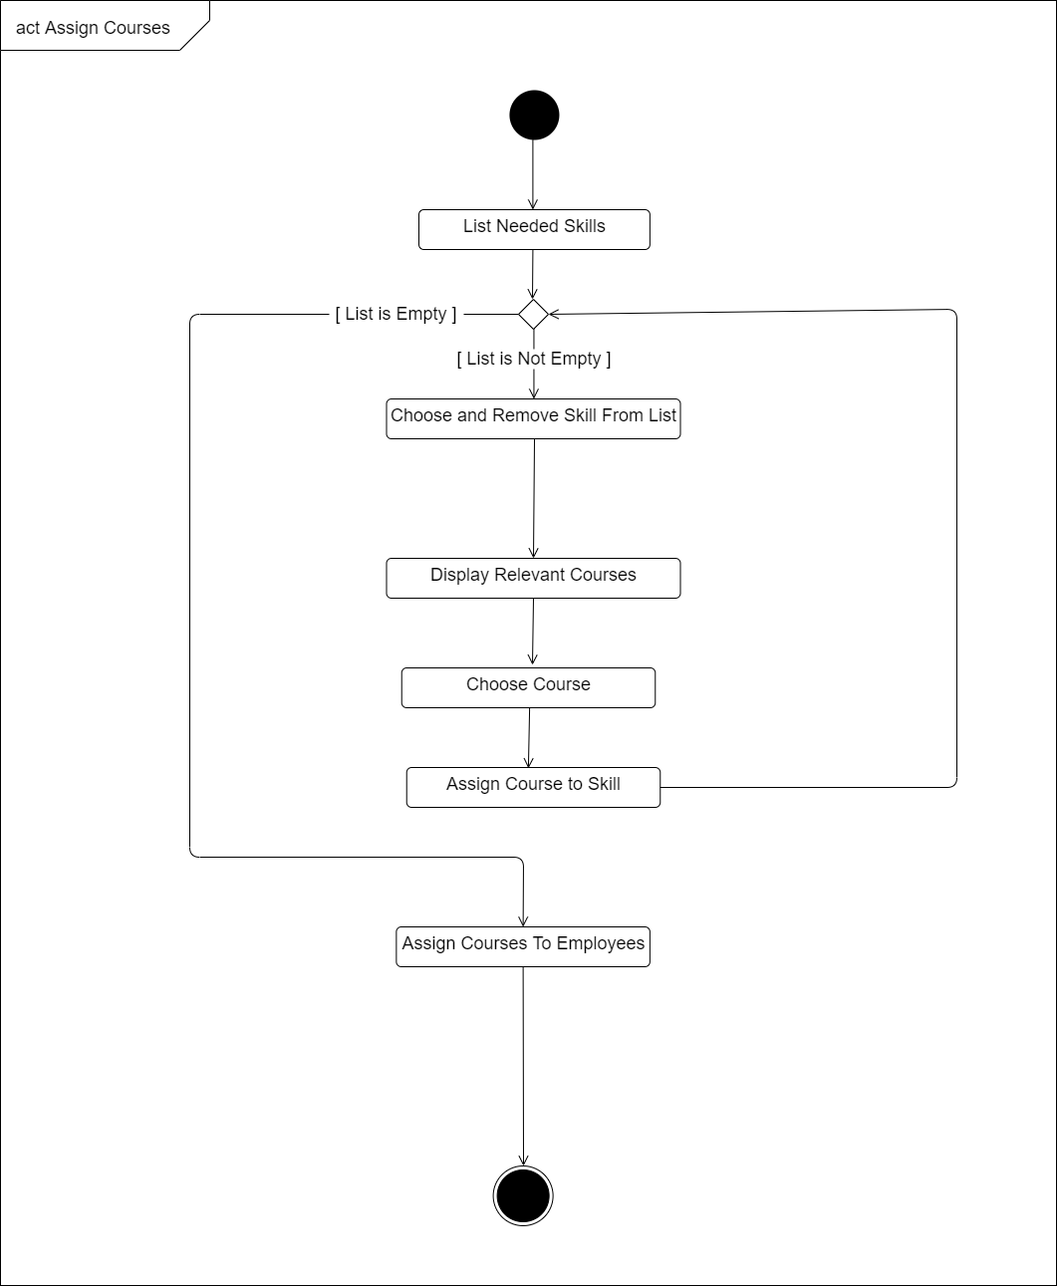

-Add Employee-

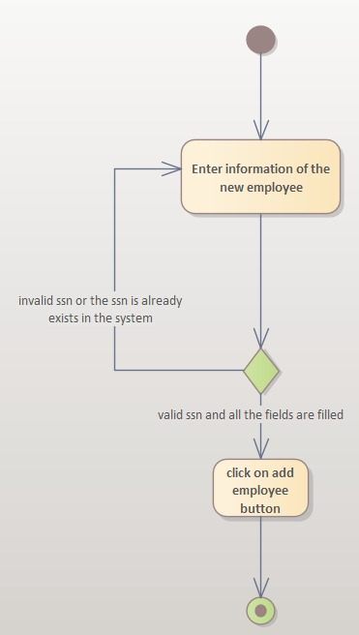

-Update Employee-

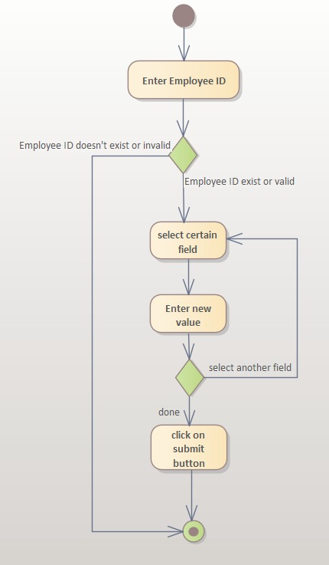

# Sequence Diagrams

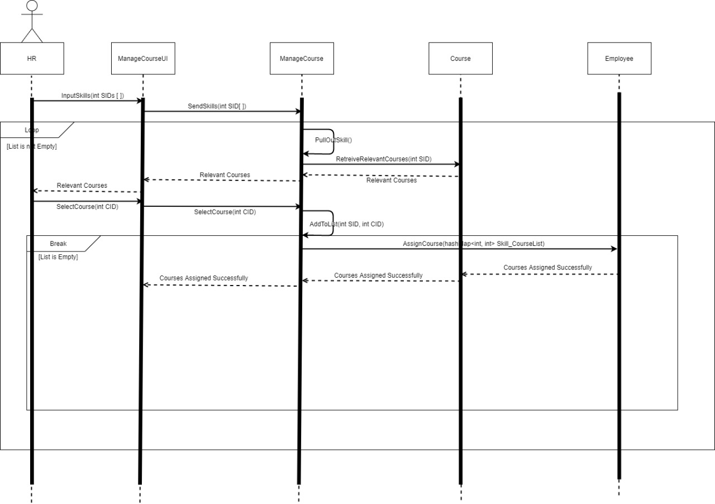-Assign Courses-

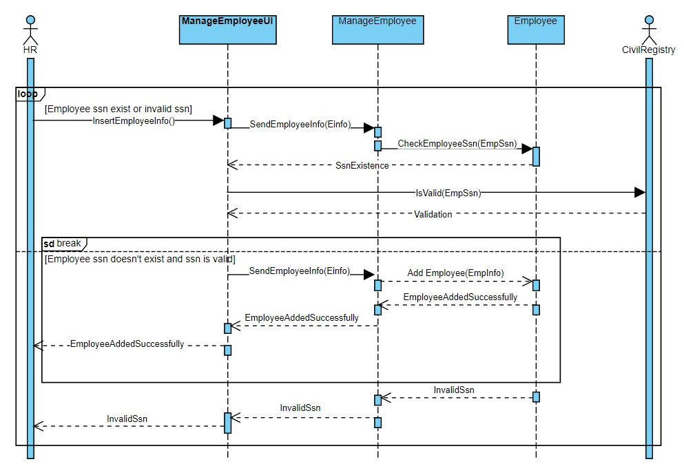-Add Employee-

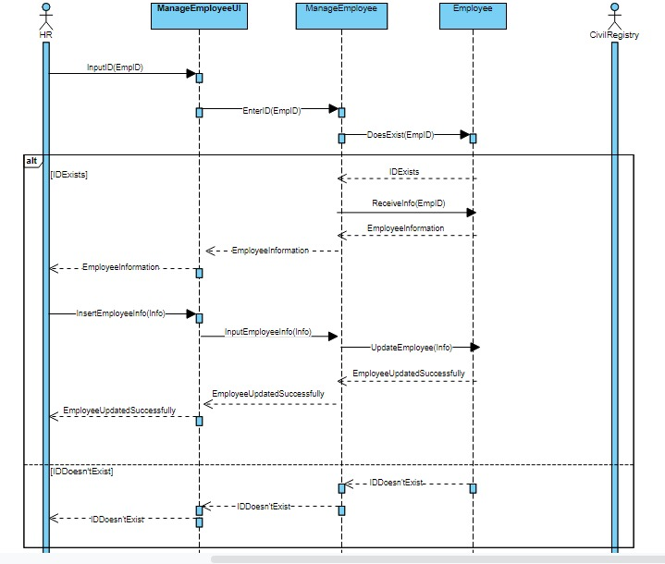-Update Employee-

# Class Diagram

# Database Schema

Employee

|  |  |  |  |  |  |  |  |  |  |  |
| --- | --- | --- | --- | --- | --- | --- | --- | --- | --- | --- |
| ID  Skill | Ssn | Name | Address | PhoneNo | Gender | Bonus | EmployementDate | DateOfBirth | JobID | InsuranceID |

|  |  |  |  |
| --- | --- | --- | --- |
| ID | Title | Description | Bonus |

Skill_Course

|  |  |
| --- | --- |
| SID | CID |

Employee_Skills

|  |  |  |  |
| --- | --- | --- | --- |
| EID | SID | CID | Completed |

Course

|  |  |  |  |
| --- | --- | --- | --- |
| ID | Title | Description | Price |

Enroll

JobTitle

|  |  |  |
| --- | --- | --- |
| EID | CID | DateOfEnrolment |

|  |  |  |  |
| --- | --- | --- | --- |
| ID | Title | Salary | Description |

Qualification

|  |  |  |
| --- | --- | --- |
| ID | Degree | Field |

GraduatedWith

|  |  |  |
| --- | --- | --- |
| EID | QID | Institution |

Achievement

|  |  |  |  |
| --- | --- | --- | --- |
| ID | Title | Description | BonusValue |

Achieve

|  |  |  |
| --- | --- | --- |
| EID | AID | DateOfAchievement |

insurancePackage

|  |  |  |
| --- | --- | --- |
| ID | Title | Description |