**Group 20**



Employees Qualifications Management System

**FINAL PROJECT REPORT**

|  |  |
| --- | --- |
| ID | Name |
| 202059 | Mostafa Nassar |
| 206637 | Bavly Benyamin |
| 194233 | Farah Aymen |
| 201762 | Amro Sherif |
| 197032 | Yossuf Yasser Mohamed |

# Requirements Engineering

**Functional requirements:**

|  |  |
| --- | --- |
| Functional requirement | Description |
| Add Employee | The system shall allow adding employees. |
| Update Employee | The system shall allow updating employees’ information. |
| Update Qualifications | The system must give each employee the ability to update their qualifications |
| Assign Courses | The system should assign appropriate courses to its employees on a need basis according to their skills. |
| View Profile | The system give the authority for the employees to view their own profiles and courses they are enrolled in. |

**Non-Functional requirements:**

|  |  |
| --- | --- |
| Non-functional requirement | Description |
| Reusability | The system shall work on the following operating systems: Windows 10, MacOS 10.0 and up, Arch-Linux-based systems, IOS 12.0 and up, Android 6.0 and up |
| Ease of use | Staff members shall be able to use all the system functions after 1 hours of training, the average number of errors shall not exceed 2 per hour of system use. |
| Reliability | The system must be available during normal working hours (Sun-Thu, 08:00 – 16:00), with a maximum of 20 minutes downtime/week |
| Robustness | The system shall take less than 2 minutes to restart after failure. Data must be backed up weekly to prevent data corruption following failure. |
| Speed | The system shall be able to 700 transactions per second and the response time will not exceed 0.5 second |
| Development | The system must be programmed using Java SE 16, and using MySQL as its database. |
| Legislative | Employees’ sensitive data (SSN, address, DoB, mobile number) shall be encrypted using AES to prevent the leaking of such data. |

# Context Diagram

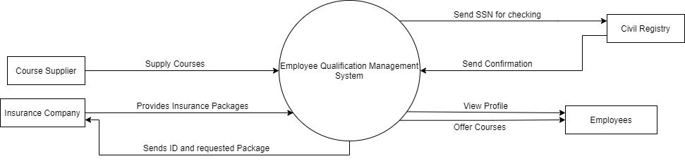

# Use case Diagram

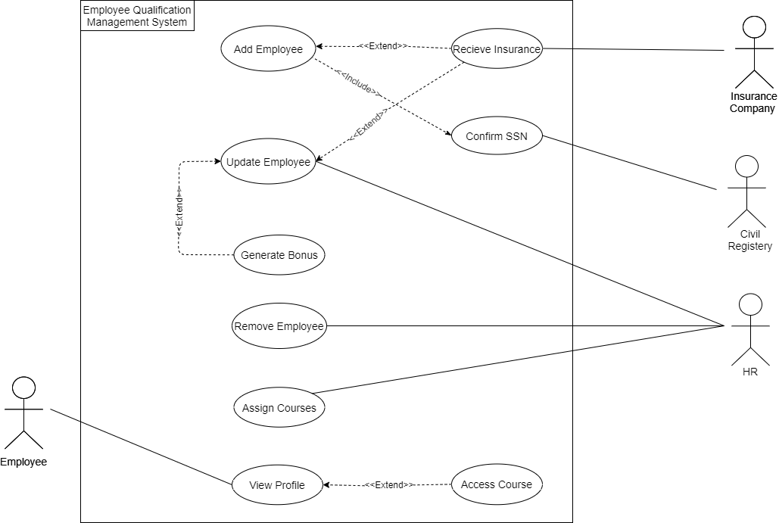

# Use case Scenarios

|  |  |
| --- | --- |
| **ID** | UC_01 |
| **Title** | Assign Courses |
| **Description** | A new skill is needed from employees to certain circumstances. For example, the employees have to work online instead of their offices. The system will provide courses for those who lack these skills. |
| **Priority** | Low |
| **Primary Actor** | HR |
| **Secondary Actor** | None |
| **Preconditions** | 1. HR is logged in. |
| **Post-conditions** | 1. Employees are notified by E-mail that new courses are unlocked for them. |
| **Main Success Scenario** | 1. HR enters the skills needed 2. HR chooses “List Employees” 3. The system goes through each employee, comparing their skills with the required ones, if the employee lacks any of them, their ID will be listed with the skills they lack. 4. The system checks the list and chooses the appropriate courses for these skills. 5. The HR Chooses specific course for each skill. 6. The HR Assigns Each course to Employee based on their lack for the skill. |
| **Extensions** | 1a. If HR entered a wrong skill ID, the system prompts him to replace the ID or remove it. |

|  |  |
| --- | --- |
| **ID** | US_02 |
| **Title** | Add employee |
| **Description** | A new employee has joined the company, the HR wants to add the information of the employee to the system. |
| **Priority** | High |
| **Primary Actor** | HR |
| **Secondary Actor** | Civil Registry |
| **Preconditions** | * HR must be logged in. |
| **Post-Conditions** | * A new employee is added. |
| **Main Success Scenario** | 1. The HR select “add employee”.   2. A form is displayed asking for the name / Ssn/ date of birth/ address/ qualifications/ position/ mobile number/ department/ starting date.  3. The HR enter the information of the employee into the form.  4. The HR clicks on “Add employee” button. |
| **Extensions** | 3b. The HR enters invalid input for example, entering characters into Ssn field instead of numbers, the system notifies the HR that he entered an invalid input and prompt him to enter a valid input.  3c. the Ssn of the employee already exists, the system will notify him that the employee is already exists in the company. |

|  |  |
| --- | --- |
| **ID** | US_03 |
| **Title** | Remove Employee |
| **Description** | An employee has left the company, the HR wants to remove the record of this employee. |
| **S7Priority** | Medium |
| **Primary Actor** | HR |
| **Secondary Actor** | N/A |
| **Preconditions** | * HR must be logged in. * If the HR wants to remove employee, this employee must exist in the system. |
| **Post-Conditions** | * An existing employee is removed. |
| **Main Success Scenario** | 1. The HR select remove employee.   1. The HR enters the ID of the employee. 2. The HR clicks on “Delete employee” button. |
| **Extensions** | 2.a. The HR enters invalid ID for example, entering characters into ID field instead of numbers, the system notifies the HR that he entered an invalid ID. |

|  |  |
| --- | --- |
| **ID** | US_04 |
| **Title** | Update Employee |
| **Description** | There has been a change in one of the details of a specific employee for example, one of the employees changed his/her address or phone number, the HR wants to update his/her information. |
| **S7Priority** | High |
| **Primary Actor** | HR |
| **Secondary Actor** | N/A |
| **Preconditions** | * HR must be logged in. * If the HR wants to update employee, this employee must exist in the system. |
| **Post-Conditions** | * An existing employee is updated. |
| **Main Success Scenario** | 1. The HR select update employee. 2. The HR enters the ID of the employee. 3. The HR sees the information of the employee. 4. The HR selects a certain field that he wants to change. 5. The HR enters the new value to the field. 6. The HR clicks on “Submit” button. |
| **Extensions** | 2a. The HR enters invalid ID for example, entering characters into ID field instead of numbers, the system notifies the HR that he entered an invalid ID.  2b. The HR enters an ID which already exists, the system notifies the HR that he entered an invalid ID. |

# Activity Diagrams

-Assign Courses-

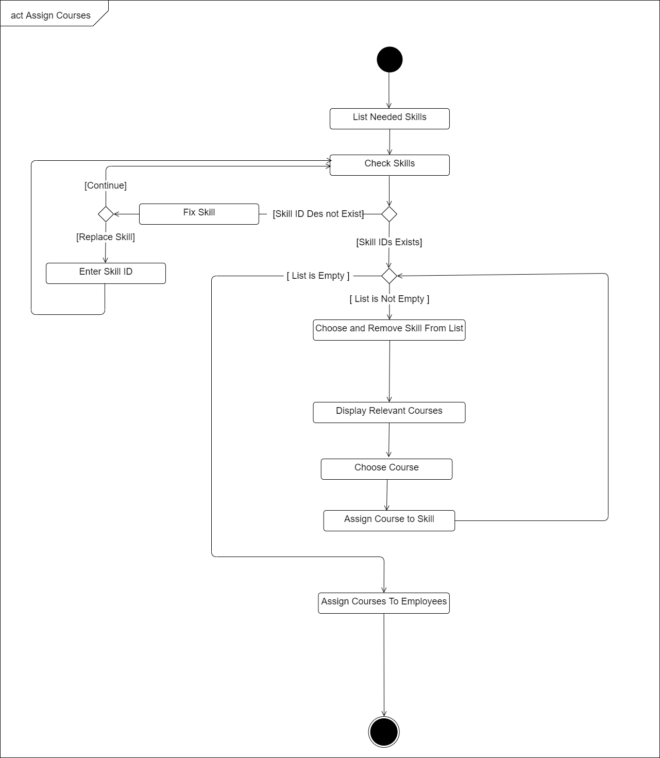

-Add Employee-

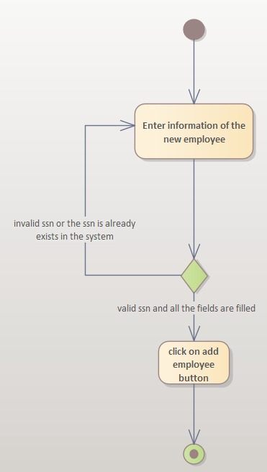

-Update Employee-

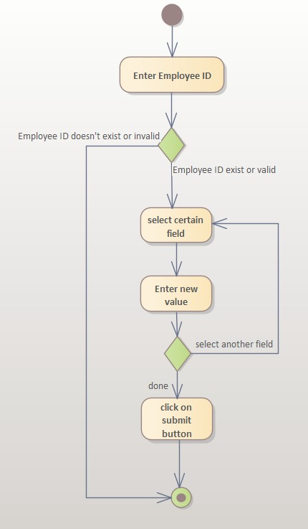

# Sequence Diagrams

-Assign Courses-

-Add Employee-

-Update Employee-

# Class Diagram

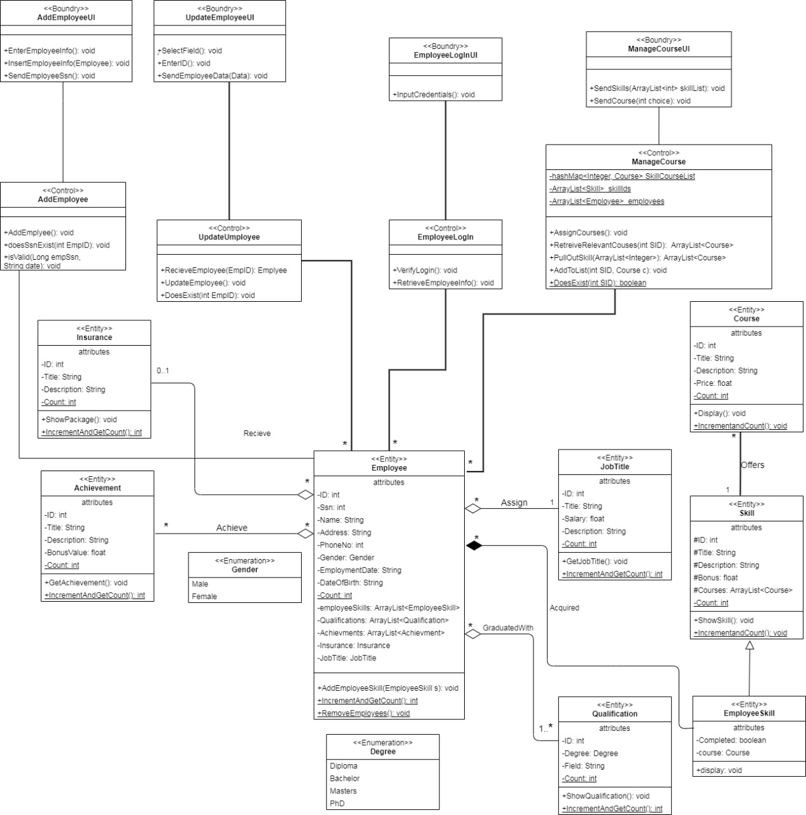

# Database Schema

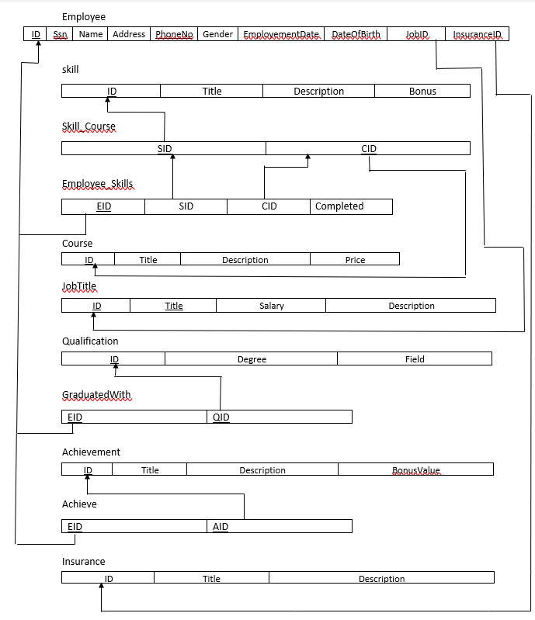

# Database Code

CREATE TABLE "JobTitle"(

"id" INT primary key

GENERATED ALWAYS AS IDENTITY

(START WITH 300001, INCREMENT BY 1),

"title" VARCHAR(100),

"salary" DECIMAL,

"description" VARCHAR(1000)

);

CREATE TABLE "Skill"

(

"id" INT not null primary key

GENERATED ALWAYS AS IDENTITY

(START WITH 400001, INCREMENT BY 1),

"title" VARCHAR(100),

"description" VARCHAR(1000),

"bonus" DECIMAL

);

CREATE TABLE "Course"

(

"id" INT not null primary key

GENERATED ALWAYS AS IDENTITY

(START WITH 500001, INCREMENT BY 1),

"title" VARCHAR(100),

"description" VARCHAR(1000),

"price" DECIMAL,

"sid" INT,

CONSTRAINT "Skill_FK" FOREIGN KEY ("sid") REFERENCES "Skill"("id")

);

CREATE TABLE "Achievement"(

"id" INT primary key

GENERATED ALWAYS AS IDENTITY

(START WITH 600001, INCREMENT BY 1),

"title" VARCHAR(100),

"description" VARCHAR(1000),

"bonusValue" DECIMAL

);

CREATE TABLE "Insurance"(

"id" INT primary key

GENERATED ALWAYS AS IDENTITY

(START WITH 700001, INCREMENT BY 1),

"title" VARCHAR(100),

"description" VARCHAR(1000)

);

CREATE TABLE "Employee"(

"id" INT primary key

GENERATED ALWAYS AS IDENTITY

(START WITH 100001, INCREMENT BY 1),

"ssn" BIGINT UNIQUE,

"name" VARCHAR(50),

"address" VARCHAR(100),

"phoneNo" BIGINT,

"gender" VARCHAR(10), --ENUM

"employmentDate" DATE,

"dateOfBirth" DATE,

"jobId" INT,

"insuranceId" INT,

CONSTRAINT "FK_Job_Title" FOREIGN KEY ("jobId") REFERENCES "JobTitle"("id"),

CONSTRAINT "FK_Insurance" FOREIGN KEY ("insuranceId") REFERENCES "Insurance"("id")

);

CREATE TABLE "Achieve"(

"eid" INT,

"aid" INT,

CONSTRAINT "PK_Emp_Acheivement" PRIMARY KEY ("eid", "aid"),

CONSTRAINT "FK_Employee" FOREIGN KEY("eid") REFERENCES "Employee"("id"),

CONSTRAINT "FK_Achievement" FOREIGN KEY("aid") REFERENCES "Achievement"("id")

);

CREATE TABLE "Employee_Skills"(

"eid" INT,

"sid" INT,

"cid" INT,

"completed" BOOLEAN,

CONSTRAINT "PK_Employee_Skill" PRIMARY KEY ("eid","sid"),

CONSTRAINT "FK_EmpSkill" FOREIGN KEY ("sid") REFERENCES "Skill"("id"),

CONSTRAINT "FK_EmpCourse" FOREIGN KEY ("cid") REFERENCES "Course"("id"),

CONSTRAINT "FK_EmpID" FOREIGN KEY ("eid") REFERENCES "Employee"("id")

);

CREATE TABLE "Qualification"(

"id" INT primary key

GENERATED ALWAYS AS IDENTITY

(START WITH 200001, INCREMENT BY 1),

"degree" VARCHAR(20),

"specialization" VARCHAR(100)

);

CREATE TABLE "GraduatedWith"(

"eid" INT,

"qid" INT,

CONSTRAINT "PK_Graduate" PRIMARY KEY ("eid", "qid"),

CONSTRAINT "FK_EmpId" FOREIGN KEY ("eid") REFERENCES "Employee"("id"),

CONSTRAINT "FK_Qualification" FOREIGN KEY ("qid") REFERENCES "Qualification"("id")

);

INSERT INTO "Skill"

VALUES(DEFAULT, 'Business Analysis', 'Lorem ipsum dolor sit amet, consectetur adipiscing elit, sed do eiusmod tempor incididunt ut labore et dolore magna aliqua. ', 1500);

INSERT INTO "Skill"

VALUES(DEFAULT, 'Data Science', 'Lorem ipsum dolor sit amet, consectetur adipiscing elit, sed do eiusmod tempor incididunt ut labore et dolore magna aliqua. Lacus vel facilisis volutpat est velit egestas', 3000);

INSERT INTO "Skill"

VALUES(DEFAULT, 'Programming Language c++', 'Lorem ipsum dolor sit amet, consectetur adipiscing elit, sed do eiusmod tempor incididunt ut labore et dolore magna aliqua. Et ligula ullamcorper malesuada proin libero nunc consequat interdum varius', 1800);

INSERT INTO "Skill"

VALUES(DEFAULT, 'Artificial Intelligence', 'Lorem ipsum dolor sit amet, consectetur adipiscing elit, sed do eiusmod tempor incididunt ut labore et dolore magna aliqua. Ornare quam viverra orci sagittis eu volutpat', 2500);

INSERT INTO "Skill"

VALUES(DEFAULT, 'Software Development', 'Lorem ipsum dolor sit amet, consectetur adipiscing elit, sed do eiusmod tempor incididunt ut labore et dolore magna aliqua. Aliquet nibh praesent tristique magna sit amet purus gravida', 2000);

INSERT INTO "Course"

VALUES(DEFAULT, 'An Introduction to Artificial Intelligence', 'Deduce how to gain strategic advantage through the use of different kinds of intelligence.', 1000, 400001 );

INSERT INTO "Course"

VALUES(DEFAULT,'Machine Learning in Business', 'Evaluate the appropriateness of a business application for machine learning', 1500, 400001);

INSERT INTO "Course"

VALUES(DEFAULT, 'Natural Language Processing in Business', 'Evaluate the appropriateness of a business application for natural language processing', 2000, 400002);

INSERT INTO "Course"

VALUES(DEFAULT, 'Introduction to Probability and Data with R', 'his course introduces you to sampling and exploring data, as well as basic probability theory and Bayes rule', 1700, 400003);

INSERT INTO "Course"

VALUES(DEFAULT, 'Bayesian Statistics: Techniques and Models', 'This is the second of a two-course sequence introducing the fundamentals of Bayesian statistics.', 1100, 400003);

INSERT INTO "JobTitle"

VALUES(DEFAULT,'Software engineer ',30000, 'sociis natoque penatibus et magnis dis. Vel eros donec ac odio tempor orci dapibus ultrices. Commodo ullamcorper a lacus vestibulum sed arcu non ');

INSERT INTO "JobTitle"

VALUES(DEFAULT,'Data Scientist', 35000 , 'Sollicitudin nibh sit amet commodo nulla facilisi nullam vehicula. Augue interdum velit euismod in pellentesque massa placerat duis ');

INSERT INTO "JobTitle"

VALUES(DEFAULT,'Information Security Analyst' , 25000 , 'eu mi bibendum neque egestas congue. Pretium viverra suspendisse potenti nullam. Scelerisque viverra mauris in aliquam ');

INSERT INTO "JobTitle"

VALUES(DEFAULT,'Web Developer' , 20000 , 'bibendum neque egestas congue quisque. Leo integer malesuada nunc vel risus commodo viverra maecenas. Lacinia at quis risus sed vulputate ');

INSERT INTO "JobTitle"

VALUES(DEFAULT,'Computer Research Scientist', 32000 , 'Lorem ipsum dolor sit amet consectetur adipiscing elit ut aliquam. Aliquet nibh praesent tristique magna sit amet purus gravida quis ');

INSERT INTO "Achievement"

VALUES(DEFAULT,'Lorem ipsum', 'risus commodo viverra maecenas. Lacinia at quis risus sed vulputate. Lorem ipsum dolor sit amet consectetur adipiscing elit ut aliquam ', 1500);

INSERT INTO "Achievement"

VALUES(DEFAULT,'dolor sit amet', 'Aliquet nibh praesent tristique magna sit amet purus gravida quis. Id volutpat lacus laoreet non curabitur gravida arcu ac tortor ', 2000);

INSERT INTO "Achievement"

VALUES(DEFAULT,'augue interdum', 'Pretium viverra suspendisse potenti nullam. Scelerisque viverra mauris in aliquam', 2500);

INSERT INTO "Achievement"

VALUES(DEFAULT,'tortor posuere', 'eget mi proin. Penatibus et magnis dis parturient. Nec feugiat nisl pretium fusce id velit ut tortor pretium. Luctus accumsan', 3000);

INSERT INTO "Achievement"

VALUES(DEFAULT,'potenti nullam', 'Lorem ipsum dolor sit amet, consectetur adipiscing elit, sed do eiusmod tempor incididunt ut labore et dolore magna aliqua. Sed faucibus turpis', 4000);

INSERT INTO "Insurance"

VALUES(DEFAULT,'A', 'Lorem ipsum dolor sit amet, consectetur adipiscing elit, sed do eiusmod tempor incididunt ut labore et dolore magna aliqua');

INSERT INTO "Insurance"

VALUES(DEFAULT,'B', 'Lobortis scelerisque fermentum dui faucibus in ornare quam viverra orci. Ut eu sem integer vitae. Iaculis at erat pellentesque adipiscing commodo');

INSERT INTO "Insurance"

VALUES(DEFAULT,'C', 'nulla porttitor massa. Mollis nunc sed id semper risus in hendrerit gravida. Massa vitae tortor condimentum lacinia quis vel eros donec ac');

INSERT INTO "Insurance"

VALUES(DEFAULT,'D', 'pretium lectus. Enim nec dui nunc mattis. Sed id semper risus in hendrerit gravida rutrum. Ac tortor vitae purus faucibus ornare suspendisse');

INSERT INTO "Insurance"

VALUES(DEFAULT,'E', 'Amet cursus sit amet dictum sit amet. Proin fermentum leo vel orci porta non pulvinar neque. Quis commodo odio aenean sed. Vulputate eu scelerisque ');

INSERT INTO "Employee"

VALUES(DEFAULT,30010101458763, 'Farah Aymen ', 'Cairo ', 01051234123, 'female', '2019-02-26', '2001-01-01', 300001, 700001);

INSERT INTO "Employee"

VALUES(DEFAULT,30023111574178, 'Bavly Shehata ', 'Alshorouk ', 01282084971, 'male', '2018-11-23','2000-11-23', 300002, 700002);

INSERT INTO "Employee"

VALUES(DEFAULT,30011164851780, 'Yousef Yasser ', 'Fifth settlement ', 01582723465, 'male', '2021-01-16','2000-11-16', 300001, 700001);

INSERT INTO "Employee"

VALUES(DEFAULT,30201184459855, 'Amro Alsharif ', 'Alshorouk ', 01061082674, 'male', '2020-12-06','2002-01-18', 300003, 700003);

INSERT INTO "Employee"

VALUES(DEFAULT,30109235287410, 'Mostafa Nassar', 'Giza ', 01161235123, 'male', '2021-03-11', '2001-09-23',300004, 700004);

INSERT INTO "Qualification"

VALUES(DEFAULT,'phd', 'Web Development');

INSERT INTO "Qualification"

VALUES(DEFAULT,'diploma', 'Data Science');

INSERT INTO "Qualification"

VALUES(DEFAULT,'bachelor', 'Information Security Analysis');

INSERT INTO "Qualification"

VALUES(DEFAULT,'masters', ' Network and Systems Administration');

INSERT INTO "Qualification"

VALUES(DEFAULT,'diploma', 'Sales Mangement');

INSERT INTO "Employee_Skills"

VALUES(100001,400004,500001,true);

INSERT INTO "Employee_Skills"

VALUES(100002,400004 ,500005,true);

INSERT INTO "Employee_Skills"

VALUES(100003,400001,500002,true);

INSERT INTO "Employee_Skills"

VALUES(100004,400002, 500004,true);

INSERT INTO "Employee_Skills"

VALUES(100005,400003,null,false);

INSERT INTO "GraduatedWith"

VALUES(100001,200003);

INSERT INTO "GraduatedWith"

VALUES(100002,200001);

INSERT INTO "GraduatedWith"

VALUES(100003,200004);

INSERT INTO "GraduatedWith"

VALUES(100004,200005);

INSERT INTO "GraduatedWith"

VALUES(100005,200002);

INSERT INTO "Achieve"

VALUES(100001,600005);

INSERT INTO "Achieve"

VALUES(100002,600003);

INSERT INTO "Achieve"

VALUES(100003,600002);

INSERT INTO "Achieve"

VALUES(100004,600001);

INSERT INTO "Achieve"

VALUES(100005,600004);

# GUI screenshots

Log in interface:

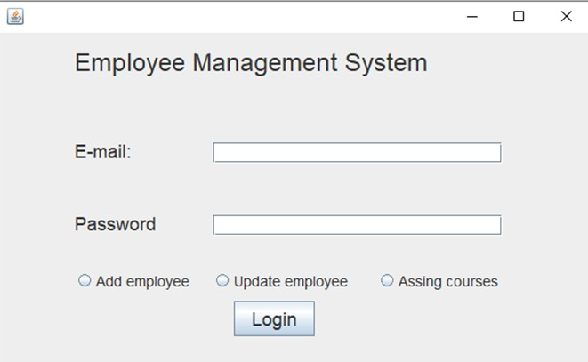

Add Employee

Assign employee