Week 1 Report: Superstore Data Transformation
Power BI & Power Query

Name: Bavadharani B
B.Sc. Data Science and Artificial Intelligence

Introduction
In this week's activity, I worked with the Superstore Sales dataset using Power BI Desktop. The main purpose was to clean and transform the existing data using Power Query Editor. These transformations help make the data more organized, consistent, and suitable for analysis.
I worked mainly with date and text columns. I extracted useful information from Order Date, cleaned text values, renamed a column, and split Customer Name into separate columns.
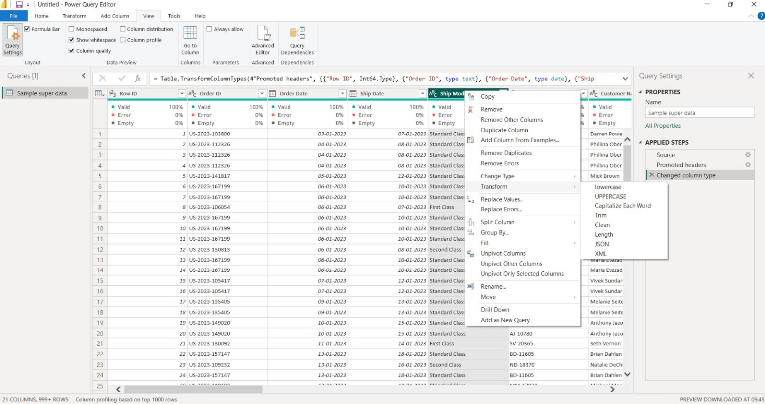
Superstore data preview in Power BI

Step 1: Opening the Data in Power Query Editor
- I opened the Superstore dataset in Power BI Desktop.
- I opened Power Query Editor to inspect and transform the data.
- The table contains columns such as Order Date, Ship Date, Customer ID, Customer Name, Category and Product Name.
- Power Query shows the transformation steps on the right side under Applied Steps.
This step helped me understand the structure of the existing table before making changes.
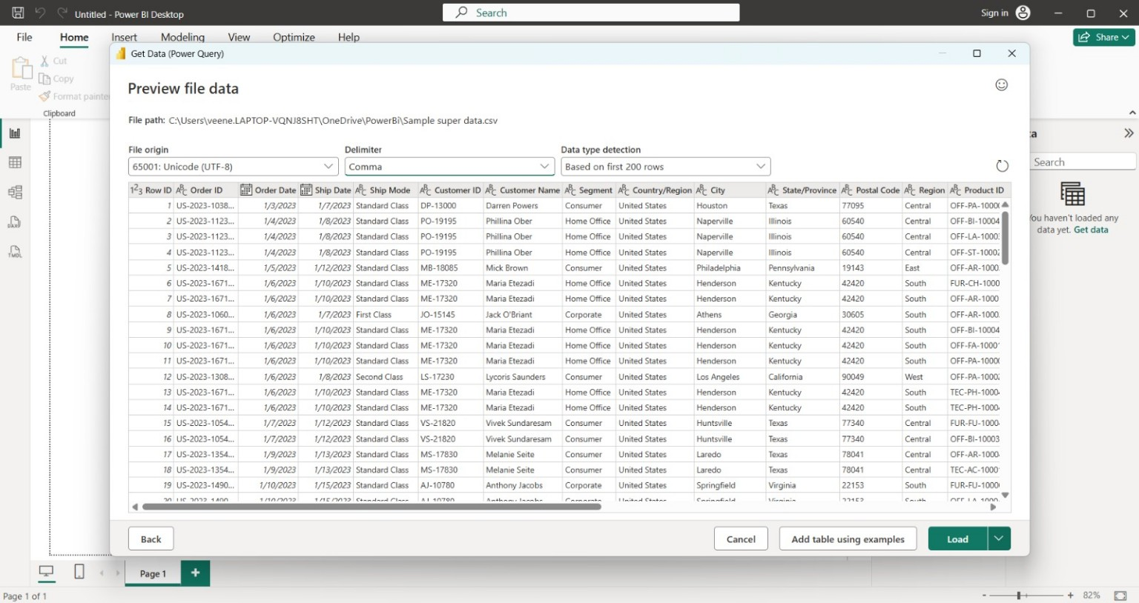
Power Query Editor with the Superstore table
Step 2: Changing the Data Type
- I checked the data type of the Order Date column.
- The Order Date column was converted to the Date/Date-Time type where required.
- I also used Change Type with Locale to correctly interpret the date format.
Correct data types are important because Power BI needs to recognize dates correctly before extracting month, day, or other date information.
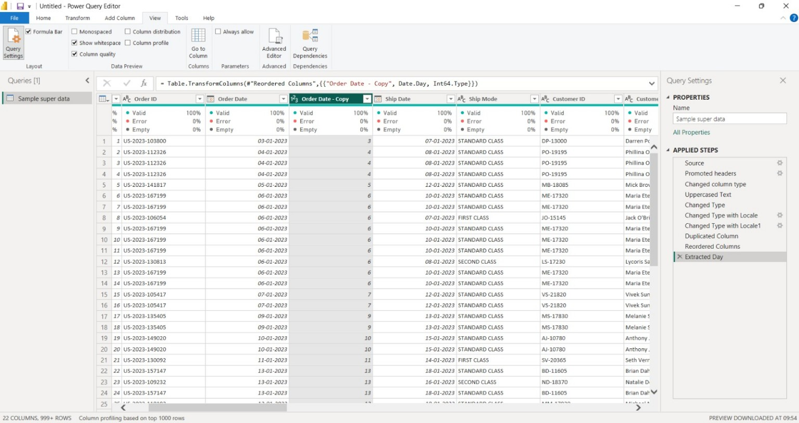
Change Type with Locale

Step 3: Extracting the Day from Order Date
- I duplicated the Order Date column so that the original date would remain available.
- From the duplicated date column, I selected the Day transformation.
- This created a new column containing the day number, such as 3, 4, 5 and 6.
For example, an Order Date of 03-01-2023 gives the day value 3.
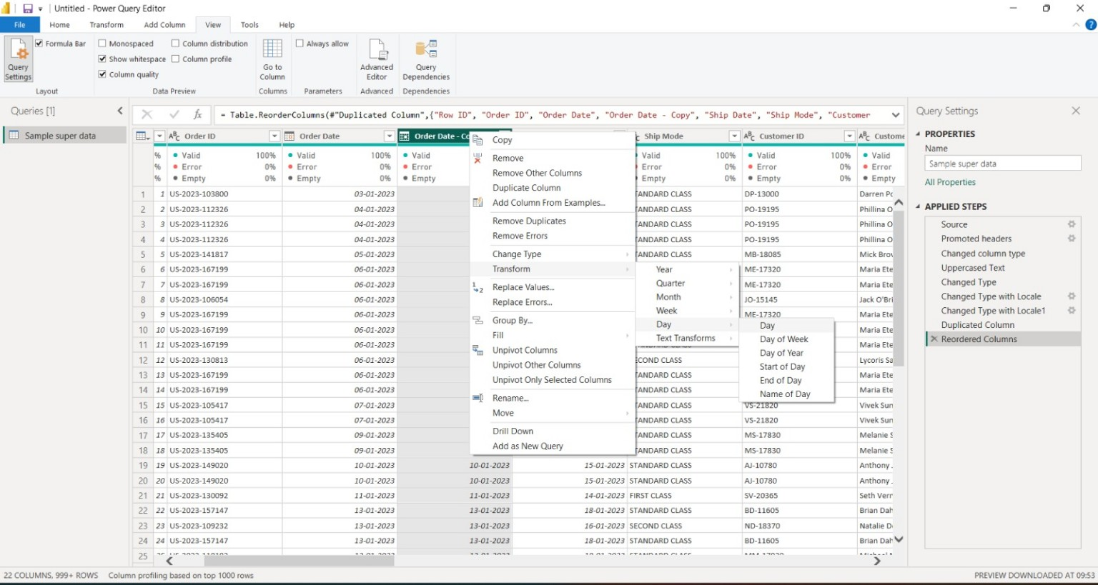
Extracting the Day from Order Date
Step 4: Extracting the Month Name and Day Name
- I used the Order Date column to extract the Month Name.
- The result gives values such as January, February and March.
- I also extracted the Day Name from the date.
- The Day Name gives values such as Monday, Tuesday and Wednesday.
These new columns can be used later to analyse sales by month or by day of the week.
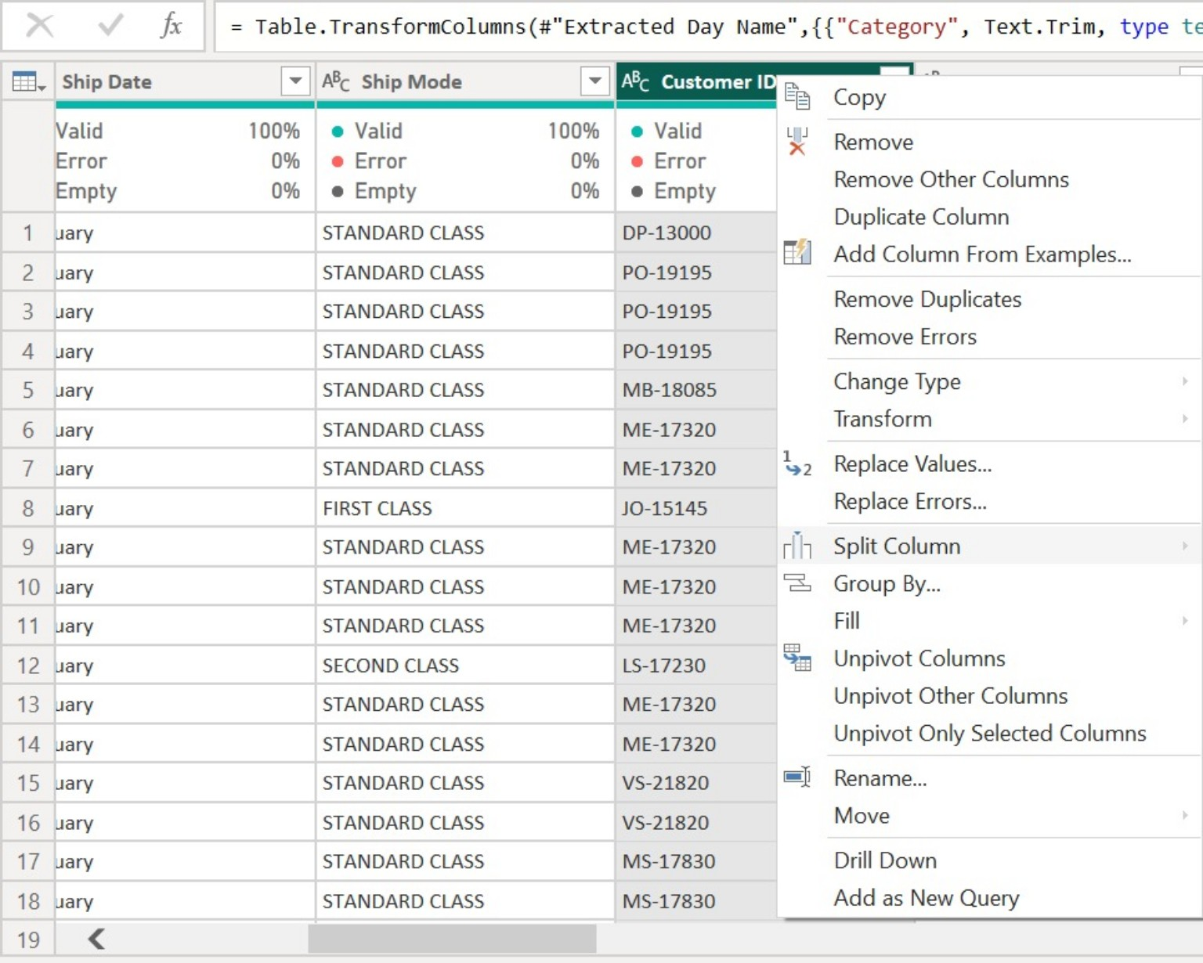
Extracting Day Name from the date column

Step 5: Cleaning Text Data
- I selected text columns that needed cleaning.
- I used the Trim transformation to remove unnecessary spaces.
- I also used text transformations such as UPPERCASE where required to keep the values consistent.
Cleaning text is useful because extra spaces or different letter cases can create inconsistent values during analysis.
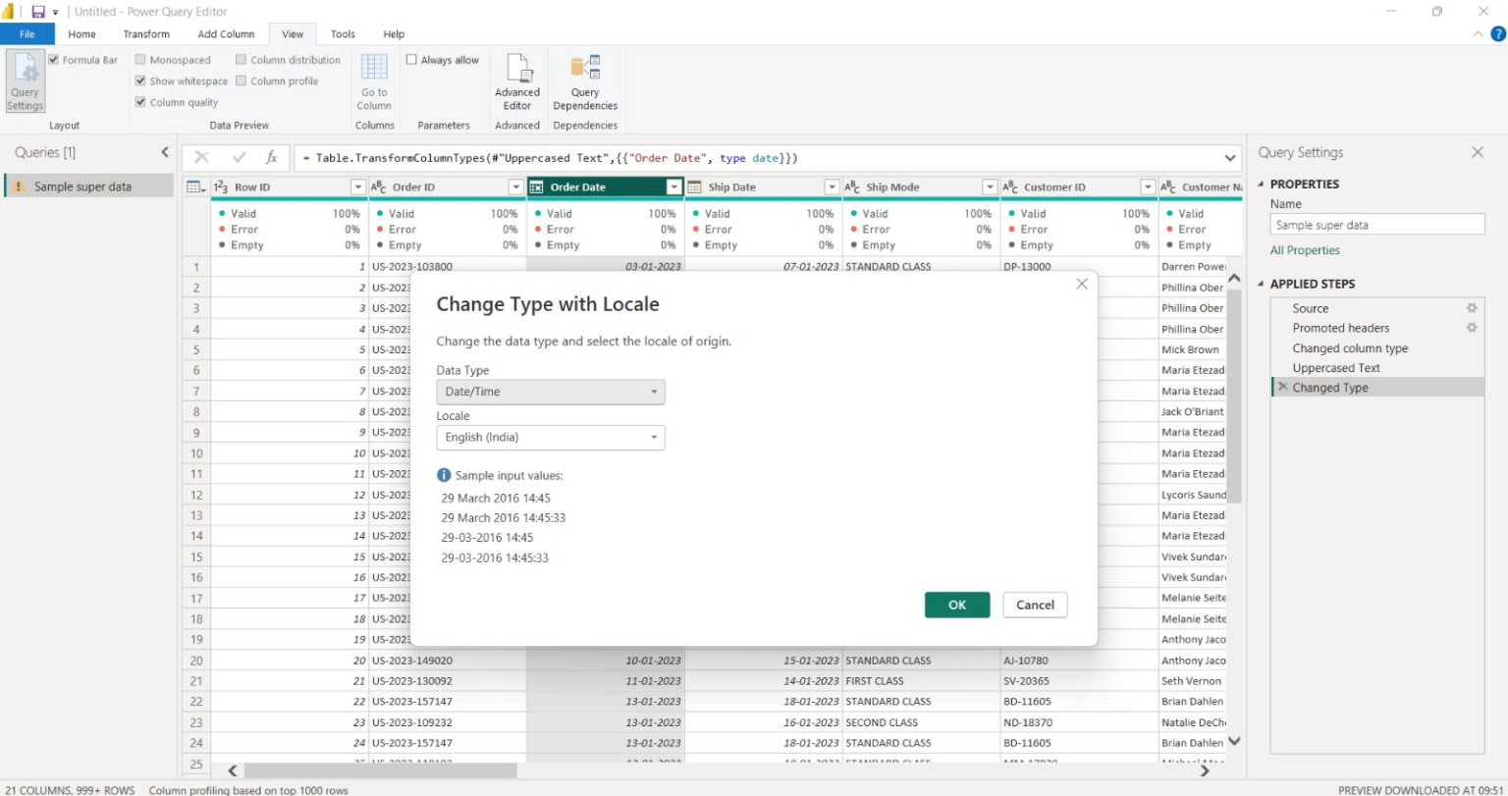
Text transformation options in Power Query
Step 6: Renaming the Customer ID Column
- I selected the Customer ID column.
- I used the Rename option from the column menu.
- The column name was changed from Customer ID to Customer_ID.
A clear and consistent column name makes the dataset easier to understand and use.
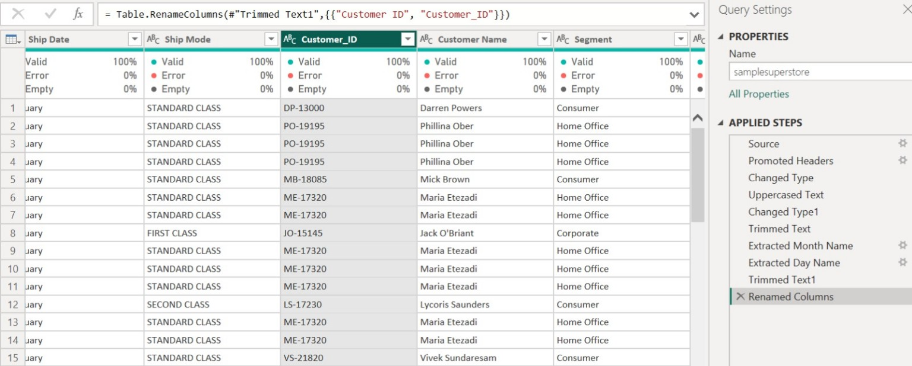
Renaming Customer ID to Customer_ID

Step 7: Splitting Customer Name
- I selected the Customer Name column.
- I chose Split Column → By Delimiter.
- I selected Space as the delimiter.
- I selected Each occurrence of the delimiter and clicked OK.
For example, the name 'Darren Powers' is divided into two columns: 'Darren' and 'Powers'.
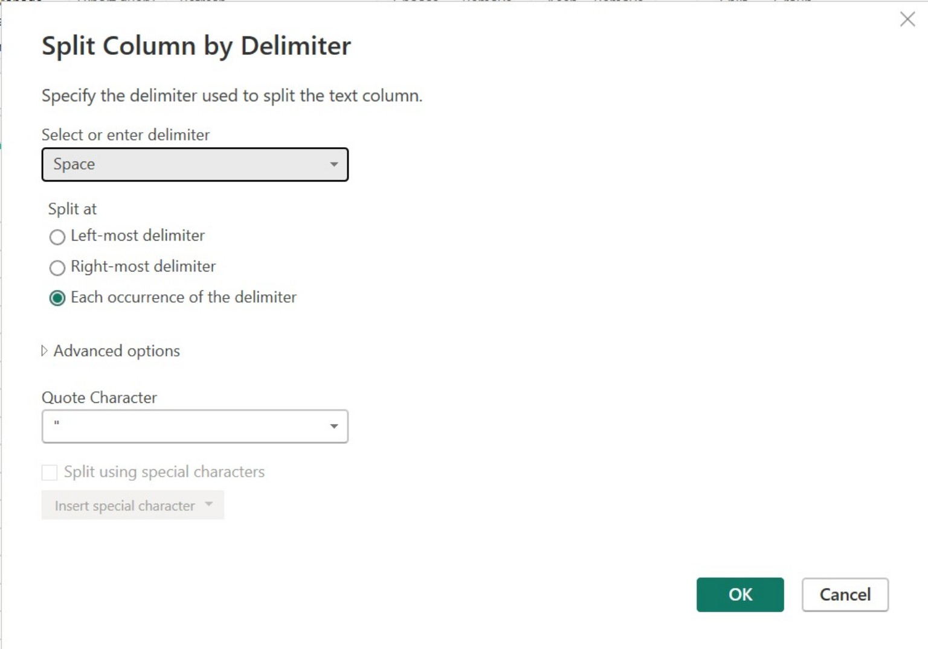
Split Column by Delimiter dialog
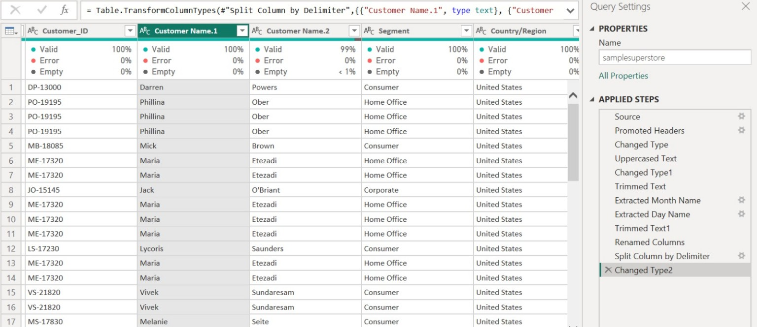
Customer Name separated into two columns
Step 8: Checking the Transformed Data
- I checked the new columns after applying the transformations.
- I verified that the values were displayed correctly.
- I checked the Applied Steps section to see the transformations performed.
The transformed table is now more organized and ready for further Power BI analysis and visualizations.
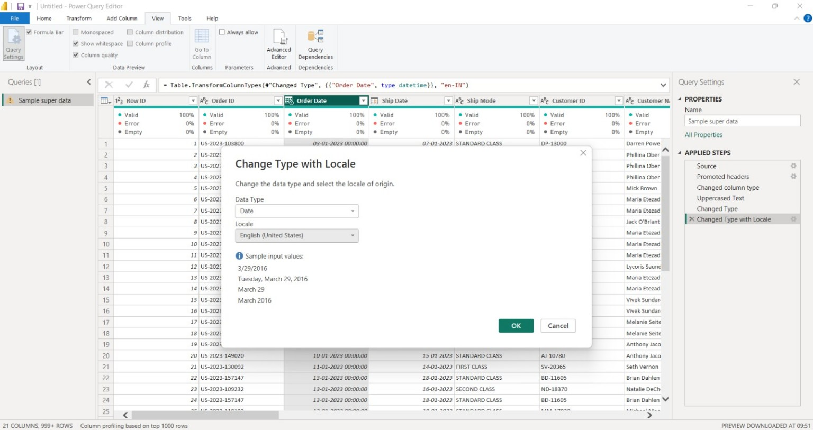
Transformed table in Power Query

Result
- The Superstore dataset was successfully transformed using Power Query.
- Order Date was used to create useful day and month information.
- Text values were cleaned using Trim and text transformations.
- Customer ID was renamed to Customer_ID.
- Customer Name was split into separate columns using a space delimiter.
- The transformed data is ready for further analysis and report creation in Power BI.
Conclusion
Through this week's Power BI project, I learned how Power Query can be used to clean and transform an existing table. I understood how to change data types, extract information from dates, clean text, rename columns, and split a column. These steps help prepare raw data before creating meaningful reports and dashboards.
Learning Outcome
- I learned the basic process of data transformation in Power Query.
- I learned how to extract Day, Month Name and Day Name from a date.
- I learned how to clean text using Trim and UPPERCASE.
- I learned how to split one column into two columns.
- I understood how data preparation supports Power BI analysis.

