**Day-36-Task**

These are the collections I have created for the task.

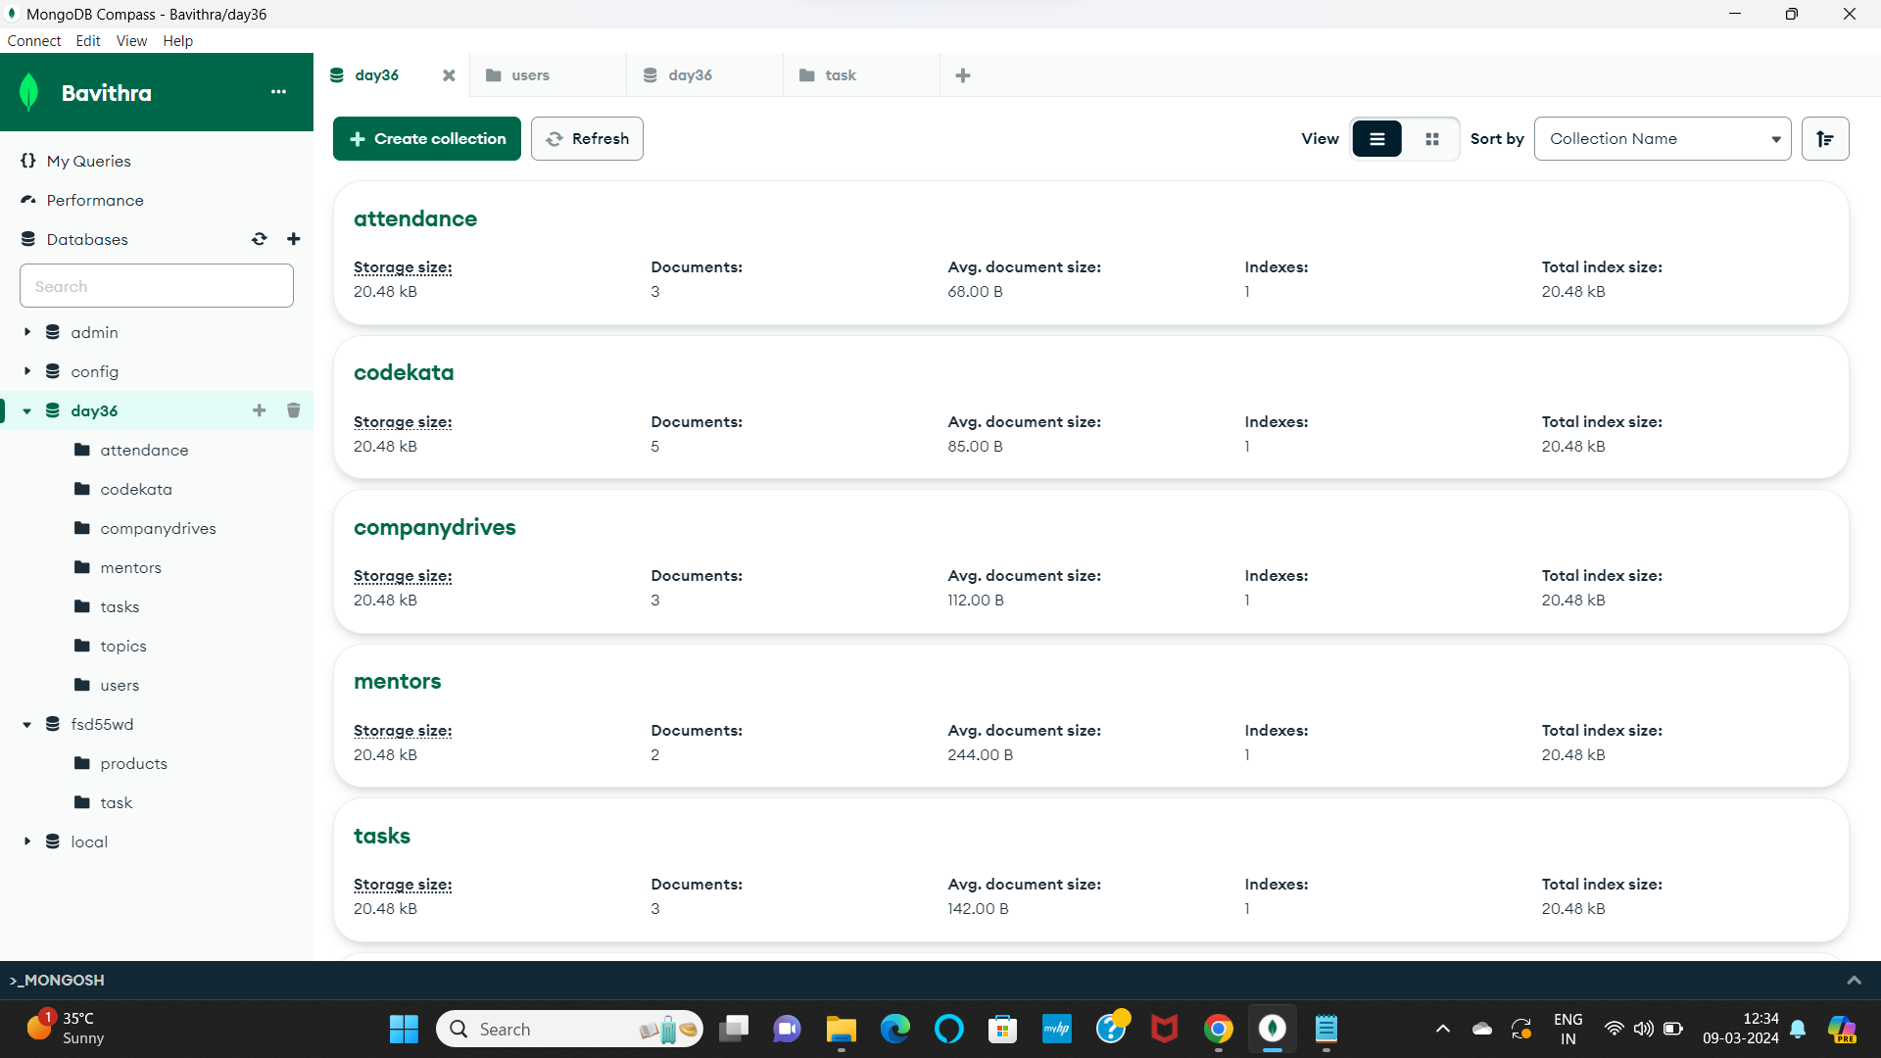

**Questions:**

1. Find all the topics and tasks which are thought in the month of October

Answer:

**const topics = db.topics.find({**

**created_at: {**

**$gte: ISODate("2020-10-01"),**

**$lt: ISODate("2020-11-01")**

**}**

**}).toArray();**

**const tasks = db.tasks.find({**

**deadline: {**

**$gte: ISODate("2020-10-01"),**

**$lt: ISODate("2020-11-01")**

**}**

**}).toArray();**

**const topicsAndTasks = topics.concat(tasks);**

**printjson(topicsAndTasks);**

{

_id: ObjectId('65ec0624d567f8d1711b6fad'),

topic_id: 1,

title: 'MongoDB Basics',

description: 'Introduction to MongoDB fundamentals',

created_at: 2020-10-01T00:00:00.000Z

},

{

_id: ObjectId('65ec0624d567f8d1711b6faf'),

topic_id: 3,

title: 'MERN stack',

description: 'Become an FSD',

created_at: 2020-10-05T00:00:00.000Z

},

{

_id: ObjectId('65ec07b3d567f8d1711b6fb0'),

topic_id: 1,

title: 'Install MongoDB',

description: 'Instructions to install MongoDB',

deadline: 2020-10-20T00:00:00.000Z,

status: 'pending'

},

{

_id: ObjectId('65ec07b3d567f8d1711b6fb2'),

topic_id: 3,

title: 'MERN basic',

description: 'Introduction to mern',

deadline: 2020-10-10T00:00:00.000Z,

status: 'completed'

}

]

1. Find all the company drives which appeared between 15 oct-2020 and 31-oct-2020

Answer: **db.companydrives.find({"date": {$gte: ISODate("2020-10-15"),**

**$lte: ISODate("2020-10-31")}});**

{

_id: ObjectId('65ec08d0d567f8d1711b6fb3'),

drive_id: 1,

date: 2020-10-25T00:00:00.000Z,

company_name: 'Tech Inc',

students_attended: [

1

]

}

1. Find all the company drives and students who are appeared for the placement.

Answer: **db.companydrives.aggregate([**

**{**

**$lookup: {**

**from: "users",**

**localField: "students_attended",**

**foreignField: "_id",**

**as: "students"**

**}**

**}**

**]);**

{

_id: ObjectId('65ec08d0d567f8d1711b6fb3'),

drive_id: 1,

date: 2020-10-25T00:00:00.000Z,

company_name: 'Tech Inc',

students_attended: [

1

],

students: []

}

1. Find the number of problems solved by the user in codekata

Answer: **db.codekata.aggregate([**

**{**

**$group: {**

**_id: "$user_id",**

**total_problems_solved: { $sum: 1 }**

**}**

**}**

**])**

{

_id: 1,

total_problems_solved: 3

} etc…

1. Find all the mentors with who has the mentee's count more than 15

Answer: **db.mentors.aggregate([**

**{**

**$project: {**

**mentor_id: "$_id",**

**name: 1,**

**email: 1,**

**students_mentored_count: { $size: "$students_mentored" }**

**}**

**},**

**{**

**$match: {**

**students_mentored_count: { $gt: 15 }**

**}**

**}**

**])**

{

_id: ObjectId('65ec098bd567f8d1711b6fb6'),

name: 'Seenivasan',

email: 'seeni@gmail.com',

mentor_id: ObjectId('65ec098bd567f8d1711b6fb6'),

students_mentored_count: 25

}

1. Find the number of users who are absent and task is not submitted between 15 oct-2020 and 31-oct-2020

Answer: **db.users.aggregate([**

**{**

**$lookup: {**

**from: "attendance",**

**localField: "_id",**

**foreignField: "user_id",**

**as: "attendance"**

**}**

**},**

**{**

**$lookup: {**

**from: "tasks",**

**let: { user_id: "$_id" },**

**pipeline: [**

**{**

**$match: {**

**$expr: { $eq: ["$$user_id", "$user_id"] },**

**deadline: { $gte: ISODate("2020-10-15"), $lt: ISODate("2020-11-01") }**

**}**

**}**

**],**

**as: "tasks"**

**}**

**},**

**{**

**$match: {**

**$or: [**

**{ "attendance.absent": true, "tasks": { $size: 0 } },**

**{ "attendance.absent": { $ne: true }, "tasks": { $size: 0 } }**

**]**

**}**

**},**

**{**

**$count: "total_users"**

**}**

**])**

{

total_users: 5

}