**A PRELIMINARY REPORT ON**

“Media Service Provider”

SUBMITTED TO THE EDUBRIDGE INDIA PRIVATE LIMITED

**SUBMITTED BY**

**Miss.Bhavithra Bharath Batch No: EON-5755**

## Under The Guidance of

Amruta Deore



# DEPARTMENT OF S PRAYAS CERTIFIED JAVA FULL STACK DEVELOPER 02

**THANE**

**EDUBRIDGE INDIA PRIVATE LIMITED 2021-2022.**

# ACKNOWLEDGMENT

It gives all of us great pleasure in presenting the preliminary project report on **“Media Service Provider”**. With due respect and gratitude we would like to take this opportunity to thank internal guide of our project **Mrs.Amruta Deore** for giving us all the help and guidance we needed. We are really grateful for his kind support. He has always encouraged us and given us the motivation to move ahead. He has put in a lot of time and effort in this project along with us and given us a lot of confidence. Also we wish to thank all the other people who have helped us in the successful completion of this project.

**Miss.Bhavithra Bharath**

# ABSTRACT

Media service provider can be used by anyone which help us to listen to stream millions of music Achieving this objective is difficult using a manual system as it is not possible to download every songs and collecting every songs may be very time consuming. All these problems are solved using this project.Media service provider is a software which is helpful for music lovers as well as the normal people to play our favourite songs,find new music,Listen to favourite artists,songs and albums for free.Our Media Service Provider deals with the various activities related to the Music.

**Chapter 1**

# INTRODUCTION

* 1. **INTRODUCTION**

The objective of Media Service Provider is to allow the normal people to stream old music,recent music,favorite artist and to play all gener music in different languages media service provider allows user to keep up to date his profile .It’ll also facilitate keeping all the records of users, such as their id, name, mailing address, phone number,.So all the information about an user will be available to provide personalised Experience.Overall, it’ll make Service Provider an easier job for the users to find their favorite music and artist. The main purpose of this SRS document is to illustrate the requirements of the project Media Service provider and is intended to help any people to experience their personalised music experience.We have to used different types of module inMedia Service Provider .Throughout the project the focus has been on presenting information in an easy and intelligible manner.

# SCOPE

Without a Media Service Provider, downloading and listening to millions of songs and podcasting s is difficult for normal people. Media Service Provider have a alots of differnt gener musics in all major languages.In addition it have playlist and we can listen to our favorite artist songs.we can also listen to any songs offline using Premium option.Further,it will shows our favorite artist playlist based on our Listenings.

# SYSTEM REQUIREMENTS

## Software Requirements

1. Operating System - Windows 10.
2. Platform - Notepad++.
3. Language - HTML,CSS,Javascript.
4. Files - stylesheet,html.

# UML DIAGRAMS

## Use case Diagram

The following UML use case diagram shows the working of a Music Service Provider.Moreover, it has eight use cases that show the particular functionality of the media provider. The eight use cases are; check id, log in info, choose plan,Make payment check id,process payment,manage user music dat,providepersonalise experience. Service provider can check id, check all info,email-id,update user info,and provide music options according to the user listening.The user, on the other hand, create id,login,choose plan and do payment or can listen to free.The interactions of the user and service provider are what sum up the media service provider use case diagram example.

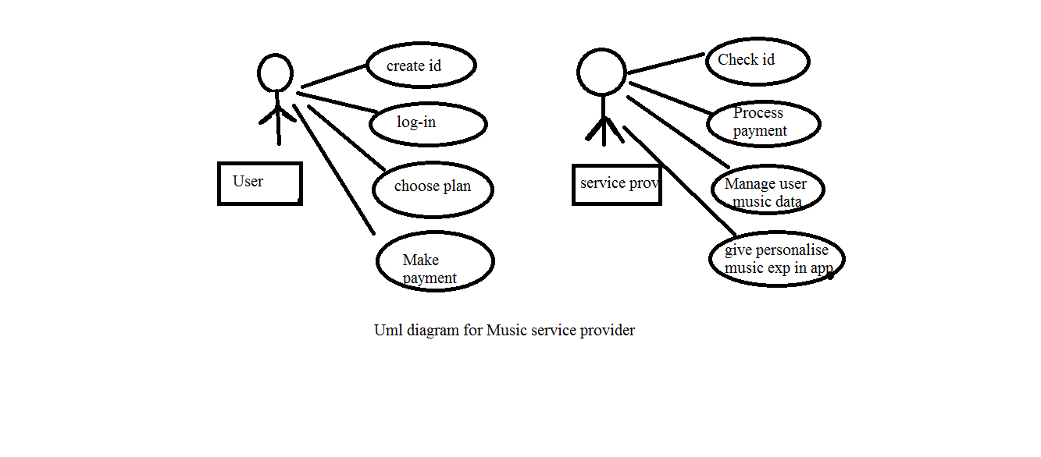

# MODULE

## Login

Login module will help in authentication of user accounts .Users who have valid login id and password can only login into their respective accounts

<body>

<h2 style="color:white;">Log-in</h2><br>

Email:

<input type="text" placeholder="username/email id"><br><br>

Password:

<input type="password" id="password" name="password" placeholder="password"><br><br>

<button style="background-color:blue;border:5px blue groove;width:8%;height:7%

border-radius:10px;" class="b1">sign-in</button><br><br>

Don't Have account?

<a href="file:///E:/edufullstacktraining/HTML%20program/frontendproject/signup.html">Touch me</a>

<div style="font-family:Bookman;font-style:italic;color:#641E16 "><strong>specially made for Music <span style="color:white;">lovers</span></strong></div>

</center>

</body>

</form>

## Registration

This module will help the user get registered from anywhere if internet is present

.This module will really simplify the task of on paper registration. Also after successful registration the user can update information and change their password as and when required.

<body>

<div class="centered">

Name:<br>

<input type="text" name="Name" placeholder="Name"> <span class="tooltiptext"></span><br><br>

Email:<br>

<input type="text" name="Email" placeholder="Mail id"><br><br>

<div class="tooltip">

Password:<br>

<input type="password" id="password" name="password" placeholder="Password" ><span class="tooltiptext" style="border-radius:20px;">password must have atleast 6 characters</span><br><br>

</div>

<div class="tooltip">

confirm password:<br>

<input type="Password" name="username" placeholder="Confirm Password"><span class="tooltiptext" style="border-radius:20px;padding:5px;height:20px;">password must be same as above</span><br><br>

</div>

<center>Mobile number:</center>

<input type="text" placeholder="Mobile Number"><br><br>

<button style="background-color:white;color:black;border:3px white groove;

border-radius:5px;">sign-up</button>

</div>

</div></body>

## Payment Method

Allow user to pay money through different medium and collect details of the user s information such:Name,mobile number, card details.

<tr>

<th>Select plan & Choose payment option<br><br><i class="fab fa-cc-mastercard" style="color:yellow;"></i>

<i class="fab fa-cc-visa" style="color:blue;"></i>

<i class="fas fa-credit-card" style="color:red;"></i></th>

</tr>

<tr>

<td>

<div class="dropdown">

<button class="dropbtn" style="width:270px;height:105px;text-align:left;">1 week<br>₹25</button>

<div class="dropdown-content">

<a href="file:///E:/edufullstacktraining/HTML%20program/frontendproject/phonepay.html">Phonepay<br><i class="fab fa-paypal" style="font-size:80%;color:#540AA7;"></i></a>

<a href="file:///E:/edufullstacktraining/HTML%20program/frontendproject/gpay.html">Gpay<br><i class="fab fa-google-pay" style="font-size:109%;color:#1115FA"></i></a>

<a href="file:///E:/edufullstacktraining/HTML%20program/frontendproject/card.html">card<br><i class="far fa-credit-card" style="font-size:80%;color:#F49A10"></i></a></td>

</div></div>

</tr>

Enter Amount:

<input type="text" placeholder="Amount" style="width:10%;height:5%;"><br><br>

Enter Account no:

<input type="text" placeholder="Acc.no" style="width:10%;height:5%;"><br><br>

Enter IFSC code:

<input type="text" placeholder="Code" style="width:10%;height:5%;"><br><br>

Card Number:

<input type="text" placeholder="Enter Last 4 digit only" style="width:10%;height:5%;"><br><br>

Enter Mobile Number:

<input type="text" placeholder="Number" style="width:10%;height:5%;"><br><br>

## Web Player

We can Listen Music on Web Using our free profile

<body style="background:linear-gradient(to right, #ffff66 31%, #9933ff 102%);">

<h1>Popular Musicians</h1>

<div class="gallery">

<a target="_blank" href="file:///E:/edufullstacktraining/HTML%20program/frontendproject/music1.html">

<img src="E:\edufullstacktraining\HTML program\frontendproject\assets\images\lovemusic9.jpg" alt="Cinque Terre">

</a>

<div class="desc">Yuvans Magic</div>

</div>

<div class="gallery">

<a target="_blank" href="file:///E:/edufullstacktraining/HTML%20program/frontendproject/rahman.html">

<img src="E:\edufullstacktraining\HTML program\frontendproject\assets\images\lovemusic20.jpg" alt="Forest">

</a>

<div class="desc">Rahmania</div>

</div>

<div class="gallery">

<a target="_blank" href="file:///E:/edufullstacktraining/HTML%20program/frontendproject/ani.html">

<img src="E:\edufullstacktraining\HTML program\frontendproject\assets\images\lovemusic23.jpg" alt="Northern Lights">

</a>

<div class="desc">Anirudh Hits</div>

</div>

<div class="gallery">

<a target="_blank" href="file:///E:/edufullstacktraining/HTML%20program/frontendproject/spb.html">

<img src="E:\edufullstacktraining\HTML program\frontendproject\assets\images\lovemusic24.jpg" alt="Mountains">

</a>

<div class="desc">Spb Vocals</div>

</div>

# ADVANTAGES

1. Stream Millions of music.
2. Listen on web for free.
3. Easy payment
4. Cost-efficient and User-friendly.
5. Easy access to different kind of music.

**Chapter 2**

# PROJECT IMPLEMENTATION

* 1. **SCREENS**

**Login page**

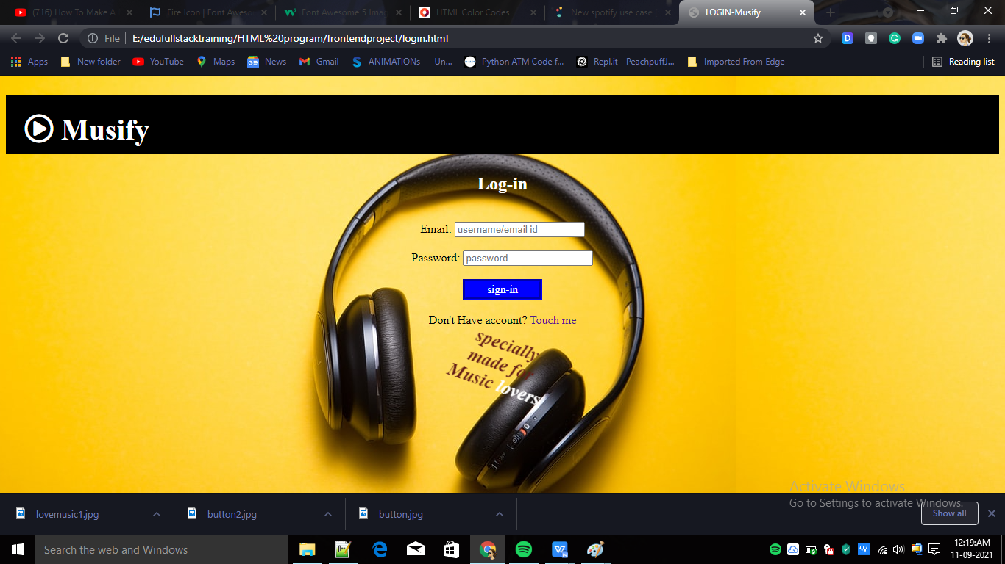

# SCREENS

**Registration page**

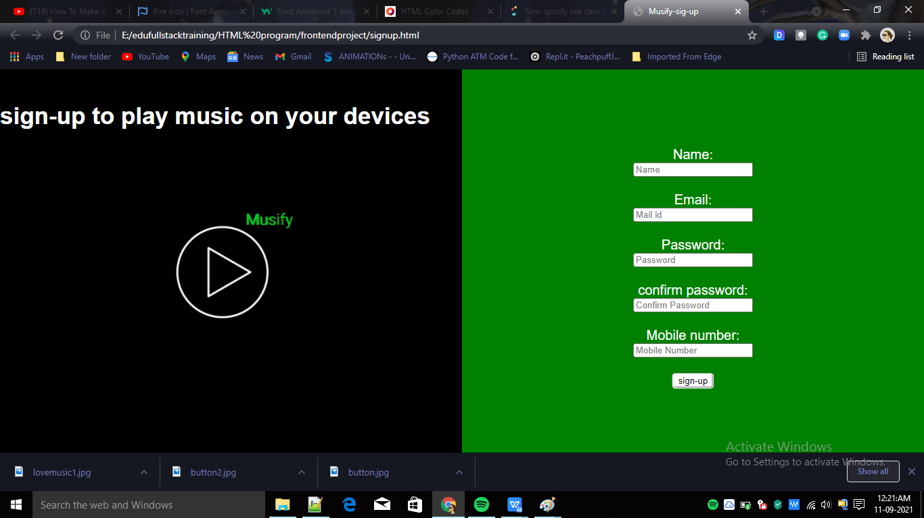

# SCREENS

**Plan &Payment Options**

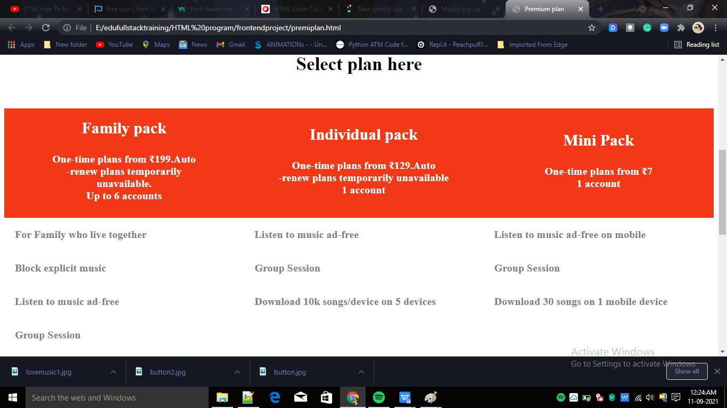

# 

# 

**2.4 Screens**

**Web Player**

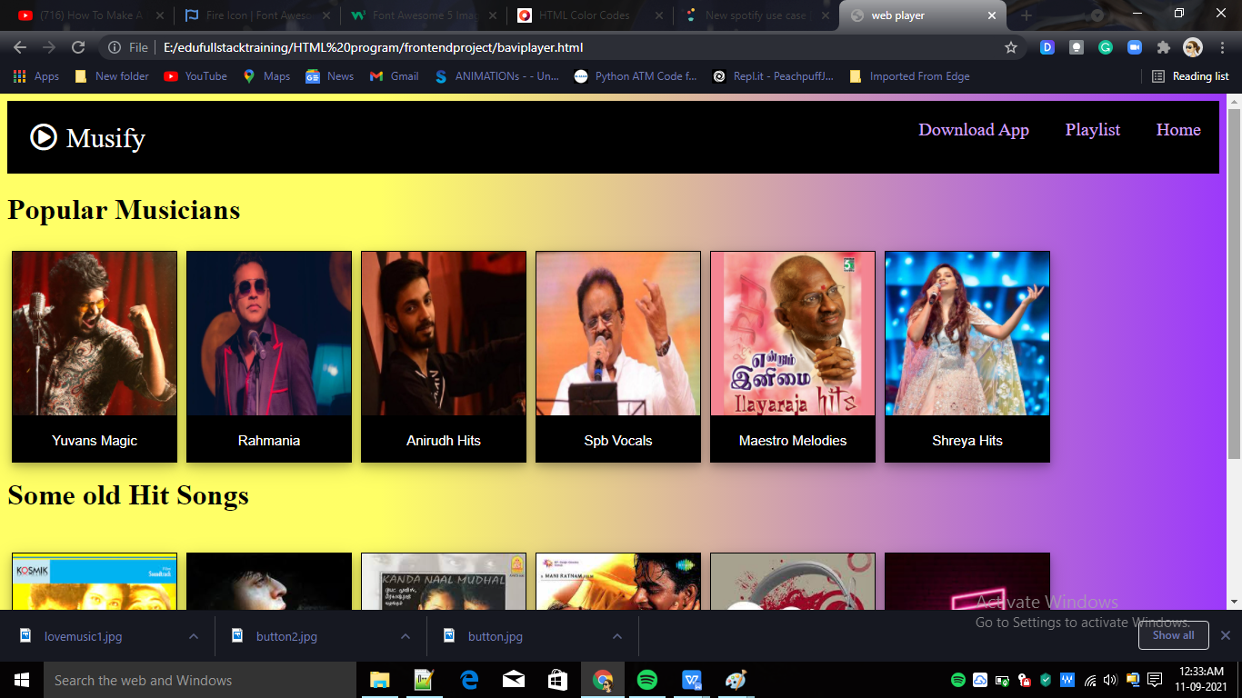

**Chapter 3**

# CONCLUSIONS

**3.1 CONCLUSION**

Music Service Provider can be used by any people to stream millions of music easily. Achieving this objective is difficult using the manual system as the music is scattered, can be redundant, and collecting lot of music may be very time-consuming. All these problems are solved by this project.