 

A Project Report on

ENGAGEMENT BLUEPRINT

Submitted in partial fulfillment of requirements for the award of the course

of

## ADI1211 – BUSINESS INTELLIGENCE

Under the guidance of

# Ms. S .SUBHA SRI M.E.,

## IBM Software Technical Trainer/AI&DS

Submitted By

## AMUTHA M(927623BAD006),

## BAVI M(927623BAD022),

## GOBIKA S(927623BAD035).

**DEPARTMENT OF ARTIFICIAL INTELLIGENCE**

# M.KUMARASAMY COLLEGE OF ENGINEERING

(Autonomous)

**KARUR – 639 113**

May 2025

i

## M. KUMARASAMY COLLEGE OF ENGINEERING (Autonomous Institution affiliated to Anna University, Chennai)

**KARUR – 639 113**

## BONAFIDE CERTIFICATE

Certified that this project report on **“Engagement Blueprint** is bonafied work of **AMUTHA M( 927623BAD006),BAVI M(927623BAD055), GOBIKA S (927623BAD035)** who carried out the project work during the academic year 2024 - 2025 under my supervision.

Signature Signature

**Ms. S. Subha Sri ,M.E., Dr. A.SELVI (Ph.D.,)**

### IBM Software Technical Trainer, HEAD OF THE DEPARTMENT,

Department of Artificial Intelligence, Department of Artificial Intelligence,

M.Kumarasamy College of Engineering,

M.Kumarasamy College of Engineering,

Thalavapalayam, Karur -639 113. Thalavapalayam, Karur -639 113.

## DEPARTMENT OF ARTIFICIAL INTELLIGENCE

### VISION OF THE INSTITUTION

To emerge as a leader among the top institutions in the field of technical education

### MISSION OF THE INSTITUTION

* Produce smart technocrats with empirical knowledge who can surmount the global challenges
* Create a diverse, fully-engaged, learner-centric campus environment to provide quality education to the students
* Maintain mutually beneficial partnerships with our alumni, industry, and Professional associations

### VISION OF THE DEPARTMENT

To create highly qualified competitive professionals in Artificial Intelligence and Machine Learning by designing intelligent solutions to solve problems in variety of business domains, applications such as natural language processing, text mining, robotics, reasoning and problem

-solving that serves society with greater cause.

### MISSION OF THE DEPARTMENT

**M1:** Impart practical and technical knowledge along with applications of various integrated technologies.

**M2:** Design and develop various intelligent engineering projects to solve societal issues.

**M3:** Use of advanced engineering tools and equipment to enable research based learning to promote ethical values, lifelong learning and entrepreneurial skills.

### PROGRAM EDUCATIONAL OBJECTIVES (PEOS)

PEO1: Develop intelligent software solutions demonstrating reasoning, learning and decision support while handling uncertainty using domain knowledge.

PEO2: Create significant research towards social benefits and engineering improvement witha wide breadth knowledge of AI & ML technologies and their applications.

PEO3: Participate in life-long learning for effective professional growth and demonstrate leadership qualities in disruptive technologies along with a capacity to critically analyse and evaluate design proposals.

### PROGRAM OUTCOMES

Engineering students will be able to:

**PO1: Engineering knowledge:** Apply the knowledge of mathematics, science, engineering fundamentals, and an engineering specialization to the solution of complex engineering problems.

**PO2: Problem analysis:** Identify, formulate, review research literature, and analyze complex engineering problems reaching substantiated conclusions using first principles of mathematics, natural sciences, and engineering sciences.

**PO3: Design/development of solutions:** Design solutions for complex engineering problems and design system components or processes that meet the specified needs with appropriate consideration for the public health and safety, and the cultural, societal, and environmental considerations.

**PO4: Conduct investigations of complex problems:** Use research-based knowledge and research methods including design of experiments, analysis and interpretation of data, and synthesis of the information to provide valid conclusions.

**PO5: Modern tool usage:** Create, select, and apply appropriate techniques, resources, and modern engineering and IT tools including prediction and modeling to complex engineering activities with an understanding of the limitations.

**PO6: The engineer and society:** Apply reasoning informed by the contextual knowledge to assess societal, health, safety, legal and cultural issues and the consequent responsibilities relevant to the professional engineering practice.

**PO7: Environment and sustainability:** Understand the impact of the professional engineering solutions in societal and environmental contexts, and demonstrate the knowledge of, and need for sustainable development.

**PO8: Ethics:** Apply ethical principles and commit to professional ethics and responsibilities and norms of the engineering practice.

**PO 9: Individual and team work:** Function effectively as an individual, and as a member or leader in diverse teams, and in multidisciplinary settings.

**PO10: Communication:** Communicate effectively on complex engineering activities with the engineering community and with society at large..

**PO11: Project management and finance:** Demonstrate knowledge and understanding of the engineering and management principles and apply these to one’s own work, as a member and leader in a team, to manage .

**PO12: Life-long learning:** Recognize the need for, and have the preparation and ability to engage in independent and life-long learning in the broadest context of technological change.

### PROGRAM SPECIFIC OUTCOMES (PSOs)

**PSO1:** Expertise in tailoring ML algorithms and models to excel in designated applications and fields.

**PSO2:** Ability to conduct research, contributing to machine learning advancements and innovations that tackle emerging societal challenges.

# ABSTRACT

The project aims to create a dashboard that tracks customer activity, transaction volumes, and engagement levels for banking services. It will display key metrics such as transaction counts, loan statuses, and account types to help banks analyze customer behavior. By visualizing data through graphs and charts, the dashboard will provide customer engagement and transaction trends. This tool will enable decision-makers to optimize services, improve customer retention, and tailor offerings to meet customer needs. Ultimately, it will enhance the overall banking experience and drive business growth.

# ABSTRACT WITH POs AND PSOs MAPPING

|  |  |  |
| --- | --- | --- |
| **ABSTRACT** | **POs**  **MAPPED** | **PSOs**  **MAPPED** |
| The project aims to create a dashboard that tracks customer activity, transaction volumes, and engagement levels for banking services. It will display key metrics such as transaction counts, loan statuses, and account types to help banks analyze customer behavior. By visualizing data through graphs and charts, the dashboard will provide customer engagement and transaction trends. This tool will enable decision-makers to optimize services, improve customer retention, and tailor offerings to meet customer needs. Ultimately, it will enhance the overall banking experience and drive business growth. | PO1(3)  PO2(3)  PO3(3)  PO4(2)  PO5(3)  PO6(2)  PO7(2)  PO8(1)  PO10(2)  PO11(2)  PO12(2) | PSO1(1)  PSO2(2) |
|  |  |  |
|  |  |  |
|  |  |  |

Note: 1- Low, 2-Medium, 3- High

**SUPERVISOR HEAD OF THE DEPARTMENT**

# TABLE OF CONTENTS

## CHAPTER

**No.**

## TITLE PAGE

**No.**

1. Introduction 1
2. Project Objective 1
3. [Tools Used 2](#_TOC_250004)
4. Dataset Overview 3
5. Key Visualizations 4
6. Security Features Implemented 6
7. Insights Derived 6
8. Screenshots of Dashboard
9. Conclusion

## INTRODUCTION:

In the modern banking sector, understanding customer behavior and transaction patterns is essential for improving services and customer satisfaction. This project focuses on developing an interactive dashboard to measure customer activity, transaction volumes, and engagement levels. By visualizing key metrics such as transaction frequency, account types, customer demographics, and loan statuses, the dashboard will provide real-time insights to help banks make data-driven decisions.The dashboard will include various data visualization components such as charts, graphs, and interactive filters to allow users to analyze trends across different time periods, customer segments, and service categories. Features like customer segmentation, anomaly detection (e.g., unusual transaction spikes), and predictive analytics for loan defaults or churn risk will also be integrated.

## PROJECT OBJECTIVE :

The objective of this project is to design and develop an interactive dashboard that provides real-time insights into customer activity, transaction volumes, and engagement levels in the banking sector. The dashboard will:

. Track and visualize key metrics such as transaction counts, loan statuses, and account types.

. Enable banks to analyze customer behavior and identify engagement patterns.

Support data-driven decision-making by presenting information through intuitive charts and graphs.

Assist in optimizing banking services, improving customer retention, and tailoring product offerings based on customer needs.

Enhance the overall banking experience while driving operational efficiency and business growth.

## TOOLS USED :

The primary tool utilized for this project is:

**IBM Cognos Analytics**

IBM Cognos Analytics is an advanced business intelligence (BI) and data visualization platform that enables organizations to transform raw data into meaningful insights. It was selected for this project due to its powerful capabilities in building dynamic, secure, and interactive dashboards.

Key reasons for choosing IBM Cognos Analytics include:

* **Interactive Dashboards**: Allows users to explore data visually through charts, graphs, and custom filters that enable analysis of registration trends, program popularity, and member retention.
* **Security and Governance**: Provides robust security features including role-based access control, user authentication, and secure sharing of reports—ensuring that only authorized users (e.g., owners vs. members) can access sensitive data.
* **Data Integration**: Supports easy integration of various data sources (CSV, Excel, databases, etc.) to create a unified view of membership and financial data.
* **Custom Visualizations**: Offers a wide range of customizable visual elements suited for fitness metrics such as attendance patterns, spending behavior, and registration sources.

# 

# DATASET OVERVIEW:

# 

**5. KEY VISUALIZATION:**

**1.Engagement\_Score Gender**

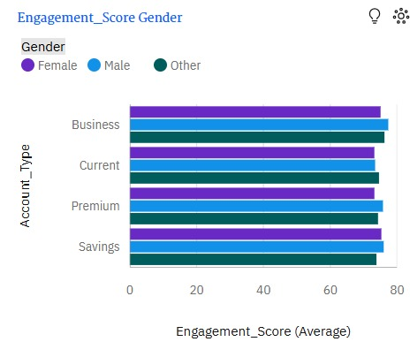**Why it's key:**

This chart shows average engagement scores across account types, segmented by gender.  
It highlights how males, females, and others engage with Business, Current, Premium, and Savings accounts.Banks can use this to identify which demographics are more active in specific account types.These insights support targeted campaigns and inclusive engagement strategies.

**2**. **Fraud\_Flag:**

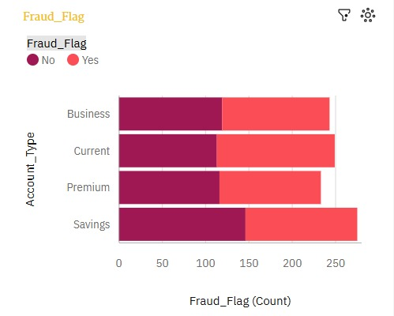**Why it's key**:

****Fraud\_Flag**** indicates whether suspicious or fraudulent activity has been detected in an account.  
It helps banks monitor and manage fraud risks across different account types.By tracking fraud trends, banks can enhance security measures and prevent losses.This metric is essential for building trust and ensuring safe financial operations.

3. **Gender by Gender:**

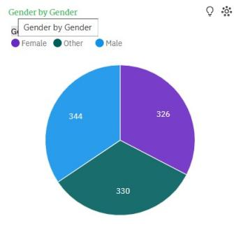**Why it's key**:

****Gender by Gender**** shows the distribution of customers across different gender identities.It helps banks understand demographic diversity within their customer base.Analyzing gender data supports inclusive product design and service delivery.

## 4.**Transaction\_count account\_type**

## **WhatsApp Image 2025-05-10 at 12.54.18_5f596aaf**

## **Why its key:**

## The **"Transaction\_Count by Account\_Type"** chart is key because it visually shows how transactions are distributed across different account types. It helps identify which account type (like Savings or Premium) is most or least used. This insight can guide customer targeting or service improvements. It also supports better decision-making in financial management and marketing strategies.

## 

## WhatsApp Image 2025-05-10 at 12.54.46_7ef1fc74 5.****Loan\_Status colored by Gender****

## **Why it's key:**

## The **"Loan\_Status colored by Gender"** chart shows how loan approvals or rejections vary by gender. It helps identify potential gender disparities in loan processing. This is important for promoting fairness and improving loan policies.

## 

## WhatsApp Image 2025-05-10 at 12.55.13_4bc998186**.Credit\_Score by Branch\_Visits colored by Gender**

## Why it's key:

## The Credit\_Score by Branch Visits colored by Gender chart shows how credit scores vary with branch visit frequency across genders. It helps uncover behavioral trends and creditworthiness by gender. This insight supports tailored financial services and gender-inclusive strategies.

## WhatsApp Image 2025-05-10 at 12.55.36_fe0869817.Investment\_Amoun Marital\_Status

## Why it's key:

## The Investment\_Amount and Marital\_Status chart compares account balance and investment behavior across marital statuses. It reveals which groups are more financially active or stable. This helps in designing targeted financial products and services.

## **WhatsApp Image 2025-05-10 at 12.56.02_c71a5f14**

## **8.Loan\_Amount and Investment\_Amount**

## **Why it's key:**

## The Loan\_Amount and Investment\_Amount chart shows how investment levels relate to loan approval status. It helps identify financial patterns between borrowers and non-borrowers. This is useful for assessing credit risk and investment behavior.

## 

## 6. SECURITY FEATURES IMPLEMENTED:

Security was a core component of the banking dashboard, implemented through:

****Role-Based Access Control (RBAC):****  
****Manager Login:**** Full access to customer analytics, transaction reports, and loan data.  
****Staff Login:**** Access limited to individual customer service dashboards and operational data.

****User Authentication and Authorization:****  
Secure login system ensures that only authorized bank employees can access or update sensitive financial data.  
Session timeouts and re-authentication for critical actions add an extra layer of protection.

****Data Privacy and Protection:****  
Customer transaction and personal data are protected using data masking and encryption techniques.  
Visualizations are permission-based, ensuring users only see data relevant to their roles.

## INSIGHTS DERIVED:

****Customer Engagement:****  
Active users who transact frequently are more likely to retain banking services, emphasizing the importance of user-focused engagement strategies.

****Transaction Patterns:****  
Analysis shows peak transaction periods (e.g., salary credit days), which helps optimize server performance and staff allocation.

****Loan Behavior:****  
Insights on loan application status and repayment trends assist in identifying potential defaulters and high-value clients for follow-up or offers.

****Account Type Usage:****  
Savings accounts dominate activity levels, but fixed deposit users show higher average balances—helping target premium services.

## SCREENSHOT OF DASHBOARD:

## Screenshot 2025-04-20 205148

## 9.CONCLUSION:

## 

This project focuses on developing a customer activity dashboard to improve engagement and business growth in the banking sector. By tracking key metrics like transaction frequency, account types, and loan statuses, it provides real-time insights for better decision-making. The dashboard allows banks to visualize customer behavior and trends, enabling more targeted services. This results in improved customer retention, personalized experiences, and efficient operations. Ultimately, it supports data-driven strategies for enhancing customer satisfaction. The tool empowers banks to drive growth through customer-centric decisions and analytics.