**BUSINESS REQUIREMENTS DOCUMENT**

Project Name:

**Stock Market Investment and Risk Management Platform**

Team Members:

1. Ratnesh Kumar Puskar
2. Bavin Kuniyamkottil

**1. INTRODUCTION**

**1.1 Purpose**

The purpose of this Business Requirement Document (BRD) is to outline the requirements for developing a comprehensive Stock Market Investment and Risk Management Platform. This platform aims to assist both novice and experienced investors in making informed investment decisions, managing risk, and aligning their investment strategies with their financial goals and risk tolerance.

**1.2 Scope**

This project will develop a user-friendly platform that provides:

* Real-time stock market data and news.
* Features to build, track, and manage investment portfolios.
* Features to buy and sell stocks.
* Stocks details and graph.

**1.3 Business Objectives**

* Empower Investors: Equip users with the necessary information to make informed investment decisions.
* Enhance Portfolio Management: Provide features that enable users to efficiently build, track, and adjust their investment portfolios.

**1.4 Stakeholders**

* Retail Investors: Individuals looking to invest in the stock market and manage their portfolios.
* Platform Administrators: Team responsible for maintaining and updating the platform.
* Regulatory Authorities: Ensure compliance with financial regulations and data protection laws.

**2. FUNCTIONAL REQUIREMENTS**

**2.1 User Registration**

- Users should be able to register with an email address.

- Provide user profile information and details of his transaction.

**2.2 Real-Time Market Data and News**

- Display real-time stock market data, including stock prices, indices, and historical data.

- Provide news feeds relevant to the stock market, including economic indicators, company performance, and geopolitical events.

**2.3 Financial Analysis and Research Tools**

- Include financial calculators (e.g., profit and loss, return on investment).

- Provide stock analysis graphs and charts.

**2.4 Portfolio Management**

- Allow users to create and manage multiple portfolios.

- Provide tools to track portfolio performance, including gains and losses.

**3. NON-FUNCTIONAL REQUIREMENTS**

**3.1 Performance Requirements**

- The platform should handle multiple concurrent users without performance degradation.

- Real-time data updates should have a latency of less than 1 second.

**3.2 Usability Requirements**

- The platform should have a responsive design, compatible with desktops, tablets, and smartphones.

- Provide a user-friendly interface with easy navigation and intuitive controls.

**4. Assumptions and Constraints**

**4.1 Assumptions**

- Users have basic knowledge of the stock market and investing.

- The platform will use third-party APIs for real-time data feeds.

- Users will have access to a stable internet connection.

**4.2 Constraints**

- The platform must adhere to strict regulatory and compliance standards.

- Limited budget and timeline for development and deployment.

- Dependence on external data providers for real-time market information.

**5. RISKS AND MITIGATION**

**5.1 Risks**

**- Data Accuracy:** Inaccurate data can lead to poor investment decisions.

**- Regulatory Changes:** Changes in financial regulations could impact platform functionality.

**5.2 Mitigation Strategies**

- Partner with reliable data providers and regularly audit data accuracy.

- Stay informed about regulatory changes and adjust platform features as needed.

**6. INTERACTION**

* Frontend and Backend Communication:
* HTTP Requests: Angular frontend communicates with Spring Boot backend via HTTP requests for budget and expense operations.
* Data Binding: Data models are exchanged between frontend and backend to keep the application synchronized.

* Real-Time Updates:
* Angular Components: Reactively update the UI based on data changes from the backend.
* Spring Boot Services: Process requests and manage data, ensuring consistency and reliability.

**7. WIRE FRAME**

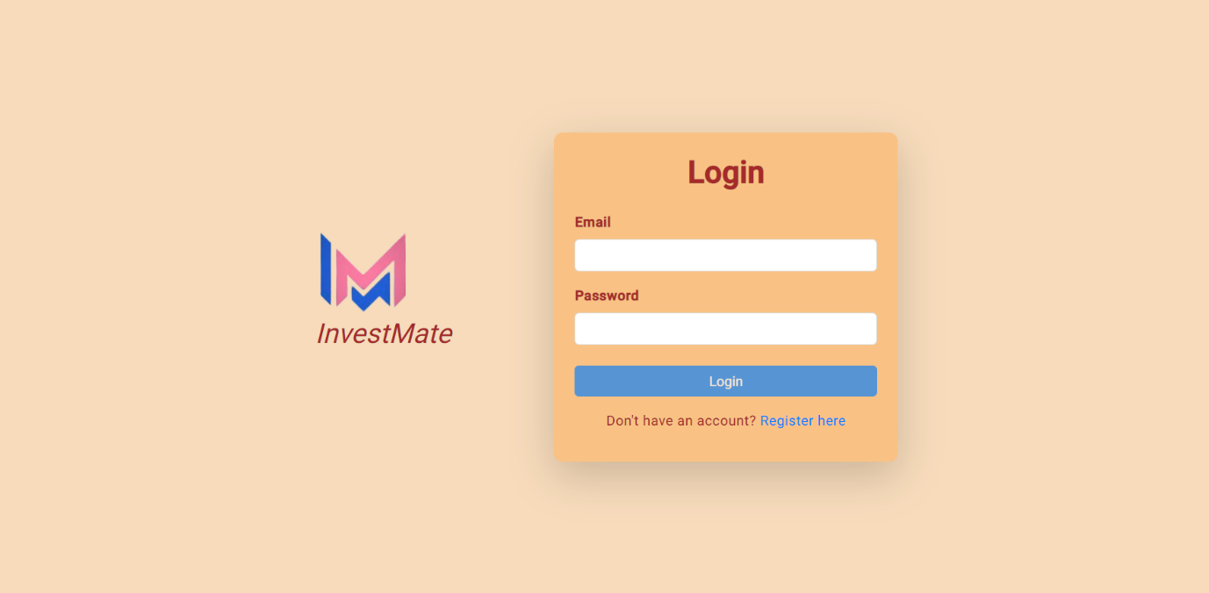

**Fig.- 7.1 Login**

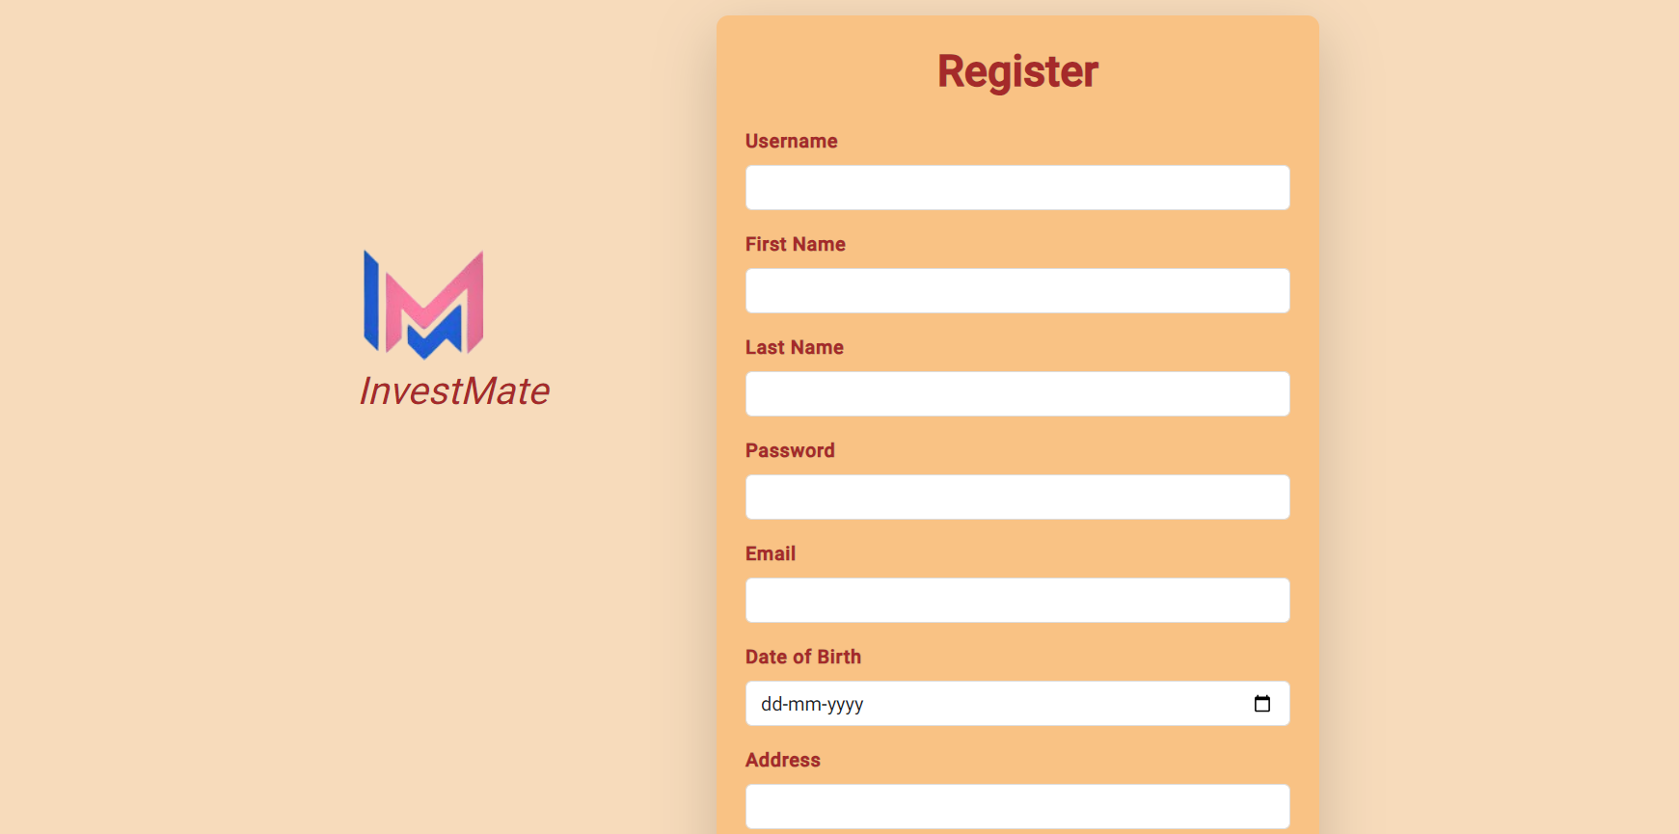

**Fig.- 7.2 Register**

**Fig.- 7.3 Dashboard**

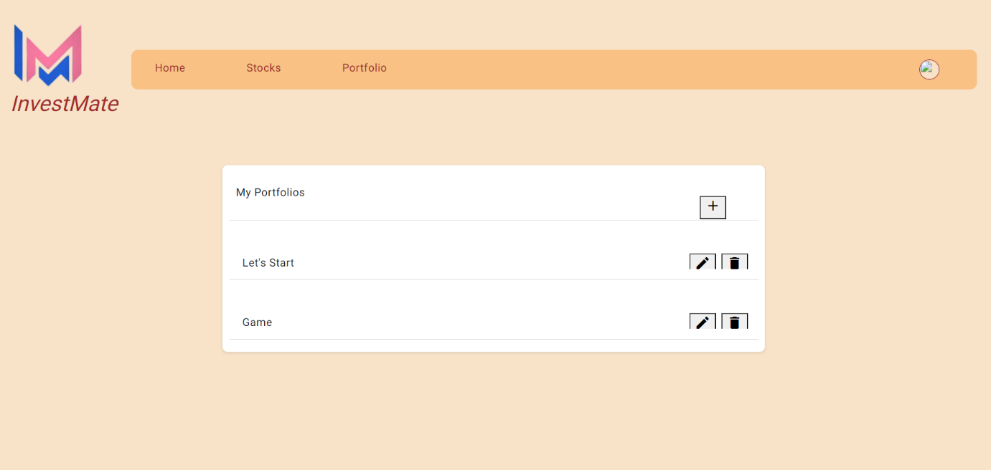

**Fig.- 7.4 Portfolio**

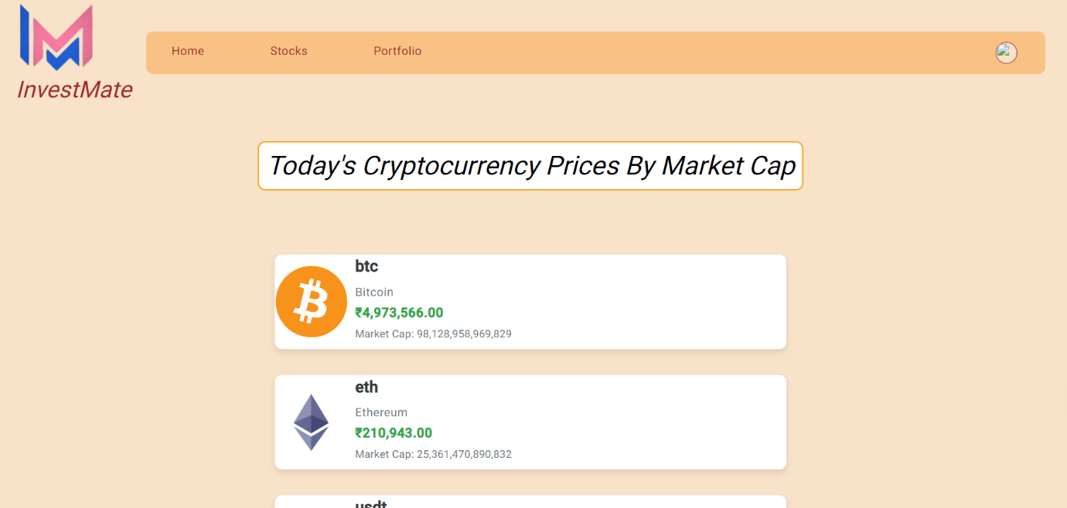

**Fig.- 7.5 Stocks**

**Fig.- 7.6 Stocks details**

**8. SCHEMA DIAGRAM**

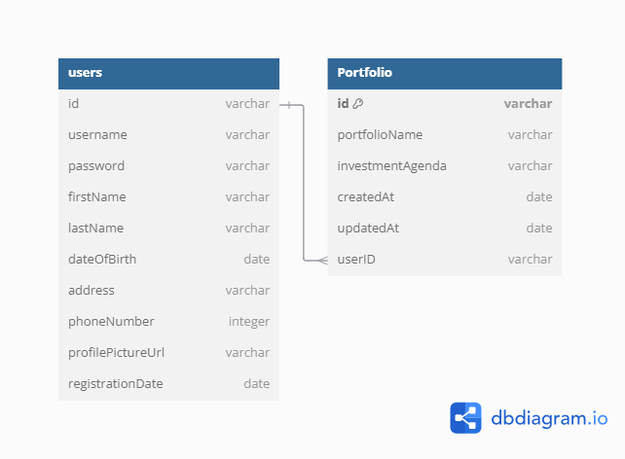

**Fig.- 8.1 Schema**

**9. ARCHITECTURE DIAGRAM**

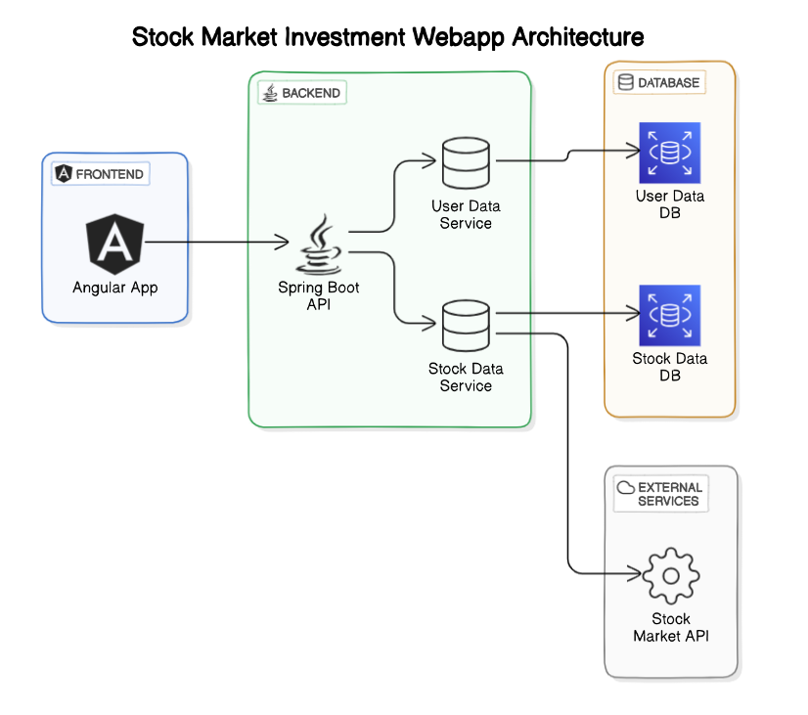

**Fig.- 9.1 Architecture**