Name:Bavly Samy Adly
ID:2205110

## **1. Introduction**

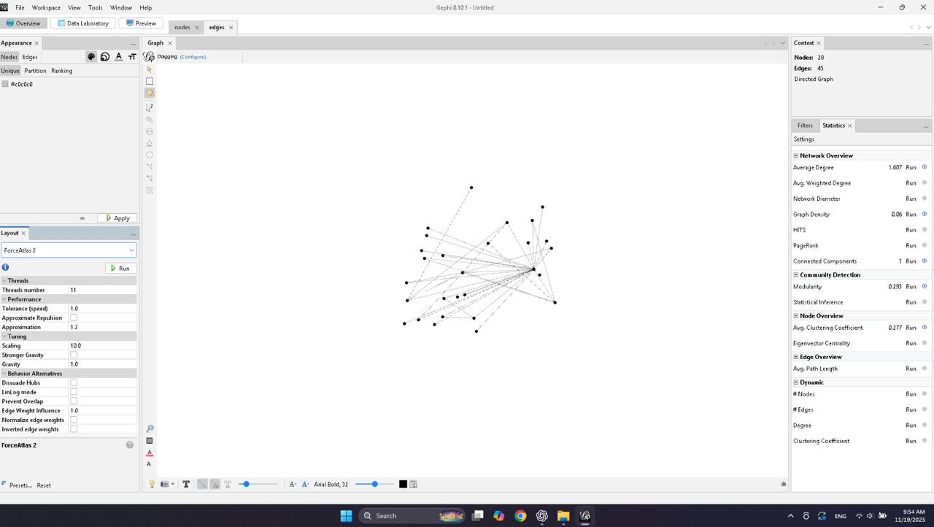
This report analyzes two network graphs created in Gephi:

1. **Non-Conspiracy Network** (first image)
2. **5G Conspiracy Network** (second image)
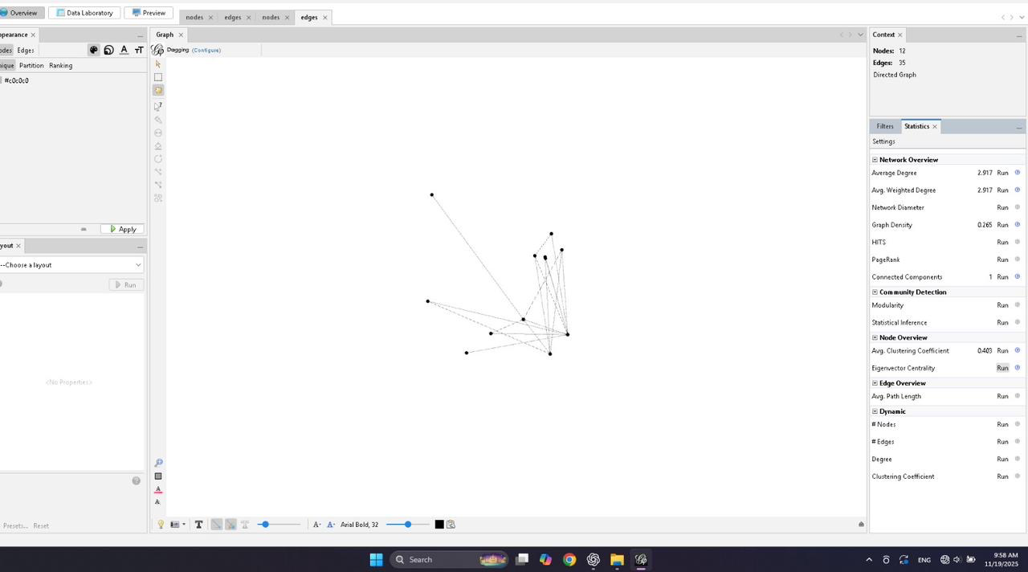
Both are directed graphs, but they differ significantly in structure, density, clustering, and connectivity. These differences reflect common patterns in how misinformation spreads versus how regular information spreads.

# **2. Network Overview**

## **2.1 Non-Conspiracy Network (Image 1)**

**Nodes:** 12
**Edges:** 35
**Graph Density:** 0.265
**Average Degree:** 2.917
**Average Clustering Coefficient:** 0.403
**Connected Components:** 1 (fully connected)

### **Observations**

* The network is **small but moderately dense**.
* It forms **one connected component**, indicating interconnected communication.
* **Moderate clustering** suggests natural, topic-based discussion groups.
* The layout shows nodes forming a **loose, open structure** with around 2–3 connections per node.

This resembles a **normal, non-extremist communication network**.

---

## **2.2 5G Conspiracy Network (Image 2)**

**Nodes:** 28
**Edges:** 45
**Graph Density:** 0.06
**Average Degree:** 1.607
**Average Clustering Coefficient:** 0.277
**Connected Components:** 1
**Modularity:** 0.293

### **Observations**

* The network is **larger but much less dense**.
* The low density (0.06) shows **sparse connections**, meaning many users are only loosely connected.
* The layout demonstrates **a star-like structure**, with many nodes pointing toward a few central hubs.
* Lower clustering means fewer sub-communities and more **centralized spread patterns**.

Such a structure is typical of **misinformation ecosystems**, where a few influential accounts spread content to many followers.

---

# **3. Structural Comparison**

## **3.1 Size**

| Metric | Non-Conspiracy | 5G Conspiracy |
| --------- | -------------- | ------------- |
| **Nodes** | 12 | 28 |
| **Edges** | 35 | 45 |

The 5G conspiracy network is **more than twice as large** in number of participants.

---

## **3.2 Density and Connectivity**

| Feature | Non-Conspiracy | 5G Conspiracy |
| ------------------------ | ---------------------------- | --------------------------------------- |
| **Graph Density** | 0.265 (moderately dense) | 0.06 (very sparse) |
| **Connected Components** | 1 | 1 |
| **Interpretation** | Balanced, mutual interaction | Weakly connected, central hubs dominate |

The conspiracy network shows **broadcast-style communication**, not conversation.

---

## **3.3 Clustering (Community Formation)**

| Metric | Non-Conspiracy | 5G Conspiracy |
| -------------------------- | -------------- | ------------- |
| **Clustering Coefficient** | 0.403 | 0.277 |
| **Modularity** | Not shown | 0.293 |

The non-conspiracy network shows **healthier, organic clustering** — people interacting with each other.
The conspiracy network is more **cluster-fragmented**, but with few meaningful communities.

---

## **3.4 Structural Behavior**

### **Non-Conspiracy Network**

* Nodes communicate across the network in **balanced, multi-directional ways**.
* No dominant node controlling information flow.
* Resembles **collaborative or informational exchange**.

### **5G Conspiracy Network**

* Shows **hub-and-spoke patterns**, where many nodes connect to a few central accounts.
* Indicates the presence of **influencers or misinformation superspreaders**.
* The overall shape reflects **one-way broadcasting**, not dialogue.

---

# **4. Visual Comparison**

## **Non-Conspiracy (Image 1)**

* More **evenly distributed** nodes.
* Edges form small clusters and triangles (sign of collaborative exchange).
* No visible central dominating hub.

## **5G Conspiracy (Image 2)**

* Much more sprawling shape.
* Many nodes point toward a **single dense central cluster**.
* Typical of conspiracy or misinformation spread:
**one source → many receivers**.

---

# **5. Interpretation**

## **What the differences imply**

### **Non-Conspiracy Network**

* People interact with each other in a healthy, distributed pattern.
* The flow of information is shared between many participants.
* Discussion is more peer-to-peer.

### **5G Conspiracy Network**

* Information flows from a few central individuals to many others.
* Much weaker clustering indicates **followers, not collaborators**.
* Shows structural signs of:

* misinformation amplification
* audience passivity
* centralized source control

These differences match established research on misinformation networks.

# **6. Conclusion**

Based on graph size, density, clustering, and layout patterns:

* The **non-conspiracy network** appears **balanced, conversational, and decentralized**.
* The **5G conspiracy network** is **centralized, sparse, and driven by a few influential nodes**, matching known patterns of how conspiracy content spreads.

These structural differences clearly illustrate how misinformation ecosystems differ from normal information networks.

