Bavo Knaeps
Jitse Wierdsma

SBD
LEIM

Lisbon Higher Institute of Engineering (ISEL)
Table of Contents
JSP JDBC web application 3
Topic 1 : The setup 3
1.1 The IDEA 3
1.2 Hosting the web application 3
1.3 Setting up the database 3
1.4 Maven 3
1.5 Dependecies 4
2 Coding the app 4
2.1 jdbc 4
2.2 jsp 5
2.3 servlet 5
2.4 routing 6
2.5 linking it all together 6
3 SQL STATEMENTS 7

JSP JDBC web application

Topic 1 : The setup

1.1 The IDEA

To create this web application we chose to write all the code in intellij IDEA ultimate from jetbrains. Intellij has the advantage to easily add various components to help further develop an application which will be useful later on this project.

1.2 Hosting the web application

hosting a web application is very easy with the correct operating system. For this project we use OS Linux ubuntu 18.04. This OS has the advantage of easy installation fo Apache Tomcat server. Intellij also has an easy integration of tomcat with a plugin that can be added via the GUI.

To actually deploy the web app on the tomcat server we first need to setup tomcat. For security purposes we host the server on another user,not root, called tomcat (located in “/opt/tomcat” in ubuntu). We then get the package using wget and install it in this directory. Finally we must add a user and give that user permissions and roles. This is decided in “/opt/tomcat/apache-tomcat/conf/tomcat-users.xml”.

1.3 Setting up the database

Allready installed on ubuntu is mysql, which we will be using for this project. We first run mysql as root to run the script the create the database we are going to use. After that we are all set to start programming the web application.

1.4 Maven

Maven is a powerful project management tool that is based on POM (project object model). It is used for projects build, dependency and documentation. It simplifies the build process like ANT. But it is too much advanced than ANT.
In short terms we can tell maven is a tool that can be used for building and managing any Java-based project. maven make the day-to-day work of Java developers easier and generally help with the comprehension of any Java-based project.

To build or project we use the standard command mvn clean compile package. This creates a target file and within this target file it creates a .war file that can be deployed on a server.

1.5 Dependecies

In a maven project all the dependencies are defined in the POM file. TO add a dependency we just add a dependency tag and maven will auto resolve and add it.

2 Coding the app

2.1 jdbc

To fetch data from the database we need “Java Database Connectivity”. By making this connection we can create Connection objects and run Prepared statements through them. These statements can be DELETE, UPDATE, SELECT or INSERT. To uphold coding standards we are going to use a standard maven layout

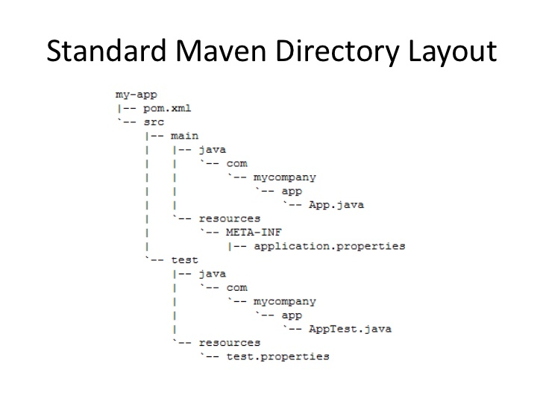
The JDBC part of this project is in main/java/DAO. In the DAO folder we create DAO object for each table we are going to use in this project. For example for the table doctor we made a DAO called DoctorDAO. All the SQL statements are found and used in these DAO objects. For each method call we create a connection and then execute a statement that will then be sent to the mysql database.

2.2 jsp

JSPs have dynamic scripting capability that works in tandem with HTML code, separating the page logic from the static elements ,the actual design and display of the page ,to help make the HTML more functional(i.e. dynamic database queries).

All the JSP are very basic with jsp/jstl.core utility so we can print out list we pass through them via the servlets.

2.3 servlet

A servlet is a Java programming language class that is used to extend the capabilities of servers that host applications accessed by means of a request-response programming model. Although servlets can respond to any type of request, they are commonly used to extend the applications hosted by web servers. For such applications, Java Servlet technology defines HTTP-specific servlet classes.

Inside these servlets we create a DAO object (matching the servlet) so we can call the methods we made in those DAO’s. If the method returns something( for example a list of models) we can then pass that value to the jsp using the request and then set an attribute that we can later acces using requestScope in the jsp’s

We can obtain each dispatcher of each jsp using the fucntion request.getRequestDispatcher(jsp url). This returns a Requestdispatcher that can forward the request and response to the jsp.

2.4 routing

Routing can be done by 2 different methods. The first one being by servlet mapping , this is done in the web.xml file under WEB-INF. The second one is adding a @Webservlet tag above the servlet class and setting the url there. We used the second method. For example in DoctorServlet we added a @Webservlet(urlPatterns= “/doctor/*”). This means that if we send a request with url doctor/ that this servlet will get that request (POST and GET).

2.5 linking it all together

Linking all these components together is sometimes a difficult job because it can be confusing. To combat that we separated everything nicely into different classes. Although this has the disadvantage of duplicate code it makes it very readable and easy to understand.

If a request is sent from a specific JSP it will send that request to the corresponding servlet, that servlet contains the DAO for that JSP and servlet so it can only acces those methods to , again , make it easy to read and understand.

3 SQL STATEMENTS
Inside the DAO we define all the sql statements that we used in the preparedstatement made by the connection. The can all be found under the folder “/main/java/DAO”.

