Creating a Chatbot in Python

Project Description:

Creating a chatbot in Python involves developing a program that can interact with users through natural language. Here's a more detailed description of the steps involved.

Step 1:

Define the Purpose:

Clearly define the purpose of your chatbot. What is its main function or goal? Is it for customer support, information retrieval, or something else?

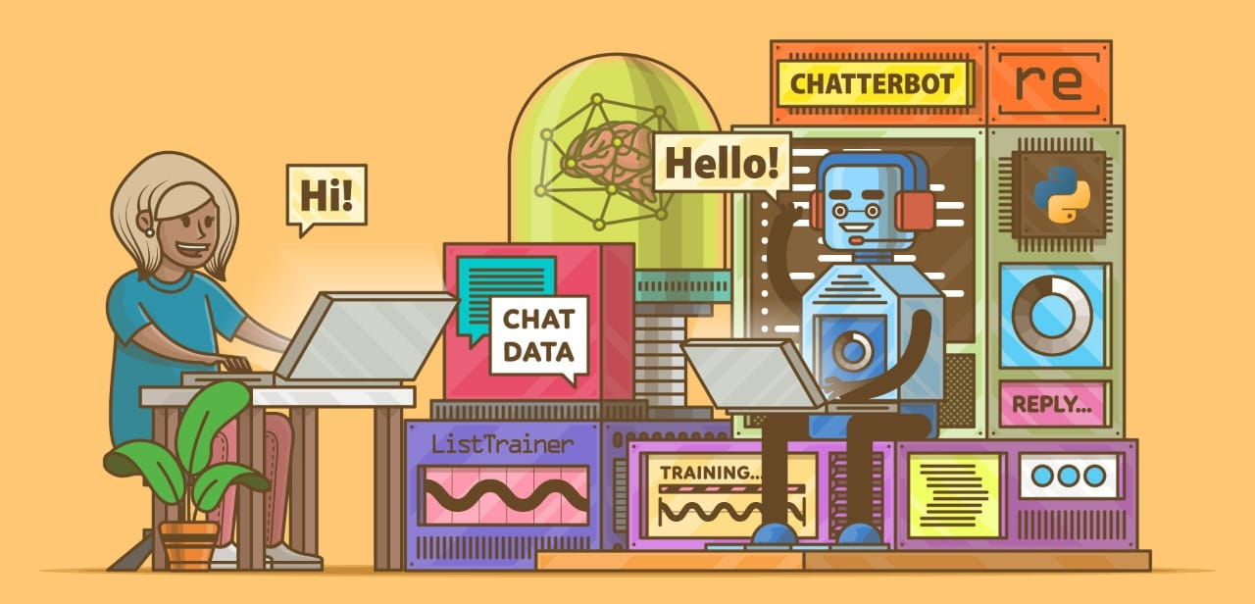

Step 2:

Select a Framework or Library:

Choose a Python framework or library for building your chatbot. Popular options include ChatBot, NLTK, spaCy, or using pre-built platforms like Dialog flow or Microsoft Bot Framework.

Step 3:

Data Collection and Preprocessing:

Collect and prepare the data your chatbot will use, such as a dataset of possible user inputs and responses. Preprocess the data by cleaning and tokenizing it.

Step 4:

Build the Natural Language Processing (NLP) Model:

Train or build an NLP model to understand user inputs and generate appropriate responses. This might involve techniques like machine learning, rule-based systems, or a combination of both.

Step 5:

Implement the Chatbot Logic in Business:

Develop the logic for your chatbot in the Business. This includes understanding user input, processing it, and generating a relevant response. You'll need to handle various user scenarios and intents.

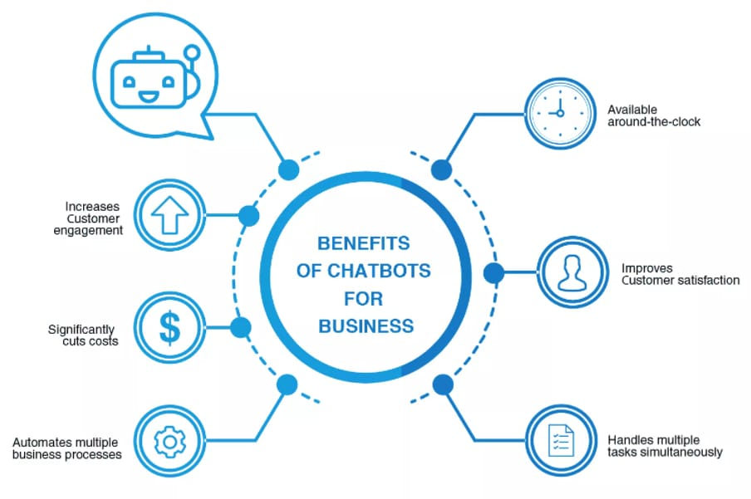

Step 6:

User Interface:

Create a user interface to interact with your chatbot. This could be a web-based interface, a command-line interface, or integration into an existing application.

https://realpython.com/build-a-chatbot-python-chatterbot/

Step 7:

Testing and Training:

Test your chatbot thoroughly to ensure it handles user input effectively. You may need to iterate on training data and model adjustments to improve its performance.

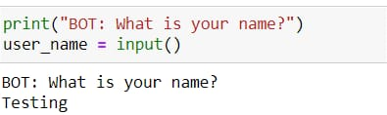

Step 8:

Deployment:

Deploy your chatbot on a server or platform of your choice. Ensure it's accessible to users.

Step 9:

Monitoring and Maintenance:

Regularly monitor the chatbot's performance, collect user feedback, and make improvements to enhance its capabilities. Update your training data and model as needed.

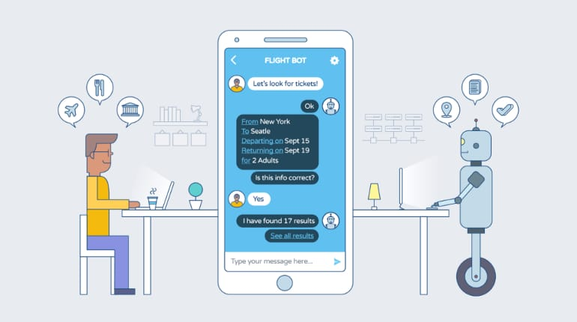

Step 10:

Security and Privacy:

Implement security measures to protect user data and ensure privacy compliance, especially if the chatbot collects or stores sensitive information.

Step 11:

Scale and Optimize (as necessary):

If your chatbot gains popularity, be prepared to scale your infrastructure to handle increased traffic and optimize its performance.

Step 12:

Documentation and User Training:

Provide clear documentation and user training materials so users understand how to interact with your chatbot effectively.