Creating a Chatbot in Python

Development part2

Objectives:

Creating a chatbot in Python involves developing a program that can interact with users through natural language. Here's a more detailed description of the steps involved.

Step 1:

Define the Purpose and Scope:

Determine the specific purpose and functionality of your chatbot. What will it do? Who is the target audience?

Step 2:

Choose a Framework or Library:

Decide whether you want to build a rule-based chatbot or an AI-powered one. You can use libraries like NLTK, spaCy, or frameworks like Rasa, Dialogflow, or the open-source ChatterBot.

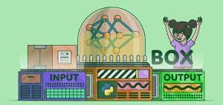

Step 3:

Collect and Prepare Data:

If you're building an AI chatbot, you'll need training data. Collect and preprocess datasets, if necessary, to train your bot.

Step 4:

Design the Conversation Flow:

Create a flowchart or outline for the conversation. Define possible user inputs and expected bot responses.

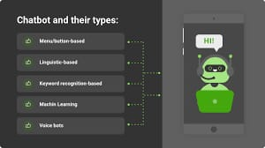

Step 5:

Coding the Bot:

Write the Python code for your chatbot. Depending on the chosen framework, you'll need to impleme nt the logic for understanding user input and generating responses.

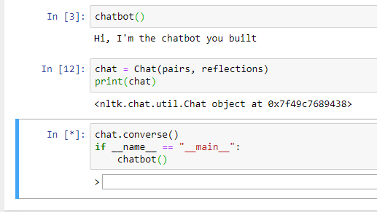

Step 6:

Natural Language Processing (NLP):

If your chatbot uses NLP, integrate NLP libraries to understand and process user input. This may involve tasks like tokenization, entity recognition, and sentiment analysis.

Step 7:

Integrate APIs:

If your chatbot needs to access external data or services, integrate relevant APIs into your code.

Step 8:

Testing:

Test your chatbot extensively. Check how it responds to different user inputs and make necessary adjustments.

<https://www.google.com/url?sa=i&url=https%3A%2F%2Fwww.pluralsight.com%2Fguides%2Fbuild-a-chatbot-with-python&psig=AOvVaw2bo38uQvgJftFAjs-2SxTQ&ust=1698302928894000&source=images&cd=vfe&opi=89978449&ved=0CBEQjRxqFwoTCOiJ67jNkIIDFQAAAAAdAAAAABAa>

Step 9:

User Interface (Optional):

If your chatbot will have a user interface, design and implement it using libraries like Tkinter, Flask, or a web framework like Django.

Step 10:

Deploy the Chatbot:

Choose where you want to deploy your chatbot. It could be a website, a messaging platform, or even a standalone application.

Step 11:

Continuous Improvement:

Monitor the chatbot's performance, collect user feedback, and make regular updates to improve its capabilities and responses.

Step 12:

Documentation:

Create documentation for your chatbot, including how to use it and maintain it.

Remember that building a chatbot can be a complex process, and the specific steps may vary based on your project's requirements. Depending on the complexity and scale of your chatbot, you may need to collaborate with others, including data scientists, UX designers, and backend developers to create a robust and user-friendly chatbot.