DOCUMENTATION

CREATE A CHATBOT IN PYTHON

PROBLEM STATEMENT :

The problem statement for creating a chatbot in Python typically includes the following key components:

Objective: Define the main goal of the chatbot. What is the chatbot supposed to do?

For example: it could be for customer support, answering FAQs, providing information, or engaging in casual conversation.

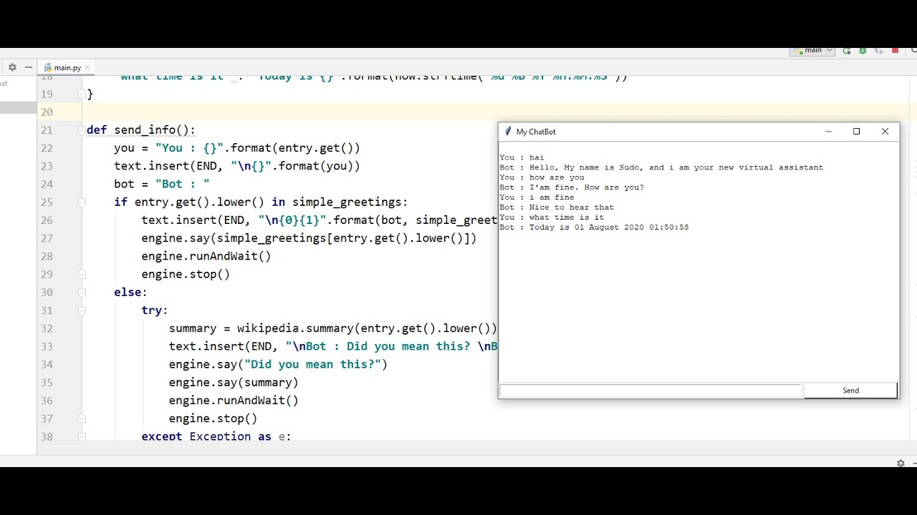

Target Audience: Specify the intended users or audience for the chatbot. Is it designed for customers, employees, or a specific group of people.

Functionality: Describe the specific tasks and functions the chatbot should be able to perform. This could include answering questions, providing recommendations, processing user requests, and more.

Integration: If the chatbot needs to integrate with other systems or databases, mention the details of these integrations. For example, if it needs to access a product database to provide information about products.

Platform and Environment: Specify the platform where the chatbot will be deployed (e.g., a website, messaging app, or standalone application) and the technology stack (Python, frameworks, libraries) that will be used to build it.

User Experience: Explain the desired user experience and the conversation flow. How should the chatbot engage with users? What should the user interface look like?

Natural Language Understanding: If the chatbot needs to understand and respond to natural language, mention the NLP (Natural Language Processing) techniques and tools that will be employed.

Testing and Evaluation: Describe the criteria for testing and evaluating the chatbot's performance, such as accuracy, response time, user satisfaction, etc.

Scalability and Maintenance: Consider scalability requirements, as well as plans for maintaining and updating the chatbot in the long run.

Budget and Resources: Specify the budget, resources, and timeline for developing the chatbot.

By clearly outlining these elements in your problem statement, you can provide a solid foundation for the development of a chatbot in Python.

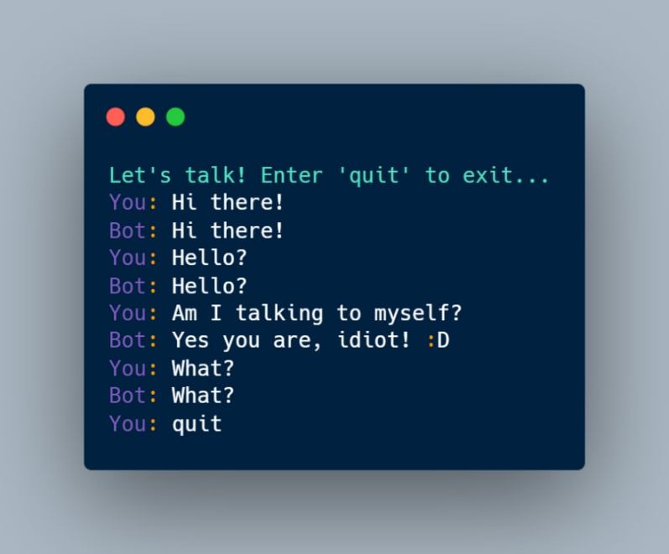

DESIGNING PROCESS:

Designing a chatbot in Python using the design thinking process involves several stages. Here's a simplified overview:

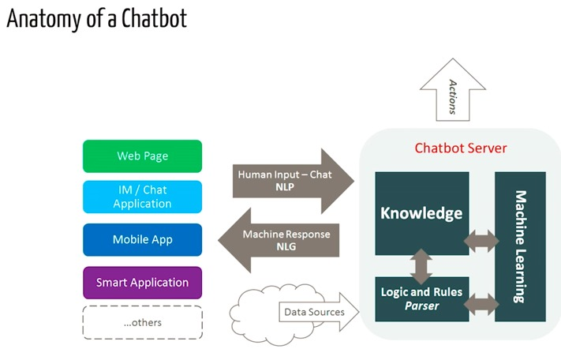

Empathize:

1. Understand the needs and pain points of your target users.

2. Conduct user interviews, surveys, or research to gather insights.

Define:

1. Clearly define the problem your chatbot will solve.

2. Create user personas and user stories to understand your users better.

Ideate:

1. Brainstorm ideas for your chatbot's functionality and features.

2. Encourage creative thinking and generate a range of solutions.

Prototype:

1. Create a basic, low-fidelity prototype of your chatbot.

2. Use Python libraries like NLTK, spaCy, or frameworks like Rasa to build the initial chatbot structure.

Test:

1. Get feedback from users by conducting usability tests.

2. Identify what works and what doesn't in your chatbot's prototype.

Iterate:

1. Based on user feedback, refine and improve your chatbot's design.

2. Adjust its functionality, user interface, and conversational capabilities.

Develop:

1. Begin coding the chatbot in Python using a suitable framework or library.

2. Integrate natural language processing (NLP) tools and machine learning if needed.

Test Again:

1. Continuously test and refine the chatbot as you develop it.

2. Address any issues or bugs that arise during testing.

Launch:

1. Deploy your chatbot to a platform where users can interact with it.

2. Monitor its performance and gather real-world user data.

Gather Feedback:

1. Collect feedback from users after the chatbot is live.

2. Use this feedback to make ongoing improvements and updates.

Maintain and Evolve:

1. Regularly update and maintain your chatbot to keep it relevant and effective.

2. Add new features and expand its capabilities as necessary.

Throughout this process, you'll use Python for the development part, making use of Python libraries and frameworks for chatbot development. You may also need a web framework like Flask or Django if you plan to integrate your chatbot into a web application.

DEVELOPING STAGE:

Developing a chatbot in Python involves several phases. Here's an overview of the typical development process:

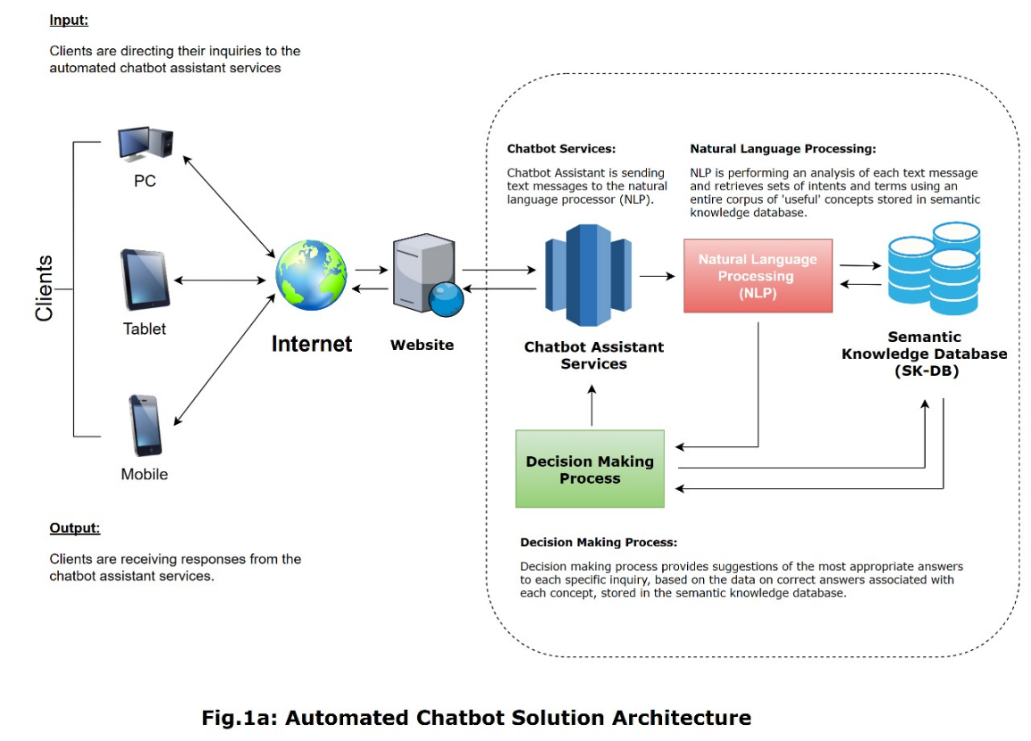

Define the Purpose and Scope:

Determine the chatbot's purpose, what it will do, and who its target users are. Understand the problem you want the chatbot to solve.

Design the Conversation Flow:

Create a conversational flowchart that outlines how the chatbot will interact with users. Define the possible user inputs and corresponding bot responses.

Choose a Framework or Library:

Select a Python framework or library for building your chatbot. Popular choices include NLTK, spaCy, and frameworks like Rasa or ChatterBot.

Data Collection and pre processing :

Gather and preprocess data, which may include conversation logs, FAQs, or any relevant information. Clean and format the data for training and understanding.

Natural Language Processing (NLP):

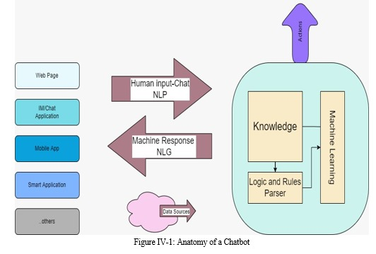

Implement NLP techniques to understand user inputs. This includes tokenization, entity recognition, and intent classification.

Training the Model:

Train your chatbot model using the preprocessed data. This could involve machine learning models like deep learning, rule-based systems, or a combination of both.

Integration with Platforms:

Integrate your chatbot with messaging platforms or websites where it will be used. For example, you can integrate with Facebook Messenger, Slack, or your own website.

User Interface (UI):

Design a user-friendly interface for the chatbot, if needed. This can be a simple text interface or a more complex graphical one.

Testing and Feedback:

Thoroughly test the chatbot with different user scenarios. Collect feedback and continuously improve its performance based on user interactions.

Deployment:

Deploy your chatbot to a server or cloud platform, ensuring it's accessible to users 24/7.

Monitoring and Maintenance:

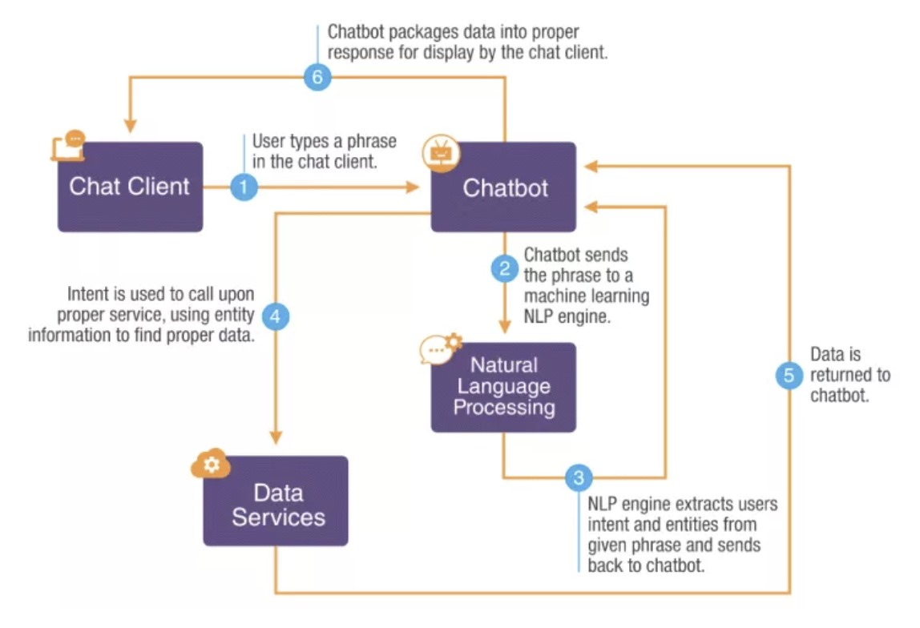

Regularly monitor the chatbot's performance, analyze logs, and address any issues that arise. Keep the knowledge base up to date.

Scaling and Optimization:

As your chatbot gains users, consider scaling its infrastructure and optimizing its response times.

Security and Privacy:

Ensure that user data and interactions are secure and comply with relevant privacy regulations.

Feedback Loop:

Continuously gather user feedback and make improvements to enhance the chatbot's capabilities and user experience.

Remember that the development of a chatbot is an iterative process, and it may require ongoing improvements and updates to meet user expectations and evolving needs.

BUILDING STEPS:

Building a chatbot in Python with NLP techniques typically involves the use of several libraries and a specific integration process. Here's a high-level overview:

1. Libraries
2. Natural Language Processing (NLP) Libraries:

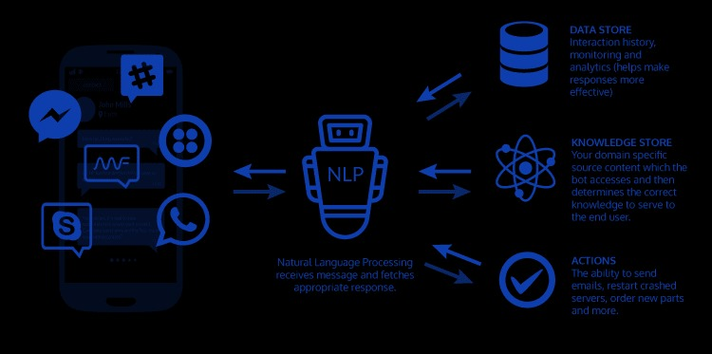

- NLTK : (Natural Language Toolkit): NLTK provides tools and resources for working with human language data. It includes tokenization, stemming, and various NLP algorithms.

- spaCy : spaCy is a popular NLP library that offers fast and efficient text processing, including tokenization, named entity recognition, and part-of-speech tagging.

- TextBlob : TextBlob simplifies text processing tasks and sentiment analysis.

Transformers (Hugging Face):

For advanced models like BERT, GPT-3, or RoBERTa, the Transformers library by Hugging Face is essential.

b. Machine Learning Libraries:

- Scikit-learn: Often used for traditional machine learning tasks within a chatbot, such as intent classification.

- TensorFlow or PyTorch: For training and deploying deep learning models, including custom chatbot architectures.

c. Chatbot Frameworks:

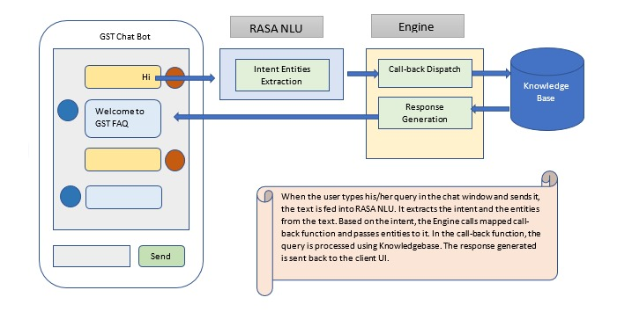

- Rasa: Rasa is an open-source chatbot development framework that offers NLP integration, dialogue management, and customizable chatbot behavior.

- Dialogflow (by Google): A cloud-based NLP platform that simplifies chatbot development with pre-trained models.

- Microsoft Bot Framework: For building chatbots that can integrate with various platforms like Microsoft Teams.

d. Web Frameworks:

- Flask or Django: These frameworks can be used to create a web-based interface for your chatbot.

2. Integration of NLP Techniques:

To create a chatbot with NLP capabilities, you typically follow these steps:

a. Data Collection: Gather and prepare conversational data for training your chatbot. This data can be in the form of text conversations, which you'll use for intent recognition, entity extraction, and dialogue modeling.

b. Preprocessing: Use NLP libraries to preprocess the text data, which may include tokenization, stemming, and cleaning.

c. Intent Recognition: Train a machine learning model (using scikit-learn, TensorFlow, or PyTorch) to recognize user intents in the chat. This helps the chatbot understand what users want.

d. Entity Recognition: Utilize NLP techniques to identify and extract specific entities from user inputs, such as dates, names, or locations.

e. Dialogue Management: Implement a dialogue management system to keep track of the conversation flow and decide how the chatbot should respond to user inputs.

f. Response Generation: Depending on the architecture of your chatbot, you might use rule-based responses or more advanced techniques like sequence-to-sequence models or transformers to generate responses.

g. User Interface: Develop a user-friendly interface for users to interact with your chatbot, which can be a web interface or integrated with messaging platforms like Facebook Messenger or Slack.

h. Testing and Deployment: Thoroughly test your chatbot and deploy it on the desired platform. Continuous monitoring and improvement are essential.

the choice of libraries and the specific integration process can vary based on your project's requirements, but this provides a general outline of building a chatbot with NLP techniques in Python.

INTERACTION WITH USERS:

A chatbot's interaction with users and a web application typically involves the following components:

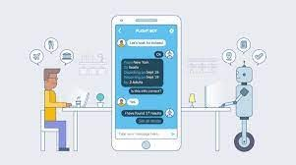

1. User Input: Users interact with the chatbot through a user interface, which can be a web application, messaging platform (e.g., Facebook Messenger), or any other communication channel. They enter text or voice messages to communicate with the chatbot.
2. User Interface (Web Application): In the context of a web application, the chatbot is embedded within the application's interface. Users can access the chatbot through a chat window or widget on the web page. This interface allows users to type or speak their messages to the chatbot.
3. Input Processing:

- When a user sends a message, the web application captures the input and sends it to the chatbot's backend for processing.

- The chatbot's backend receives the user's message as a text input.

4. NLP Processing:

- The chatbot's backend uses NLP techniques and libraries to process the user's input. This includes tasks like tokenization, intent recognition, and entity extraction.

- NLP models may be employed to understand the user's intent and extract relevant information from the input.

5. Intent Recognition:

- The chatbot identifies the user's intent, determining what action the user wants to take. For example, if a user asks, "What's the weather like today?" the intent might be to retrieve weather information.

6. Response Generation:

- The chatbot uses machine learning models or predefined rules to perform intent recognition.

- Response generation can involve rule-based responses or more complex natural language generation using models like GPT-3 or transformers.

7. Dialogue Management:

- The chatbot keeps track of the conversation context and maintains a history of user inputs and chatbot responses.

- This context helps the chatbot maintain a coherent and relevant conversation.

8. Web Application Integration:

- The chatbot's backend sends the generated response back to the web application.

- The web application displays the chatbot's response to the user within the chat interface.

9. User Feedback and Interaction Loop:

- Users can continue the conversation, provide feedback, or ask follow-up questions.

- The chatbot processes subsequent user messages and follows the same interaction flow to respond appropriately.

10. Data Storage and Analysis:

- The chatbot may log user interactions and responses for analysis and improvement.

- Data analytics and user feedback can be used to enhance the chatbot's performance over time.

11. Deployment and Maintenance:

- The chatbot and web application are deployed on a server or cloud platform, making them accessible to users.

- Regular maintenance, updates, and monitoring ensure the chatbot functions effectively and provides a positive user experience.

The chatbot interacts with users through a web application by processing user input, applying NLP techniques, recognizing intents, generating responses, and maintaining a coherent dialogue. The web application acts as the interface for users to

communicate with the chatbot, displaying the chatbot's responses and facilitating the conversation.

VARIOUS TECHNIQUES:

Creating a chatbot in Python involves various techniques and approaches. Here are some innovative techniques and approaches that can be used in chatbot development:

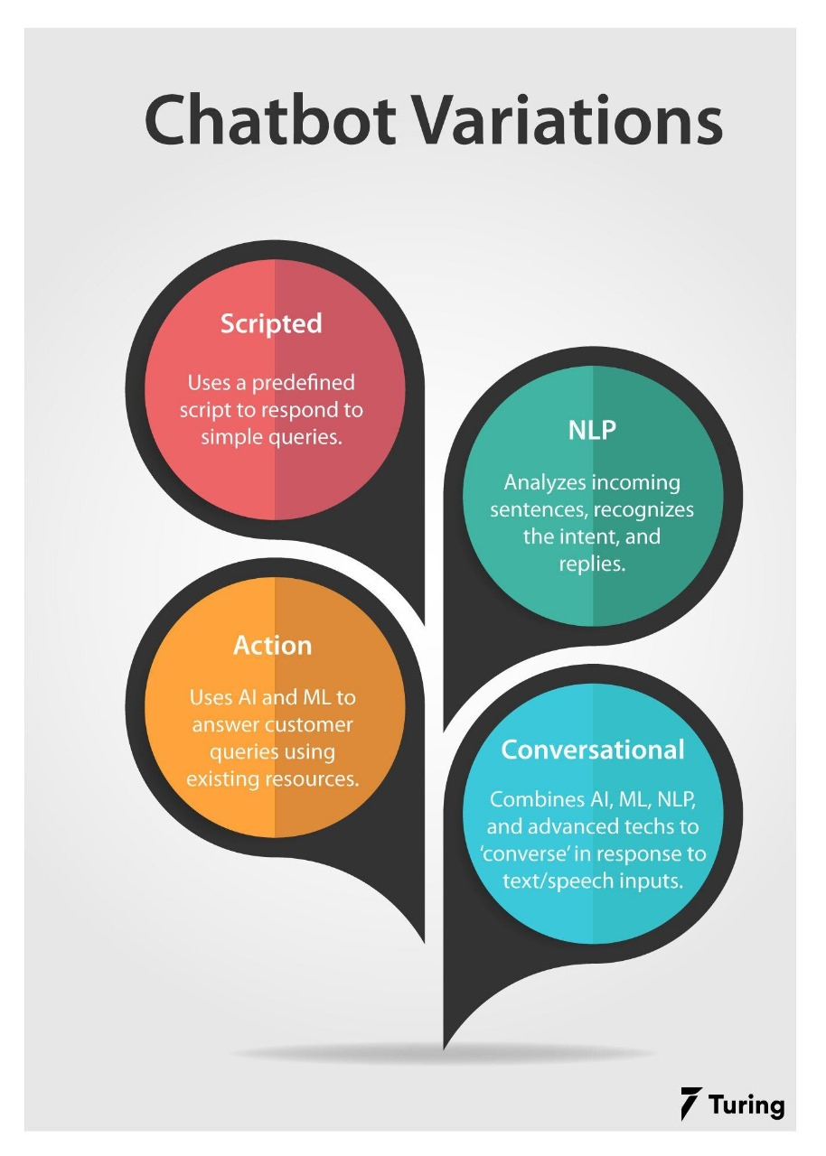

1. Natural Language Processing (NLP):

- Utilize NLP libraries like spaCy, NLTK, or Hugging Face's Transformers to process and understand user input.

- Implement Named Entity Recognition (NER) to identify entities like names, dates, and locations in user messages.

2. Pre-trained Models:

- Fine-tune pre-trained language models (e.g., GPT-3, BERT) for chatbot-specific tasks to leverage their knowledge and language understanding.

3. Reinforcement Learning:

- Train your chatbot using reinforcement learning techniques to improve its conversational abilities over time through user interactions.

4. Context Management:

- Maintain context and conversation history to provide meaningful responses. Contextual chatbots understand references to prior messages.

5. Multi-turn Conversations:

- Design your chatbot to handle multi-turn conversations by keeping track of the dialogue flow and context.

6. Sentiment Analysis:

- Analyze user sentiment using sentiment analysis libraries to provide more empathetic and context-aware responses.

7. Rich Media Support:

- Enhance user engagement by incorporating support for rich media such as images, videos, and interactive elements in the chatbot's responses.

8. Integration with APIs:

- Connect the chatbot to external APIs for real-time data retrieval, such as weather information, news updates, or e-commerce product details.

9. User Profiling:

- Create user profiles to personalize interactions and tailor responses based on user preferences and history.

10. A/B Testing:

- Experiment with different conversation strategies, responses, or user interfaces to continuously improve the chatbot's performance.

11. Explainability:

- Implement techniques to make the chatbot's decision-making process more transparent and understandable to users.

12. Multilingual Support:

- Make your chatbot multilingual by using translation APIs and language-specific models to serve a broader audience.

13. Voice Recognition:

- Integrate speech recognition and synthesis for voice-based interactions alongside text-based chat.

14. Emotion Recognition:

- Recognize user emotions through text and voice cues and adjust responses accordingly for a more emotionally intelligent chatbot.

15. Chatbot Deployment:

- Deploy your chatbot on various platforms, including websites, messaging apps, and social media, to reach a wider audience.

These innovative techniques and approaches can help you create a more advanced and effective chatbot in Python. Keep in mind that the choice of techniques should align with your chatbot's specific goals and target audience.