

DESIGN GUIDELINES and BEST PRACTICES

General Design Considerations:

While most high quality files will print well with digital print, ensuring your file is formatted properly
will help you achieve the highest quality print possible. That means ensuring that the colors used in
your design are safe to print, the physical dimensions (length and width) of the logo are large
enough, and the resolution (clarity) is high enough to print clearly at our standard print sizes.
The system will NOT inspect your logo after uploading it. If your design has poor resolution or a
solid colored background, it will display and print that way on products your customers purchase.

Artwork Specifications:

- Dimensions: 11 inches x 13 inches
- Resolution: 300 dots per inch
- File Type: PNG image with a transparent background
- Colors: sRGB color profile

The dimensions of your file are determined by the tallest and widest points in your design that
include pixels (or dots of color). We will remove all negative space in your design when it’s uploaded.
Regardless of the dimensions of your file, your artwork will be scaled to fit the standard print
dimensions for the specific garment type and size that’s ordered. For best print results, make sure
your design is 300 DPI at 11 inches wide and/or 13 inches tall so it can be printed on all products
effectively. We will automatically scale your artwork down to fit products with smaller print sizes.

Default Print Sizes by Product:

- Adult Shirt Default: 11 x 13 inches (on size Large)
- Youth Shirt Default: 9 x 11 inches (on size X-Large)
- Adult Hoodie Default: 11 x 11 inches (on size Large)
- Youth Hoodie Default: 10 x 10 inches (on size X-Large)
- Left Chest (also shorts, pants, bags): 4 x 3.5 inches (on size Large apparel)
- Tote Bags Default: 11.41 x 13 inches

We take care of image sizing for you, scaling your artwork to ensure your print size is proportional to
the placement on your mockup regardless of garment size. The dimensions above represent the
standard print size on size Men’s/Unisex Large or Ladies’/Youth X-Large garments as indicated.
Designs that are low resolution (or become low resolution when scaled to print size) will print with
low quality. This is particularly important with DIGISOFT® printing, as DIGISOFT® is capable of
capturing the detail in high or low resolution designs. Ensure the edges of your artwork are clean
and crisp at print size, without being blurry or jagged.

Colors: RGB vs. CMYK:

We recommend using in-gamut sRGB colors or CMYK colors to create your design files and can accurately capture all CMYK and print-safe sRGB colors.

What’s the Difference?

Put simply, RGB colors are from a wider color spectrum than CMYK colors. RGB colors use light to
create their vibrancy, so they’re not always achievable in print.

RGB: Generally, when designers are creating images for use on screens, they will use an RGB color
profile. RGB colors come from a wider spectrum and take into consideration that a screen is backlit
-- RGB profiles can create very bright and vibrant colors. Using RGB color profiles to design your
artwork will result in beautiful on-screen color that may not translate accurately to print.

CMYK: For all types of physical print, Cyan, Magenta, Yellow, and Black pigment is added together
to create the print color. When a printer converts a file created with an RGB file into CMYK colors for
print, they can lose quite a bit of their vibrancy unless the files were created with that process in
mind. We recommend designing in print-safe sRGB colors for the most accurate on-screen
representation of the print colors you'll see on a garment. When saving your artwork as a .png file, it
will need to be converted into an RGB profile (but your colors will maintain more accuracy on
screen).

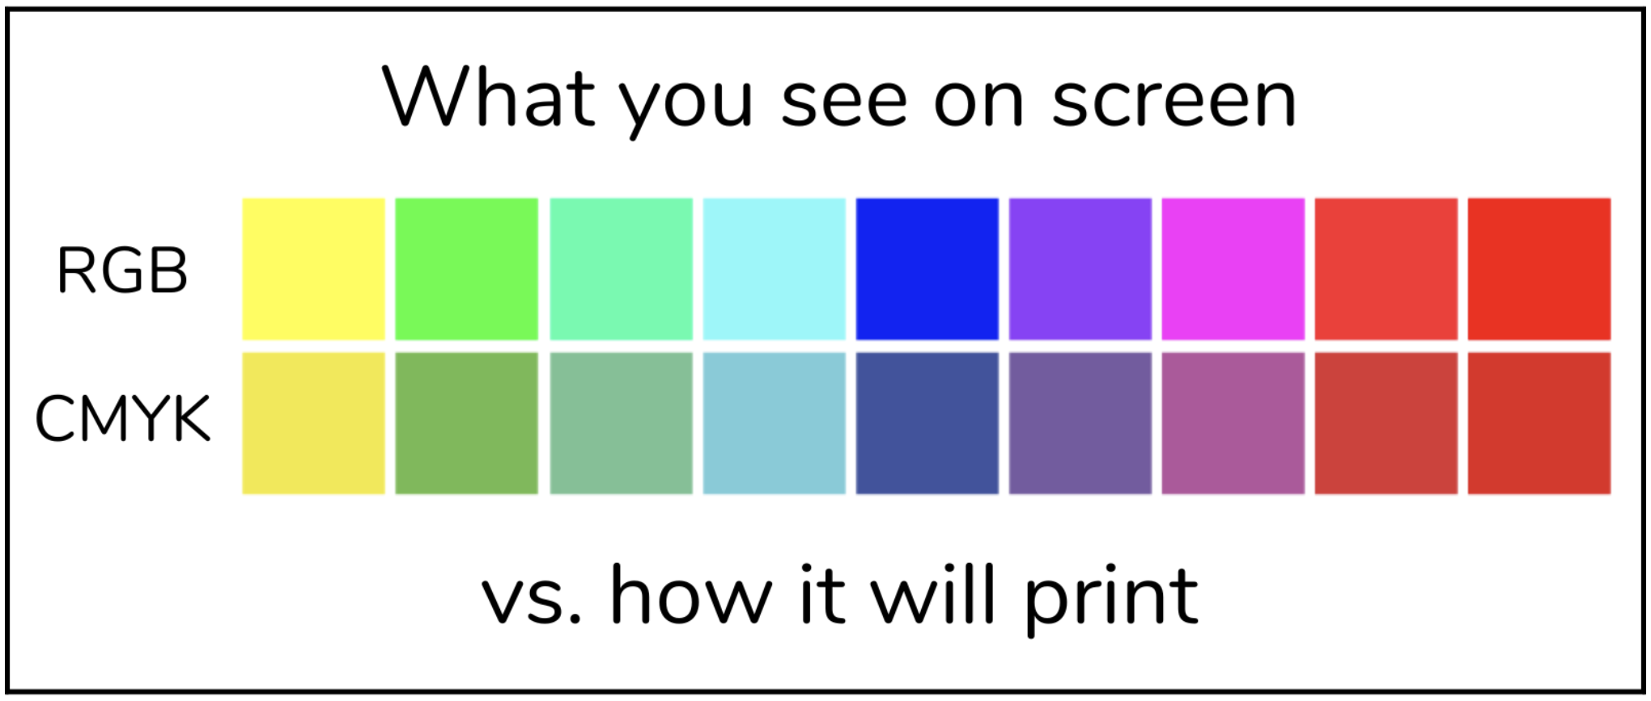

Special Design Considerations:

Use areas of full transparency in your design for a softer hand-feel.
If you’re looking for a barely-there hand-feel on your garments, you can use areas of transparency
throughout your design to achieve a more lightweight print. A big block of ink will always feel heavy
regardless of the decoration method, but DIGISOFT® allows designs with areas of transparency to
blend nicely with the garment, giving a much softer hand-feel than other print types on the market.



Use 100% opacity in all design elements.
In order to ensure the most vibrant print colors, be sure to use 100% opacity in all your design
elements. Similar to DTG, DIGISOFT® uses a base layer below pigmented ink to help your print bind
to the garment. When there isn’t enough pigmented ink laid on top of that base layer, you may
experience muddier print colors. Stick with 100% opacity for full vibrancy.

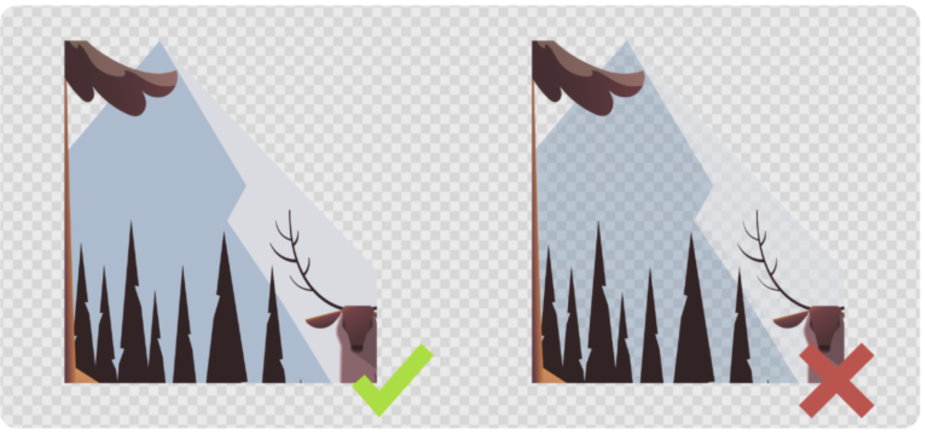

Avoid transparent gradients – Opt for halftones instead.
Just as you want to use 100% opacity in your design elements, you’ll also want to avoid effects like Glow, Smoke, and other types of transparent gradients that rely on reducing the opacity of your pixels. Instead, opt for halftones, which use dots of 100% opacity that reduce in size and density as
they move further away from the main design elements. Gradients from one color to another will
print beautifully with DIGISOFT®, but avoid gradients that fade from one color to transparency.

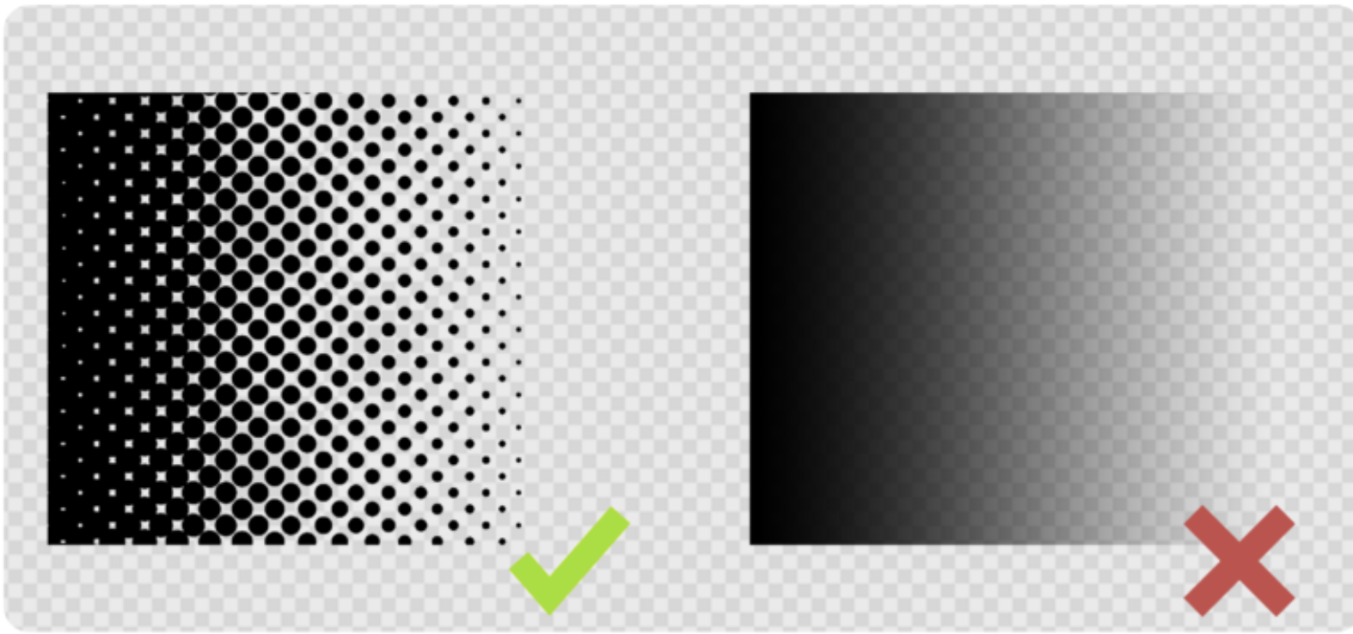

Use background color to achieve distressing rather than relying on low opacity pixels.
If you want to achieve a distressed look, try adding a white background layer behind your distressed
design elements. This will allow you to achieve a “scuffed” appearance without compromising print
quality. If you want to use more traditional distressing techniques, try removing semi-transparent
pixels afterward for a cleaner result.

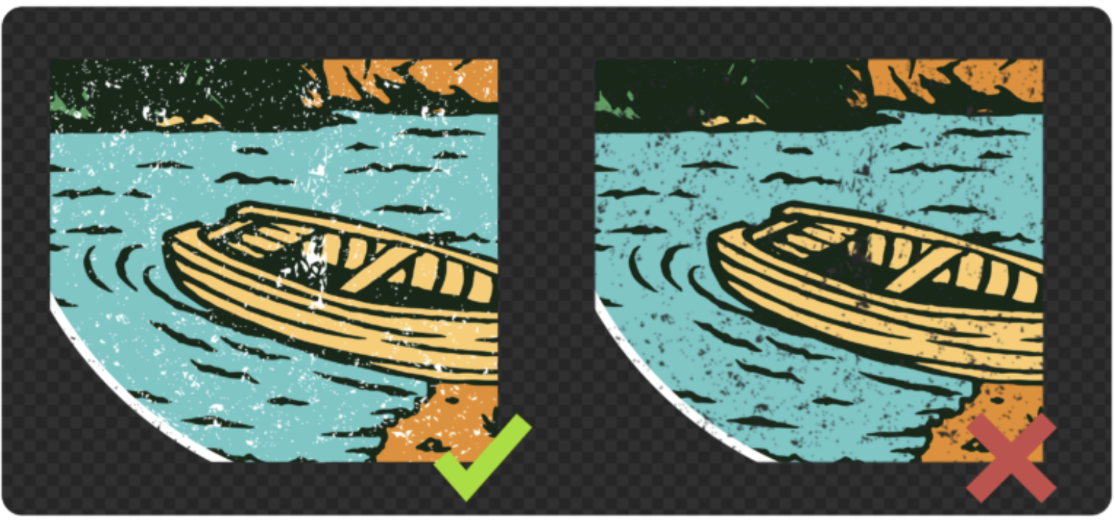

Ensure the edges of your design elements are clean and contain no stray pixels.
Following the guidelines above will ensure that the edges of your design are clean, but it’s worth
mentioning again – anything that is included in your design will be printed with DIGISOFT®. That
means if you accidentally leave a few stray pixels in your design file, they will print. Similarly, if you
resize your file from a smaller size, it may leave semi-transparent pixels around the edge of your
design elements. The cleaner the file, the cleaner the print!

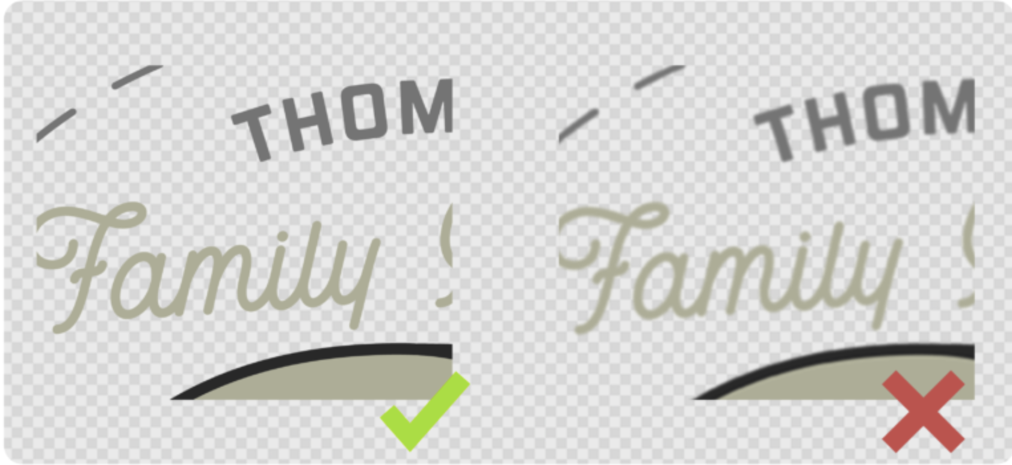

Keep in mind that every color in your design will print. That means if you submit a
design with a black background, the black background will be printed. Similarly, a design submitted
with a white background will be printed with a white background (regardless of garment color).

Please submit files exactly as you want them to be printed.

Print Size Scenarios:
In the first example, a file is uploaded that is smaller than the print size for a t-shirt. The negative space within the file is removed when the file is uploaded to the platform, which reduces the overall file size to match the size of the logo within it. When the design is printed, it’s enlarged to fill the print space for the t-shirt. If your logo is too small, it may cause the edges of your print to be less crisp when it’s enlarged for print.
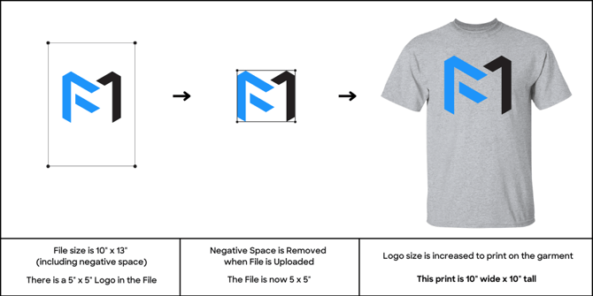

Next, this same logo is uploaded with file cropping turned off during upload. You will need to specify this to Imaginate.
Please note: the logo is positioned at the top of the art file to ensure proper print placement. If the print should be positioned lower, please lower the design within your file.
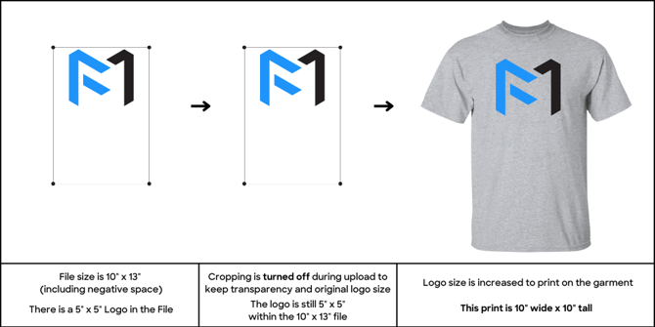

In the next example, the same logo size is used, but with the addition of full-width text below the logo. This text matches the full print width of 10”, which will ensure the logo size remains fixed & no scaling is required.
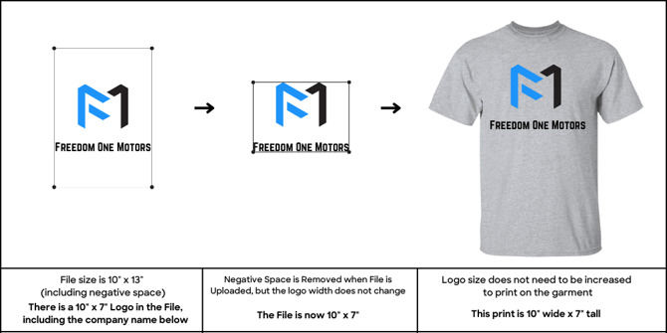

In our final example, we can see how the logo from above is resized to fit a Left Chest print placement. Because this artwork is wider than it is tall, we reach the maximum Left Chest print width of 4.5” on size Large. In order to maintain the design’s original shape, it prints at 2.8” tall.
