**Analyzing Electric Vehicles Data Using Power BI**

Mehar Singh Bawa

College of Business, Colorado State University

**CIS-570: Business Intelligence**

**Dr. Hamed Qahri-Saremi**

**May 12, 2025**

# Table of Contents

|  |  |  |
| --- | --- | --- |
| **Section No.** | **Section Title** | **Page No.** |
| 1 | Introduction | 3 |
| 2 | Research Questions and Relevance | 4 |
| 3 | Dataset Description and References | 6 |
| 4 | Data Modeling in Power BI | 9 |
| 5 | DAX measures and calculated columns | 12 |
| 6 | Dashboards and Visualization | 15 |
| 7 | Conclusion and Final Remarks | 29 |
| 8 | References | 31 |

# Introduction

Electric Vehicles (EVs) have become a major part of today’s automotive conversation not just for sustainability, but also from a financial and economic point of view. As the shift away from internal combustion engines gains momentum, it’s important to understand whether EVs genuinely offer long-term economic advantages, both to consumers and to the global market.

The rapid shift toward electric mobility has sparked global interest in EVs as an economically and environmentally sustainable alternative. However, cost remains a major adoption barrier for consumers and stakeholders. This report investigates whether EVs offer tangible economic advantages and identifies models and regions where EV performance is strongest. Our goal is to derive insights using data visualization and business intelligence tools.

This project aims to explore those questions using real-world data. We wanted to analyze how EVs perform in terms of annual and long-term costs, which EV types (BEVs, PHEVs, Hybrids) offer better returns, which region have charging points (fast & slow) and where in the world EV adoption and infrastructure is growing the fastest. The goal was to turn complex data into something visual and understandable using Power BI.

One segment of our analysis focused on the efficiency and environmental performance of both electric and fuel-based vehicles. We explored which EV makes offer the highest range per hour of charge and which traditional vehicles produce the highest CO2 emissions. By using quadrant-based scatter plots and animated bubble charts in Power BI, we were able to visualize how charging time, range, and emissions vary across makes and model years. This helped translate technical metrics into intuitive visuals that support smarter decisions for buyers, manufacturers, and policymakers.

Our project doesn’t just look at whether EVs are better, it connects cost metrics, vehicle types, regional adoption patterns and charging points to help draw meaningful, data-driven conclusions. For decision-makers like buyers, investors, and policy planners, these insights matter.

Through this report, we walk through the research questions that shaped our analysis, the datasets we used, how the Power BI model was designed, and the dashboards we built to make those answers visible and clear.

# Research Questions and Justification

To guide this project, we focused on the below questions that are not only relevant from a business and consumer standpoint but also align with current trends in data-driven decision-making and digital reporting. Each question was chosen with practical justification in mind:

**Q1: Are Electric Vehicles Economically Better Than Gas Vehicles?**

This is the starting point for most buyers and investors. EVs are often marketed as being “cheaper in the long run,” but how much cheaper? We wanted to answer this with real cost data, looking at annual fuel expenses and five-year ownership costs, compared directly between EVs and traditional ICE vehicles. This insight is useful not just to buyers but also to companies and governments looking to understand the return on EV adoption.

**Q2: Which EV Type Offers the Best Return? And Which Models in Particular?**

Not all EVs are the same. There are Battery Electric Vehicles (BEVs), Plug-in Hybrid Electric Vehicles (PHEVs), and standard Hybrids, each with its own performance and cost profile. This question allowed us to explore those differences and identify which EV type actually offers the most savings. We also drilled down to the model level to find standout vehicles offering the best combination of range and cost-effectiveness. This is useful for consumers, businesses managing vehicle fleets, and industry analysts.

**Q3: Which Regions Are Emerging as the Most Economically Viable EV Markets?**

EV growth isn’t equal across the globe. Some regions are well ahead in adoption, and market share, while others are just starting. We wanted to understand which regions have the strongest EV penetration, how fast their EV sales are growing, and what this says about their economic readiness for EV expansion. This is valuable for policymakers, global automakers, and investors assessing market potential.

**Q4: How does EV performance vary by price and brand?**

This question identifies which manufacturers deliver superior value across price segments, supporting consumer decision-making and manufacturer benchmarking.

**Q5: What is the relationship between annual EV sales and the installation of new charging points?**

Shows if charging stations are being built fast enough to match EV sales. Helps governments and businesses plan where to invest next to avoid shortages.

**Q6: How has the charging infrastructure evolved annually, including YoY growth?**

Tracks how quickly charging stations are being added each year. Understanding infrastructure dynamics helps measure market maturity and the effectiveness of fast-charging deployment to reduce adoption barriers.

**Q7: How has the ratio of fast EV charging points yearly, and what growth patterns emerge?**

Tracks if charging stations are keeping up with EV drivers' needs. Fast chargers help on highways, while slow chargers work for overnight charging. This shows where governments should invest more to reduce wait times and boost EV adoption.

**Q8: Which regions and countries lead in charging infrastructure density?**

Reveals which countries have the most charging stations. This helps other regions compare their progress and learn from leaders. High charger density means more convenience for drivers and faster EV sales growth.

**Q9. Which vehicle Makes deliver the highest charging efficiency in terms of miles gained per hour of charge?**

For EV users, understanding which makes provide the best mileage for every hour of charging is essential for informed purchasing decisions. It provides a practical comparison of efficiency.

**Q10. Which electric vehicles provide the best range for the number of hours charged?**

A quadrant-based scatter plot analysis helps distinguish EVs that are exceptionally efficient - i.e., those that charge faster and provide higher range, critical for consumers looking to minimize charging time.

**Q11. Which fuel-based vehicle models are the highest polluters based on CO2 emissions?**

Understanding which vehicles contribute the most to carbon emissions helps policymakers, manufacturers, and users push for environmental-friendly transportation solutions.

These questions shaped our dashboards and analysis, helping us draw clear, actionable insights from complex datasets.

# Dataset Description and References

This project uses three publicly available datasets that cover both vehicle-level and region-level data. These datasets were selected for their relevance, credibility, and completeness. Together, they provide the information required to evaluate cost, model performance, and regional adoption of Electric Vehicles (EVs).

**3.1 FuelEconomy.gov Dataset**

* **Source**: U.S. Department of Energy
* **URL**: <https://www.fueleconomy.gov/feg/download.shtml>
* **Scope**: This dataset contains detailed records for individual vehicles, including make, model, fuel type, annual fuel cost, and five-year ownership cost estimates.
* **Purpose**: It is used to compare the cost of owning and operating EVs versus Internal Combustion Engine (ICE) vehicles. It also helps identify top-performing EV models based on cost.

**3.2 IEA Global EV Data Explorer**

* **Source**: International Energy Agency (IEA)
* **URL**: <https://www.iea.org/data-and-statistics/data-tools/global-ev-data-explorer>
* **Scope**: This dataset includes global EV sales data by vehicle type, region, and year. It provides EV market share data relative to total vehicle sales. It also includes EV charging points data by charge type, region and year.
* **Purpose**: It supports the analysis of EV growth trends and Identify infrastructure gaps. It also helps compare EV adoption and infrastructure development across different regions.

**3.3 Kaggle Electric Vehicle Population Dataset**

* **Source**: Kaggle
* **URL**: <https://www.kaggle.com/datasets/sahirmaharajj/electric-vehicle-population>
* **Scope**: This dataset includes information about EV models, types (BEV, PHEV, Hybrid), and classification.
* **Purpose**: It is used to confirm vehicle categorisation and enhance the analysis of EV performance across different types.

All datasets were accessed in April 2024. They were cleaned, standardized, and structured in Power BI to support dashboard creation and time-based analysis.

**3.4 Data Granularity and Structure**

The data used in this project operates at two main levels of granularity. This structure allows the dashboards to support both detailed, model-specific analysis and broader, region-level comparisons. Maintaining consistency in granularity was important for producing accurate and meaningful insights across all three dashboards.

**3.4.1 Vehicle-Level Granularity**

The following tables operate at the vehicle level, where each record represents a unique vehicle identified by its model and production year:

* FuelEconomy
* EVPerformance
* VehicleInfo

This level of detail supports calculations related to annual fuel costs, five-year ownership costs, electric range, and charging characteristics for individual models.

**3.4.2 Region-Level Granularity**

The region-level data represents aggregated sales and market share information across multiple vehicle types within a specific year and region:

* EVSales
* EVSalesShare

Each record in these tables corresponds to a specific region, year, and EV category. This structure allows for the analysis of adoption trends and market growth across different parts of the world.

**3.4.3 Lookup Tables**

* YearTable: A calendar table with a continuous yearly range, enabling uniform time-based filtering across all data sources.
* Region: A table containing a unique list of regions extracted from the EV sales data.
* VehicleType: A table grouping vehicles by classification, used to filter dashboard visuals by BEV, PHEV, or Hybrid.

|  |  |  |
| --- | --- | --- |
| **Table name** | **Granularity level** | **Description** |
| FuelEconomy, EVPerformance, VehicleInfo | VehicleID and Year | One record per unique vehicle configuration |
| EVSales, EVSalesShare | Region, Year, Vehicle Type | Aggregated data per region and EV category |
| YearTable | Year | Continuous range for time-based filtering |
| Region | Region name | Lookup table for region-based analysis |
| EVInfrastrucure | Region, Year | Aggregated data per region and charge type category |

# Data Modeling in PowerBI

Once the datasets were collected, we designed a unified data model in Power BI to support the kinds of questions we were trying to answer. This model enables consistent filtering and analysis across all dashboards. It was designed to support cross-comparisons based on vehicle type, year, and region.

**Fact Table:**

* VehicleInfo: Contains metadata such as vehicle make, model, and type.

**Dimension Tables:**

* FuelEconomy: Contains economic data for each vehicle, such as annual fuel cost and five-year ownership cost.
* EVSales: Includes historical EV sales data by region, year, and vehicle type.
* EVSalesShare: Tracks the percentage of EV sales relative to total vehicle sales by region and year.
* EVPerformance: Provides additional details such as electric range, efficiency and charging time for selected EV models and brands and their prices.
* EVInfrastructure: Provides details such as charge type (fast or slow) by region and year.
* VehicleType: Used to group EVs by type (BEV, PHEV, Hybrid) for comparisons.
* YearTable: A generated calendar table used to enable uniform filtering and time-based calculations.
* Region: A table containing unique region names, used to link EV sales and share data.

**Relationships and Keys:**

* Vehicle-level tables are linked using VehicleID.
* Sales, Infrastructure and share data are connected using the year and region fields.
* All relationships are defined as one-to-many and directionally filtered to avoid ambiguity and ensure performance.

**Data Preparation and Transformation:**

* In Power Query, all datasets were cleaned to remove duplicate records, standardize column names, and correct inconsistent labels.
* Multiple EV sales files (for cars, vans, buses, and trucks) were appended into a single table to simplify modelling.
* Labels for vehicle types were aligned across all datasets to ensure compatibility with lookup tables.
* A date table was created using DAX to support filtering and time-based aggregation across dashboards.
* For the charging efficiency and emissions analysis, we filtered out entries with missing or zero values in key fields like ElectricRange_Total, ChargeTime_240V_Hours, and CO2Emissions_PrimaryFuel_gpm to ensure accurate and meaningful visual comparisons.
* A new region table was created to normalize data.
* New Measures like Yearly Growth and Fast Charger ratio were created to derive information for analysis.

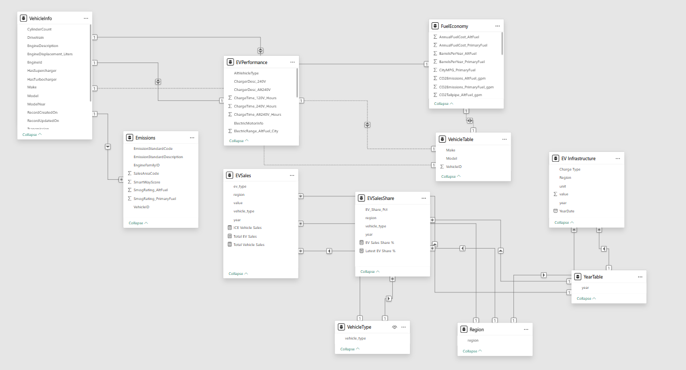Fig 5.1: Power BI Data Model

The resulting model enables the use of shared slicers and dynamic measures, allowing the dashboards to respond interactively to user selections across vehicle types, time periods, and regions.

# DAX measures and calculated columns

**5. 1 DAX Measures**

These measures were created to compute aggregated insights across dashboards. They are dynamic and respond to slicers and filters applied to Year, Region, and Vehicle Type.

|  |  |
| --- | --- |
| **Measure Name** | **Purpose** |
| AverageAnnualFuelCost | Calculates the average annual fuel cost across all vehicles |
| AverageFiveYearCost | Computes the average five-year total ownership cost |
| LatestEVSharePct | Returns the latest EV market share percentage based on max year |
| LatestEVSales | Returns the total EV sales for the most recent year |
| EVSalesTrend | Used in line charts to track EV vs ICE sales over time |
| TopCostSavingModels | Filters and ranks models based on lowest five-year cost |
| AverageAnnualFuelCostByType | Computes average annual fuel cost segmented by vehicle type |
| Yearly Charging Points Growth | Calculates annual % increase in chargers to track infrastructure expansion. |
| Sum of Charging Points | Aggregates total chargers for country comparisons |
| Prev Year Charging Points | Enables YoY growth analysis by storing prior year’s charger count. |
| Fast Chargers | Isolates high-power chargers to assess long-distance travel readiness. |
| Fast Charge Ratio | Measures % of fast chargers vs. total to evaluate infrastructure quality. |
| FiveYearCostByModel | Aggregates and ranks models using five-year cost savings |

**5.2 DAX Measure Definitions**

-- Average Annual Fuel Cost

AverageAnnualFuelCost =

AVERAGEX(FuelEconomy, FuelEconomy[AnnualFuelCost_PrimaryFuel])

-- Average Five-Year Ownership Cost

AverageFiveYearCost =

AVERAGEX(FuelEconomy, FuelEconomy[FiveYearCostComparedToAvg])

-- Latest EV Market Share Percentage

LatestEVSharePct =

VAR LatestYear = MAX(EVSalesShare[year])

RETURN CALCULATE(

AVERAGE(EVSalesShare[EV_Share_Pct]),

EVSalesShare[year] = LatestYear

)

-- Latest Total EV Sales

LatestEVSales =

VAR LatestYear = MAX(EVSales[year])

RETURN CALCULATE(

SUM(EVSales[Total EV Sales]),

EVSales[year] = LatestYear

)

-- Fast Charge Ratio

Fast Charge Ratio = DIVIDE([Fast Chargers], [Fast Chargers] +[Slow Chargers],0)

-- Fast Chargers

Fast Chargers = CALCULATE([Sum of Charging Points],

'EV Infrastructure'[Charge Type] = "Publicly available fast")

-- Prev Year Charging Points

Prev Year Charging Points = CALCULATE(

[Sum of Charging Points],SAMEPERIODLASTYEAR('EV Infrastructure'[YearDate]))

-- Sum of Charging Points

Sum of Charging Points = SUM('EV Infrastructure'[value])

-- Yearly Charging Points Growth

Yearly Charging Points Growth = DIVIDE(

[Sum of Charging Points] - [Prev Year Charging Points],

[Prev Year Charging Points], BLANK())

**5.3 Calculated Columns**

These are columns created to enable lookups, filtering, and classification logic across datasets.

|  |  |
| --- | --- |
| **Column Name** | **Purpose** |
| VehicleCategory (VehicleInfo) | Classifies vehicles into BEV, PHEV, or Hybrid using type logic |
| FullModelName | Concatenates make and model for display in visuals |
| EVType (EVSales) | Standardises EV type labels across datasets |
| IsTopPerformer | Flags top-performing models based on thresholded cost metrics |
| Charge miles per hour | Number of miles a make can offer for one hour charge. |
| Average CO2 Emissions | Average grams per mile of CO2 emitted by every make. |

# Dashboard and Visualization

This section presents the dashboards developed in Power BI to address the research questions. Each dashboard is built on a shared data model that uses consistent filters and dimensions across time, vehicle type, charge type and region. This integrated design allows the dashboards to function both independently and in coordination, providing a complete view from vehicle-level cost efficiency to region-level adoption trends.

**6.1 Dashboard Design and Structure**

All dashboards are connected through common dimension tables, including YearTable, Region, ChargeType and VehicleType. This ensures that filters applied to one dashboard, such as selecting a specific year or EV type, are automatically reflected across all other visuals.

For example:

* Selecting the year 2020 filters data across cost trends, model-level comparisons, and regional adoption rates.
* Selecting BEVs as a vehicle type applies the filter to both model performance and sales trends globally.

This retains consistency in the visuals and dashboards for more uniformity.

**6.2 Dashboard 1: Are Electric Vehicles Economically Better Over Time?**

This dashboard evaluates whether EVs provide better economic value compared to internal combustion engine (ICE) vehicles. It focuses on operating cost, ownership cost, and the historical response of the market through sales trends.

Fig 6.2: Dashboard 1: Are Electric Vehicles Economically Better Over Time?

**6.2.1 Visualisations and Measures Used**

This dashboard includes four key visuals. A bar chart displays average annual fuel cost by vehicle type, showing EVs as the lowest, followed by hybrids and gasoline vehicles (FuelEconomy). Another bar chart compares five-year ownership costs to the industry average, confirming EVs as more cost-effective over time. A line chart shows EV and ICE sales trends from 2010 to 2023 (EVSales), highlighting steady EV growth and stagnating ICE sales. A table ranks cost-efficient EV models: such as the Tesla Model 3 and Nissan Leaf, based on fuel and ownership cost (VehicleInfo, FuelEconomy).

Measures used include average annual fuel cost, five-year ownership cost, and year-based filtering via the YearTable.

**6.2.2 Interpretation**

The dashboard confirms that EVs provide a better economic return over time, supported by both cost data and adoption trends. The alignment between cost benefits and rising EV sales further strengthens the conclusion.

**6.3 Dashboard 2: Which EV Type and Models Offer the Best Return?**

This dashboard compares BEVs, PHEVs, and Hybrids on cost performance, and identifies top-performing individual models in terms of ownership savings and range.

Fig 6.3: Dashboard 2: Which EV Type and Models Offer the Best Return?

**6.3.1 Visualisations and Measures Used**

This dashboard includes four key visualisations comparing EV types and identifying top-performing models. A bar chart shows that Battery Electric Vehicles (BEVs) have the lowest average annual fuel cost (FuelEconomy, EVPerformance). A line chart presents sales trends by EV type (EVSales), with BEVs demonstrating the most consistent growth. Another bar chart ranks models such as the Tesla Model 3, Fiat 500e, and Nissan Leaf as offering the greatest five-year ownership savings (VehicleInfo, FuelEconomy). Finally, a scatter plot compares electric range against five-year cost, where models in the lower-right quadrant indicate high range and low cost (EVPerformance, FuelEconomy).

Measures used include average annual fuel cost by EV type, five-year ownership cost by model, and a visual comparison of electric range versus ownership cost.

**6.3.2 Interpretation**

The analysis confirms that Battery Electric Vehicles provide the best financial return among EV types. Specific models such as the Tesla Model 3 and Chevrolet Bolt consistently demonstrate favourable performance in both cost and range, making them strong candidates for consumers seeking long-term value.

**6.4 Dashboard 3: Which Regions Are Emerging EV Markets?**

This dashboard examines global EV adoption by comparing market share, sales growth, and regional performance over time. It highlights areas with the highest EV penetration and sales volume.

Fig 6.4: Dashboard 3: Which Regions Are Emerging EV Markets?

**6.4.1 Visualisations and Measures Used**

This dashboard analyses EV adoption by region using three visualisations. A bubble chart compares latest EV market share and sales volume, showing that Norway, China, and the Netherlands lead in both metrics (EVSales, EVSalesShare). A line chart tracks annual EV sales growth across regions, with China and several European countries demonstrating strong upward trends (EVSales). A map visual highlights regional EV share, revealing high adoption in Europe and Asia, and lower uptake in developing regions (EVSalesShare).

Key measures used include the latest EV share percentage, total EV sales in the most recent year, and year-based sales trend analysis.

**6.4.2 Interpretation**

Regions such as China and several European countries demonstrate high and growing EV adoption. These areas represent mature or rapidly maturing markets with supportive infrastructure and favourable policies, positioning them as leaders in the EV transition.

**6.5 Dashboard 4: How does EV performance vary by price and brand?**

Visualizations focus on comparing EV efficiency metrics and price-performance ratios across manufacturers and body types:

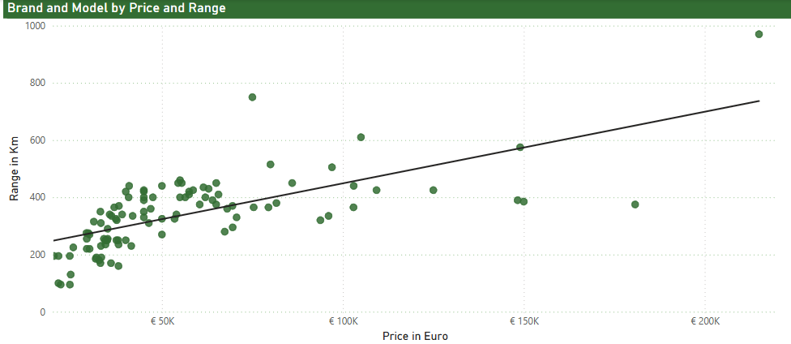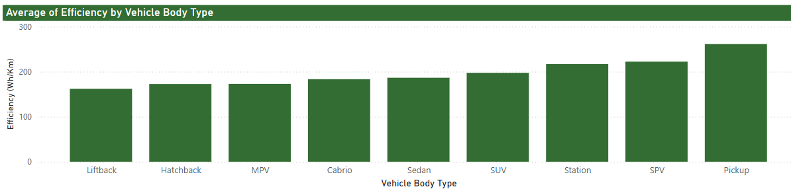Fig 6.5: Dashboard 4: How does EV performance vary by price and brand?

**6.5.1 Interpretation**

Tesla emerges as a market leader delivering superior electric range both in premium and mid-price vehicles. This confirms Tesla’s technological leadership in battery efficiency and energy management.

Efficiency varies sharply by vehicle segment: compact hatchbacks and liftbacks achieve high efficiency scores below 170 Wh/km, making them environmentally and economically attractive. Conversely, SUVs and luxury sedans typically exceed 200 Wh/km, reflecting higher energy consumption due to size and performance demands. Body type accounts for a 20-30% efficiency gap—critical for urban planners prioritizing charging infrastructure in high-density areas.

**6.6 Dashboard 5: What is the relationship between annual EV sales and the installation of new charging points?**

This dashboard highlights the critical relationship between charging infrastructure and EV adoption through key visualizations. A dual-axis line chart tracks the growth of charging points (reaching 5.2M) against EV sales (peaking at 78M), revealing a widening gap post-2020 where sales grew 3x faster than infrastructure. 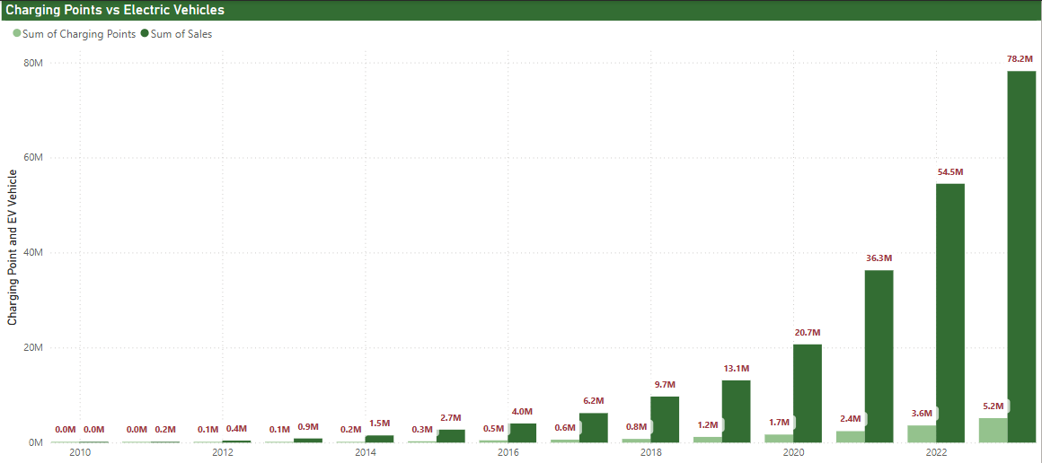Fig 6.6: Dashboard 5: What is the relationship between annual EV sales and the installation of new charging points?

Measures Used: Sum of charging points.

**6.6.1 Interpretation**

Annual sales volumes and new charging point installations display distinct parallel growth trends till 2016. Post pandemic diverging lines could be seen.

Policy makers must make 2x infrastructure investment to avoid adoption barrier.

**6.7 Dashboard 6: How has the charging infrastructure evolved annually, including YoY growth?**

Tracks total infrastructure expansion has reached 16.6 million. There was an average increase of 45% between 2010 to 2023.

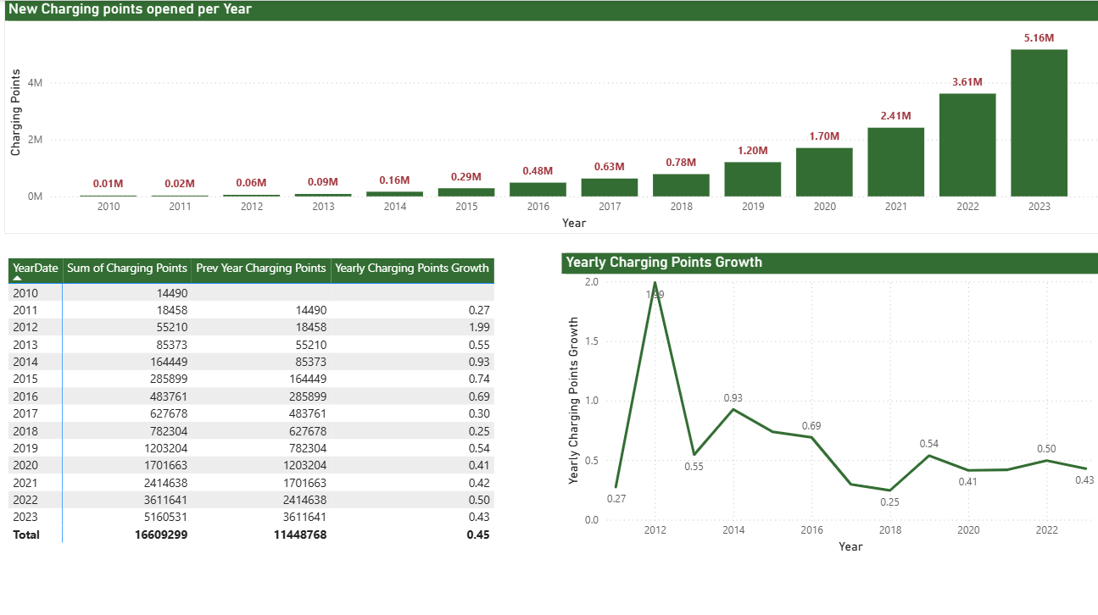Fig 6.7: Dashboard 6: How has the charging infrastructure evolved annually, including YoY growth?

**Measures Used:** Sum of Charging points, Yearly charging points growth.

**6.7.1 Interpretation**

The charging infrastructure experienced rapid growth: peak YoY percentage increases, notably in 2012 with 199% growth, have smoothed to mature rates of approximately 43.5% in 2023. Despite fluctuations, the steady upward trajectory has resulted in 5.16 million new charging points installed globally in 2023 alone.

**6.8 Dashboard 7: How has the ratio of fast EV charging points yearly, and what growth patterns emerge?**

The evolving infrastructure mix demonstrates industry and policymaker responsiveness to consumer needs, where fast charging capability is becoming a competitive differentiator within EV networks.

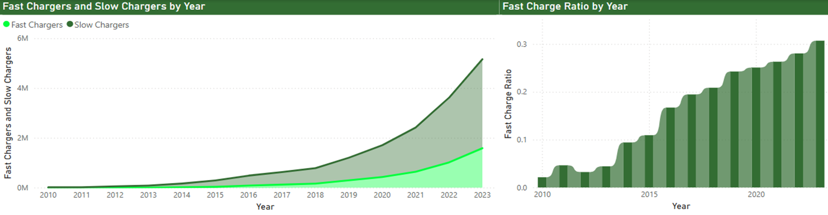 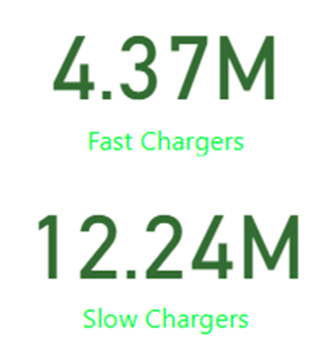Fig 6.8: Dashboard 7: How has the ratio of fast EV charging points yearly, and what growth patterns emerge?

**Measures Used:** Fast Charger, Slow Charger, Fast charge ratio

**6.8.1 Interpretation**

The ratio of fast chargers relative to slow chargers has exhibited consistent annual increases, rising from a mere 0.02 in 2010 to 0.3 in 2023. This shift reflects strategic prioritization of rapid-charge networks designed to meet the demands of long-distance EV travel.

Although slow chargers remain more numerous, the strong growth rate in fast charger installations points to targeted efforts to overcome infrastructure barriers to convenience and is a straegic investment to meet long distance travel demands.

**6.9 Dashboard 8: Which regions and countries lead in charging infrastructure density?**

The total available charging infrastructure is heavily concentrated in a handful of regions and countries. China leads worldwide with 7.6 million charging points, dwarfing the USA’s 820,000 units by a factor of nearly ten.

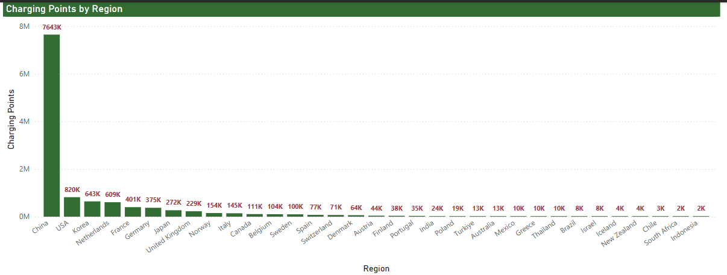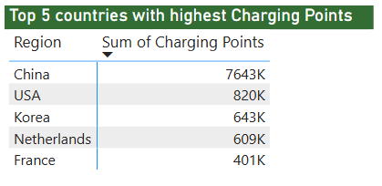

Fig 6.9.1: Dashboard 8: Which regions and countries lead in charging infrastructure density?

**Measures Used:** Sum of Charging points.

**6.9.1 Interpretation**

The top five countries collectively hold 85% of global charging infrastructure, underscoring significant regional disparities in EV readiness. The concentration in Asia, especially China, is illustrated in bubble map visualizations showing dense clustering, while other regions display more scattered and limited distributions.

These disparities suggest that EV adoption and infrastructure policies vary substantially across jurisdictions, possibly influenced by national-level energy policies, economic incentives, and market maturity.

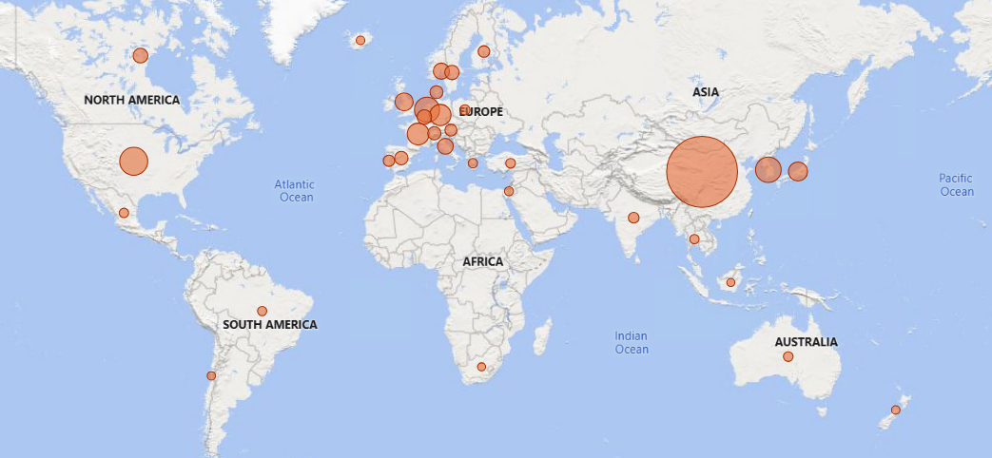Fig 6.9.2: Dashboard 8: Which regions and countries lead in charging infrastructure density?

**6.10 Dashboard 9: Which vehicle Makes deliver the highest charging efficiency in terms of miles gained per hour of charge? Which electric vehicles provide the best range for the number of hours charged?**

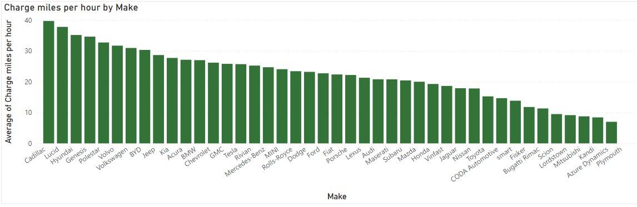  
Figure 6.10.1 Average chage per miles per hour by Make

**6.10.1 Interpretation**

This visual ranks vehicle makes based on average charging efficiency. Cadillac, Lucid, and Hyundai lead with over 38-40 miles per hour of charge.

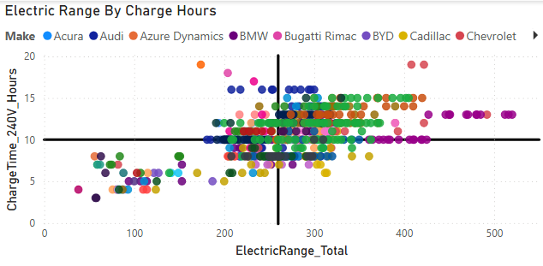  
Figure 6.10.2 Scatter plot of electric range by charge hours by make

**6.10.2 Interpretation**

This scatter plot helps identify high-performing EVs: Bottom-right quadrant = best performers (low charge time, high range). Makes like Tesla, Lucid, and Rivian dominate this area.

**6.11 Dashboard 10: Which fuel-based vehicle models are the highest polluters based on CO2 emissions?**

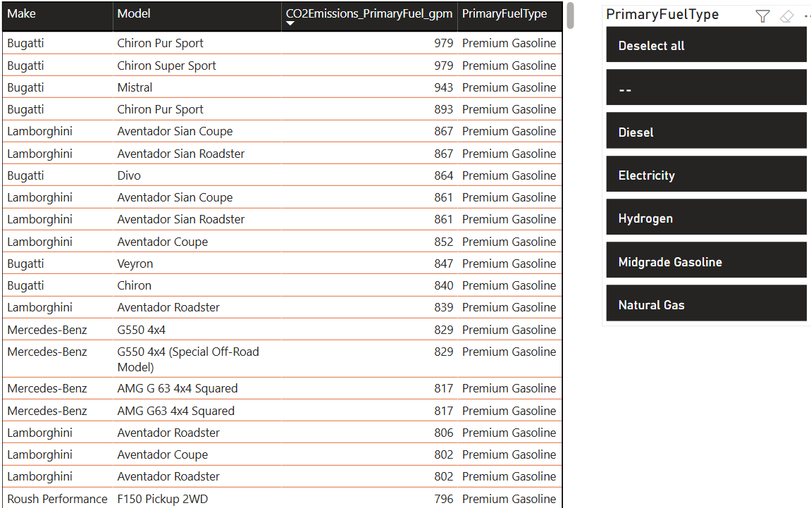  
Figure 6.11.1 CO2 emissions for Make-Model

**6.11.1 Interpretation**

This table chart enables quick comparisons across manufacturers while offering the flexibility to explore emissions trends by category. It’s a vital tool for both consumer education and regulatory review. A sortable table that displays Make, Model, Fuel Type, and CO2 Emissions per mile. Filtered dynamically by slicer for PrimaryFuelType. Vehicles with high performance (e.g., Bugatti, Lamborghini) show extreme emissions (~740-790 gpm).

**6.12 Dashboard 11: Which fuel-based vehicle models are the highest polluters based on CO2 emissions over the years 2009 to 2025?**

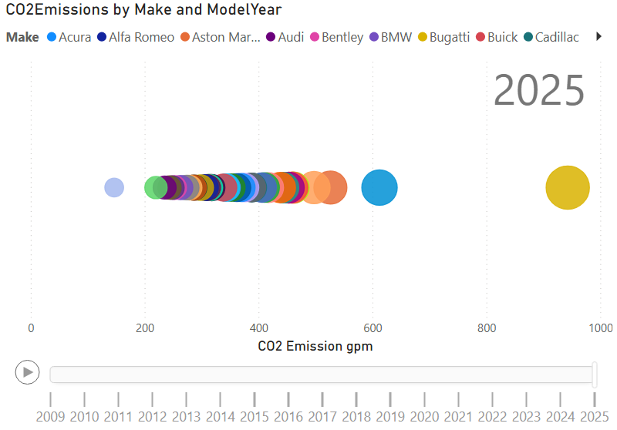  
Figure6.12.1 Animated Bubble Chart – CO2 Emissions over Model Years

**6.12.1 Interpretation**

This interactive visualization utilizes a bubble chart with a play axis to reveal how CO2 emissions have evolved over time across different vehicle manufacturers. Each bubble represents a specific vehicle make in a given model year, and the visual is designed to communicate both the magnitude and the temporal trend of emissions.

This chart is particularly effective in:

* Highlighting the trajectory of CO2 performance for each manufacturer
* Showing whether emissions are increasing, decreasing, or remaining static
* Allowing side-by-side temporal comparisons without needing to filter manually

# Conclusion

#### Environmental Impact:

Electric vehicles consistently demonstrate substantial emissions advantages over ICE vehicles, particularly in markets with cleaner electricity grids. The data confirms that even in regions with carbon-intensive electricity generation, EVs maintain a modest emissions advantage that grows over vehicle lifetime.

#### Economic Viability

Battery Electric Vehicles (BEVs) now offer compelling economic advantages over traditional ICE vehicles in most markets, with the Tesla Model 3, Chevrolet Bolt EV, and Nissan Leaf demonstrating particularly strong value propositions. This economic case strengthens with increased annual mileage and in regions with higher fossil fuel taxation.

#### Performance Metrics

Tesla maintains a technical advantage in range efficiency across price segments, while compact body types deliver the best efficiency metrics. The data suggests optimal battery capacity for most applications lies between 60-75 kWh, balancing range, weight, and cost considerations.

#### Infrastructure Development

Charging infrastructure shows rapid growth with 5.16M new units in 2023 alone, but extreme regional concentration persists. China's dominant position (7.6M points) creates potential competitive advantages for manufacturers with access to this ecosystem, while fast-charging ratios are increasing globally to address range anxiety.

**Recommendations:**

The analysis points to several strategic implications for stakeholders in the EV ecosystem:

* For policymakers, infrastructure deployment remains a critical enabler of adoption, with evidence suggesting that targeted fast-charging networks may offer better returns on investment than broad coverage with standard chargers.
* For manufacturers, the data indicates a "sweet spot" for mass-market adoption in the mid-range vehicle segment with moderate battery sizes, challenging the industry's current trend toward ever-larger battery packs.
* For investors, regional disparities in infrastructure create distinct market opportunities, with China, Europe, and targeted North American regions showing the strongest near-term growth potential.
* For Consumers and Fleet Managers, consumers evaluating vehicle ownership from a financial standpoint should priorities Battery Electric Vehicles, as they offer the lowest total cost of ownership over five years.

**Future Research and Analysis**

* Additional variables such as insurance cost, maintenance expenditure, and battery replacement impact should be included in future studies for a more complete cost analysis.
* Emissions data and lifecycle analysis could complement the economic analysis presented in this report, providing a more holistic view of EV impact.
* Future efforts should focus on optimizing infrastructure locations, prioritizing fast-charging capabilities, and fostering continued improvements in vehicle efficiency to maximize environmental and economic benefits from the transition to electric mobility.

# References

[1] U.S. Department of Energy, “Fuel Economy Data,” *fueleconomy.gov*. [Online]. Available: <https://www.fueleconomy.gov/feg/download.shtml>. [Accessed: Apr. 2024].

[2] International Energy Agency, “Global EV Data Explorer,” *iea.org*. [Online]. Available: <https://www.iea.org/data-and-statistics/data-tools/global-ev-data-explorer>. [Accessed: Apr. 2024].

[3] S. Maharaj, “Electric Vehicle Population Dataset,” *Kaggle*. [Online]. Available: <https://www.kaggle.com/datasets/sahirmaharajj/electric-vehicle-population>. [Accessed: Apr. 2024].