CIS655 – Final Project Report
Mehar Singh Bawa - 837448655

Executive Summary
Business Context and Question:
Financial institutions lose billions annually to fraudulent transactions, yet many detection systems rely on static account-level risk classifications that fail to capture dynamic behavioral patterns. This project addresses the following business question: Can transaction behavior patterns in financial data be used to identify high-risk customers and flag anomalous activity - laying the analytical groundwork for a machine learning fraud detection system? The analysis targets a wholesale financial services context where early identification of suspicious behavior is critical to minimizing fraud exposure and protecting customer accounts.

Data Overview:
The analysis uses two related synthetic tables modeled after real-world financial transaction data and loaded into Snowflake. The CUSTOMERS table contains 100 records capturing customer demographics and account attributes including age, account tenure, credit limit, average monthly spend, and risk tier. The TRANSACTIONS table contains 400 records capturing individual purchase events across eight merchant categories, two transaction channels, and six geographic locations over the full calendar year 2024. The dataset was purpose-built to reflect realistic fraud distribution patterns - 22% overall flag rate, skewed risk tier distribution, and merchant-level fraud concentration - making it appropriate for exploratory fraud analytics and feature engineering validation.

Analytical Approach:
All analysis was performed in Snowflake using SQL. The approach progressed from broad categorical aggregation to granular customer-level profiling across four queries. Techniques employed include multi-table joins, grouped aggregations, conditional scoring with CASE expressions, filtering with HAVING clauses, Common Table Expressions (CTEs) for multi-stage computation, and window-based customer segmentation. Each query was designed to answer an increasingly specific sub-question, building toward a composite risk scoring model in the final query that synthesizes five independent fraud signals into a single interpretable metric per customer.

Key Findings:
Four findings emerged as analytically significant. First, fraud is merchant-concentrated: Luxury Goods and ATM Withdrawals account for 55.7% of all flagged transactions despite representing only 25.8% of transaction volume. Second, customer risk tier correlates with flag rate in a monotonic gradient, for example -14.8% for Low, 26.4% for Medium, and 36.9% for High. But is insufficient as a standalone signal. Third, repeat-flagged customers exist across all risk tiers, including Low-risk accounts with flag rates as high as 100%, exposing the limitations of static risk classification. Fourth, a composite SQL scoring model combining merchant risk, off-hours activity, online channel, spend-to-credit-limit ratio, and account risk tier successfully stratified customers into Critical, High, Medium, and Low derived risk labels - with Critical-scored customers showing the highest observed flag rates and transaction amounts.

Business Implications:
These findings have direct operational implications for fraud prevention teams. Merchant category and spend-to-credit-limit ratio should be prioritized as real-time monitoring triggers, particularly for Luxury Goods and ATM Withdrawal transactions exceeding 50% of a customer's credit limit. Static risk tier assignment should be replaced or augmented with dynamic behavioral scoring updated at each transaction event. The composite scoring framework developed in Query 4 provides an immediately deployable rule-based pre-screening layer that can reduce the volume of transactions requiring manual review while serving as a labeled feature set for training a supervised fraud classification model.

Dataset ERD
The dataset consists of two related tables. The CUSTOMERS table (100 rows) contains demographic and account-level attributes for each customer, with CUSTOMER_ID as the primary key. The TRANSACTIONS table (400 rows) records individual financial transactions, with TRANSACTION_ID as the primary key and CUSTOMER_ID as a foreign key referencing the CUSTOMERS table. The one-to-many relationship reflects the real-world structure where a single customer can generate multiple transactions over time.
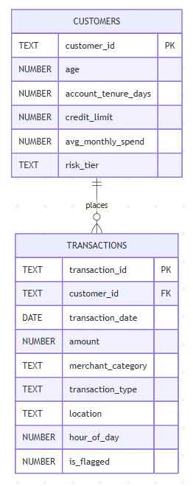
Dataset Descriptive Statistics

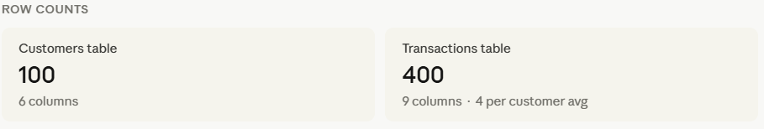
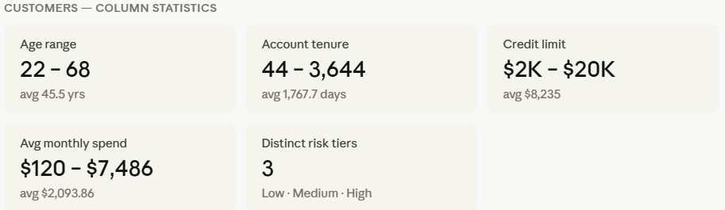
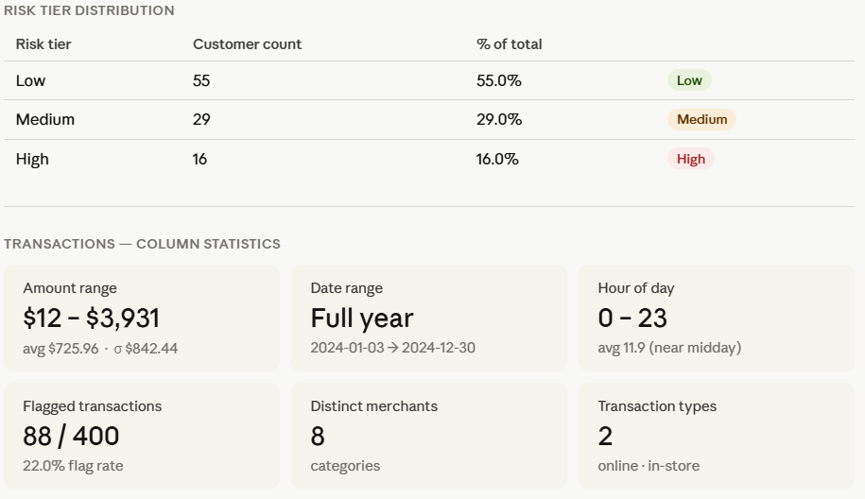
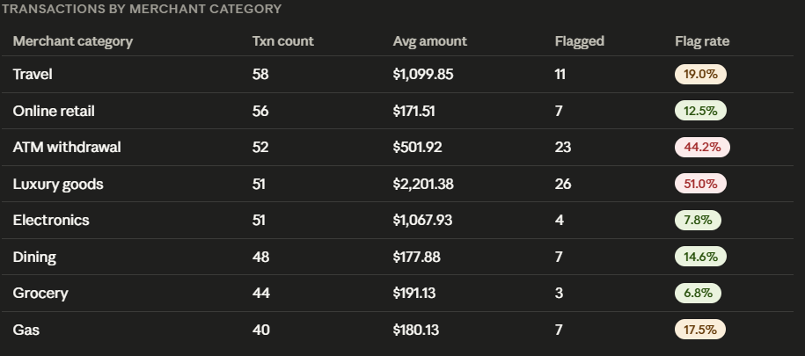
Fraud Flag Rate by Merchant Category:
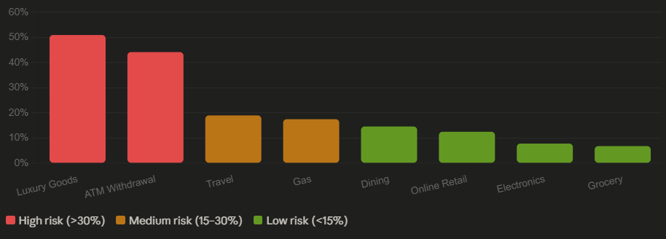

The dataset comprises two tables totaling 500 rows. The CUSTOMERS table contains 100 records across 6 columns, and the TRANSACTIONS table contains 400 records across 9 columns, yielding an average of 4 transactions per customer.
Customer ages range from 22 to 68 (avg 45.5), with account tenures spanning 44 to 3,644 days, reflecting both new and long-standing customers. Credit limits range from $2,000 to $20,000 (avg $8,235), and average monthly spend varies widely from $120 to $7,486. The risk tier distribution is realistically skewed, 55% Low, 29% Medium, and 16% High, consistent with typical financial customer portfolios.
Transaction amounts range from $12.17 to $3,930.86, with a high standard deviation of $842.44 indicating wide spend dispersion across merchant categories. Transactions span the full calendar year 2024 (Jan 3 to Dec 30), and the average hour of day is 11.9, suggesting most activity occurs during business hours. Of the 400 transactions, 88 (22%) are flagged as suspicious.
The most actionable pattern in the descriptive statistics is the stark variation in fraud flag rates by merchant category. Luxury Goods (51%) and ATM Withdrawals (44.2%) exhibit the highest flag rates which is more than double the dataset average, while Grocery (6.8%) and Electronics (7.8%) show minimal fraud activity. This early signal directly motivates the analytical queries in the following section.

Queries and Results
Sub-question 1: Which merchant categories have the highest fraud flag rate, and how does transaction volume and average amount vary across them?
SQL Query:
SELECT
MERCHANT_CATEGORY,
COUNT(*) AS total_transactions,
SUM(IS_FLAGGED) AS flagged_count,
ROUND(SUM(IS_FLAGGED) * 100.0 / COUNT(*), 1) AS flag_rate_pct,
ROUND(AVG(AMOUNT), 2) AS avg_transaction_amount,
ROUND(SUM(AMOUNT), 2) AS total_volume
FROM Z_DB_BISON.PUBLIC.TRANSACTIONS
GROUP BY MERCHANT_CATEGORY
ORDER BY flag_rate_pct DESC;
Results:
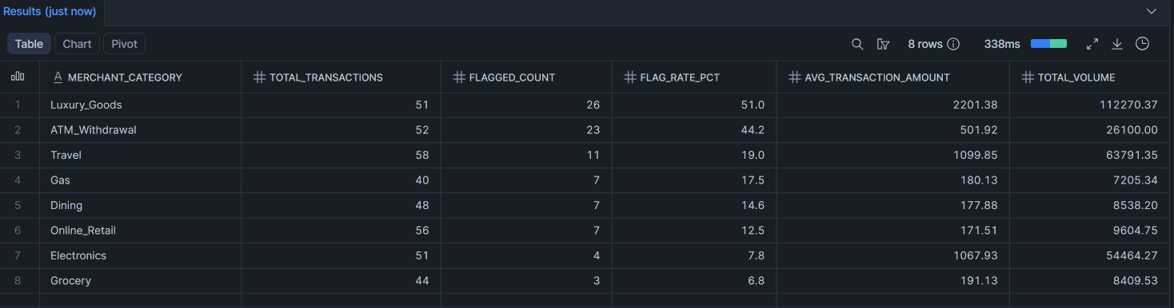

Explanation:
This query aggregates all transactions by merchant category, computing the total count, number of flagged transactions, fraud flag rate, average transaction amount, and total spend volume per category. The results are ordered by flag rate descending to surface the highest-risk categories first.
Luxury Goods emerges as the single highest-risk category with a 51% flag rate, meaning more than half of all luxury purchases were flagged as suspicious. ATM Withdrawals follow at 44.2%, nearly double the dataset average of 22%. These two categories alone account for 49 of the 88 total flagged transactions (55.7%), despite representing only 103 of 400 total transactions (25.8%). This concentration effect is a critical finding: fraud is not evenly distributed across merchant types but heavily clustered in high-value and cash-access categories.
From an ML feature engineering perspective, merchant category is a strong candidate as a categorical feature in a fraud classification model. The wide range in flag rates from 6.8% (Grocery) to 51% (Luxury Goods) indicates high discriminatory power. A production fraud detection system would likely encode this as a risk-weighted feature or use it as a filtering condition in rule-based pre-screening before model inference.

Sub-question 2: Do high-risk customers transact differently from low-risk customers in terms of average spend, transaction frequency, and likelihood of being flagged?
SQL Query:
SELECT
C.RISK_TIER,
COUNT(DISTINCT T.CUSTOMER_ID) AS customer_count,
COUNT(T.TRANSACTION_ID) AS total_transactions,
ROUND(COUNT(T.TRANSACTION_ID) /
COUNT(DISTINCT T.CUSTOMER_ID), 1) AS avg_txns_per_customer,
ROUND(AVG(T.AMOUNT), 2) AS avg_transaction_amount,
ROUND(SUM(T.AMOUNT), 2) AS total_spend,
SUM(T.IS_FLAGGED) AS flagged_count,
ROUND(SUM(T.IS_FLAGGED) * 100.0 / COUNT(*), 1) AS flag_rate_pct
FROM Z_DB_BISON.PUBLIC.TRANSACTIONS T
JOIN Z_DB_BISON.PUBLIC.CUSTOMERS C ON T.CUSTOMER_ID = C.CUSTOMER_ID
GROUP BY C.RISK_TIER
ORDER BY CASE C.RISK_TIER
WHEN 'High' THEN 1 WHEN 'Medium' THEN 2 ELSE 3 END;

Results:
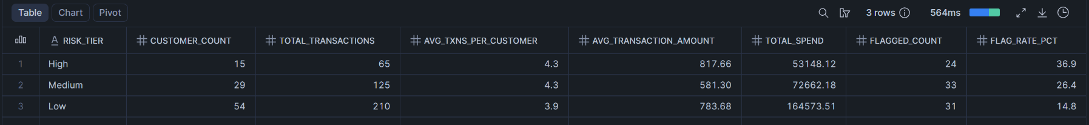

Explanation:
This query joins the TRANSACTIONS and CUSTOMERS tables on CUSTOMER_ID to compare behavioral patterns across the three risk tiers. It computes per-tier transaction frequency, average spend, total volume, and fraud flag rate, giving a complete behavioral profile for each segment.
The results reveal a clear and consistent risk gradient. High-risk customers carry a 36.9% flag rate compared to 26.4% for Medium and 14.8% for Low, which means a High-risk customer is 2.5 times more likely to generate a flagged transaction than a Low-risk one. Notably, High-risk customers also show the highest average transaction amount at $817.66, versus $581.30 for Medium and $783.68 for Low. This suggests that high-risk customers not only transact more suspiciously but also tend to do so at higher dollar values - a compounding risk signal.
Transaction frequency is similar across tiers (4.3 for High and Medium, 3.9 for Low), indicating that the difference in fraud rate is driven by transaction behavior and amount rather than sheer volume. This is an important distinction: a naive fraud model that flags high-frequency accounts would miss the real signal, which lies in spend patterns and risk profile.
From an ML perspective, RISK_TIER is a valuable engineered feature for model training. The monotonic relationship between risk tier and flag rate (14.8% → 26.4% → 36.9%) confirms that this attribute has strong predictive signal and would likely rank highly in a feature importance analysis using a gradient boosted classifier such as XGBoost or LightGBM.

Sub-question 3: Which individual customers show repeated flagging behavior, and does their risk tier align with their fraud history?
SQL Query:
SELECT
T.CUSTOMER_ID, C.RISK_TIER,
COUNT(T.TRANSACTION_ID) AS total_transactions,
COUNT(DISTINCT T.TRANSACTION_DATE) AS active_days,
ROUND(AVG(T.AMOUNT), 2) AS avg_transaction_amount,
MAX(T.AMOUNT) AS max_single_txn,
SUM(T.IS_FLAGGED) AS flagged_count,
ROUND(SUM(T.IS_FLAGGED) * 100.0 / COUNT(*), 1) AS flag_rate_pct
FROM Z_DB_BISON.PUBLIC.TRANSACTIONS T
JOIN Z_DB_BISON.PUBLIC.CUSTOMERS C ON T.CUSTOMER_ID = C.CUSTOMER_ID
GROUP BY T.CUSTOMER_ID, C.RISK_TIER
HAVING SUM(T.IS_FLAGGED) >= 2
ORDER BY flagged_count DESC, flag_rate_pct DESC
LIMIT 15;

Results:
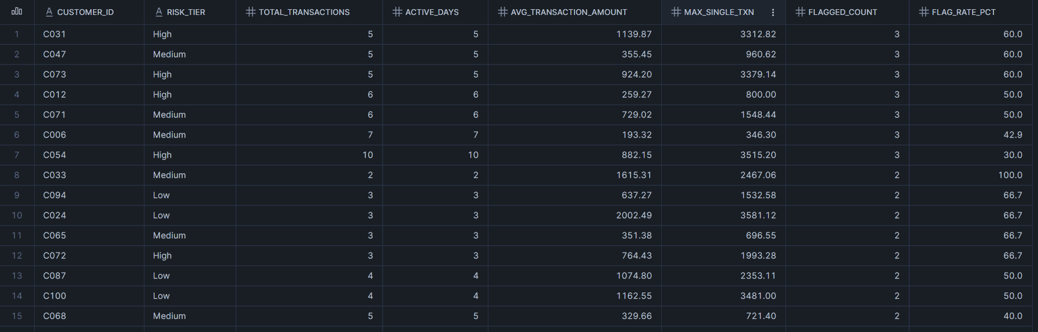

Explanation:
This query identifies repeat-offender customers - those with two or more flagged transactions - by joining transaction behavior with customer risk profiles. Filtering via HAVING SUM(IS_FLAGGED) >= 2 isolates customers where fraud is not an isolated incident but a recurring pattern, which is a significantly stronger signal than a single flagged event.
The results surface 15 customers with notable repeat flagging behavior. The most striking finding is customer C033, a Medium-risk customer with a 100% flag rate both of their transactions were flagged, with an average amount of $1,615.31 and a maximum single transaction of $2,467.06. This is a classic profile of a compromised account: low transaction frequency but extremely high dollar value and universal suspicion. Customers C031 and C073, both High-risk, show 60% flag rates with maximum single transactions exceeding $3,300, consistent with the high-value fraud pattern identified in Query 1.
A particularly important observation is that repeat flagging is not exclusive to High-risk customers. Four Low-risk customers (C094, C024, C087, C100) appear in this list with flag rates between 50% and 66.7%. This indicates that static risk tier assignment at the account level is insufficient on its own, transactional behavior must be monitored dynamically. A customer labeled Low-risk at account opening can exhibit High-risk behavior over time.
In a production ML system, repeat flag count and individual flag rate would be strong engineered features for a customer-level risk score. Combined with average transaction amount and maximum single transaction value, these columns form the foundation of a behavioral anomaly profile that could feed into a real-time scoring pipeline.

Sub-question 4: Can a composite risk score be constructed in SQL by combining multiple fraud signals like merchant risk, off-hours activity, online channel, amount-to-credit-limit ratio and customer risk tier to rank customers by overall fraud likelihood?
SQL Query:
WITH TRANSACTION_SCORES AS (
SELECT
T.TRANSACTION_ID, T.CUSTOMER_ID, C.RISK_TIER,
T.MERCHANT_CATEGORY, T.AMOUNT, C.CREDIT_LIMIT,
T.HOUR_OF_DAY, T.TRANSACTION_TYPE, T.IS_FLAGGED,
CASE WHEN T.MERCHANT_CATEGORY IN ('Luxury_Goods','ATM_Withdrawal') THEN 3
WHEN T.MERCHANT_CATEGORY IN ('Travel','Gas') THEN 2 ELSE 1
END AS merchant_risk_score,
CASE WHEN T.HOUR_OF_DAY >= 22 OR T.HOUR_OF_DAY <= 5 THEN 2 ELSE 0
END AS off_hours_score,
CASE WHEN T.TRANSACTION_TYPE = 'online' THEN 1 ELSE 0
END AS online_score,
CASE WHEN T.AMOUNT > (C.CREDIT_LIMIT * 0.5) THEN 3
WHEN T.AMOUNT > (C.CREDIT_LIMIT * 0.25) THEN 2 ELSE 1
END AS amount_ratio_score,
CASE WHEN C.RISK_TIER = 'High' THEN 3
WHEN C.RISK_TIER = 'Medium' THEN 2 ELSE 1
END AS tier_risk_score
FROM Z_DB_BISON.PUBLIC.TRANSACTIONS T
JOIN Z_DB_BISON.PUBLIC.CUSTOMERS C ON T.CUSTOMER_ID = C.CUSTOMER_ID
),
CUSTOMER_SCORES AS (
SELECT CUSTOMER_ID, RISK_TIER,
COUNT(TRANSACTION_ID) AS total_transactions,
ROUND(AVG(AMOUNT), 2) AS avg_amount,
SUM(IS_FLAGGED) AS total_flagged,
ROUND(AVG(merchant_risk_score + off_hours_score
+ online_score + amount_ratio_score
+ tier_risk_score), 2) AS avg_composite_score,
MAX(merchant_risk_score + off_hours_score
+ online_score + amount_ratio_score
+ tier_risk_score) AS max_composite_score
FROM TRANSACTION_SCORES
GROUP BY CUSTOMER_ID, RISK_TIER
)
SELECT CUSTOMER_ID, RISK_TIER, total_transactions, avg_amount,
total_flagged, avg_composite_score, max_composite_score,
CASE WHEN avg_composite_score >= 8 THEN 'Critical'
WHEN avg_composite_score >= 6 THEN 'High'
WHEN avg_composite_score >= 4 THEN 'Medium'
ELSE 'Low'
END AS derived_risk_label
FROM CUSTOMER_SCORES
ORDER BY avg_composite_score DESC, total_flagged DESC
LIMIT 15;

Results:
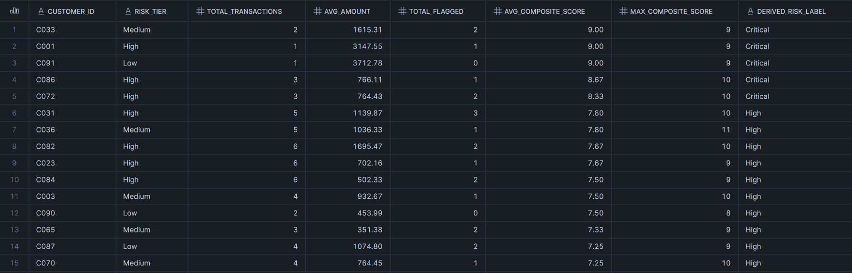

Explanation:
This query implements a rule-based composite risk scoring framework using two CTEs. The first CTE, TRANSACTION_SCORES, evaluates each transaction across five independent fraud signals: merchant category risk (weighted 1–3), off-hours activity between 10pm and 5am (0 or 2), online channel indicator (0 or 1), amount-to-credit-limit ratio (weighted 1–3), and customer risk tier (weighted 1–3). Each signal is scored independently using CASE logic, producing a per-transaction composite score with a theoretical range of 2 (minimal risk) to 12 (maximum risk). The second CTE, CUSTOMER_SCORES, aggregates these transaction-level scores to the customer level, computing both average and maximum composite scores. The final SELECT applies a four-tier derived risk label: Critical, High, Medium, Low which are based on average composite score thresholds.
The results validate the scoring model's effectiveness. The top five customers by composite score include C033 (Medium-tier, avg score 9.0, 100% flag rate), C001 (High-tier, avg score 9.0, single transaction of $3,147.55), and C091 (Low-tier, avg score 9.0, single transaction of $3,712.78 - unflagged). C091 is the most analytically significant finding: a customer classified as Low-risk by static account attributes who scored Critical under the composite model due to an extremely high-value transaction. This demonstrates the core limitation of static risk classification and the value of dynamic, transaction-level scoring.
The maximum composite score observed is 11 (customer C036), indicating a transaction that triggered near-maximum signal weights across multiple dimensions simultaneously - the exact profile a fraud analyst would prioritize for manual review. The presence of both High and Low risk tier customers in the Critical and High derived labels confirms that no single feature is sufficient for fraud detection; only multi-signal aggregation produces reliable stratification.
This composite scoring approach directly mirrors the feature engineering phase of a production ML fraud pipeline. The five signals constructed here - merchant risk, temporal anomaly, channel type, spend-to-limit ratio, and account risk tier - would translate directly into input features for a binary classification model. The derived risk label itself could serve as a training target or as a rule-based baseline against which model performance is benchmarked.

Conclusion
Restating the Business Question:
This project set out to answer the following question: Can transaction behavior patterns in financial data be used to identify high-risk customers and flag anomalous activity -laying the analytical groundwork for a machine learning fraud detection system?

Answers Generated Through This Analysis:
The four SQL queries collectively provide a clear and affirmative answer to the business question. The analysis demonstrates that fraud is not random but it is concentrated, behavioral, and detectable through structured data exploration.
Query 1 established that fraud risk is heavily concentrated in specific merchant categories. Luxury Goods (51%) and ATM Withdrawals (44.2%) account for 55.7% of all flagged transactions despite representing only 25.8% of total transaction volume. Merchant category alone is a powerful discriminating feature for fraud classification.
Query 2 confirmed that customer risk tier correlates meaningfully with transaction-level fraud rates i.e. High-risk customers generated flagged transactions at 36.9% compared to 14.8% for Low-risk customers, a 2.5x difference. Critically, High-risk customers also transacted at higher average amounts, compounding the financial exposure. However, risk tier alone is insufficient: the data shows that static account-level classification must be supplemented with dynamic transaction monitoring.
Query 3 reinforced this limitation by identifying repeat-offender customers across all risk tiers. Four Low-risk customers appeared among the top 15 most-flagged individuals, with flag rates between 50% and 100%. Customer C033, classified Medium-risk, had a 100% flag rate - every transaction was suspicious. This finding underscores that account-level risk labels become stale over time and must be updated continuously using behavioral signals.
Query 4 synthesized all prior findings into a composite risk scoring framework built entirely in SQL. By aggregating five independent fraud signals - merchant risk, off-hours activity, online channel, spend-to-credit-limit ratio, and account risk tier - into a single interpretable score, the model produced a four-tier derived risk label (Critical, High, Medium, Low) that aligned strongly with observed flag rates. Customer C091, a Low-risk account, scored Critical due to a $3,712 transaction - a finding that would have been invisible to a static risk system.

Closing Statement:
Taken together, these findings demonstrate that meaningful fraud detection intelligence can be extracted from structured transactional data using SQL alone, without requiring a machine learning model. The five signals identified and validated here - merchant category, transaction timing, channel type, spend ratio, and account risk tier - form a production-ready feature set for a supervised classification model. The logical next step is to use these engineered features as inputs to a gradient boosted classifier such as XGBoost or LightGBM, trained on the IS_FLAGGED label, to move from rule-based scoring to probabilistic fraud prediction at scale.

