Database Configuration

The organization is collecting general data for various colleges in California, our database is consisting of seven tables: campuses, csu-fees, degrees, discipline-enrollments, disciplines, enrollments and faculty

Below is the description for each table:

Campuses: record for each campus, including their names, locations, and year of founding.

Csu-fees: record for each campus’s fee from the year 1996 to 2006

Degrees: record for each campus’s number of people who successfully earned a degree from the year 1990 to 2004

Discipline-enrollments: record for each campus’s amount of undergraduate and graduate students from each discipline (major)

Discipline: a collection for the name of each discipline (major).

Enrollments: record for each campus’s amount of enrollment for the past few decades.

Faculty: record for each campus’s faculty number.

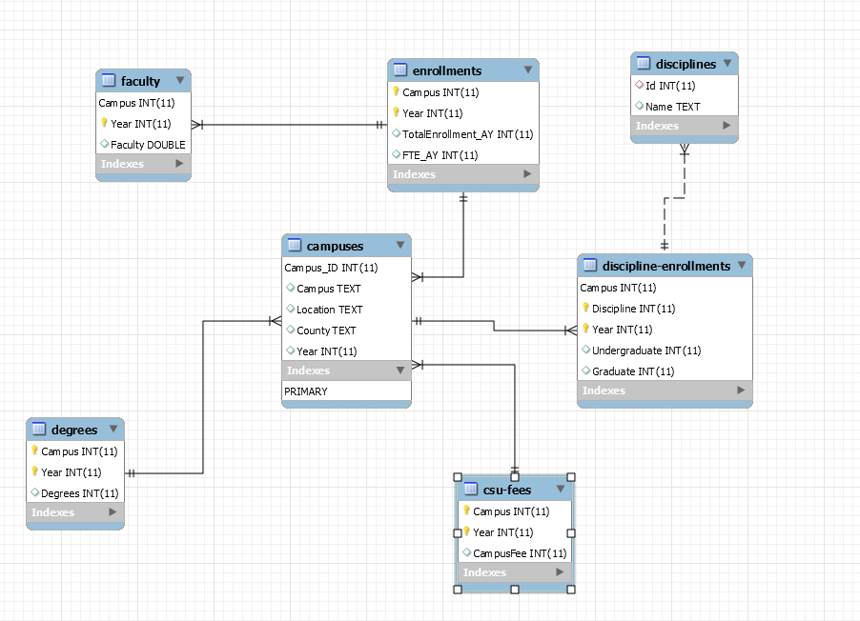

Figure 1 - Relationship between tables

2. MySQL Server on XUbuntu 18.04 Configuration

XUbuntu can be downloaded from here:

<https://xubuntu.org/>

Once it is installed in your virtual machine, go to Settings -> Network and change it to Bridged Adapter

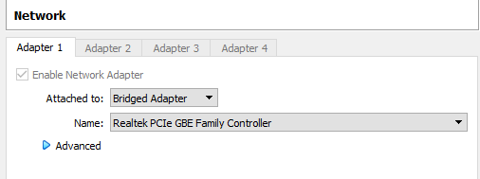

Fire up XUbuntu 18.04, open terminal and supplement the following command to install mysql-server

Step 1:

Sudo apt-get update

Sudo apt-get install mysql-server

After the installation is done, run the following command to allow remote access:

sudo ufw allow mysql

systemctl start mysql

Step 2:

Allow mysql to start automatically at system startup:

systemctl enable mysql

Step 3:

Enter the following command to launch the mysql shell

/usr/bin/mysql -u root -p

Step 4:

Enter the following command to give the root account a password

UPDATE mysql.user SET authentication_string = PASSWORD(Itms4528!) WHERE User = 'root';

Step 5:

We will create a new user for connection:

CREATE USER 'YOUR_USERNAME_HERE'@`%` IDENTIFIED BY 'YOUR_PASSWORD_IN_PLAIN_TEXT_HERE';

We will then grant all privileges for this user:

GRANT ALL PRIVILEGES ON *.* TO 'YOUR_USERNAME_HERE'@`%`WITH GRANT OPTION;

Step 6:

Next up, we need to make some changes to the mysqld.cnf file:



Change the bind-address to 0.0.0.0 to allow remote access:

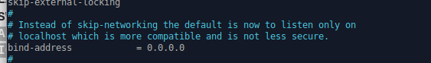

Run ifconfig to check your ip address, mine is 192.168.0.35, we will use this to connect to our sql server.

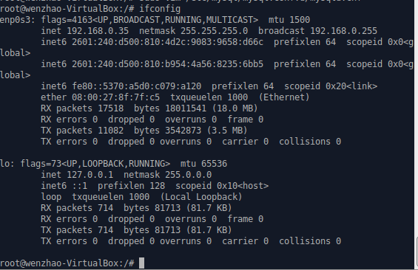

3. **MySQL Workbench Configuration**

Windows 10 is used as the operating system for our databases and MySQL Workbench 8.0 CE is used for performing database related actions.

Link to download MySQL Workbench 8.0.15: <https://dev.mysql.com/downloads/workbench/>

* In order for MySQL Workbench to be installed successfully, Microsoft .NET Framework 4.5 and Visual C++ Redistributable for Visual Studio 2015 are required.

Here are the links for them:

<https://www.microsoft.com/en-us/download/details.aspx?id=30653>

<https://www.microsoft.com/en-us/download/confirmation.aspx?id=30653>

Accept all default installation options for MySQL Workbench, select “Complete” for the Setup Type:

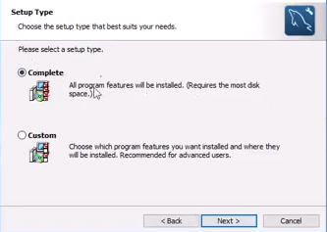

Figure 2 – Complete installation

Go ahead and open up MySQL Workbench after the installation is done.

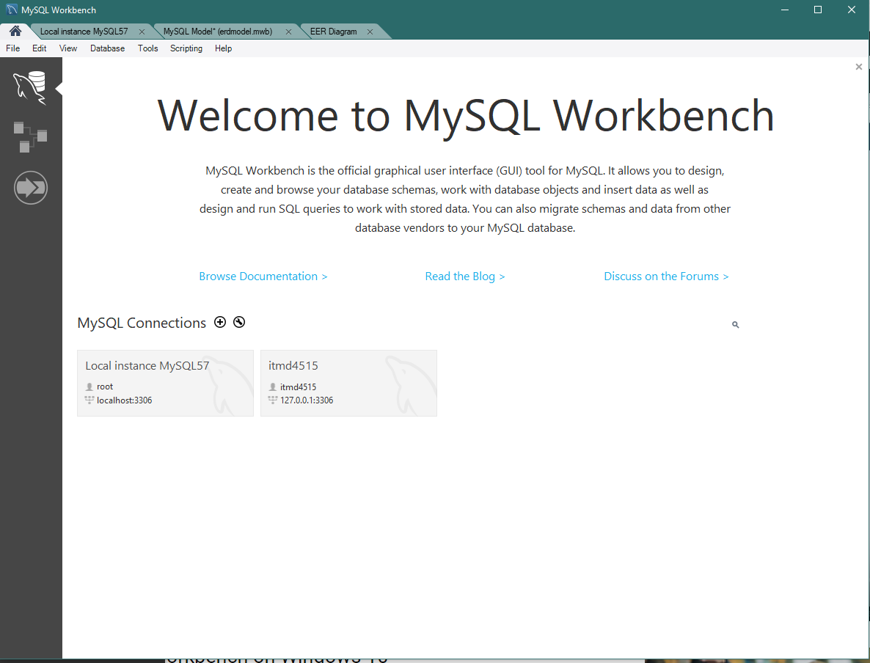

Figure 3 – MySQL Workbench Interface

For first time user, we need to create a new connection, click on the little “add” button next to MySQL Connections.

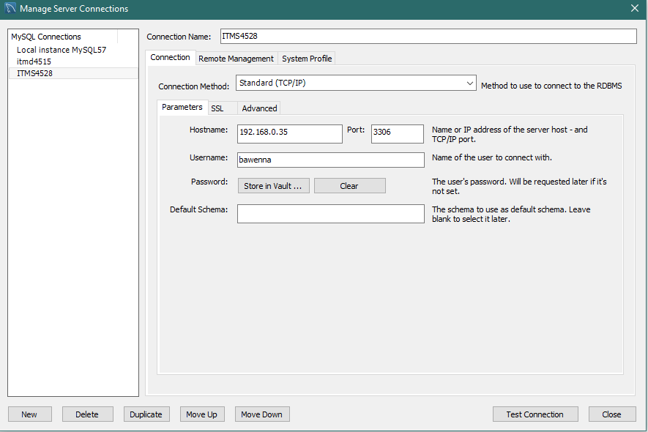

Figure 4: Configure new connection

By default, we need a hostname, the port, the username and password to connect to a database, enter the ip address for your virtual machine on the field ‘HostName’, enter the name of the user you created in Section 2 Step 5 above and click on Test Connection.

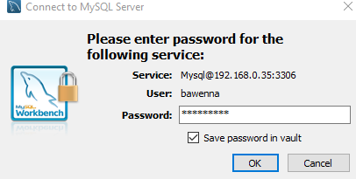

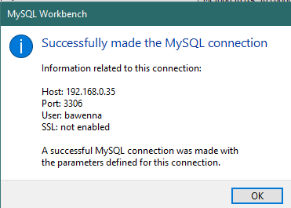

Figure 5 – Notification of a successful connection

Once we are in, right click on the blank space on the SCHEMAS section and select “Create schema”

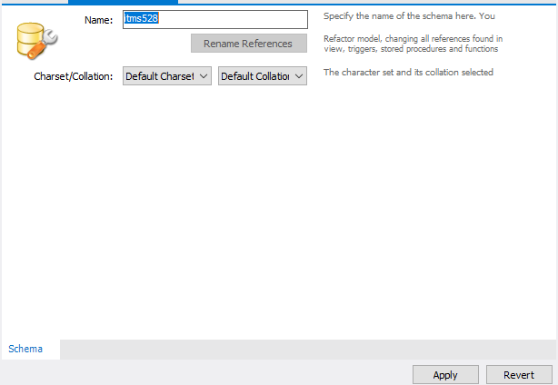

Figure 6 – Provide a name for your schema

Once the schema is created, navigate to Server -> Data Import in order to import our dataset.

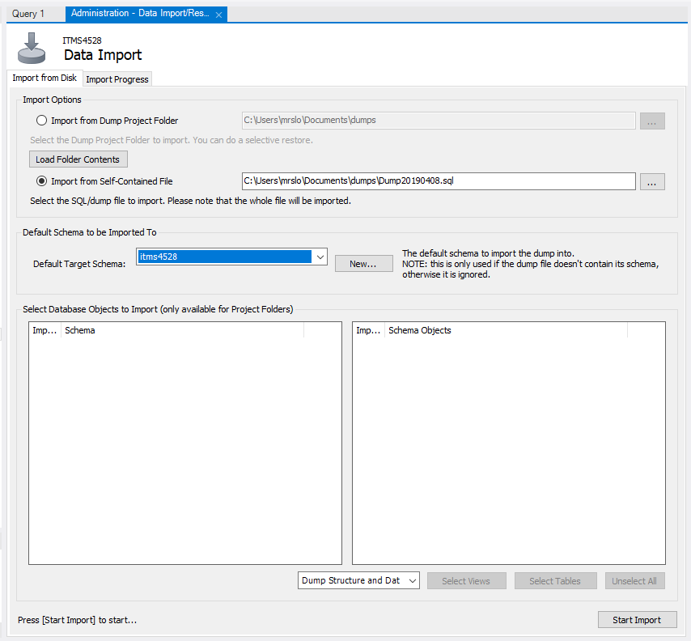

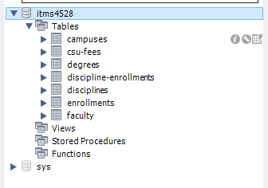

Table will be loaded after the import is done