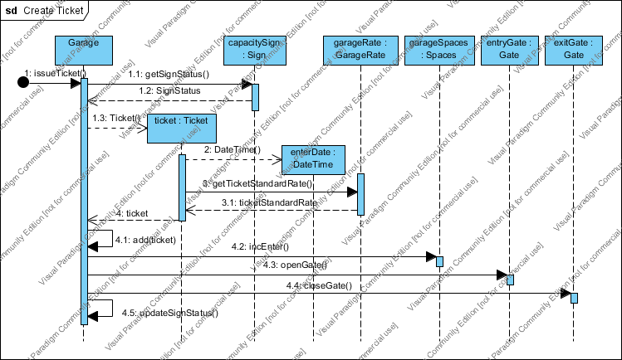

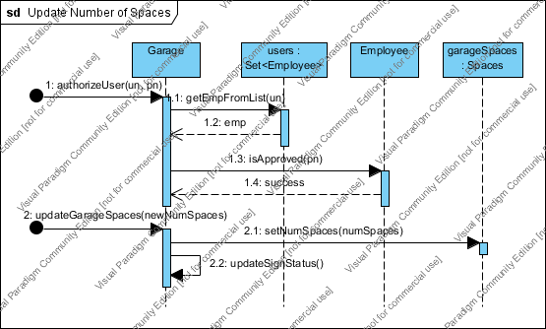

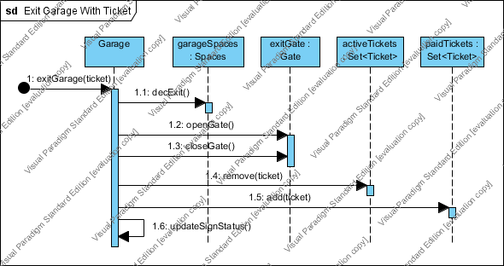

System Test Plan:

Test Case 1: Garage Entry

1. Tests entrance function. Must account for increasing number of used spaces in garage and give a ticket reference to customer for successful exit.
2. Steps
   1. Enter “1” to enter garage.
   2. Press enter to continue.
   3. Enter “5” for capacity status.
   4. Press enter to continue
3. Expected result
   1. Ticket ID and entrance date is dispayed.
   2. Entrance gate is opened and closed.
   3. Used spaces is incremented 1 and vacancy is shown as status.

Test Case 2: Ticket Number Increments

1. Tests entrance function. Must give new ticket IDs for each entering customer for accurate use and charge upon exit.
2. Steps
   1. Enter “1” to enter garage.
   2. Press enter to continue.
   3. Enter “5” for capacity status.
   4. Press enter to continue
3. Expected Result
   1. Ticket ID is 2
   2. Used spaces incremented to 2.

Test Case 3: Exit Garage Goes to Exit Menu

1. Tests exit menu function. Must traverse menus appropriately.
2. Steps
   1. Enter “2” to exit garage and press enter to continue.
3. Expected result
   1. Exit menu with enter ticket ID or flat rate payment options shown.

Test Case 4: Test Exit with Invalid Ticket ID

1. Tests exit function. Must not allow system to accept invalid ticket upon exit for accurate charging and tracking.
2. Steps
   1. Enter “1” to select enter ticket ID and press enter to continue.
   2. Enter “99” and press enter.
3. Expected Result
   1. Alerted of invalid ticket ID and directed back to exit menu.

Test Case 5: Test Exit with Valid Ticket ID

1. Tests exit function. Must allow exit with valid ticket ID and display accurate charge.
2. Steps
   1. Enter “1” to select enter ticket ID and press enter to continue.
   2. Enter “1” and press enter.
3. Expected Result
   1. Amount due for ticket is displayed.
   2. Amount due equals default garage rate, 4, multiplied by hours rounded up.
   3. Directed to payment menu.

Test Case 6. Test Cash Payment and Receipt

1. Tests payment function. Must accept cash payment, display remaining balance accurately for proper payment. Must create receipt for tracking and for customer use.
2. Steps
   1. Enter “1” for cash payment and press enter to continue.
   2. Enter payment amount “2” and press enter.
   3. Enter payment amount “1” and press enter.
   4. Enter payment amount “2” and press enter.
   5. After receipt shown, press enter to continue.
   6. At main menu, enter “5” and press enter to view capacity status.
3. Expected Result
   1. Prompted to enter payment amount.
   2. After each insufficient payment, remaining balance displayed and prompted to enter amount again.
   3. After total payment amount exceeded, correct change amount is displayed and receipt is displayed showing payment date/time, total payment, and cash payment type.
   4. Exit gate opened and closed for exit.
   5. Directed back to main menu.
   6. Number of used spaces decreased by 1.

Test Case 7. Test Flat Rate Payment

1. Tests payment function. Must allow customer to exit if a ticket is lost or destroyed.
2. Steps
   1. At main menu, enter “2” to exit garage.
   2. At exit menu, enter “2” for flat rate payment.
3. Expected Result
   1. Amount due displayed equal to flat rate default amount, 50.

Test Case 8. Test Invalid Account number electronic payment.

1. Tests payment function. Must check account number validity for charges.
2. Steps
   1. At payment menu, enter “2” for electronic payment.
   2. Enter “112233445**w**667788” for account number and press enter.
   3. Enter “12/2014” for expiration date and press enter.
3. Expected Result
   1. Alerted that account number format is invalid.
   2. Directed back to payment menu.

Test Case 9. Test Invalid Account format for electronic payment.

1. Tests payment function. Must check account number validity for charges.
2. Steps
   1. At payment menu, enter “2” for electronic payment.
   2. Enter “112233445**5**6677” for account number and press enter.
   3. Enter “12/2014” for expiration date and press enter.
3. Expected Result
   1. Alerted that account number length is invalid.
   2. Directed back to payment menu.

Test Case 10. Test Invalid expiration date format for electronic payment.

1. Tests payment function. Must check expiration date validity for charges.
2. Steps
   1. At payment menu, enter “2” for electronic payment.
   2. Enter “112233445**5**667788” for account number and press enter.
   3. Enter “12/14” for expiration date and press enter.
3. Expected Result
   1. Alerted that expiration date format invalid.
   2. Directed back to payment menu.

Test Case 11. Test Valid Account format for electronic payment.

1. Tests payment function. Must check account number validate for charges.
2. Steps
   1. At payment menu, enter “2” for electronic payment.
   2. Enter “1122334455667788” for account number and press enter.
   3. Enter “12/2014” for expiration date and press enter.
   4. Press enter after receipt shown.
3. Expected Result
   1. After payment validated, receipt is displayed showing payment date/time, total payment, and electronic payment type.
   2. Directed back to main menu.

Test Case 12: Employee invalid login

1. Test employee function. Must ensure only valid users have access to employee functions.
2. Steps
   1. Enter “4” at main menu and press enter.
   2. Enter “bwitt” for username and press enter.
   3. Enter “123” for pass code and press enter.
   4. After message, press enter to continue.
   5. Enter “baw” for username and press enter.
   6. Enter “1234” for pass code and press enter.
   7. After message, press enter to continue.
3. Expected Result
   1. Login unsuccessful message displayed after each failed login attempt.
   2. Directed back to main menu after each failed login attempt.

Test Case 13: Employee valid login

1. Test employee function. Must ensure only valid users have access to employee functions.
2. Steps
   1. Enter “4” at main menu and press enter.
   2. Enter “bwitt” for username and press enter.
   3. Enter “1234” for pass code and press enter.
3. Expected Result
   1. Successful login message displayed
   2. Directed to employee menu.

Test Case 14: Create New User

1. Test employee function. Must allow new user creation for hiring of employees.
2. Steps
   1. Enter “4” for create new user and press enter.
   2. Enter “baw” for new username and press enter.
   3. Enter “123” for new pass code and press enter then press enter to continue.
   4. Enter “4” for employee login and press enter.
   5. Enter “baw” for username and press enter.
   6. Enter “123” for pass code and press enter.
3. Expected Result
   1. Directed back to main menu after new user info entered.
   2. New user credentials allow access to user menu.

Test Case 15: Deactivate Employee

1. Tests employee function. Must allow deactivation for termination of employees.
2. Steps
   1. Enter “5” for deactivate user.
   2. Enter “baw” for username and press enter.
   3. At main menu, enter “4” for employee login.
   4. Enter “baw” for username and press enter.
   5. Enter “123” for pass code and press enter.
   6. Press enter to continue.
3. Expected Result
   1. Access to employee menu not allowed for deactivated user.
   2. Login unsuccessful message displayed.
   3. Directed to main menu.

Test Case 16: Update Total Garage Spaces

1. Tests employee function. Employees must have ability to update total number of spaces for downsizing/upsizing.
2. Steps
   1. At main menu, enter “4” for employee login.
   2. Enter “bwitt” for username and press enter.
   3. Enter “1234” for pass code and press enter.
   4. Enter “3” for update spaces.
   5. Enter “10” for new number of total spaces and press enter.
   6. At main menu, enter “5” for capacity status and press enter.
   7. Press enter to continue.
3. Expected Result
   1. Total spaces updated to 10.

Test Case 17: Update Hourly Rate

1. Tests employee function. Must allow employees to update rate as business needs change.
2. Steps
   1. At main menu, enter “4” for employee login.
   2. Enter “bwitt” for username and press enter.
   3. Enter “1234” for pass code and press enter.
   4. At employee menu, enter “1” for update hourly rate and press enter.
   5. Enter “5” for new hourly rate and press enter. Press enter to continue.
   6. At main menu, press “1” to enter garage and press enter. Note ticket ID.
   7. Press enter to continue.
   8. Enter “2” for exit garage and press enter.
   9. Enter “1” for enter ticket ID option and press enter.
   10. Enter ticket ID from step f and press enter.
   11. Enter 3 for back and press enter. Press enter to continue.
3. Expected Result
   1. Amount due reflects new hourly rate.
   2. Directed back to main menu.

Test Case 18: Update Flat Rate

1. Tests employee function. Must allow employees to update rate as business needs change.
2. Steps
   1. At main menu, enter “4” for employee login.
   2. Enter “bwitt” for username and press enter.
   3. Enter “1234” for pass code and press enter.
   4. At employee menu, enter “2” for update hourly rate and press enter.
   5. Enter “40” for new flat rate and press enter. Press enter to continue.
   6. At main menu, press “1” to enter garage and press enter.
   7. Press enter to continue.
   8. Enter “2” for exit garage and press enter.
   9. Enter “2” for flat rate payment option and press enter.
   10. Enter 3 for back and press enter. Press enter to continue.
3. Expected Result
   1. Amount due reflects new flat rate.
   2. Directed back to main menu.

Test Case 19: Entrance Prohibited When Garage is Full

1. Tests entrance function. Must not allow access to new customers if garage is full.
2. Steps
   1. At main menu, enter “5” for capacity status and press enter. Note number of used spaces.
   2. At main menu, enter “4” for employee login.
   3. Enter “bwitt” for username and press enter.
   4. Enter “1234” for pass code and press enter.
   5. Enter “3” for update spaces.
   6. Enter number of used spaces noted in step a for new number of total spaces and press enter. Press enter to continue.
   7. At main menu, press “1” for enter garage.
   8. Press enter to continue.
3. Expected Result
   1. Garage entry is prohibited and directed back to main menu.

Test Case 20: Test Exit Application

1. Tests exit function for when application exit is necessary.
2. Steps
   1. At main menu, enter “6” for quit and press enter.
   2. Press enter to continue
3. Expected Result.
   1. Application is exited.