Fall Motion Detector with GPS Transmitter

**S e á n H a y e s**

**T00175319**

**Bachelor of Science (Hons) in Computing**

**with Multimedia**

**12/5/2016**

Sean Hayes

Table of Contents

Abstract 2

2.1 Introduction 4

2.2 GPS Function 4

2.3 Types of Data Transmitted 5

2.4. Space Race 5

2.5 First NASA Satellites 6

2.6 Commercial Application of GPS 6

2.6.1 GPS in Commercial Technology 7

Chapter 3: Sensor Technology 9

3.1 Introduction 9

3.2. Accelerometers 9

3.3. Acceleration 9

3.3. Accelerometer Function 10

3.3. Some Specifications 11

Chapter 5: Methodology & Design 12

5.1. R*e*search Undertaking 12

5.2. Research Question 12

5.3. Design 12

5.3.1 Vision Document 12

5.2.2 Setting Up a New Android Studio Project 16

5.2.3 Building the Application 16

Chapter 6: Implementation 21

Chapter 7: Data Analysis/Synthesis 22

Chapter 8: Findings & Conclusions 23

References 24

# Abstract

As technology continues to change and grow at a rapid pace, and is everywhere in everyday life, it becomes important that the technology developed is considered for average person. Computer technology is tending to become more compact, to the point that the smallest of technologies can do major tasks considering the size of the technology is phenomenal. Mobile phones are the same, as they can store many applications that can do anything from sending texts and emails, post onto social media, play games, or even transfer money into a bank account. The new android smartphones even allow owners to develop and test their very own applications on the smartphone. More so, the modern smartphone have different sensors such temperature reading, GPS location, magnetic sensors, accelerometers and many more sensors. Developers can develop application to not only access this data but also use the data to perform a certain task. As a result, many applications have been developed to manipulate the data.

Accelerometers on an android smartphone will change the screen layout from portrait to landscape or vice a versa when the user turns the phone at a certain angle. However, accelerometers in other technologies are used to do certain tasks, such as fall detection. Before any research was carried out there was knowledge that fall detectors have been around for some time now with panic buttons that would notify the next of kin when pressed down for a period of a few seconds. During the research, it was discovered that many companies in America have developed fall detectors. The problem with these fall detectors are they were only available in the US, they were exactly affordable and they all seemed to require contacting emergency units. With the availability of an accelerometers on a smartphone allows developers to test and develop a system that would be more affordable to develop, also an application could be developed that could notify the next of kin directly or emergency units.

Chapter 1: Introduction

Chapter 2: Global Positioning System

## 2.1 Introduction

GPS or Global Positioning System can be described as a constellation or a network of orbiting satellites that transmit accurate data of their position in space back to earth. These signals are gained by GPS revivers such as navigation devices (Mio Technology, 2011). The very first GPS satellite prototype was launched in February 1978. In 1980 the American Government made the first GPS available to the public. The very first fully operational Block 2 satellite was launched in February 1989. It took until December 1993 to complete the 24 satellite constellation, but full operation status was recognised until April 1995. (Bradford W. Parkinson, GPS Eyewitness: The Early Years, September 1994, cited in Societal Impact of Spaceflight, 2007, p331). In June 2011 the 24 slots were expanded and six satellites were repositioned, as result 3 satellites were introduced to the constellation. Since October 2016 the constellation was again expanded to 31 satellites. The 31 satellites are part of NAVSTAR system (Navigation Satellite Timing And Ranging), the satellites at a range of 12000 miles above earth and can circle navigate the earth twice a day. (GPS.gov, 2016)

At this stage it had cost NASA between $10 and $12 billion to complete the constellation, and an estimated value of $400 million to service the projects. Each satellite is built to last about ten years, as result GPS satellites are constantly been built to be launched into space.

(Bradford W. Parkinson, GPS Eyewitness: The Early Years, September 1994, cited in Societal Impact of Spaceflight, 2007, p331).

## 2.2 GPS Function

GPS is generated by a satellite ID called the Pseudo Random Code, every satellite has a unique code, which is simply on and off pulses GPS is sent by two frequencies, these are; L1 at 157.42MHz and L2 at 1227.60 MHz. There is also two-pseudo random code, the first is called ‘Coarse Acquisition’ code that modulates L1 carrier, repeats every 1023 bits at 1MHz. The second is called ‘Precise’ code it repeats on a seven-day cycle and modulates both L1 and L2 carriers at 10MHz. (Trimble Inc., 2016).

GPS receivers compute the position and time by using a number of satellites and ground stations. The information is transmitted back to earth over radio frequencies, ranging from 1.1GHz to 1.5GHz. WAAS (Wide Area Augmentation System) and DGPS (Differential Global Positioning System) are used to improve signal accuracy. WAAS is air navigation aid developed by Federal Aviation Administration and common on most GPS receivers improves accuracy to about 5 meters. DGPS on the other hand requires a specific type of GPS receiver. It gets accuracy up to centimetres. There expensive and require additional antennas. (A1RONZO, 2012).

## 2.3 Types of Data Transmitted

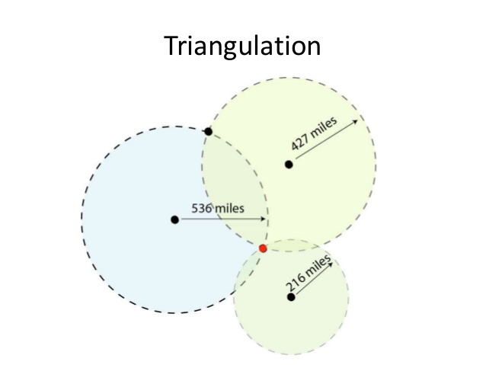

Figure1. 2D trilateration

Satellites send out two types of data Almanac and Ephemeris. Almanac data is course orbital parameters; there are six parameters to specify the motion and position fully, however very precise but valid for several months. Ephemeris data by comparison is very precise orbital and clock correction for each SV and is necessary for precise positioning but valid for 30 minutes. The almanac enables the receiver to know which satellites to search for. A 2D position cannot be given until at least three satellites received the data from the ephemeris. This data is broadcasted every 30 seconds. (Mehaffey, 1998).

## 2.4. Space Race

Satellites have played a major part in GPS technology. During the Cold War the USA and USSR were in a competition to see who would come out on top in the Space Race. The Soviets launched Sputnik I on 4th October 1957. Sputnik I would become the very first artificial satellite into space. The satellites weighing 83.6 kg, 58 cm in diameter, orbited the earth every 98 minutes. As a result, this started the “Space Race” and accelerated science, technology and military developments especially in America. The Soviets now had ability to develop missiles that could hit main land America from Europe. The Soviets launched Sputnik II, with an animal passenger, a dog named Laika on November 3rd 1957. America responded with the launch of Explorer I on January 31st 1958. By July 1958 America set up NASA or National Aeronautics and Space Administration. (Garber, 2007).

## 2.5 First NASA Satellites

Echo 1 became the very first Communication Satellite launched into space on August 12 1960. The satellite or balloon was 30.48m in diameter and was constructed out of mylar polyester film 0.5 mil thick. The balloon was designed for sending telephone (voice), radio, and television signals for both transcontinental and intercontinental means. The balloon was constructed as a passive communication reflector; this means a satellite reflects communications signals between stations without a providing amplification. It transmitted on 107.9MHz beacon for telemetry measurements purpose. The reasons for the large area-to-ratio of the balloon were to allow for calculation of atmospheric density and solar pressure. For the transmitters to work the balloon was fitted with five nickel-cadmium batteries, that were charged by 70 solar cells. NASA continued to send satellites to space with the launch of TIROS 1 on April 1st 1960. The TIROS 1 was the very first meteorological satellite. Again on November 20th 1998 NASA launched The International Space Station. (Mackey, 2004).

## 2.6 Commercial Application of GPS

GPS systems are used in many areas of life today such as navigation in vehicles, aircraft and ships. Anyone one with a GPS receiver is allowed to pinpoint their speed position to incredible accuracy, whether they are on land, sea or air. Modern car GPS allow for drivers to find a route, detour and receive traffic alerts. GPS is also useful for hikers and athletic people, the GPS device can mark rendezvous points along their route or mark out a route for a certain distance. GPS devices can very important for scientific and engineering experiments and monitoring geological activities such as volcanic and seismic activities and climate change. GPS receivers are also built into many everyday commercial technologies. These range from mobile phones, watches, smartphones, tablets, cameras, road vehicles and agriculture machinery.

### 2.6.1 GPS in Commercial Technology

Since the mid 1990’s GPS receivers became more affordable to the public. As a result the industry has become multibillion-dollar market. In 2002 General Motors OnStar and Mercedes Teleaid made a telematics IBs available to consumers. In April 2002 a survey carried out revealed that 20,000 homes in the US had a strong interest in using GPS for mainly security purpose such as tracking stolen vehicles, other purposes is to get traffic updates and navigation. Today GPS is widely available on different portable devices. (Bradford W. Parkinson, GPS Eyewitness: The Early Years, September 1994, cited in Societal Impact of Spaceflight, 2007, p331).

GPS in commercial technologies usetrilateration to calculate exact location. GPS receiver uses trilateration to determine its position on the earth’s surface by using timing signals from a least three GPS satellites. These signals transmit signal with precise details of location, time of day and the speed the device is moving. Each of the signals sends out a periodic signal. The GPS device calculates the distance between the device and each satellite, based on the time it was transmitted and the time the signal was received. The device can now calculate the trilateration’s. Trilateration’s are calculated like a 3D version compasses on a map. The positions were at least three circles meet this is the precise position of the GPS device. For this to happen the receiver needs to have a clear sight to the satellite, interference can come from dense tree cover and buildings. Some phones use wireless assisted GPS or enhanced GPS. This system can retrieve a user location quicker using this system. More so this system can work in buildings, poor transmission areas and in dense forests. Some phones have a complete GPS located in the phone or connect through a Bluetooth connection. These GPS enabled phones can understand programming languages like Java. These features allow tracking device. The phone must have a compatible receiver, and supports transmission of map GPS data, software that provides the actual maps and location. (Mio Technology, 2011).

GPS on phones have certain advantages such as trackers which allow business companies to pinpoint GPS coordinates of their employees and allow the user to dial an emergency number. Parents can locate the location of their children to see if they are in a safe area. Such technologies that are available in this market include a Japanese technology watchdog GPS watch phone. GPS technology on mobile phones is displayed on the screen, with indications of turning directions and also phone speakers. Unfortunately the data may not be up to date as this depends on data provided by the company. Such companies include TeleNav, ViaMotonand and MapQuestFind. (Wilson, 2005).

## Chapter 3: Sensor Technology

## 3.1 Introduction

“A sensor is a device that converts a physical phenomenon into an electrical signal.” (Wilson, 2005, p.1) There is a range of sensors found in technology today. These include Accelerometers, Shock and Vibration Sensors, Biosensors, Chemical Sensors, Humidity Sensors, Position and Sensors and many more. Many of these sensors can be found in everyday technology such as mobile phones. Sensors are either active or passive and have four different outputs; voltage, current, resistance and AC voltage. For example, thermocouple temperature sensor that is a passive sensor with a voltage output. A force strain gage is an active sensor that has a resistance output. Acceleration is an accelerometer that is active sensor with a capacitance output. A position LVDT sensor is an active sensor with an AC voltage output. On a rare occasion, a sensor may have more than one output. A temperature silicon sensor, which is an active sensor, has two outputs, voltage and current. (Wilson, 2005).

## 3.2. Accelerometers

“Accelerometers are sensing transducers that provide an output portioned to acceleration, vibration and shock.” (Wilson, 2005, p.137). There are many uses of accelerometers in smartphones from a compass knowing what direction the phone is pointing to turning the phone from portrait view to landscape and respond to a certain required action in video games such as turning a virtual car left or right. Motion sensors are capable of detecting earthquakes and used in bionic limbs. “Acceleration is the measurement of the change in velocity, or speed divided by time”, such as a car accelerating to a certain speed over a short period of time. (Goodrich, 2013).

## 3.3. Acceleration

Acceleration plays a major part in accelerometers. For example a car accelerates from an immobile position to a velocity of 100km/h in six seconds. The acceleration is the change of velocity divided by time: v=, so in this case 100/6 = 16.66 km/s. Isaac Newton stated that if you have a certain force and you apply it to mass, you’ll make the mass accelerate. (Woodford, 2016)

Acceleration = Force/Mass

## 3.3. Accelerometer Function

Accelerometers are used in many areas of technologies such as in laptops. The accelerometers protect the hard drive from damage. The accelerometer turns off the hard drive to avoid hitting the reading heads into hard drive platter when the laptop is suddenly dropped in use. Otherwise the reading heads would scratch the platter causing extensive reading damage. Accelerometers can determine if an object is moving uphill or if an object will fall over. It can also determine if an object is flying horizontally or at an angle. (Goodrich, 2013).

An accelerometer works in many ways the most common been piezoelectric effect and the capacitance sensor. Piezoelectric uses “microscopic crystals structures that become stressed due to accelerative forces”. (Goodrich, 2013). The accelerometers interpret voltage from the stress to determine velocity and orientation. Capacitance accelerometer works by sensing changes between microstructures located next to the device. The accelerometer will translate any capacitance changes caused by forced movement to voltage for analysis. The components of an accelerometer can either be purchased individually but most components are integrated into the technology that access either operating systems or governing software. Accelerometers tend to have multiple axes either two to determine two dimensional movements, or a third axes for 3d positioning. Two dimensions are mainly used to determine the moment of impact of a car crash, while mobile phones tend to use 3 axes. Accelerometers tend to be very sensitive, the more sensitive an accelerometer is the more easily it can measure acceleration. (Goodrich, 2013). Mechanical accelerometers act like a spring suspended within a container. When acceleration occurs the container moves off instantly, the spring stretches with a force that corresponds to the acceleration, and the mass lags behind. The force and the acceleration can be measured by the distance of the stretch of the spring. For example seismometer measures an earthquake. When an earthquake occurs the seismometer cabinet shakes, however the pen attached takes longer to move, and as a result the pen attached erratic trace onto a piece of paper. (Woodford, 2016). Other accelerometers include:

* Null-balance
* Optical
* Resonance
* Servo Force Balance
* Strain Gauge
* Surface Acoustic Wave (SAW)

## 3.3. Some Specifications

There are many specifications for accelerometers; one of the main specifications is the type of output, which can be either analog or digital. The main difference between analog and digital is; analog output is a constant variable voltage, while digital accelerometer output has a variable frequency 10 square wave. Another specification of accelerometers is the number of axis; they can be 2-dimension or 3-dimension axis. F. The most common type of accelerometer is 2-dimensional but 3-dimensional accelerometers are common use for gravity acceleration and tilt sensors. (Siddhesh C. Narkar, Siddhesh R.Bhalekar, Tushar K. Nawge, Keshav H. Parab, 2013).

# Chapter 5: **Methodology & Design**

## 5.1. R*e*search Undertaking

Fall detection technology has improved and evolved, just like any technology that maybe implemented with the fall detector in question. From the research carried out for this thesis presented that the technology in certain part of the word such as the United States of America, have fall motion detectors that take in everything into consideration. This includes panic button, response time of a user to and GPS location. Despite these detectors on the market are well received with very good reviews, there is few areas that could be improved on. It was discovered that these fall detectors were only available with in the United States. The fall detectors on the market were all owned by third party companies, which generally ring up emergency services. The user may not be comfortable communicating with emergency services when the individual has fallen. These fall detectors also tend to be expensive that many elderly people may not be able to afford.

## 5.2. Research Question

Is it possible to improve on current fall detector technologies that are feasible and affordable, which will trigger an action?

## 5.3. Design

To carry out the test an accelerometer is required to extract and store data. An Accelerometer can be accessed easily either but one online or buy a smartphone. As a smartphone was available this was the option that was chosen. From here an application will be built on android studio, once the application is built it is then uploaded to the smartphone. The application will then retrieve the data from the accelerometer on the smartphone and display the values according to the movement of the phone. More people have access to smartphones. Other reasons the tests will be carried out on a smartphone is that smartphones have GPS installed on them.

Please See Appendix 1.

### 5.3.1 Vision Document

**Title:**

Fall Motion Detector with GPS Transmitter

**Project Description:**

To develop an application that will retrieve data from an smartphone accelerometer, that will test record and transmit the retrieved data that will detect whether an individual has fallen down/over. The idea is to test whether or not an affordable fall detector could be developed, by simple designing an application on smartphones compared to the current detectors that currently on the market. The detector will monitor an individual on the application on that person smartphone, if the individual falls an notification is sent to a loved one’s phone. Rather than ringing up an emergency number if they rather the notification sent to their loved ones instead, as they may not be comfortable talking to an emergency unit.

**Deliverables/Outcomes:**

An application will be built that will monitor the accelerometer on the smartphone. If the individual has fallen, the application will detect the fall through the accelerometer data. Then a notification is sent a receiver end such as text to a phone with the GPS location.

If the application correctly detects a fall it will prove that a more feasible and affordable fall detector could be developed.

**Functionality & Technology**

The application will be built on Android studio. Need access to a smartphone. Languages that the project will be written in XML, Java……

GPS and Accelerometer data needs to be accessed.

**MoSCoW Method**

|  |  |  |
| --- | --- | --- |
| **Unique ID:** | **Description** | **MoSCoW method** |
| 001 | Android Studio Installed | Should have |
| 002 | Smartphone | Must have |
| 003 | Accelerometer on the phone | Must have |
| 004 | GPS | Should have |
| 005 | JavaScript Frame work to develop the app | Could have |

**Audience:**

There are two types of individuals;

Elderly people who maybe have a condition that could cause a fall or a prone to falling.

Special needs people.

### 5.3.2 Risks

|  |  |
| --- | --- |
| **Type of Risk** | **Prevention** |
| Never used Android studio before | Find tutorials to learn how to use the software. Mess around with the features outside the main project. |
| Coding in XML | Find tutorials to learn how to code in XML practice the code outside the project. |
| Testing the accelerometer data | Research how to test accelerometer data |
| Coding with GPS data | Research about coding with GPS data |
| Sending GPS data and Accelerometer to another source | Research how to send data separately and then figure out how to send the combined data together |

## Chapter 6: Implementation

## 6.1. Sprint Schedule

|  |  |  |
| --- | --- | --- |
| **Sprint Number** | **Start Date** | **Finish Date** |
| 1 | 30/11/2016 | 2/12/2016 |
| 2 | 16/01/2016 | 20/02/2016 |

### 

### Sprint 1:

|  |  |  |
| --- | --- | --- |
| **Sprint Number** | **Start Date** | **Finish Date** |
| 1 | 30/11/2016 | 01/12/2016 |

|  |  |  |
| --- | --- | --- |
| **Task Number** | **Details** | **Status** |
| 1 | Unlock the developer options on the android phone. | Complete |
| 2 | Unlock OEM on the android phone. | Complete |
| 3 | Download and install Android Studio. | Complete |
| 4 | Set up new project. | Complete |
| 5 | Reconfigure the android studio to allow the application to be built onto the android phone. | Complete |
| 6 | Practice using android studio to get a better understanding in how use android studio. | Complete |
| 7 | Do a pre-test to see will see if the application will build on the android phone. | Complete |
| 8 | Research a way to retrieve the data from the android phone | Complete |
| 9 | Use found example code and build the prototype. | Complete |

The first sprint is the start of building and testing the prototype. This sprint is a way to get use to android studio and how xml coding works. This first part was to unlick the android phone features which is crucial to test fall motion of the accelerometer. This was straight forward, just like unlocking the OEM on the android phone. The only problem with the unlocking of the phone is wasn’t as clear as unlocking the developer options. This is because of the make and model of the phone did not have a clearest of explanations on the main website. Android studio was easy to install however, with the lack of knowledge of the product it made thing difficult to get use of. Secondly, the software takes up a lot of the CPU, which took time for the application to build. As result it seemed that he application was been built on the phone, but it was just taking time to pick up the android phone. The code was easy to follow despite on error that took a while to figure out. When the application was built on the phone it was reading the data from the accelerometer perfectly.

## Chapter 7: Data Analysis/Synthesis

# Chapter 8: Findings & Conclusions

# References

A1RONZO, 2012. *GPS Basics*. [Online] Available at: <https://learn.sparkfun.com/tutorials/gps-basics?_ga=1.267002122.566327705.1474925827> [Accessed 27 September 2016].

Bryant, J., n.d. *Keplers Second Law*. [Online] Available at: <http://demonstrations.wolfram.com/KeplersSecondLaw/> [Accessed 4 October 2016].

Dimension Engineering LLC, 2016. *A beginner’s guide to accelerometers*. [Online] Available at: <http://www.dimensionengineering.com/info/accelerometers> [Accessed 18 October 2016].

Garber, S., 2007. *Sputnik and The Dawn of the Space Age*. [Online] Available at: <http://www.hq.nasa.gov/office/pao/History/sputnik/> [Accessed 3 October 2016].

Goodrich, R., 2013. *Accelerometers: What They Are & How They Work*. [Online] Available at: <http://www.livescience.com/40102-accelerometers.html> [Accessed 11 October 2016].

Goodrich, R., n.d. [Online].

GPS.gov, 2016. *Space Segment*. [Online] Available at: <http://www.gps.gov/systems/gps/space/> [Accessed 7 December 2016].

Mackey, R.J.J., 2004. *Echo 1*. [Online] Available at: <http://www.nasa.gov/missions/science/f-satellites.html> [Accessed 4 October 2016].

Mehaffey, J., 1998. *Almanac and Ephemeris Data as used by GPS Receivers*. [Online] Available at: <http://gpsinformation.net/main/almanac.txt> [Accessed 27 September 2016].

Mio Technology, 2011. *What is GPS?*. [Online] Available at: <http://www.mio.com/technology-what-is-gps.htm> [Accessed 10 October 2016].

Project Calliope, 2011. *The 6 Classic Orbital Elements*. [Online] Available at: <http://www.science20.com/satellite_diaries/6_classic_orbital_elements-79561> [Accessed 27 September 2016].

Sturdevant, R.W., 2007. *Societal Impact of SpaceFlight*. Washington DC: NASA.

Trimble Inc., 2016. *Pseudo Random Code*. [Online] Available at: <http://www.trimble.com/gps_tutorial/sub_pseudo.aspx> [Accessed 27 September 2016].

Wilson, T.V., 2005. *How GPS Phones Work*. [Online] Available at: <http://electronics.howstuffworks.com/gps-phone2.htm> [Accessed 17 October 2016].

Woodford, C., 2016. *Accelerometers*. [Online] Available at: <http://www.explainthatstuff.com/accelerometers.html> [Accessed 22 November 2016].

Zogg, J.-M., 2009. *Foundations of Satellite Technology*. [Online] Available at: <http://zogg-jm.ch/Dateien/GPS_Compendium(GPS-X-02007).pdf> [Accessed 4 October 2016]. p.35.

Appendix

## Appendix 1

To carry out the test on a smartphone, the accelerometer data had to be retrieved from the smartphone. During the research it was discovered many ways to get the data from the phone. All the examples agreed the data should be retrieved by building an app on the smartphone. To allow tester apps to be run on an android phone, the developer options and OEM, had to be unlocked. To unlock the developer options on the android smartphone, the following steps had to be taken out:

1. Tap on Settings
2. Tap on About
3. Tap on Software Information
4. Tap on More
5. Now tap on Build Number 7 times

Now a message will appear on the screen:

“You are now 4 steps away from being a developer.”

This now allows the user to enable developer options. To this hit the return symbol twice on the screen to get back to the settings page. Now on the screen appears the option ‘Developer options’. Tap on this option. Scroll down to the USB debugging and tap on the box beside the option. To Unlock the OEM unlocking just tap the box beside the ‘OEM unlocking’. This may not be required to start developing on every smartphone but from the research carried out that the OEM needed to unlocked. If this is the case the smartphone will ask the user to enter their unlock code or pattern or password depending on the format the user had originally entered (if any).

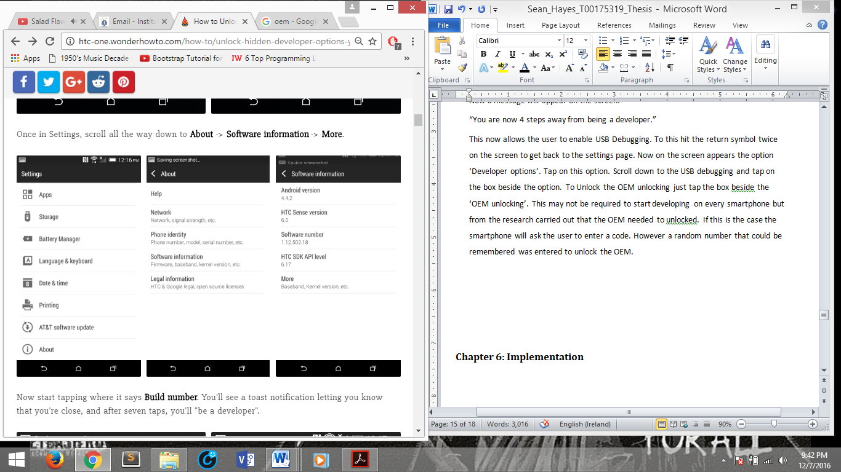 Figure 2. Screenshot to access the debug and OEM modes

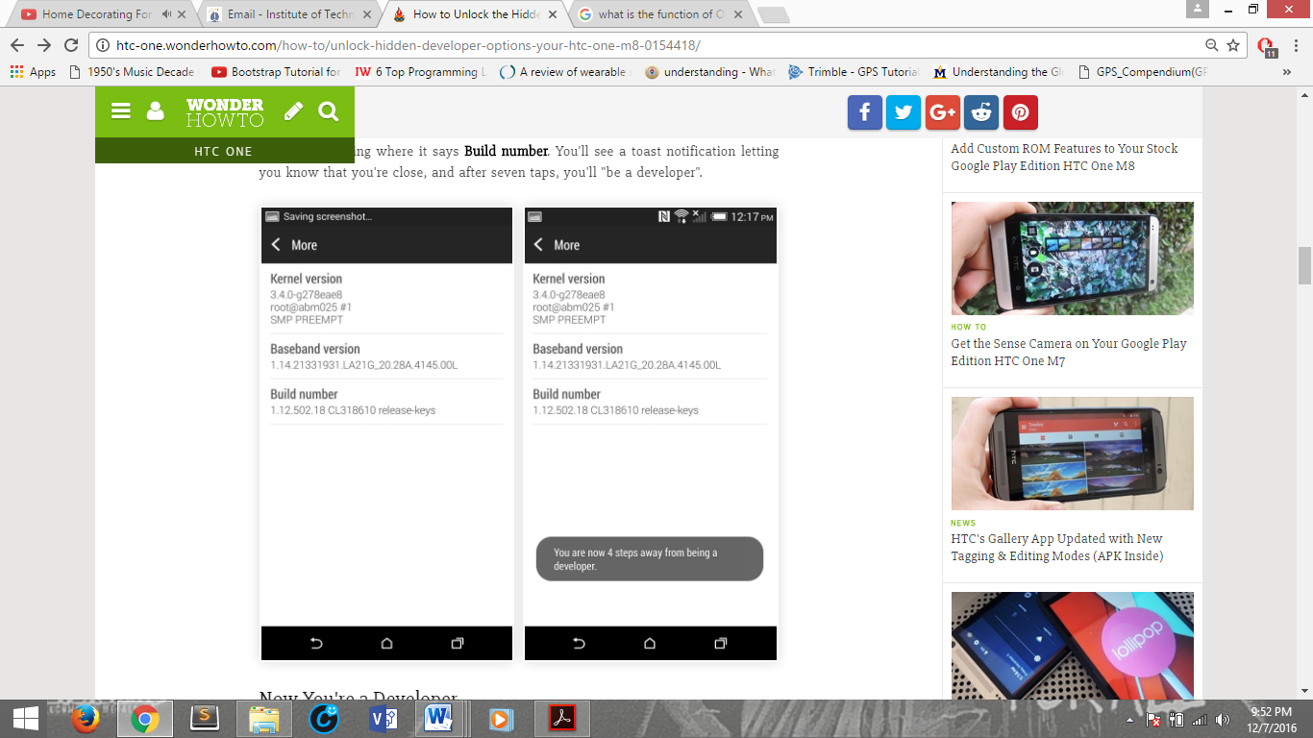

Figure 3. Screenshot unlocking developer options.

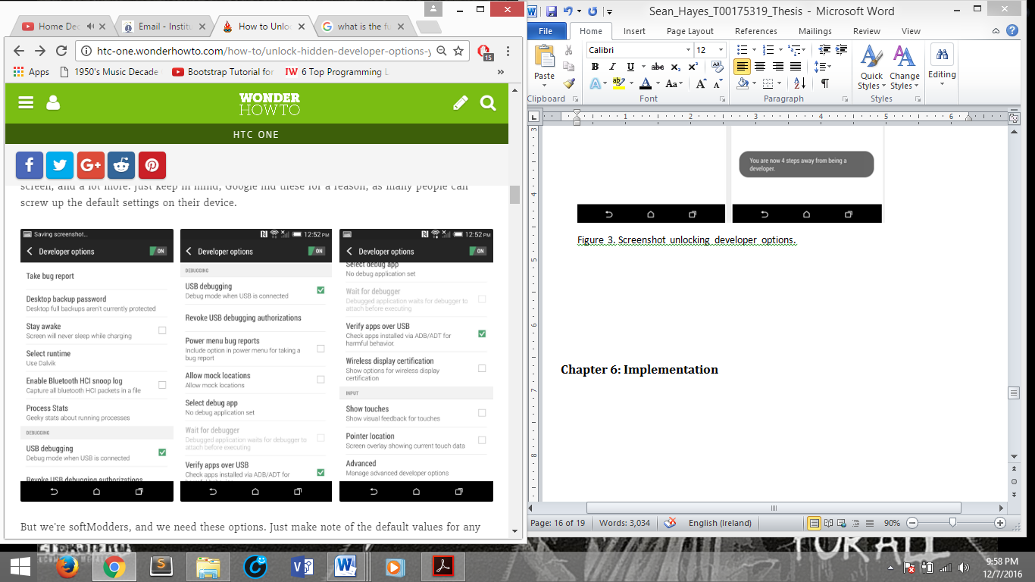

Figure 4. Screenshot of Developer Options

### Setting Up a New Android Studio Project

To develop the application that retrieved the data from the android smartphone accelerometer, Android Studio had to be downloaded to the computer from this link:

<https://developer.android.com/studio/index.html>. Once the download is complete the installation process was run. When the installation was complete the software could be run. The first option allowed the user to create a new project here they name the application name complain domain chose the location. Next step was to choose the minimum SDK such as Android Marshmallow. Next step was to choose the Screen Activity such as Empty Screen Activity. Finally an activity a name and layout name classes. Android Studio created the new application.

### Building the Application

For the application to be built onto the smartphone, the settings had to be configured to the user’s smartphone developer lollipop specifications. If the user doesn’t know the specifications they can be found online. In this case the lollipop version Android 6.0 Marshmallow. The library has to be installed by doing the following:

Clicked on tools -> Android -> SDK Manager. A new Screen will have popped up. Here chose the SDK platform by clicking the box beside the SDK that needs to installed, then click apply. Android Studio now installed the package. The application is going to be tested on an actual android smartphone android studio needs to pick up the smartphone USB input. For this to happen the configuration settings were changed. To do this clicked on Run tab -> choose Edit configuration, a new screen appeared. In this screen the target option was changed to USB Device. The smartphone was connected to the computer. A test was carried out to see if the application as built onto the smartphone. To this a button and a label was added to the design in android studio and then clicked the green triangle on the tab and waited for the app to build on the phone. It successfully built the test.

The next thing was to retrieve the data from the accelerometer on the phone. To do this a tutorial was found through the research. The tutorial was then put into practice. The steps to build the application went as followed:

The layout display was coded from top bottom according to the tutorial.

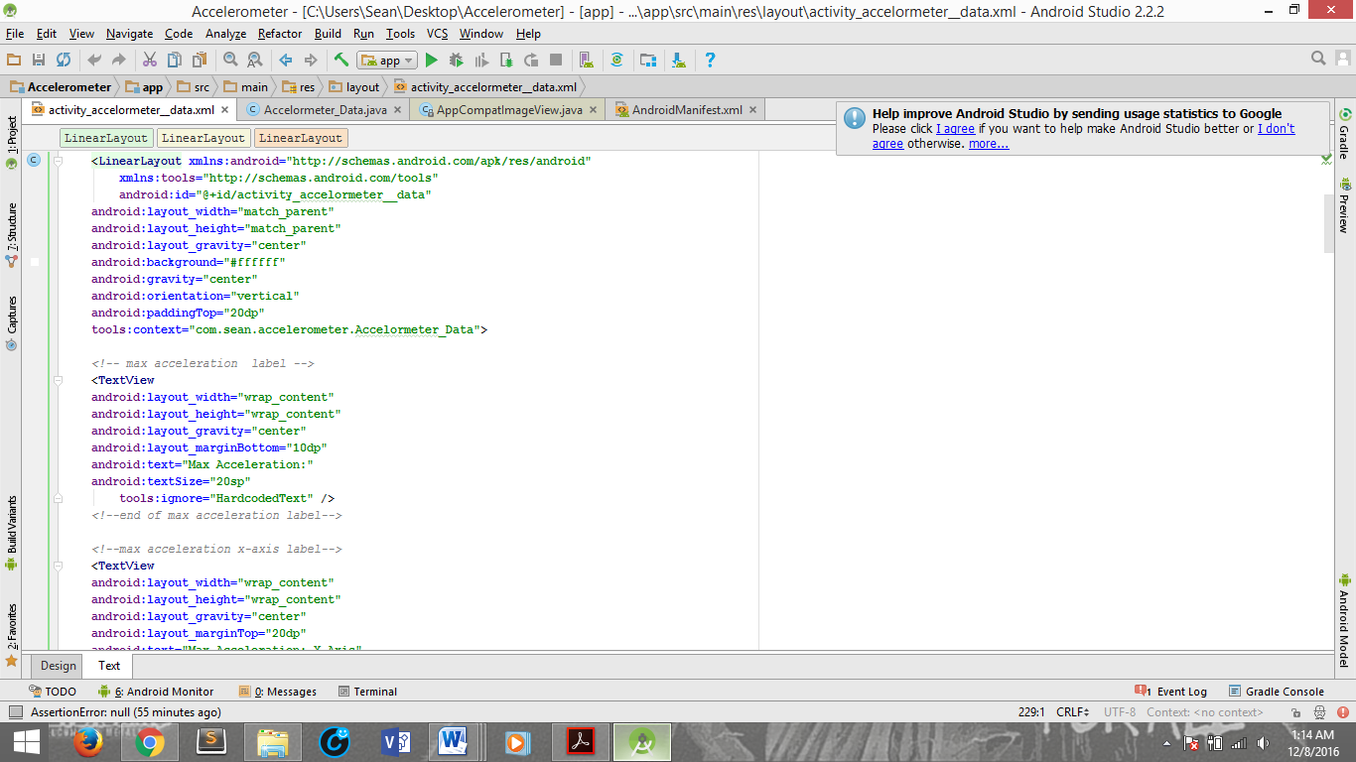

Figure 5. Example of design layout code.

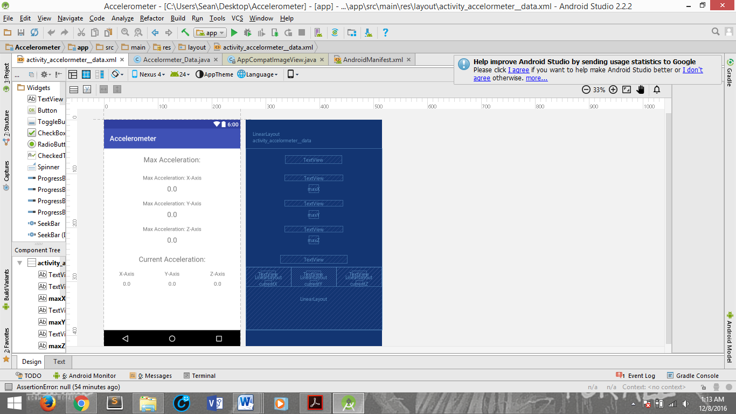

Figure 6. Prototype Application Design.

After the design phase the code to retrieve the accelerometer data was coded.

The 3 axis are giving a variable each. Each of the value above is set to default value of 0.0. Next the code to retrieve the sensor is code and the sensor package is imported. Other packages such sensor listeners are imported from the phone. Final the code to check for the phone movement on the 3 axis, x-axis, y-axis, and z-axis is coded.

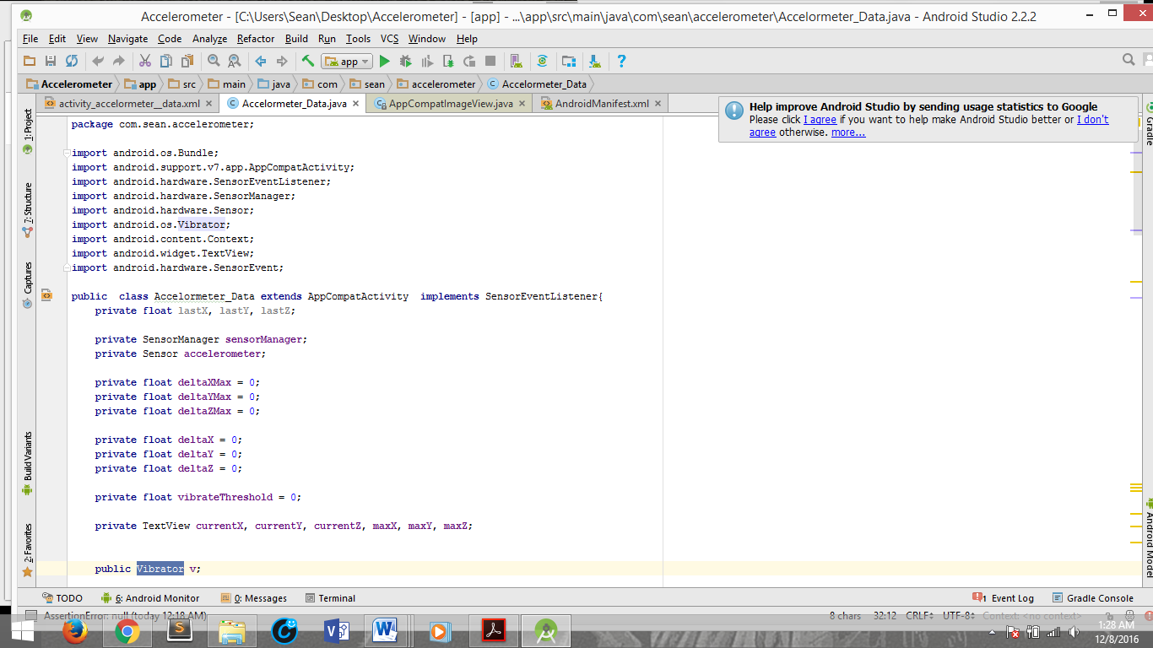

Figure 7. Shows the packages that are imported plus the variables of the application.

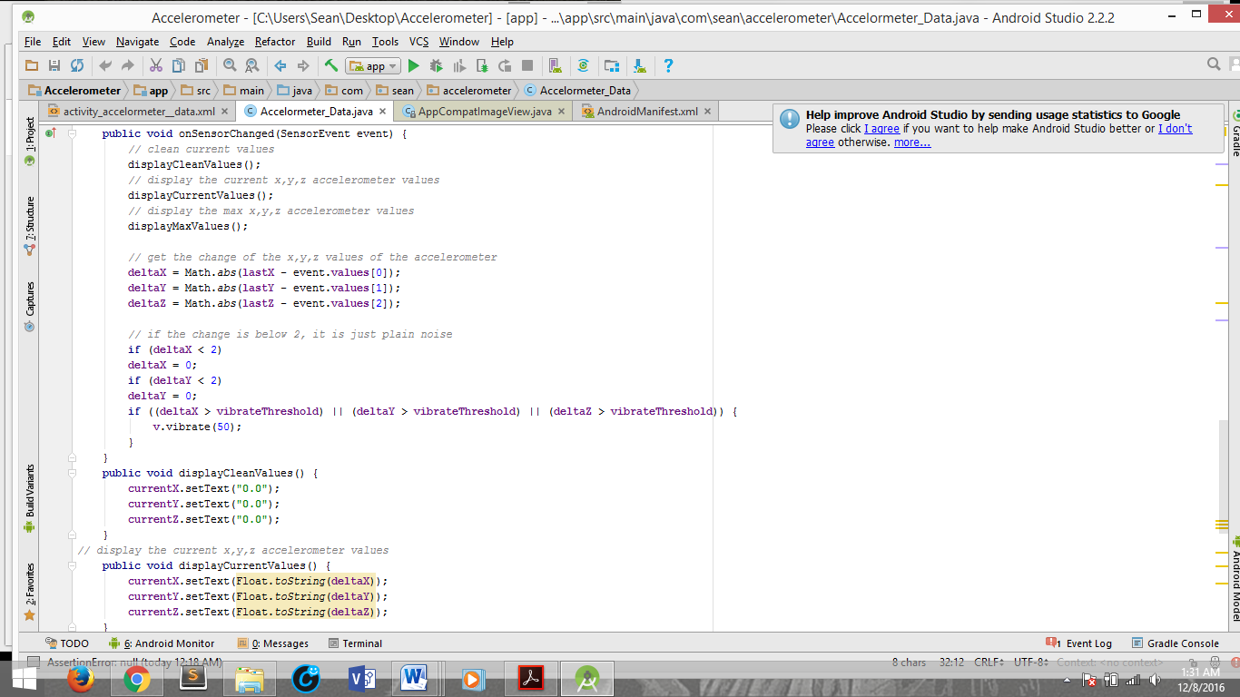

Figure 8. This is the code that calculates the axis of the phone’s accelerometer.

Finally the xml for the Main SDK is coded to allow the application to run the smartphone.

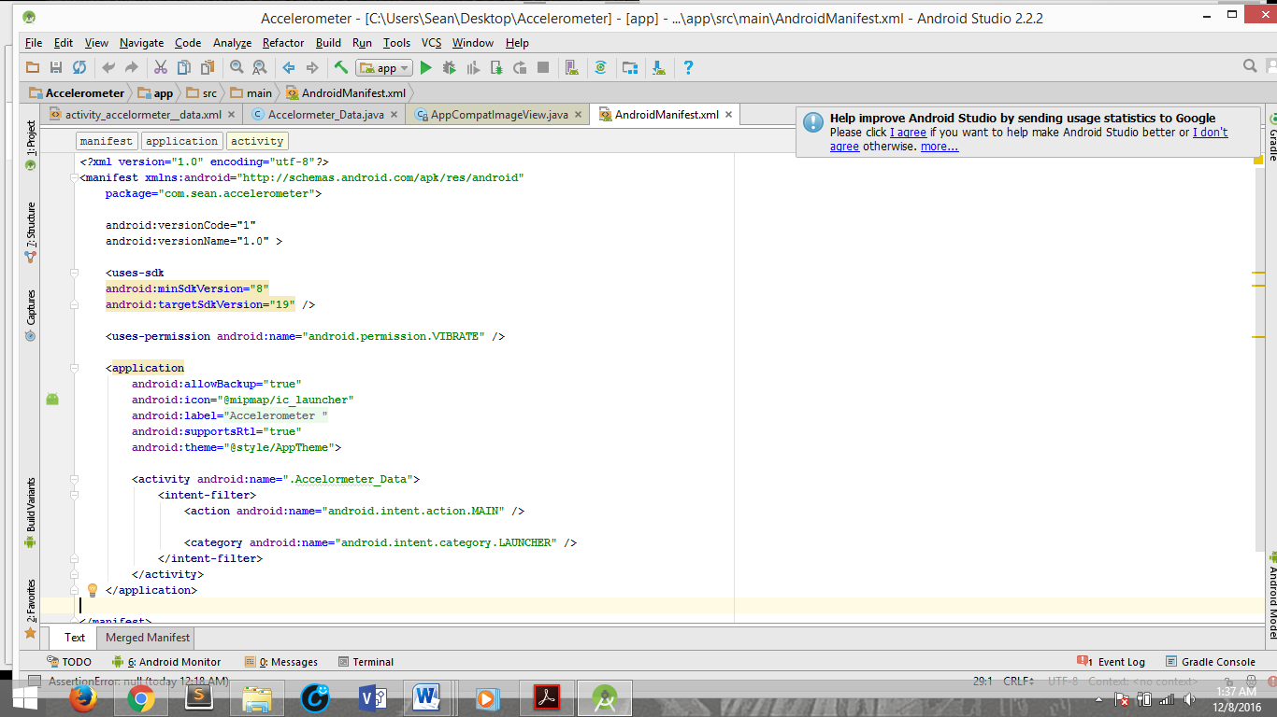

The code was completed the application was built. The application was created correctly on the phone, and retrieving the data from the smartphone. The values changed depending on the direction and acceleration of the phone direction.