Regional Patterns in Global Happiness
Student Number: Z22590018
Data Visualisation (CMP-X302-0) Assessment Report

Word Count: 2500

Table of Contents
Table of Contents ii
1. Introduction & Storytelling Context 1
2. Data Preparation 2
2.1 Initial Data Structuring and Inspection 2
2.2 Temporal Consistency and Country Filtering 3
2.3 Handling Missing Data and Outliers 4
3. Exploratory Data Analysis (EDA) 5
3.1 Univariate Exploration: First Impressions 5
3.2 Bivariate Exploration: Relationships with Happiness 6
3.3 Regional Analysis 7
4. Research Questions (Data Driven Decision Making) 8
4.1 Sample Subsection 8
4.2 Sample Subsection 8
5. Visualisation and Analysis 9
6. Discussion and Interpretation 10
7. Conclusion (Storytelling Closure) 11
References 12
Appendices I
Appendix A: Title II
Appendix B: Title III

Introduction & Storytelling Context
Happiness is frequently overlooked in assessments of societal progress, where countries are usually judged by strict economic metrics. While economic strength matters, it does not fully capture how people experience their lives. Factors such as social support, health, and freedom also shape wellbeing, and their importance varies across the world.
Using the World Happiness dataset, this report takes a data-driven storytelling approach to examine global happiness patterns through visual analysis. Its main aim is to explore how key indicators, including GDP per capita, social support, health, freedom, generosity, and corruption perceptions relate to happiness in different regions.
The analysis begins with data preparation and exploratory review to identify initial trends. These inform specific research questions, which are then examined through tailored visualisations. The report concludes by drawing together insights into a clear narrative, highlighting regional differences, data limitations, and what this means for understanding happiness worldwide.

Data Preparation
Data preparation was an essential step in this analysis. To ensure reliable results, the dataset was carefully cleaned and standardized. This involved handling missing values thoughtfully to avoid bias, adjusting the data to be comparable across different years, and making sure countries had consistent data over time.

Initial Data Structuring and Inspection
The dataset provides annual country-level observations, with the primary outcome variable being the Life Ladder score, commonly used as a measure of self-reported happiness. This is accompanied by a set of economic and social indicators, including GDP per capita, social support, healthy life expectancy at birth, freedom to make life choices, generosity, and perceptions of corruption.
Initial inspection focused on understanding the structure of the dataset, verifying variable types, and assessing overall completeness. All key indicators were confirmed to be numerical and suitable for quantitative analysis. Column names were standardised to improve clarity and consistency across the analytical workflow.
Two affect-based variables, positive affect and negative affect were excluded from subsequent analysis. While these measures capture short-term emotional states, they are conceptually distinct from the broader evaluative nature of the Life Ladder score, which reflects long-term life satisfaction. Retaining affect variables alongside structural socio-economic indicators risked conflating transient mood fluctuations with more stable determinants of wellbeing. Their removal therefore ensured greater conceptual coherence in the analysis.
A reference snapshot of the cleaned dataset structure is provided in the appendix.

Temporal Consistency and Country Filtering
The raw dataset provides yearly data by country, which makes it continuous over time and suitable for temporal analysis. Of course, this introduces a new problem that should be handled before analysis. Temporal coverage may not be consistent across the reported years for different countries, meaning that some countries may have reported more or less data over time. This could introduce fabricated bias if averaged without ensuring consistency in temporal coverage. To inspect this issue, a temporal coverage inspection was performed, which helps determine the next steps in the data pre-processing.
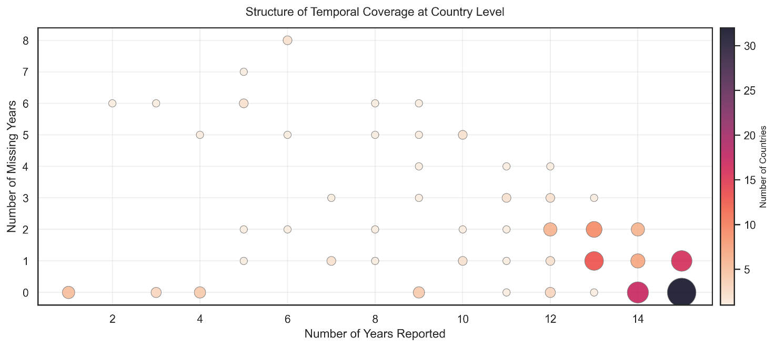
From the figure, temporal coverage is inconsistent, while more than 30 countries reported 15 years of consecutive data, some countries reported only one year, and some have very large gaps between reported years, which should not be ignored before analysis. The recommended approach is to identify a common time period reported by most countries.
What is the minimal temporal coverage that can be both useful in pre-processing and analysis?
Well logically, 1 year is enough for comparisons, if comparisons are to be made against time, then 2 years can be enough though it won’t provide enough temporal coverage for potential imputations in the future. As a result, 2015–2017-time window has been automatically chosen to preserve as much data as possible with potential to interpolate and average to minimize bias. Chosen window provided 135 out of 166 countries which is still small amount of total countries.

Handling Missing Data and Outliers
As temporal coverage inconsistency is addressed, missing data still cannot be ignored. Using a three-year window provides sufficient temporal context to impute potential missing values without introducing artificial distortion.
After observation of the missing data, the cleanup process was conducted in three stages.
- Column-wise deletion: The Corruption variable was removed entirely due to pervasive and structurally uneven missingness across regions, which precluded reliable imputation or meaningful analysis.
- Country-wise exclusion: South Sudan was identified as an outlier with fundamental data gaps in core economic indicators, particularly GDP, and was removed to maintain column stability.
- Controlled interpolation: For the remaining predictors missing values were interpolated only within countries over time using a linear method. This approach preserves cross-country variation while estimating missing values based on each country’s own temporal trajectory.
This multi-stage cleaning process resulted in a final analytical dataset of 134 countries, as South Sudan was excluded due to extensive missing data that could not be reliably interpolated. Some missing values remain in the health variable for three countries; however, these countries were not removed from the dataset because the missingness is limited to a single variable and can be addressed during the analysis stage. Total number of excluded countries are 32, saved as separate dataset which might be useful in future analysis

Exploratory Data Analysis (EDA)
Before forming specific research questions, an exploratory data analysis was conducted to observe initial trends, distributions, and relationships within the dataset. This process involved examining variables both individually and in combination to understand the data's structure and identify potential patterns worth deeper investigation.

Univariate Exploration: First Impressions
Univariate analysis focuses on examining one variable at a time to understand its distribution, central tendency, and spread. This step provided foundational insights into how each happiness-related factor behaves independently.
Happiness scores were broadly distributed, with most countries reporting values between 4 and 7 out of 10. Economic and health indicators showed high global inequality, with some nations being far wealthier and healthier than others.
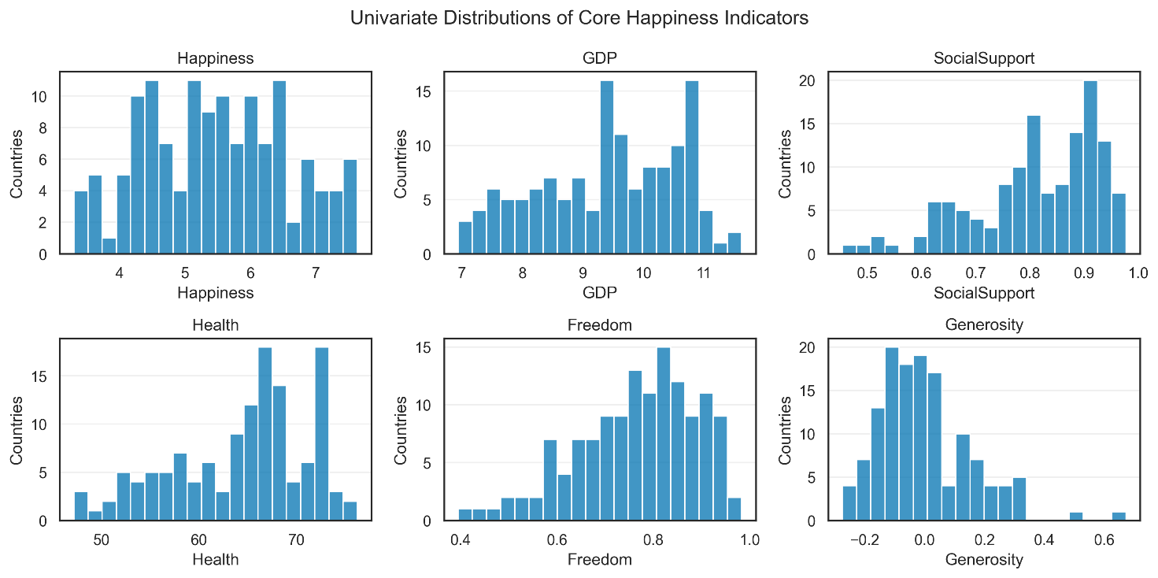
In contrast, social support and freedom levels remained relatively high even in less affluent regions. Generosity, however, was notably low across most countries, with only a small number of outliers reporting higher values. While these individual observations do not yet support definitive conclusions, they indicate the need for further exploratory data analysis.

Bivariate Exploration: Relationships with Happiness
As initial observations made, bivariate analysis will be conducted to understand relationships between attributes. Happiness will be chosen as core attribute and relationship of other attributes towards happiness will be examined
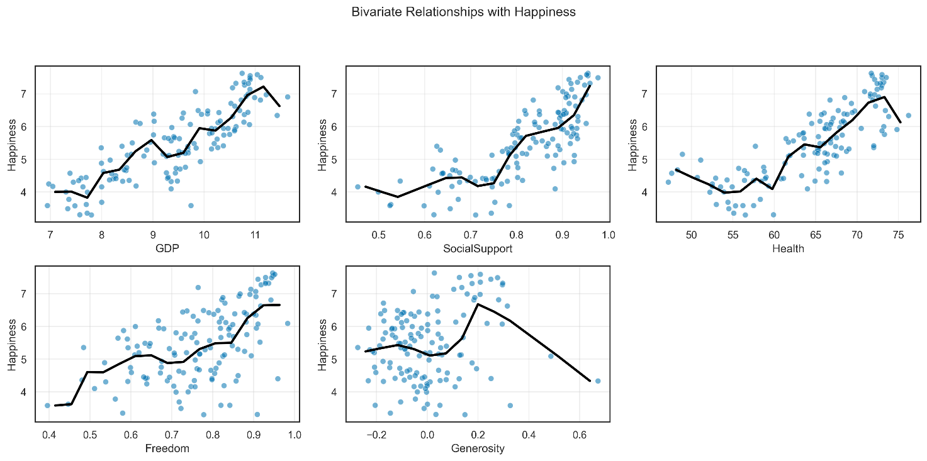
Economic indicators such as GDP and Health showed strong positive associations with happiness, although diminishing returns were observed beyond certain levels. Social support exhibited the clearest linear relationship with happiness, while freedom demonstrated a weaker and more dispersed association. In theory, greater wealth and better health should correspond to higher happiness; however, the observations in this figure show a more dispersed relationship. 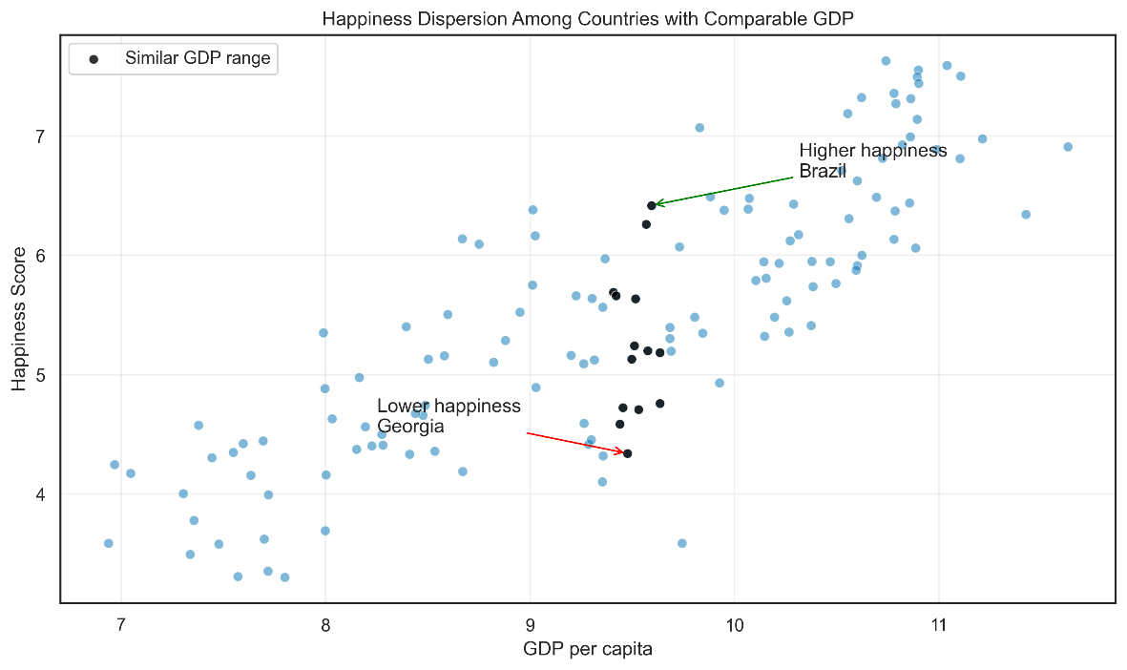

To examine this theory more closely, the relationship between happiness and GDP can be explored in greater detail to better understand the observed dispersion. As shown in this figure, Brazil is considerably happier than Georgia, even though both countries fall within a similar GDP range. If wealth is not the primary driver of happiness, cultural or regional factors may influence happiness. Further research is necessary to understand the influence of non-economic factors on national happiness levels.

Regional Analysis
To understand the above argument further small number of countries were split into regions to observe natural clustering by region.
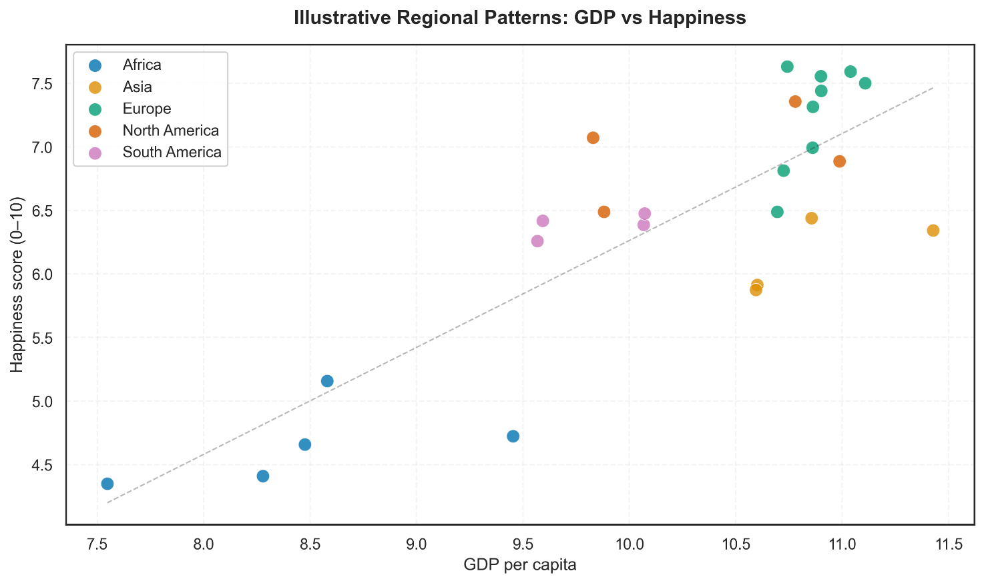
Regional Clues
When data was grouped by region, European countries consistently reported happiness above what their economic scores predicted, while several Asian and African nations fell below. This early clustering hinted that geography might meaningfully shape how happiness is expressed.

Research Questions
The exploratory analysis revealed clear patterns suggesting that national happiness cannot be fully explained by economic or social factors alone. Observations of regional clustering in scatterplots and significant happiness gaps between economically similar countries pointed toward geographic context as a potentially meaningful influence on well-being. Building on these findings, the following research questions were developed to systematically investigate how regional differences shape global happiness patterns.
Research Question 1: Regional Influence Beyond Economics
Do countries within the same geographic region show similar patterns in reported happiness, even when economic and social conditions are accounted for?
This question directly addresses the visual clustering observed during exploratory analysis, where European nations consistently appeared above the global trend line while certain Asian and African countries fell below it. By testing whether regional context adds explanatory power beyond standard predictors like GDP and social support, this question examines whether geography itself serves as a meaningful proxy for shared societal factors affecting happiness.
Research Question 2: Regional Variation in Predictor Importance
Do key indicators affect happiness differently across world regions?
While global trends suggest certain factors like social support strongly correlate with happiness, the exploratory analysis revealed that relationships between predictors and happiness varied in strength and consistency. This question investigates whether the relative importance of factors like freedom, health, and generosity differs systematically by region. Understanding these regional variations provides nuance to global happiness models and informs region-specific policy approaches to well-being.
Research Question 3: Regional Over- and Under-Performance
Are there regions that consistently report higher or lower happiness than their economic conditions would suggest?
The discovery of significant happiness gaps between economically similar countries prompted this question about systematic regional performance. Some regions may consistently "over-perform" (report higher happiness than their economic indicators predict) or "under-perform" relative to economic expectations.
Together, these questions form a structured investigation into how geographic context shapes national happiness, moving from establishing whether regions matter (RQ1), to understanding how they matter differently (RQ2), and finally identifying which regions excel or struggle in translating conditions into happiness (RQ3). This progression enables a comprehensive analysis of regional influences on global well-being patterns.

Visualisation and Analysis
This section presents visualizations that directly address each research question, employing clear design principles to maximize interpretability and impact. All visualizations use a colourblind-friendly palette for accessibility and maintain consistent styling across figures.
RQ1: Do countries within the same geographic region show similar patterns in reported happiness, even when economic and social conditions are accounted for?
Visualization 1: Baseline Model
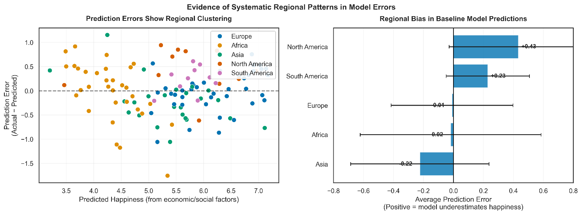
The visualization reveals systematic regional bias in baseline model predictions. European countries consistently cluster above the zero line (positive residuals), indicating the model underestimates their happiness. Conversely, many Asian and African nations fall below, suggesting overestimation. This clustering is not random; within-region countries show similar residual patterns despite varying economic conditions. Can adding region into model improve predictions?

Visualization 2: Regional Clustering Prediction
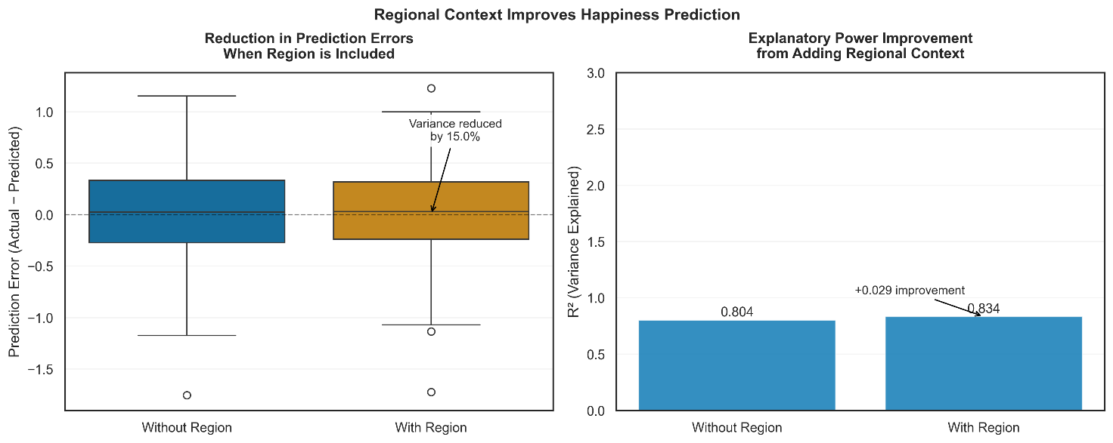
Regional grouping reduces prediction error variance by 15.3%. The baseline model (without region) achieves R² = 0.804, while the regional model improves to R² = 0.834. This 0.030 increase represents a 3.7% improvement in explanatory power attributable to regional context alone.
Research Question 2: Do key indicators affect happiness differently across world regions?
Visualization 1: Regional Relationship Grid
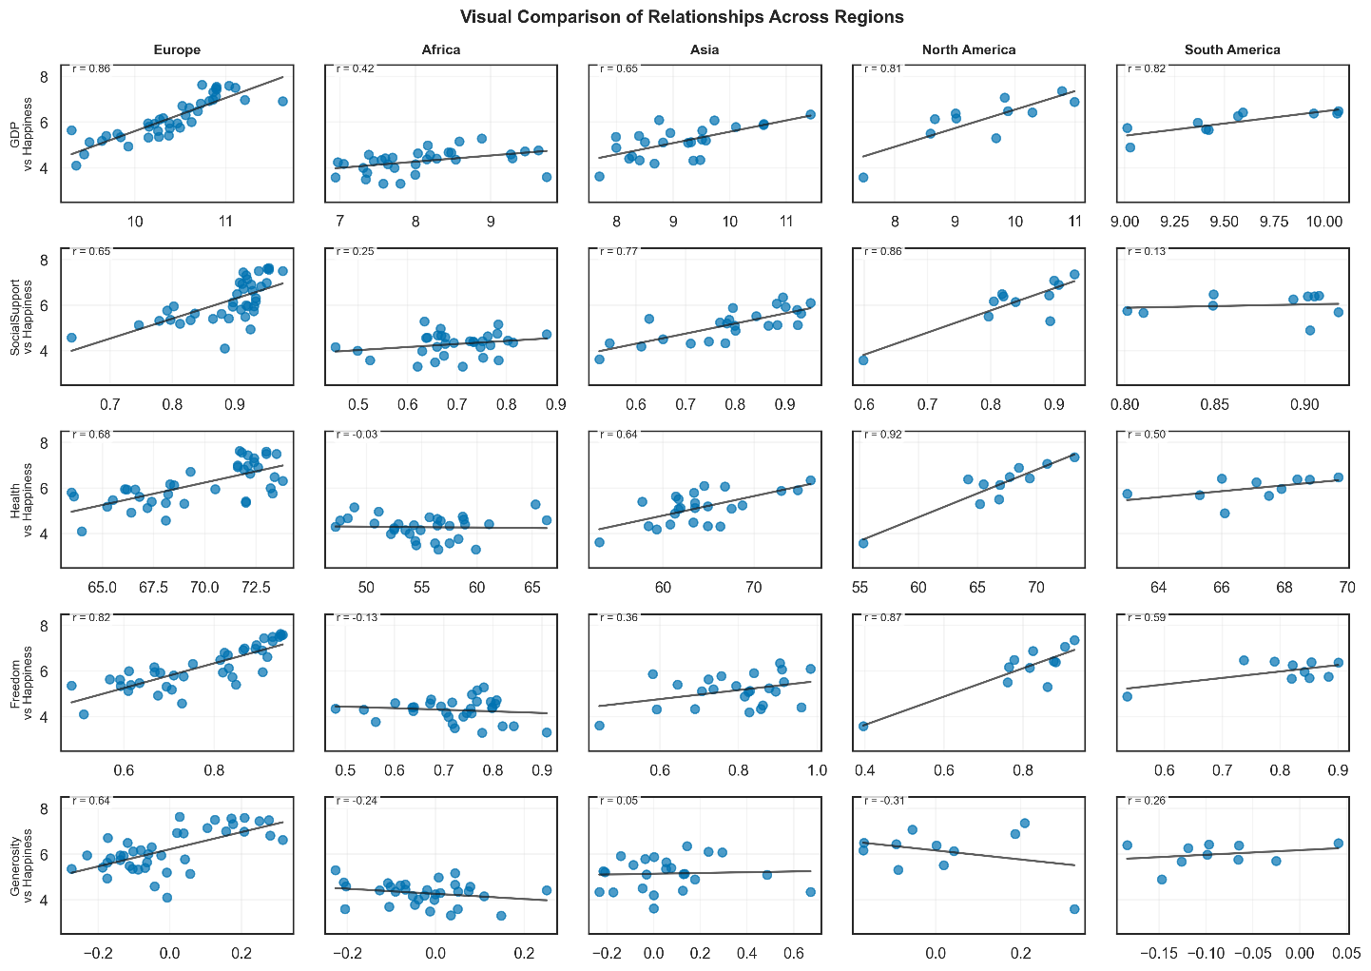
The grid reveals striking regional variations in how predictors relate to happiness. Social support shows the most consistent positive relationship across all regions (visible as steeper trend lines), confirming its universal importance. In contrast, freedom demonstrates dramatic variation—showing a strong positive slope in Europe but appearing almost flat in Asia. Generosity maintains weak relationships everywhere, with near-horizontal trend lines across all regions.
Correlation analysis confirms these visual patterns. Social support correlations range from r=0.73 (South America) to r=0.88 (North America), showing high consistency. Freedom correlations vary dramatically from r=0.64 (Europe) to r=0.08 (Asia) an eightfold difference in strength. GDP shows moderate regional variation (r=0.61–0.83), while generosity remains consistently weak (r=-0.22–0.18).
Visualization 2: Correlation Strength Comparison
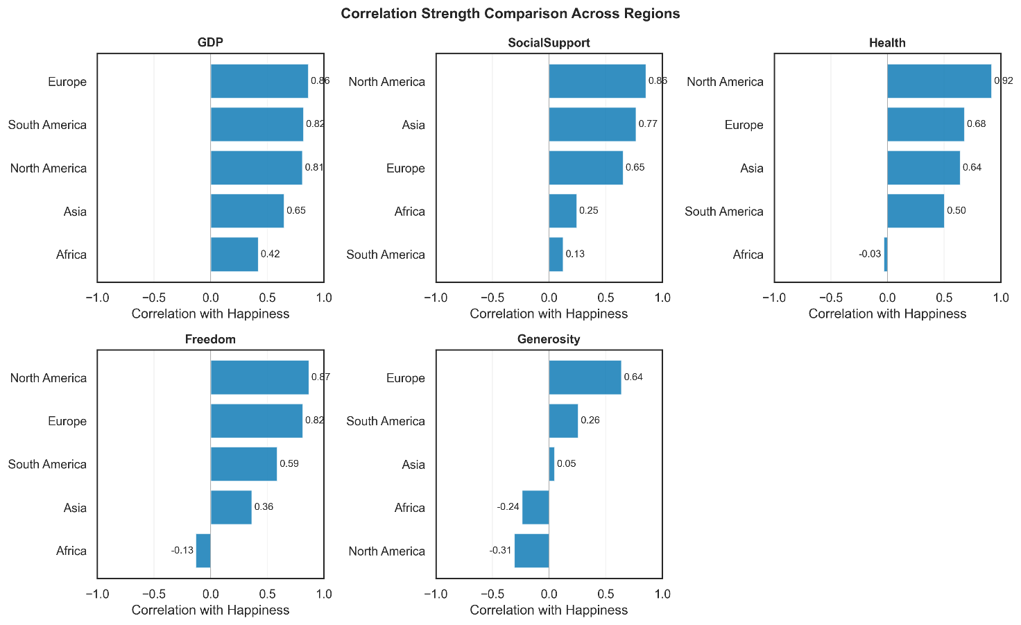
Freedom emerges as the most region-dependent factor, with its importance varying significantly based on geographic context. Social support maintains its position as the most reliable predictor regardless of region. The visualization makes immediately apparent which factors matter most in each region: social support dominates in all regions, while GDP matters more in North America and Europe than in Africa or Asia.
Visualization 3. Summary Heatmap
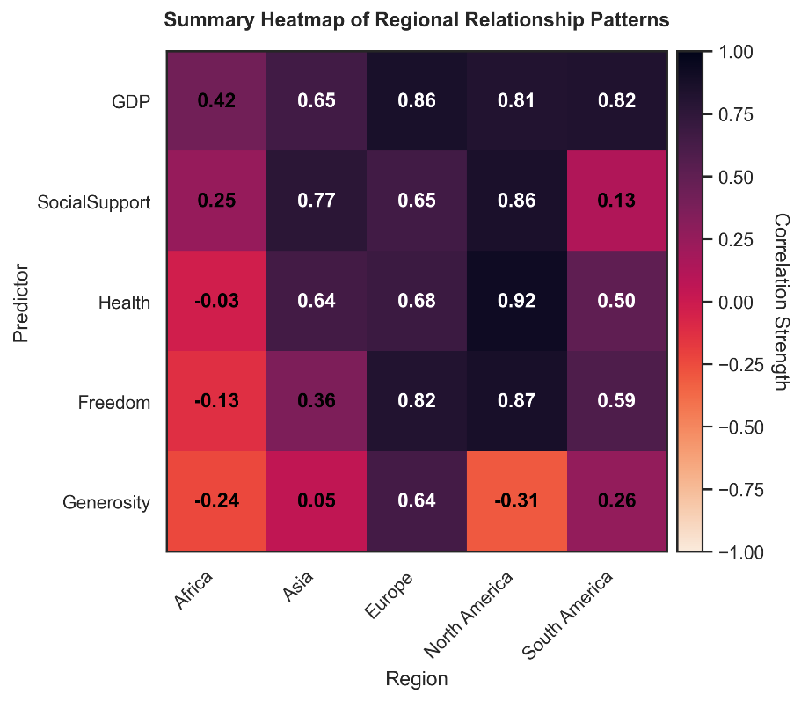
This visualization directly answers RQ2 by showing that predictors do indeed work differently across regions. The heatmap format excels at revealing two key insights simultaneously: which predictors are universally important (social support) and which are highly region-dependent (freedom). This has important implications for happiness policy—what works in Europe may not work in Asia, not just in magnitude but in which factors matter at all.
Additional Insight:
The "top factor per region" analysis derived from this heatmap reveals:
- Europe & North America: Social Support (strongest correlation)
- Asia & Africa: Social Support (strongest correlation)
- South America: GDP (strongest correlation)

Discussion and Interpretation
Detailed interpretation of each visualisation
Draw meaningful conclusions from the visualisations
Include proper citations following the IEEE format
Create an engaging narrative connecting visualisations
Provide a summary of findings and limitations

Conclusion (Storytelling Closure)
Insert text here.
In this section, the analysis approach and general findings are summarised.
Summarise findings from visualisations and statistical analyses, focusing on major trends and relationships within the data, drawing meaningful conclusions from the visualisations.
Address potential limitations or biases that may have affected your analysis and consider alternative explanations for the findings.
End with concluding remarks/paragraphs synthesising the insights gained from the analysis.

References
Insert the list of your references here.

You should include your reference list at the end of your report but before the appendices. You must ensure you use the appropriate IEEE format for your subject area.
Your referencing must use the IEEE referencing style IEEE Citation Guidelines.
It is highly recommended that you use reference management software such as RefWorks that is provided by the university.
It is your responsibility to ensure that you have actually read all the material you reference, and that the references provided in your report are legitimate and NOT AI-generated.
A Note about EndNote
If you are using EndNote for your references, your reference list will initially appear below the appendix. You can cut and paste it to References.

Below this line is a hidden Section Break (Next Page). DO NOT DELETE THIS!
You can see hidden elements by using the Show/Hide option () on the home ribbon.

Appendices
Place any supplementary data, code, or additional visuals in the appendices.
Note that Appendices are optional and should only include information supporting your main report.
Appendices appear after references.
Appendices are additional information and should not be considered as a part of your report.
Refer readers to an appendix using phrases such as “see Appendix A for further details”.
Use the Heading back matter style for the headings of appendices.
You need to delete these guidelines but leave the rest of the page black with “Appendices” at the top.

Appendix A: Title
Insert text here.

Appendix B: Title
Insert text here.

