# Adventure Works Cycles Production Forecasting Analysis for Coming Year

# Christine Baxter, Data Analyst

# Baxter’s, LLC

# Findings and Recommendations

The objective of this analysis was to determine what production mix of Touring Bikes will generate the most gross profit for Adventure Works Cycles (AWC) this coming year while satisfying all given constraints as well as a recommendation on how many units of the new BMX-9000 model should be produced based on a simulation. AWC has committed to their distributors that it will produce at least 50 Touring-1000 models, 10 Touring-2000 models, and 10 Touring-3000 models. With all three Touring bikes being produced at the same factory (by same group of workers), the company’s business plan limits the budget and labor hours available for the Touring Bike subcategory. Lastly, the BMX-9000 model is not under the same constraints as the existing Touring Bike models since it is a new product line; however, demand for this new product is uncertain.

The Touring Bike analysis accounted for the maximum number of labor hours (2000) and the total material production costs ($40,000) allocated for the coming year. When analyzing the new BMX-9000 model, the marketing department’s best projections for full-price sales (100 units) with standard deviation (30 units) and per unit profits ($500) and loss (-$100) values were included within the analysis process.

According to the Touring Bike analysis, the best production mix to meet distributor commitments, to meet the company’s budget numbers, and to achieve the highest gross profit is to reduce the Touring-1000 model production by 36% (producing 50 bikes versus 79 bikes), decrease the Touring-2000 model production by 45% (producing 13 bikes versus 24 bikes), and increase the Touring-3000 model production by 67% (producing 82 bikes versus 27 bikes). Please note the above solution produces the highest gross profit margin of $74,215. The following table details the lower limits of the range while still meeting constraints.

Table . Upper and Lower Range for Touring Bike Production

|  |  |  |  |  |
| --- | --- | --- | --- | --- |
| **Lower** | **Objective** |  | **Upper** | **Objective** |
| **Limit** | **Result** |  | **Limit** | **Result** |
| 50 | $74,215 |  | 50 | $74,215 |
| 10 | $72,698 |  | 13 | $74,215 |
| 10 | $53,917 |  | 82 | $74,215 |

Wrapping up the Touring Bikes analysis/recommendations, AWC can re-allocate money and resources to the Touring-3000 model production as it has the lowest material cost per unit, takes 7 hours less to make than the Touring-1000 model, and has a very similar 41% profit margin as the Touring-2000 models. One last item to note, if the Touring-2000 bike’s gross profit increases by 10% then the production mix for the Touring-2000 and Touring-3000 Bikes can change to 57 and 10, respectively. With this scenario, the gross profit margin slightly decreases by less than 10 dollars.

The BMX-9000 production forecast analysis shows that producing 100 units would place AWC above $40,000 while producing 120 units of the motocross bike would yield the highest average profit of $44,082. For the full range and further detail, see Figure 1 below.

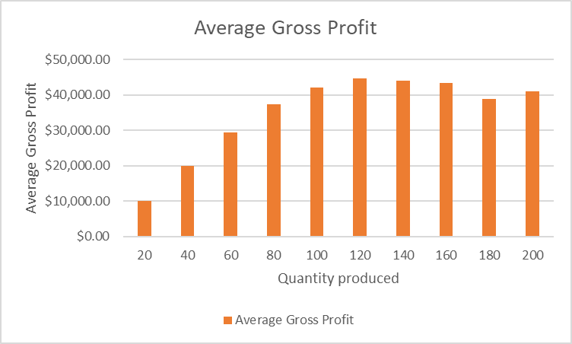

Figure Average Gross Profit for the BMX-9000 New Product Line