Adventure Works Cycles   
Online Sales Data Analysis

Christine Baxter, Data Analyst

Baxter’s, LLC

# Table of Contents

Table of Contents 2

Objective 3

Findings 3

Recommendations 3

Attachments 4

Figure 1: Three-dimensional OLAP Cube 4

Figure 2: Online Sales by Year and by Country 5

Figure 3: Online Sales by Year and by Country 6

Figure 4: Average Customer Lifetime Value, Total Sales, Total Purchases, and Total Customers 7

References 7

# Objective

Adventure Works Cycles (AWC) management and leaders have reviewed financial results showing that online sales have been more profitable this last year. As a result, AWC will use their online sales data, pulled from the company’s enterprise data warehouse, for an analytical review. The main objective of this analysis is to determine additional/new ways to sell more products through the company website, ultimately increasing online sales. An online analytical processing (OLAP) data cube was created and deployed (Figure 1), allowing the sales data to be reviewed from three different multidimensional perspectives (i.e., Product, Region, and Time).

# Findings

Online sales in the United States and Australia have been on a steady rise since 2010. Australia’s online sales did decrease in 2013 (↓19%); however, the remaining country’s online sales numbers are still running 50% lower than Australia (Figure 2). In addition, the Touring Bike product line has substantially less online sales than the Mountain, Off-road, and Sporting Bike product lines (Figure 3). Lastly, for January 2012 through January 2014, the average AWC customer spent approximately $387 dollars during each online shopping session and typically has a business relationship with AWC for an average of 101 days (Figure 4).

# Recommendations

It is recommended that AWC review and compare their Canada, France, Germany, and United Kingdom websites and online sales/shipping processes with the United States branch as it has steadily and consistently increased its online sale activity since 2010. AWC should critically review their Touring Bike product line and possibly discontinue that model allowing the company to put those resources into launching a new product such as the e-Bike (electric bike) and further building out their new Motocross bike line. Engaging and involving customers through online surveys, ramping up social media involvement, implementing machine learning processes to monitor customer comments through the social media outlets, and introducing a customer incentive/rewards program for their online sale activity are additional ways to not only increase online sales but also increase customer loyalty.

# Attachments

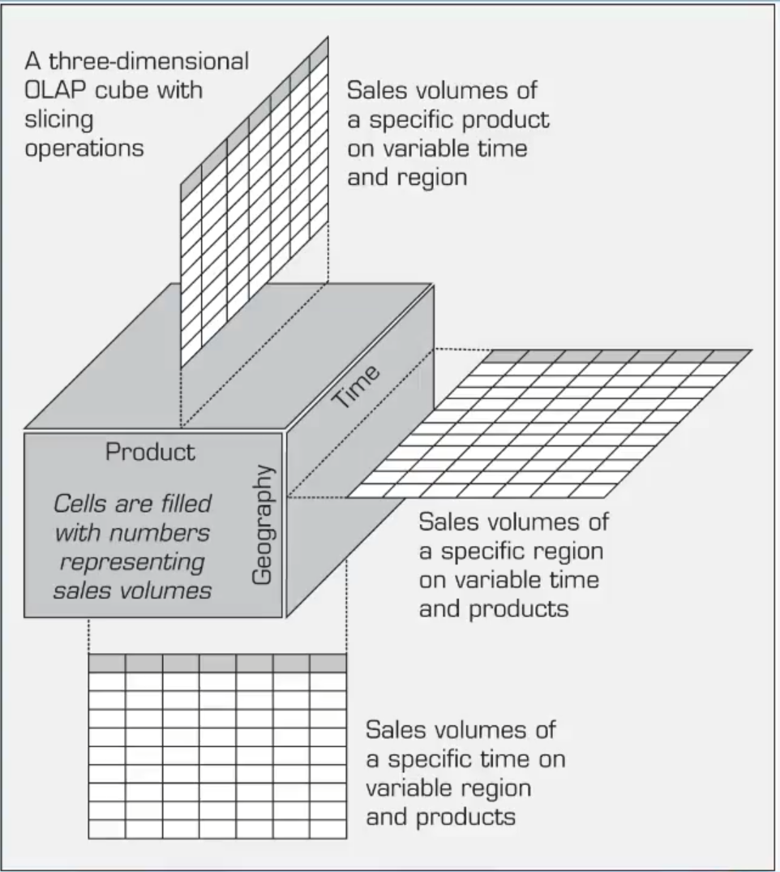

## Figure 1: Three-dimensional OLAP Cube

Source: (Jennings, 2020)

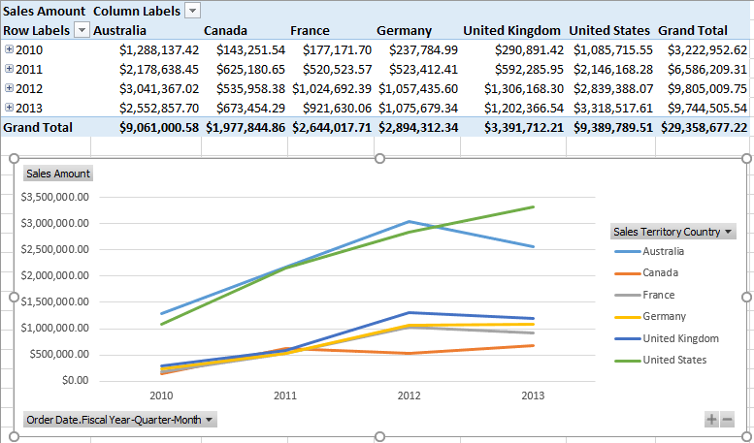

## Figure 2: Online Sales by Year and by Country

Source: (Microsoft, 2016); (Microsoft, 2015)

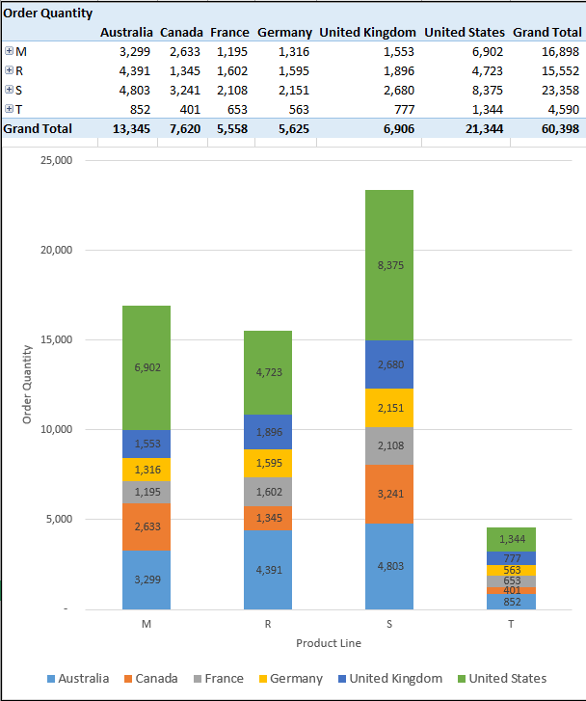

## Figure 3: Online Sales by Year and by Country

Source: (Microsoft, 2016); (Microsoft, 2015)

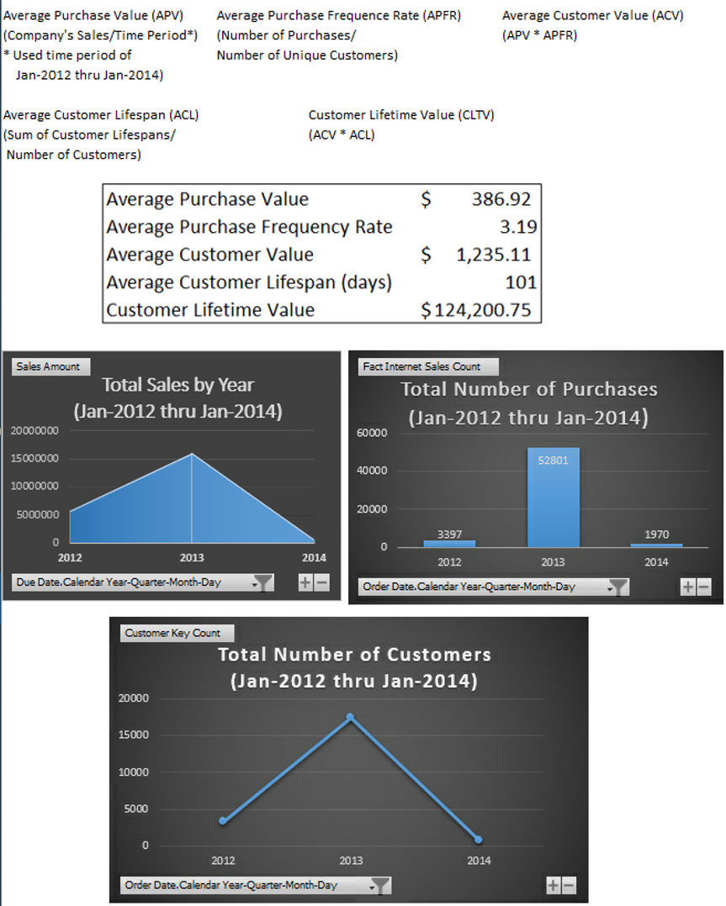

## Figure 4: Average Customer Lifetime Value, Total Sales, Total Purchases, and Total Customers

Source: (Microsoft, 2016); (Microsoft, 2015); (HubSpot. Fontanella, Clint, 2020)

# References

HubSpot. Fontanella, Clint. (2020, October 08). *How to Calculate Customer Lifetime Value*. Retrieved from https://blog.hubspot.com/service/how-to-calculate-customer-lifetime-value

Jennings, D. (2020, November). BIAM500 W5 Lab Part 1. United States of America.

Microsoft. (2015). Microsoft SQL Server 2015 Data Tools. United States of America.

Microsoft. (2016). Microsoft SQL Server 2016 Import Utility. United States of America.