**Step 1: Create Simplified Star Schema in Student Data Warehouse**

f. Capture a screenshot of the result window showing successful completion of the operation, and paste it into a Word document.  
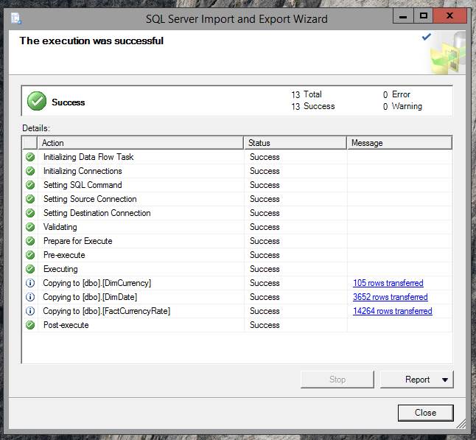

## Step 2: View Data From Related Tables in the Data Warehouse

**f. Capture a screenshot showing data from all three tables (DimCurrency, DimDate, and FactCurrencyRate). Paste the screenshot into your Lab5_yourlastname_Screenshots.docx Word document.**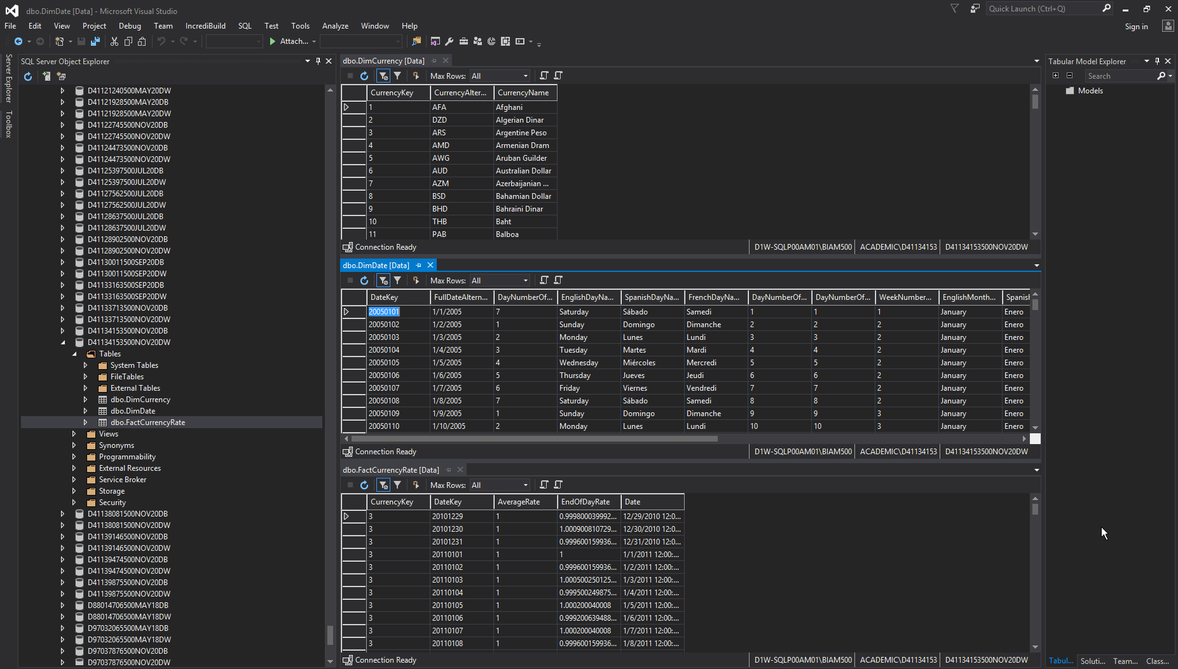

## Step 3: Create and Deploy a Data Cube

Capture a screenshot showing the Internet Sales cube design tab with the central FactInternetSales measure and the surrounding dimensions and a message indicating successful deployment of the cube. Paste the screenshot into your Lab5_yourlastname_Screenshots.docx Word document.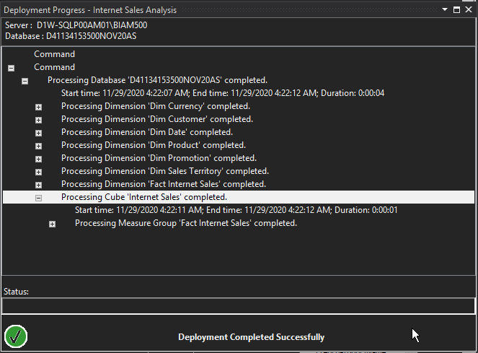

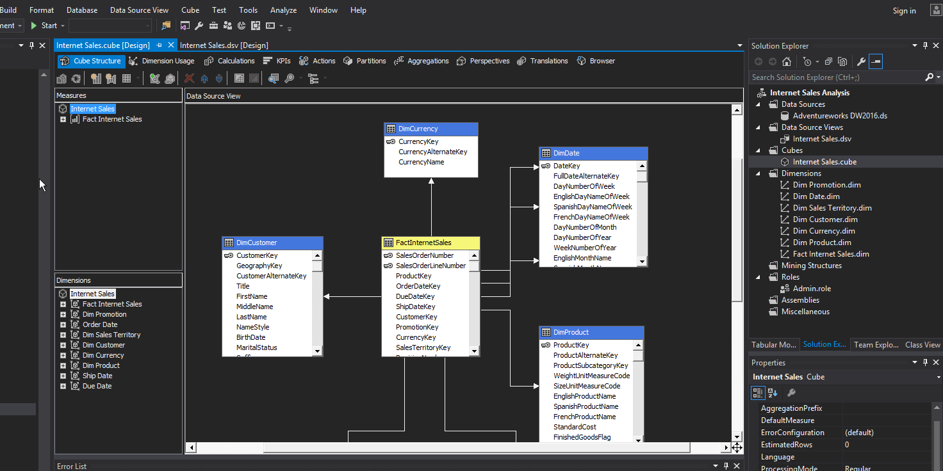

## Step 4: Browse the Cube

**Capture a screenshot showing the pivot table and pivot chart, and paste it into your Lab5_yourlastname_Screenshots.docx Word document.**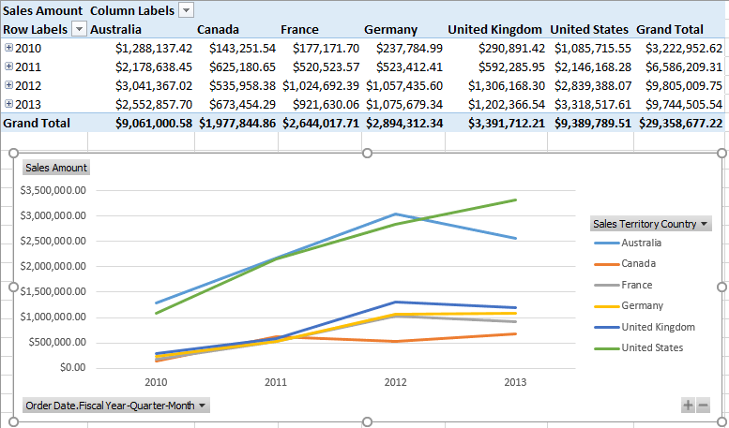

**d.1 On your own: Create at least two additional pivot tables and pivot charts, using different choices for the row and column dimensions. You may use the SalesAmount measure as the values, or choose a different measure. Capture screenshots of these additional pivot tables and pivot charts, and paste them into your Lab5_yourlastname_Screenshots.docx Word document.**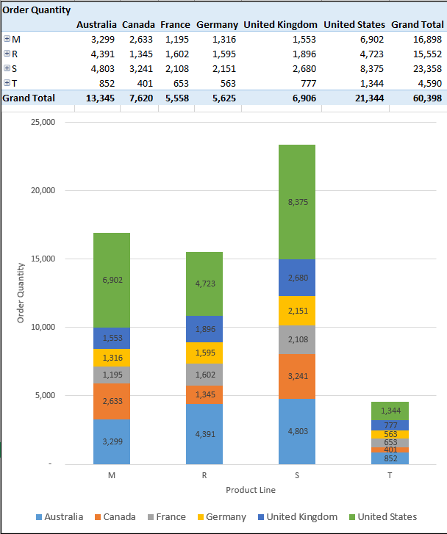

**d.2 On your own: Create at least two additional pivot tables and pivot charts, using different choices for the row and column dimensions. You may use the SalesAmount measure as the values, or choose a different measure. Capture screenshots of these additional pivot tables and pivot charts, and paste them into your Lab5_yourlastname_Screenshots.docx Word document.**