# Week 6 Lab Market Basket Analysis

## Which rules do you think should be used in a marketing program for this scenario? Why? Use the concepts of actionable, trivial, and inexplicable rules in your answer.

For this analysis, it is recommended to use an undirected data mining technique called association analysis in combination with sequential pattern analysis. The association analysis technique works well at locating/discerning patterns within transactional data where a target is not previously specified; whereas sequential pattern analysis will help us determine if one DVD movie purchase leads to another DVD purchase. Standardly, market basket analysis contains point-of-sale transactional data that describes stores, customers, orders, and items which are central to the purchasing experience. Our transactional data includes an order identifier and item name to show what movie(s) were purchased in a particular customer order. If a virtual item for retail location (physical/online) and order date were introduced, further sequential associations could be analyzed. This market basket analysis was conducted using a support of 0.100 and confidence of 0.100 with a minimum length of one. Overall summary of measure averages were 19% support, 52% confidence, and a 1.8 lift value. Below is a list of initial questions/rules identified with an actionable, trivial, or inexplicable rule status.

|  |  |  |  |
| --- | --- | --- | --- |
|  | Question/Rule | Rule Status | Comment/Story |
|  | What was the average order size? | Actionable | Average count is 1.55 or 2 movies |
|  | What movie was purchased most? | Actionable | Patriot was the most purchased movie with a  50% support value and Gladiator next in line with a 38% support value. |
|  | If Gladiator, then Patriot. | Actionable | 38% of all transactions support this rule there is a high degree (100%) of confidence that the right side will be Patriot if Gladiator is purchased with a prediction/lift value of 2. |
|  | Customers who purchase LOTR like fantasy/adventure movies. | Trivial | LOTR movies are high fantasy movies so those who purchase would in fact be fans of the fantasy/adventure genre. |
|  | Customers who like Braveheart purchase more drama DVDs. | Inexplicable | This could be an interesting fact; however, Braveheart was only purchased once, and order detail was dropped from this analysis due to pruning criteria. This rule also does not give insight into the customer as whole. |
|  | Does each customer order contain at least 1 DVD? | Trivial | DVDs are the product of this store so any order would have at least 1 DVD |

## A summary of your marketing program based on the analyzed results. Use the four P's of marketing as paragraphs (Product, Place, Price, Promotion).

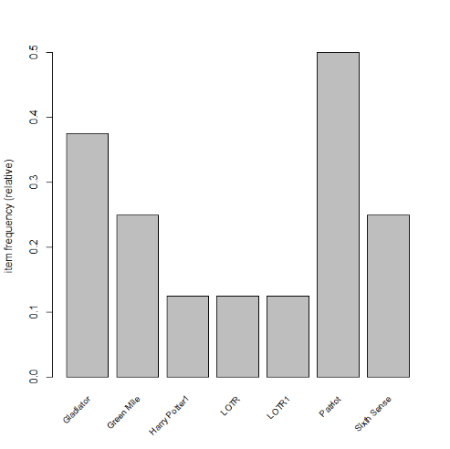Our physical store sells popular, just-released and in-demand movies in a DVD format as well as older movies at a discounted price. The DVDs are displayed by genre and alphabetically ordered so the perfect movie(s) is easily and quickly found by our customer. Our DVDs are of high quality and acquired directly from the creators, enabling extra features such as director’s narrative and scenes that never made it to the final movie.

Figure 1: Frequency of More Common Items by Support Value

To differentiate our stores from others within this market, we propose updating the store itself to have a unique and inviting environment, enabling our customers to get lost in another world….the world of adventure, drama, and action movies. To assist in sales our store would have a custom-tailored inventory for its neighborhood that is based on local demographics; this inventory would be stored and managed in-house using our backroom for overflow storage. Since our movie selection is displayed by genre, we propose adding display and memorabilia pieces into our customer’s surrounding environment that help them transcend into that different world. As an example, for the science fiction and fantasy fans, strategically placed memorabilia and movie excerpts would lead them to that section’s DVDs where they will find many of their favorite movies. As noted in Figure 1 and Figure 2, the data supports the idea of like/similar products selling in groups.

Figure 2: Transactional Data Rules

Our prices are already very competitive and accepted by our customers, so no price changes are planned with this marketing campaign. Monies needed for store updates will come from existing store improvement and upkeep funds. We also found a sponsor that will be donating popcorn for this promotional timeframe.

Ultimately, this marketing campaign includes running an initial two-week buy 1 get 1 half-off promotional period on DVD movies in addition to offering a bag of free popcorn during in-person visits. Fifteen days leading up to promotion, we will use in-store signage as well as social media, email blasts, and word-of-mouth to help promote this exciting event. The goals of this promotion are: (1) encourage customers to return to our store, (2) increase/boost sales, and most importantly, (3) provide our customers a chance to experience this new and exciting world.

# References

R Core Team (2021). R: A language and environment for statistical  
computing. R Foundation for Statistical Computing, Vienna, Austria.   
URL https://www.R-project.org/.

Berry, G.S.L.M. J. (2010). *Data Mining Techniques: For Marketing, Sales, and Customer Relationship Management*. [devry]. Retrieved from https://devry.vitalsource.com/#/books/9781118275603/