# Practical QA Test

**Time Estimate:**

**Q1. 60 Minutes**

# **Q1.** Given the following feature requirements and mock design please create test cases that test all the requirements mentioned below. Every test case must follow the structure:

# Title

# Set of preconditions

# Steps to achieve expected condition

# Expected result

# You can use any application you like but test cases must be easily accessible for Limelight to review (Excel and Microsoft word are also fine).

Requirements:

* A user should be able to create and save a group for use in Limelight’s application
* A group creation page should consist of the following fields to be populated
  + Company Name – Input field, length of the value is 3-50 symbols
  + Zip Code – Input field (Numeric values only – 5 or 6 digits)
  + County – Input field (length 30 letters)
  + SIC Code – Input with search results returned in a dropdown box, any value not from dropdown is invalid
  + Group Type – Dropdown (Prospect, Client)
  + Does this group have over 100 Employees? - Dropdown (Yes, No)
  + Save & Continue – button
* Mandatory fields
  + Company Name
  + Zip Code
  + County
  + Group Type – Dropdown (Prospect, Client)
  + Does this group have over 100 Employees? - Dropdown (Yes, No)
* Optional fields
  + SIC Code
* If a mandatory field is not set then the Save & Continue button should be disabled
* If any field has invalid value, then the Save & Continue button should be disabled
* If all mandatory fields are set the Save & Continue button should redirect a user to the next page (www.limelighthealth.com/nextPage)
* The County field should be automatically populated when a user enters a zip code. You can use <http://www.unitedstateszipcodes.org/> for testing purposes.
* For testing SIC code use <https://www.sec.gov/info/edgar/siccodes.htm> for sample data

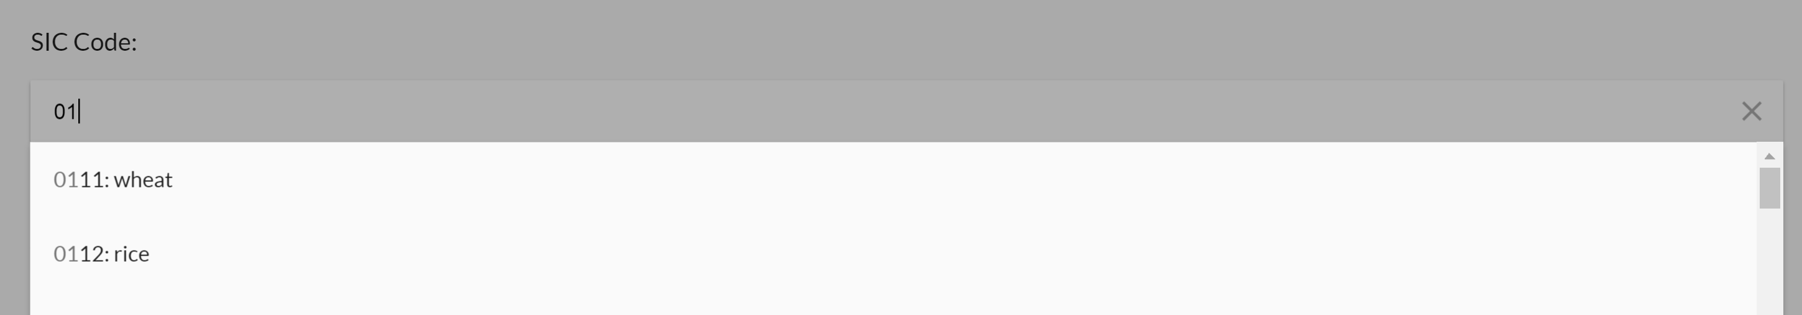The following is an example of the feature in a mock design

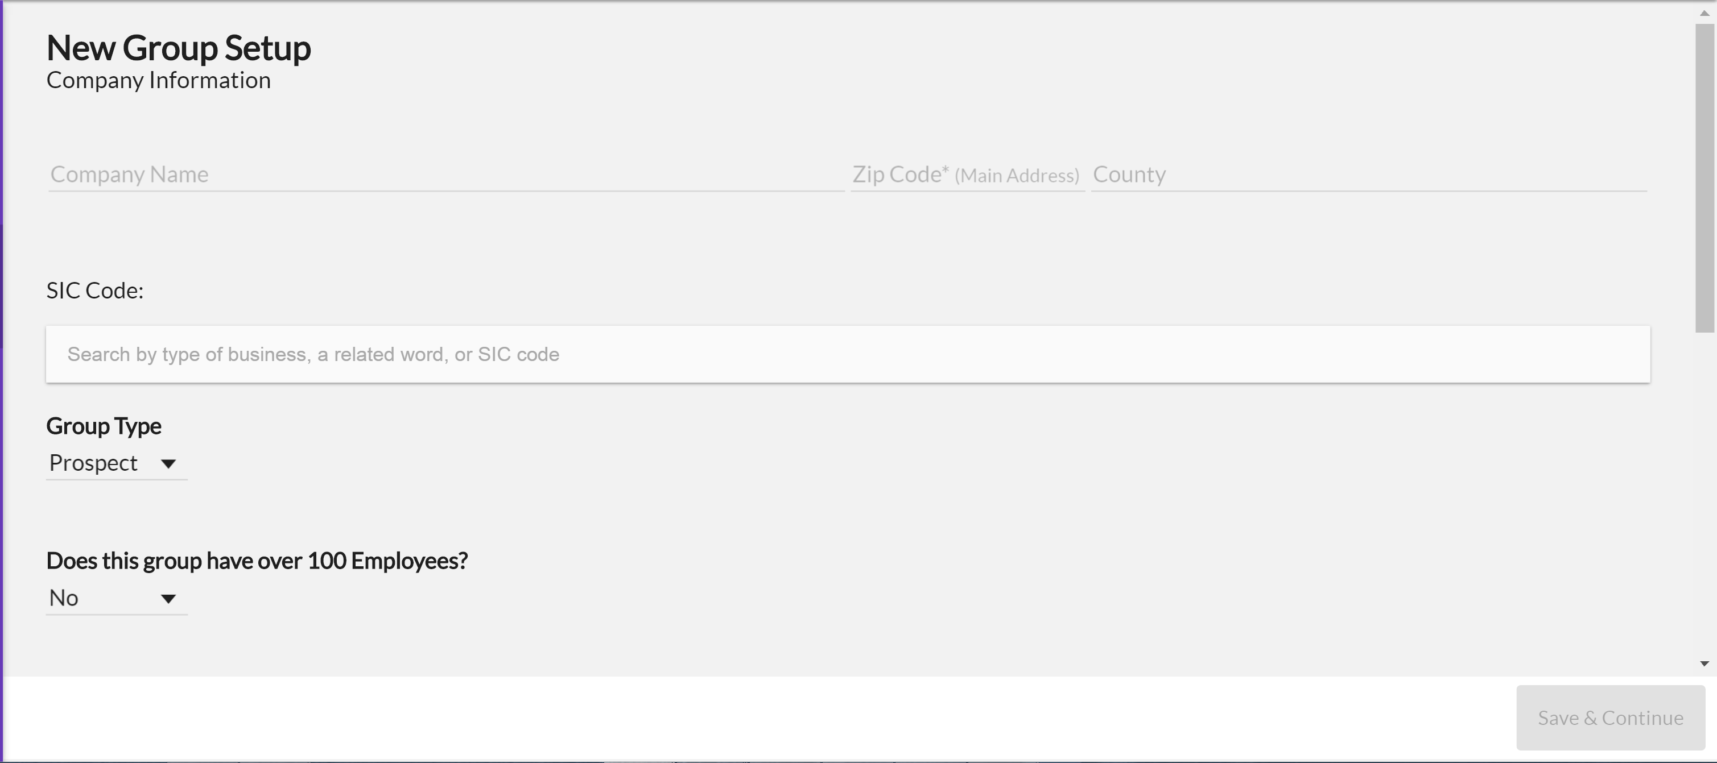

SIC Dropdown design