Sun Vector Azimuth and Elevation Computation

Scope
First draft version - meant for internal use only.

Introduction
The position of the sun is important for several reasons. For one, the terminal should have a sun-exclusion zone to keep the optics safe. Additionally, the sun can be used for mounting offset calibration purposes. However, the computation of the sun’s position is non-trivial. While computations offline can be done directly using planetary ephemerides, these require too much static memory to be used on-board the terminal. Simplified mathematical methods can be used too, and are fit to be used on-board the terminal. However, these result in a lower precision position and still need to be converted to the terminal’s global frame to compute the azimuth and elevation angles. Therefore, in this document, the approximate computation of the sun vector and its interface with the pointing algorithm is described.

Methods
  - Architecture to Determine Sun Vector’s Azimuth and Elevation
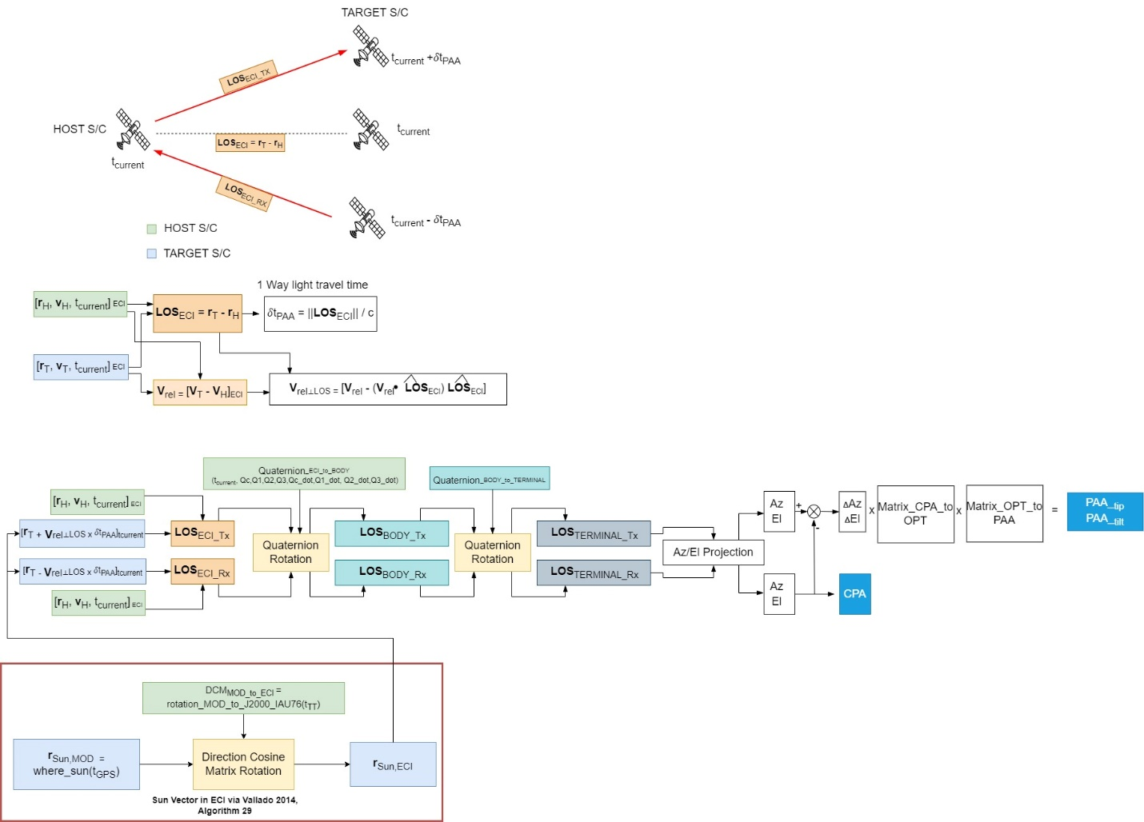
  - Sun Vector in Mean Of Date frame - Numerical Theory Approach
The method follows the description in [Vallado 2014, Fundamentals of Astrodynamics, Algorithm 29]. As the algorithm is originally described, the time input must be Julian Date in Universal Time (UT1). To fit in with Mynaric conversions, a time conversion is added, such that GPS Seconds can be used as the input.
Thus, the only input will be the current GPS time and the output will be the Sun position in Mean Of Date (MOD) frame. A subsequent conversion will be needed to convert the Sun vector to Earth Centered Inertial frame.
The GPS seconds must be converted to Julian Centuries $T_{GPS}$:
$$T_{GPS}=\frac{JD_{GPS}-2451545}{36525}$$

Where $JD_{GPS}$ is the Julian Date in the GPS time-scale, which can be computed as:
$$JD_{GPS}={JD_{GPS,0}+ t}_{i,GPS}/86400$$
Where $JD_{GPS,0}$ is the Julian Date corresponding to the GPS [s] start date (1980-01-06 00:00:00 UTC, matching with GPS, later offset by number of leap seconds since 1980). $t_{i,GPS}$ is the number of GPS seconds at the current time. The Julian Date at GPS,0 is equal to 2444244.5.
$$JD_{UTC}=JD_{GPS,0}+\frac{t_{i,GPS}-499-18 }{86400}$$
These allow to compute the relevant Earth Equator - Sun Ecliptic plane angles in degrees:
Mean longitude of the Sun:
$$λ_{S}=280.46+36000.771 T_{GPS}$$
Mean anomaly of the Sun: (must be reduced to 0:360 degrees)
$$M_{S}= 357.5291092+35999.05034 T_{GPS}$$
Approximate ecliptic longitude:
$$λ_{ecl}= λ_{S}+ 1.914666471 * sin\left(M_{S}\right)+ 0.019994643 sin\left(2 M_{S}\right)$$
Obliquity of the ecliptic:
$$ϵ= 23.439291 - 0.0130042 T_{GPS}$$
Which are all used to compute the normalized Earth-Sun vector in MOD:
$$r_{Sun,MOD}=\left[\begin{matrix}\cos\left(λ_{ecl}\right) \\ \cos\left(ϵ\right)\sin\left(λ_{ecl}\right) \\ \sin\left(ϵ\right)\sin\left(λ_{ecl}\right)\end{matrix}\right]r_{Earth_to_Sun}$$
Where $r_{Earth_to_Sun}$ is the distance from Earth to Sun in Astronomical Units and is calculated using:
$$r_{Earth_to_Sun }= 1.000140612 -0.016708617\cos\left(M_{S}\right)- 0.000139589cos(2M_{S})$$
Finally, the Sun vector is converted to meters by multiplying it with 149597870700 [m/AU] .
  - Rotation of Sun Vector from MOD to ECI
A simplified IAU76 convention approach can be used to get the Precession Rotation matrix. This is used to rotate from MOD to J2000/ECI/GCRF. In the IAU76 conventions, 3 angles are set up to combine the effects of general Precession [Vallado 2014, Section 3.7.3, equations (3-88), (3-89)].

$$ζ= 2306.2181T_{TT} + 0.30188T_{TT}^{2}+ 0.017998T_{TT}^{3} \\ Θ= 2004.3109{ T}_{TT}- 0.42665 T_{TT}^{2}- 0.041833 T_{TT}^{3} \\ z= 2306.2181T_{TT}+ 1.09468 T_{TT}^{2}+ 0.018203 T_{TT}^{3}$$
$$r_{Sun,ECI}=ROT_{3}\left(ζ\right)ROT_{2}\left(-Θ\right)ROT_{1}\left(z\right)r_{Sun,MOD}$$

$$T_{TT}=\frac{JD_{TT}-2451545}{36525}$$
$$JD_{TT}=2444244.5+ \frac{t_{i,GPS}-51.184}{86400}$$

Where
$$DCM_{MOD_to_ECI}=ROT_{3}\left(ζ\right)ROT_{2}\left(-Θ\right)ROT_{1}\left(z\right)$$

$$r_{Sun,ECI}=DCM_{MOD_to_ECI}r_{Sun,MOD}$$

