PAA Unit Tests

Introduction
In this document, unit tests are defined for the Point Ahead Angle (PAA) computations. The Coarse Pointing Assembly (CPA) Pointing angles are also provided.
The states are simulated with the host always starting at [0,0,0] and target at [3000, 0, 0] km ECI. The Terminal/ECI rotation is a unity quaternion (identity matrix rotation) and thus the ECI axes are aligned with Global Terminal Az/El axes.
Later, these inputs/expected outputs shall be implemented as automatic software tests, to be done whenever changes in software are made.

Test File Description
All inputs and outputs are summarized in a single file PAA_tests_inout.csv
A single vector given per input and output.
States include position x, y, z and velocity vx, vy, vz
Attitude given with quaternion and rates. Scalar-first. Set as unity quaternion (identity matrix rotation)
Space ‘ ‘ used as delimited within a single vector- eg [x y z vx vy vz].
Comma ‘,’ used as delimiter between rows
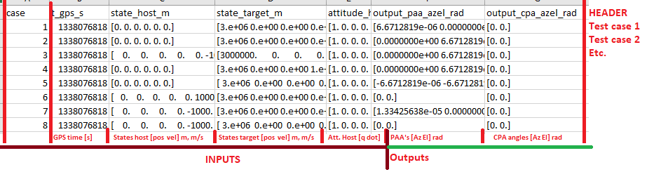
Figure 1 PAA_test_inout.csv explanation

Case Descriptions
Cases 1,2,4,5. Target moving horizontally or vertically. Host stationary
Case 3. Host moving vertically. Target stationary
Cases 6-8. Both moving. Relative velocity either 0 or double of previous cases.
- Target moving along Y. Positive PAA in Az, 0 in El
- Target moving along Z. PAA 0 in Az, positive in El
- Host moving along -Z. PAA 0 in Az, positive in El
- Target moving in X; Z. PAA 0 in Az, positive in El
- Target moving in -Y; -Z. PAA negative in Az, negative in El
- Host and Target moving in Z with 0 relative velocity. PAA 0 in Az, 0 in El
- Host and Target moving in Y with opposite velocities, host -Y, target Y. PAA positive in Az, 0 in El
- Host and Target moving in Y and Z with 0 relative velocity. PAA 0 in Az, 0 in El

Expected outputs for time-series data
  - Case 1. Target moving along Y. Positive PAA in Az, 0 in El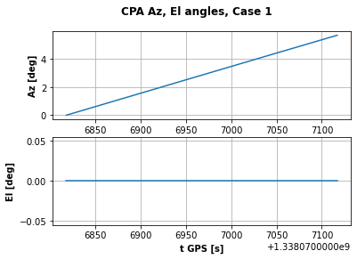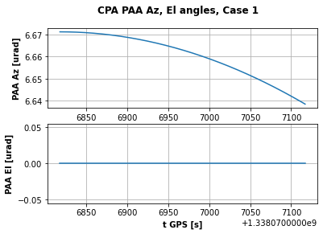
  - Case 2 Target moving along Z. PAA 0 in Az, positive in El
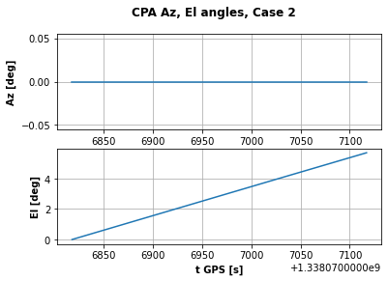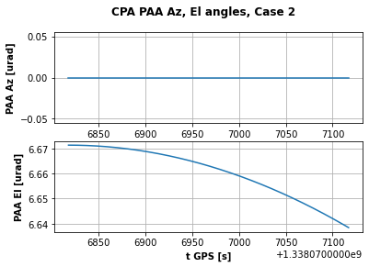
  - Case 3 Host moving along -Z. PAA 0 in Az, positive in El
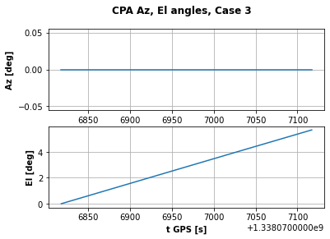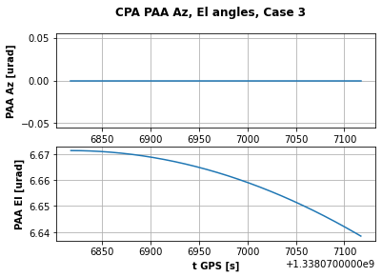
  - Case 4 Target moving in X; Z. PAA 0 in Az, positive in El

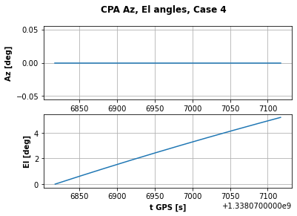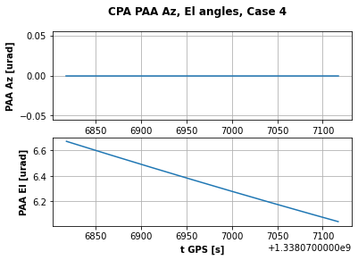
  - Case 5 Target moving in -Y; -Z. PAA negative in Az, negative in El
Note PAA Az almost constant at -6.67 urad
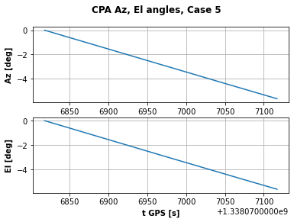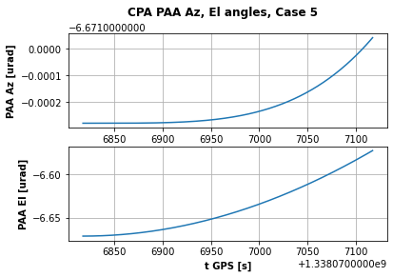
  - Case 6 Host and Target moving in Z with 0 relative velocity. PAA 0 in Az, 0 in El

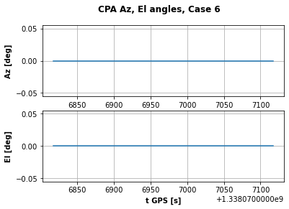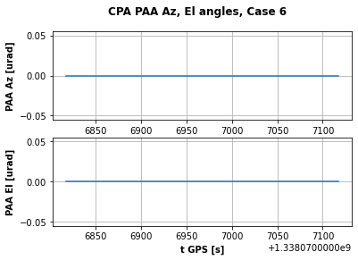
  - Case 7 Host and Target moving in Y with opposite velocities, host -Y, target Y. PAA positive in Az, 0 in El
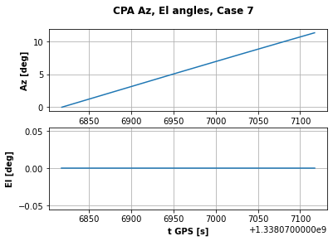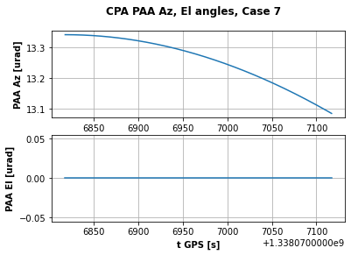
  - Case 8 Host and Target moving in Y and Z with 0 relative velocity. PAA 0 in Az, 0 in El

