HAMILTONIAN QUATERNION ROTATION :
https://www.mathworks.com/help/aerotbx/ug/quatrotate.html -> USES THE OTHER WAY AROUND AS BAYAJID’S
Use Hamiltonian product ham(q,r):
Is it qxr or q*r (where qxr == r*q)
https://math.stackexchange.com/questions/40164/how-do-you-rotate-a-vector-by-a-unit-quaternion
MATLAB
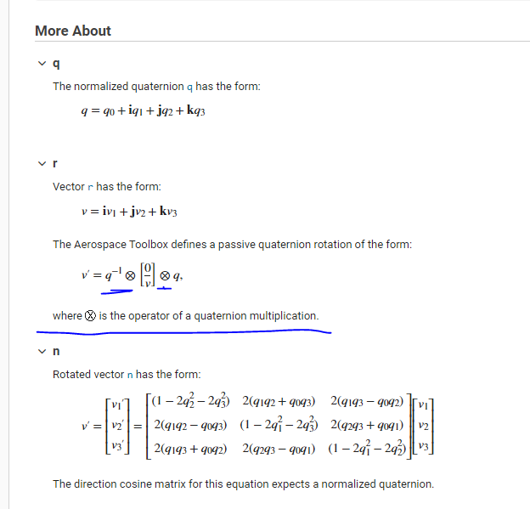
Crassidis 2014 describes both operations:
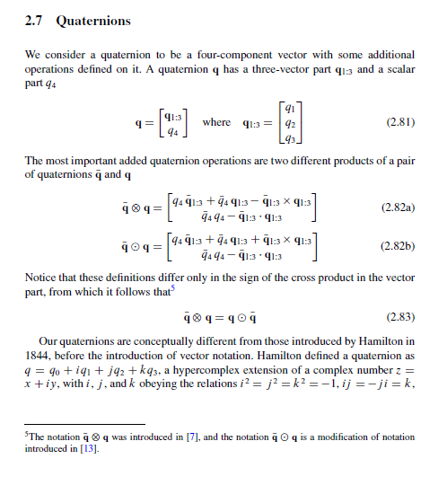
What I see- circle/dot notation is Hamiltonian product and circle/cross – the modified. With the modified one- its q_conj vec q. Dot – q vec q_conj.

