AI ASSISTED CODING
NAME : BAYANA ARJUN ROLLNO:2403A510A9
BATCH : 05 ASSIGNMENT : 17.1

#TASK-1
PROMPT :
Write a python program to Clean raw social media posts dataset.
Instructions:
- Remove stopwords, punctuation, and special symbols from post text.
- Handle missing values in likes and shares columns.
- Convert timestamp to datetime and extract features (hour, weekday).
- Detect and remove spam/duplicate posts.
CODE :
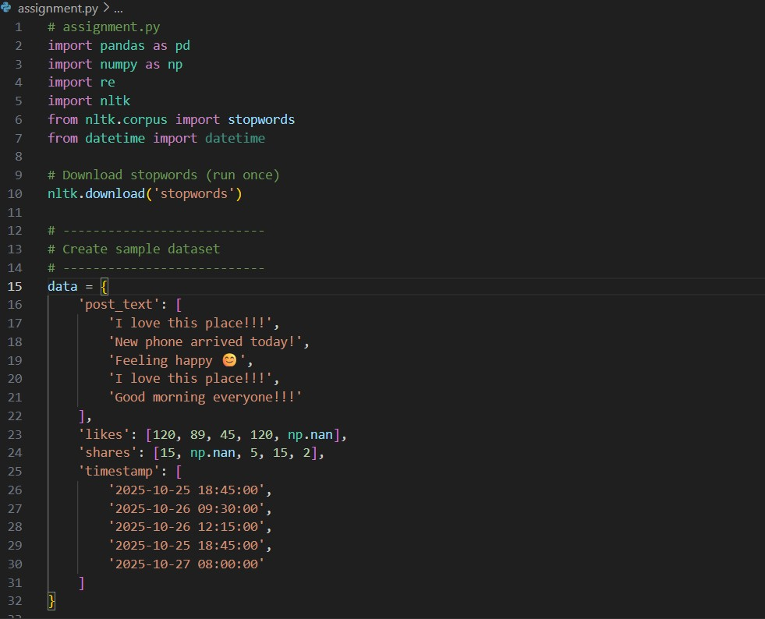
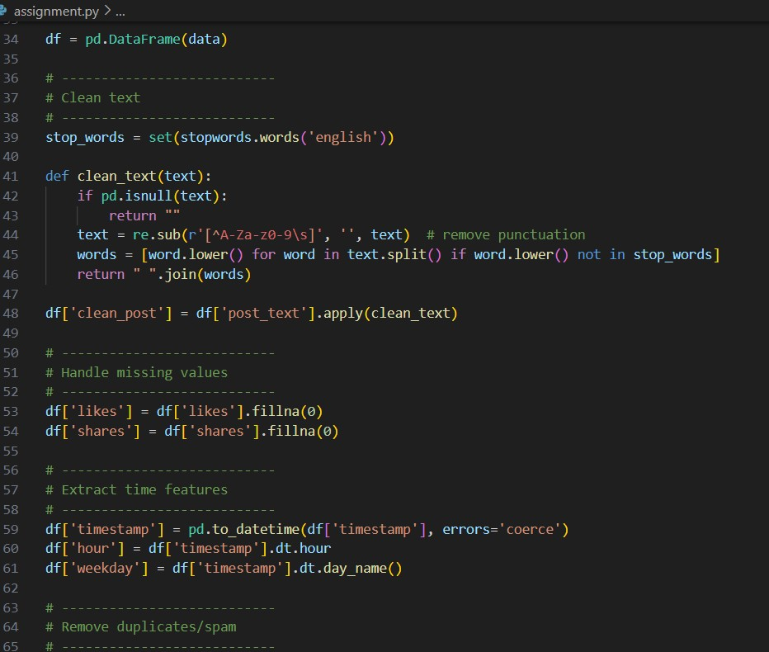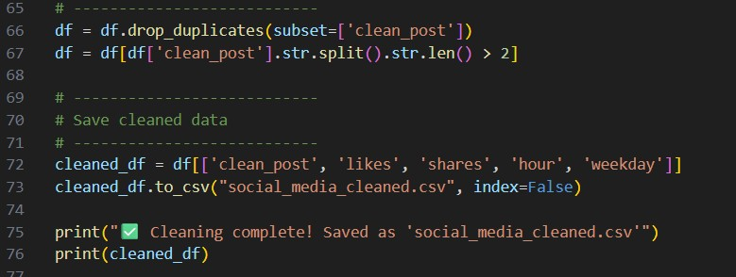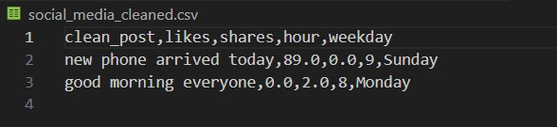

OUTPUT :
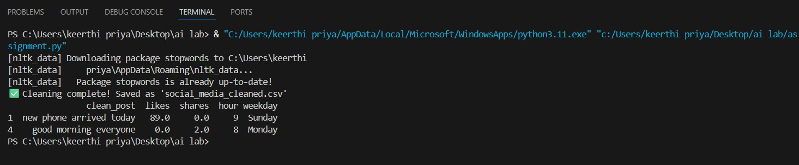
OBSERVATION :
1.Modules used are pandas , re , numpy , nltk and datetime for data clean task
2.nltk stopwords downloaded
- Cleaned the text by removing punctuation, symbols, and stopwords.
- Handled missing values by replacing empty likes/shares with 0.
- Saved the cleaned data into a new file named social_media_cleaned.csv.

#TASK-2
PROMPT :
Write a python program to Preprocess a stock market dataset.
Instructions:
- Handle missing values in closing_price and volume.
- Create lag features (1-day, 7-day returns).
- Normalize volume column using log-scaling. - Detect outliers in closing_price using IQR method CODE :
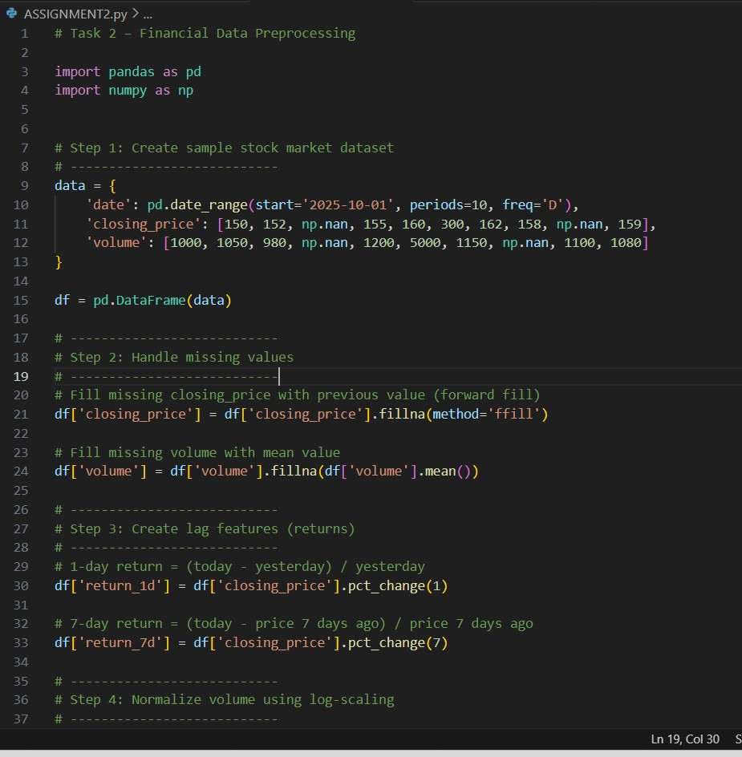
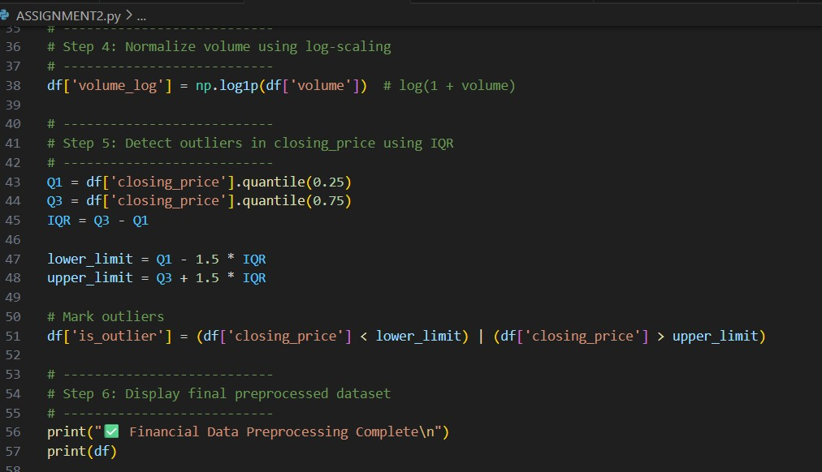
OUTPUT :
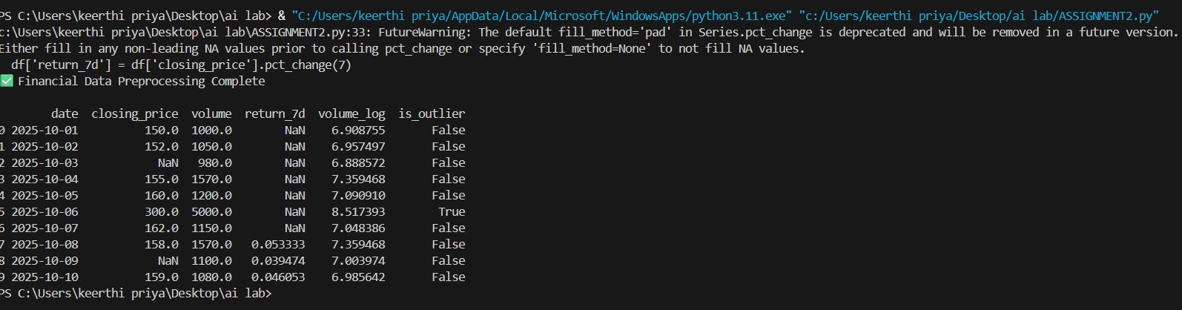
OBSERVATION :
1. Imported pandas and numpy for data handling and calculations.
2.Created a sample stock dataset with date, closing price, and volume.
- Filled missing closing_price using fillna and volume with mean value.
- Applied log normalization to the volume column to reduce skewness.
- Added a new column is_outlier showing whether a price value is unusually high/low.
- Final dataset is clean, normalized, and feature-rich for stock analysis or modelling

#TASK-3
PROMPT :
Write a python program to Clean and preprocess IoT temperature and humidity logs.
Instructions:
- Handle missing values using forward fill.
- Remove sensor drift (apply rolling mean).
- Normalize readings using standard scaling. - Encode categorical sensor IDs.
CODE :
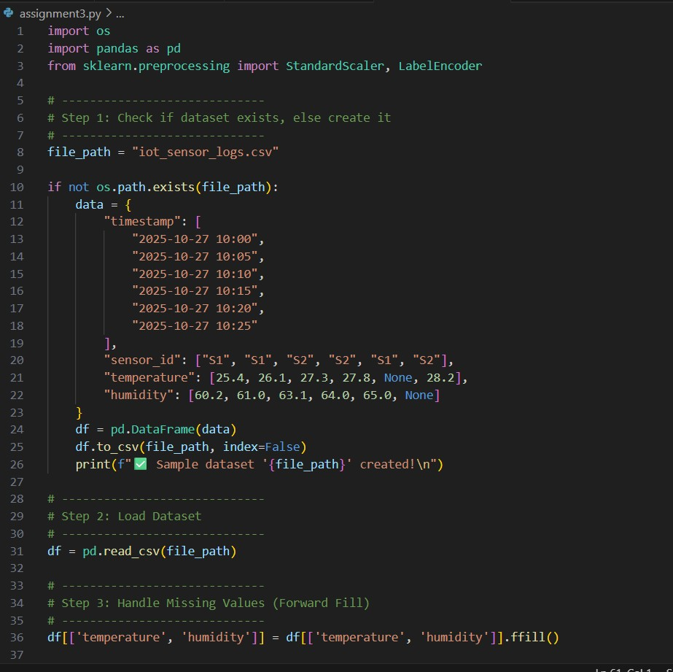
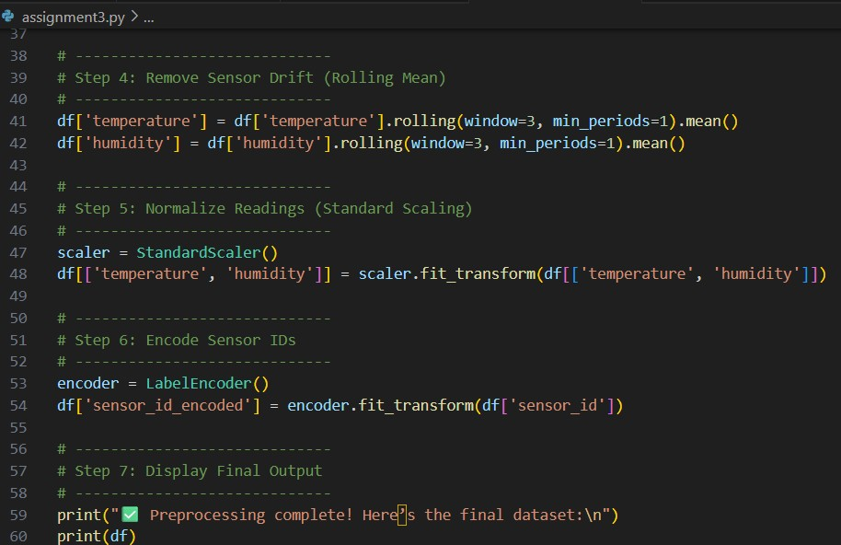
OUTPUT :
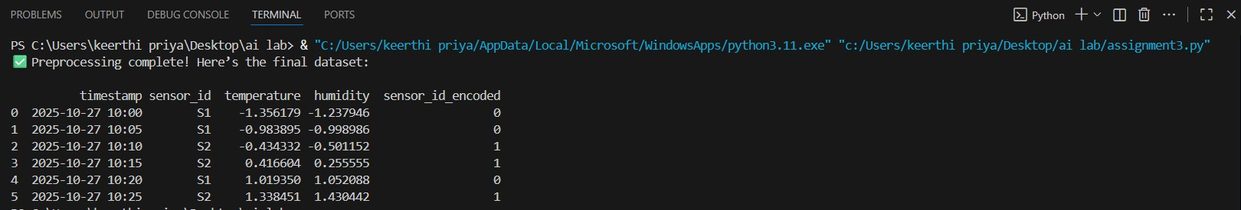
OBSERVATION :
- Missing values were filled using forward fill to preserve temporal continuity.
- Rolling mean removes short-term noise and drift in sensor readings.
3.Standard scaling ensures both temperature and humidity have mean = 0 and standard deviation = 1 (good for anomaly models).
4. Sensor ID encoding converts categorical identifiers into numeric format required for ML algorithms.

#TASK- 4
PROMPT :
A streaming platform wants to analyze customer reviews.
Instructions:
- Standardize text (lowercase, remove HTML tags).
- Tokenize and encode reviews using AI-assisted methods (TF-IDF or embeddings).
- Handle missing ratings (fill with median).
- Normalize ratings (0–10 → 0–1 scale).
- Generate a before vs after summary report.
CODE :
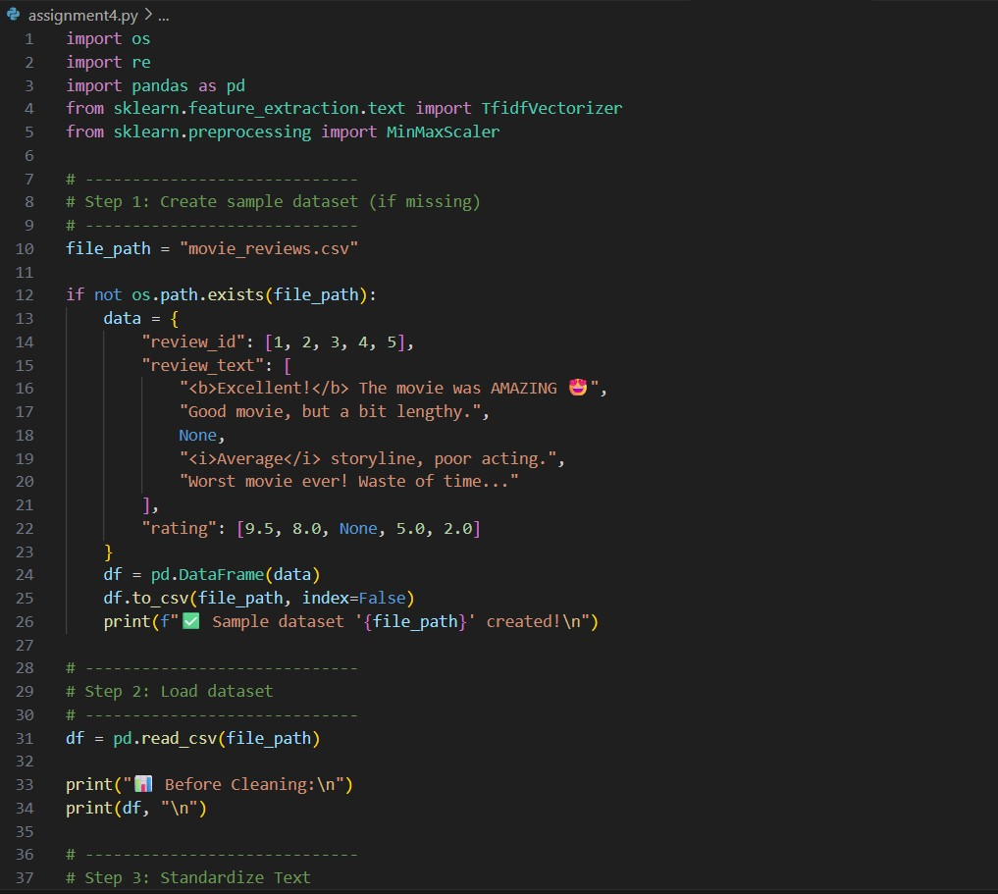
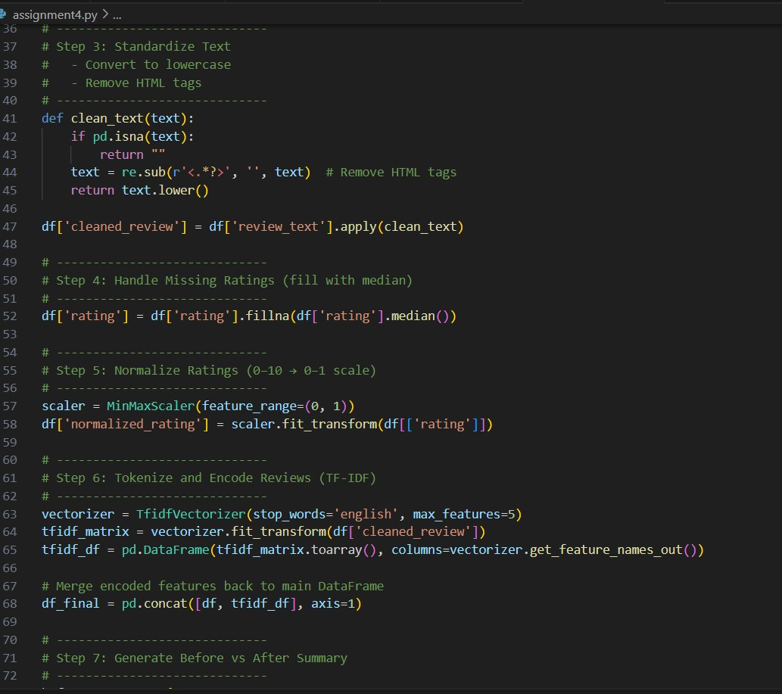
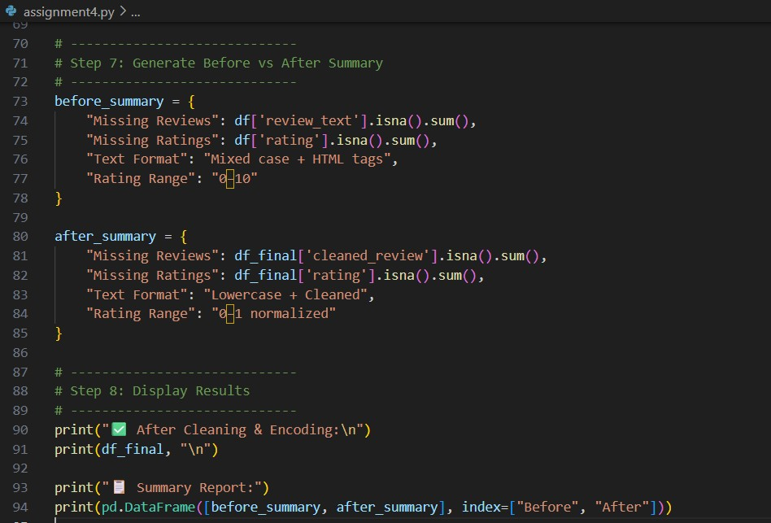
OUTPUT :
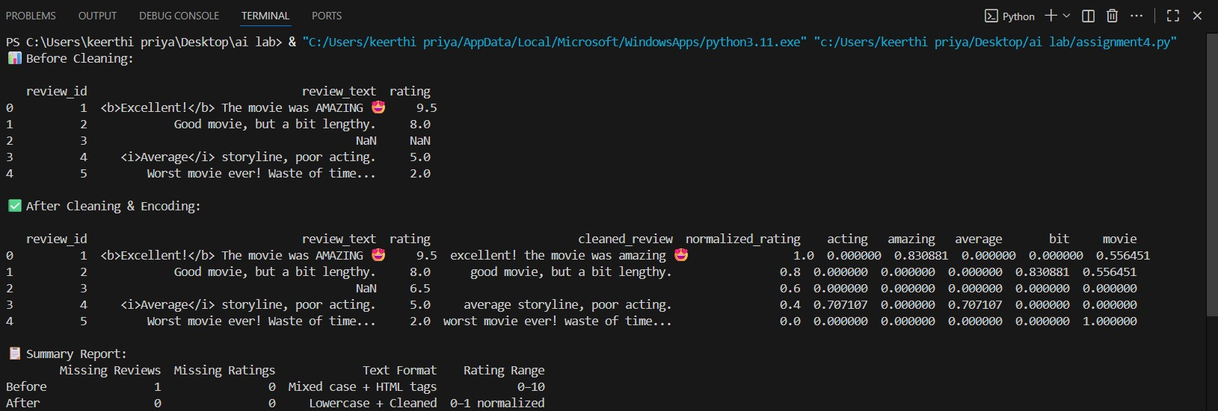
OBSERVATION :
- All reviews were converted to lowercase for consistency.
- HTML tags such as <b>, <i> were successfully removed.
3.Missing review texts were replaced with empty strings ("").
4.Removed inconsistencies in text format and missing values.
5.The final dataset is clean, consistent, and AI-ready for sentiment or anomaly detection tasks.

