LAB10

Create a bucket, upload a file, and retrieve the file name from event object and save the file name as an item { '<yourname>': <yourfile_name>} to a table in DynamoDB. For inserting data to dynamoDB with Lambda, refer to link https://www.geeksforgeeks.org/aws-dynamodb-insert-data-using-aws-lambda/

Upload the sreenshot of your bucket and screenshot of logging in CloudWatch

1. **Create Bucket**

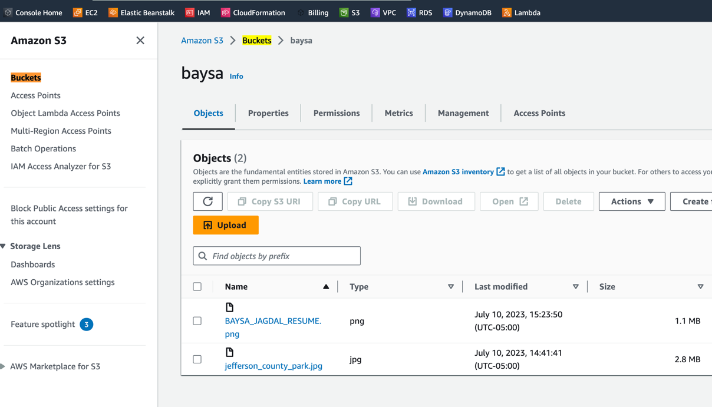

1. **Create Lambda**

1. 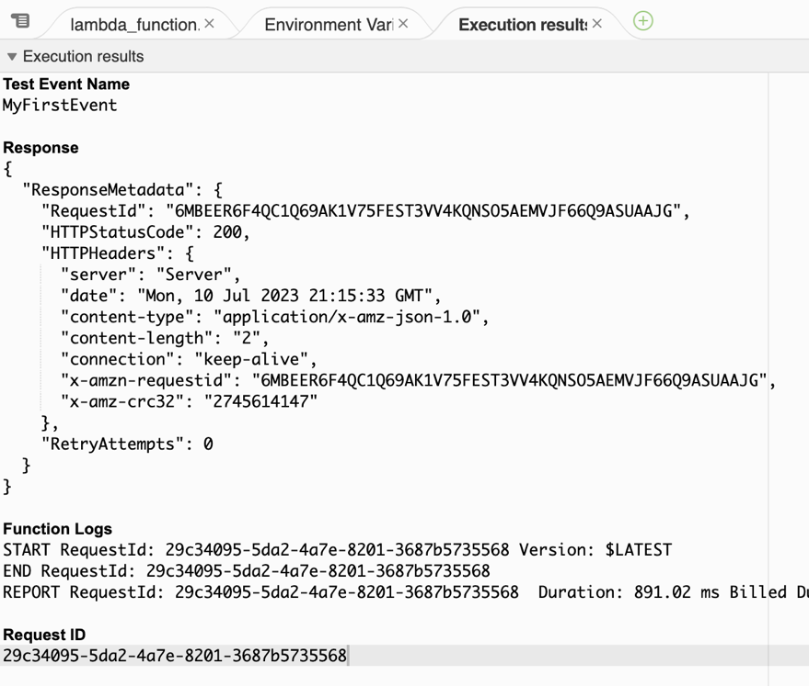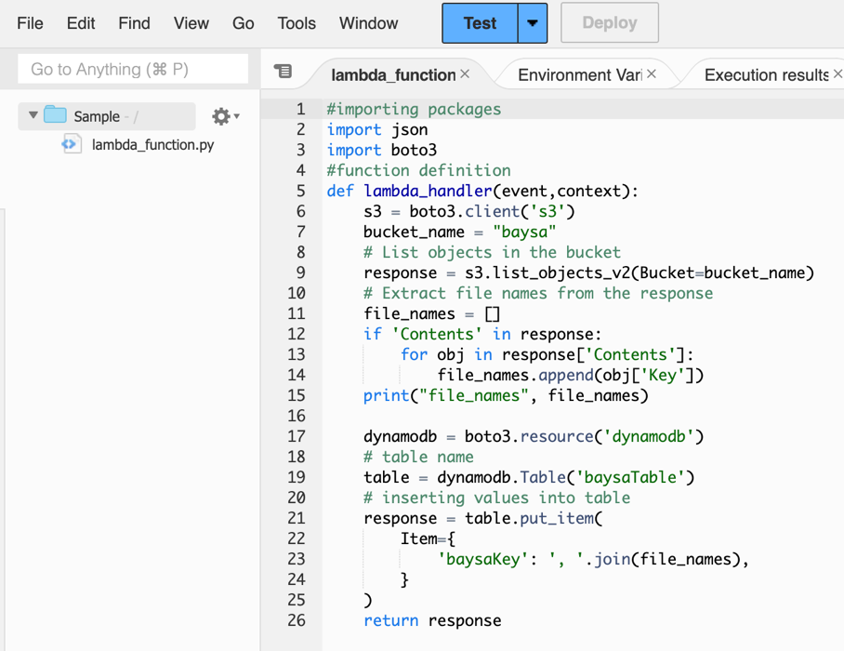**I written some code and run it.**
2. **It automatically works input DynamoDB table.**

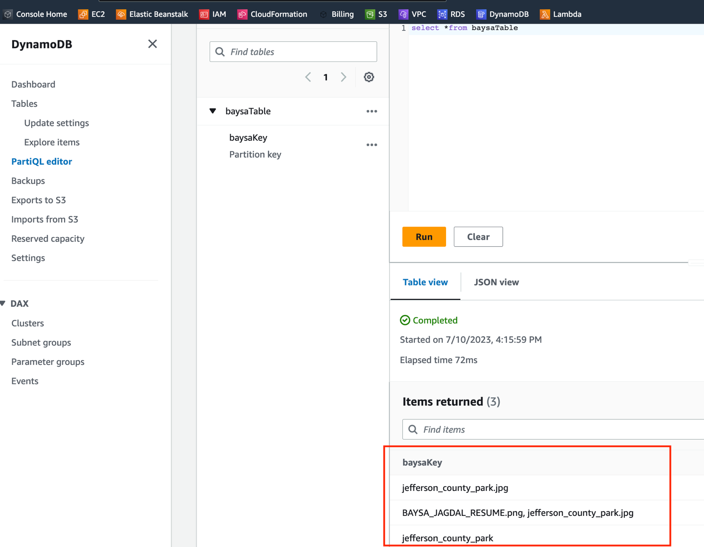

1. **Result one the CloudWatch log.**

