Follow this document https://catalog.workshops.aws/general-immersionday/en-US/basic-modules/30-iam/iam,  complete the experiment, but create bucket name with your name in, then send the final screenshot for testing CLI commands as solution, upload it.

aws s3 ls iam-<your name>

**Create S3 iam-baysa**

**Create user**

**Setting Policy on User**

**Login new dev-user**

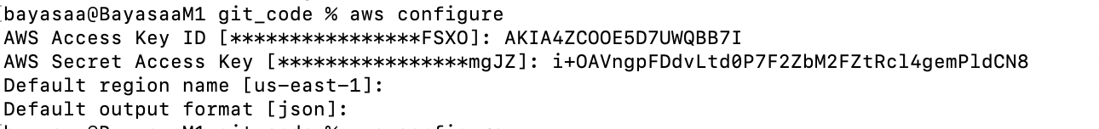

**LAST CHECK USER PERMISSION**

