LAB6

Following the link https://catalog.workshops.aws/general-immersionday/en-US/basic-modules/20-vpc/vpc, upload the screenshot of the VPC instance you created with your name.

**CREATED VPW WITH MY NAME**

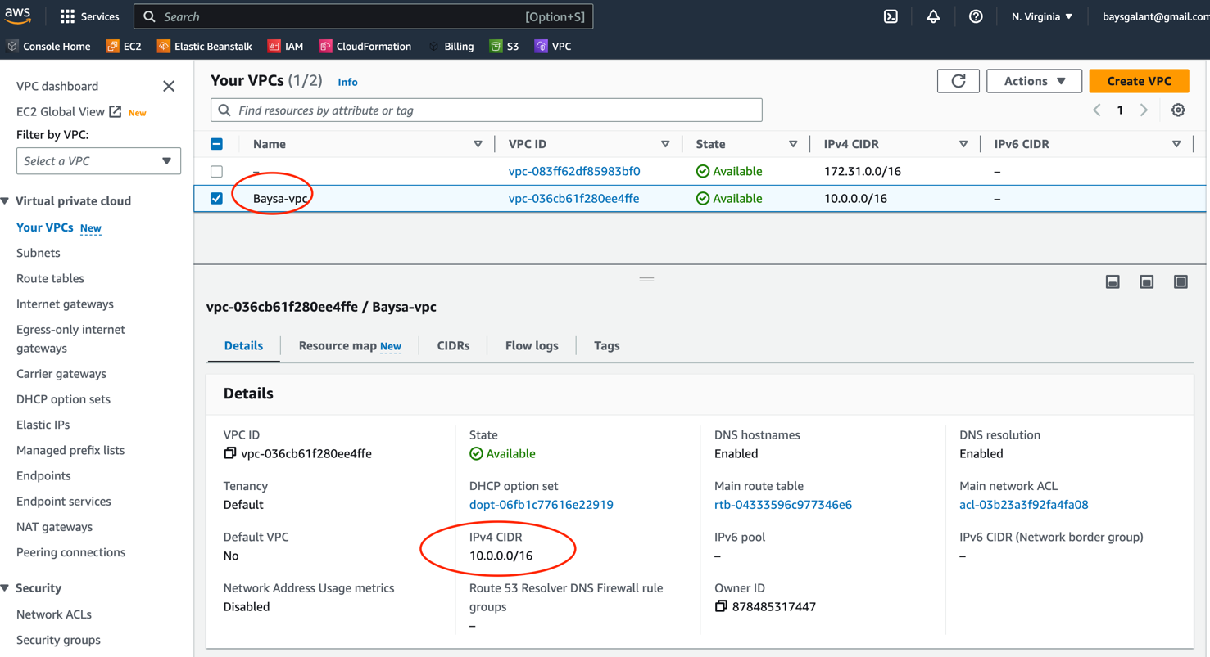

**CREATE ADDITIONAL SUBNET**

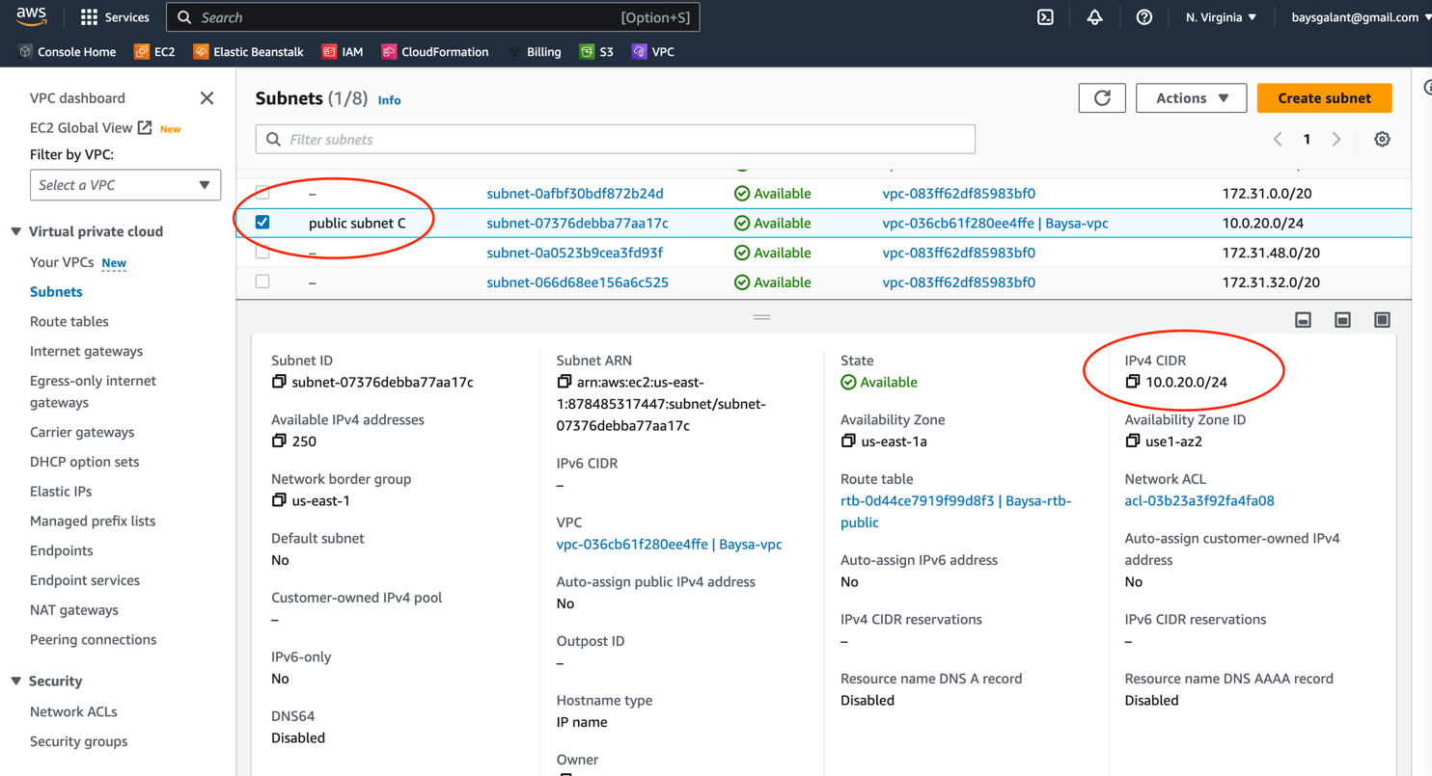

**ALSO CREATED ROUTE TABLE**

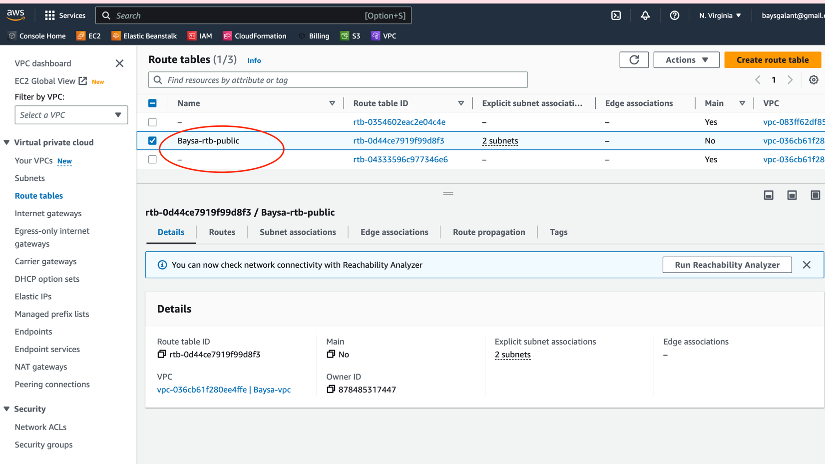

**AND CREATE SECURITY GROUP WITH INBOUND RULES**

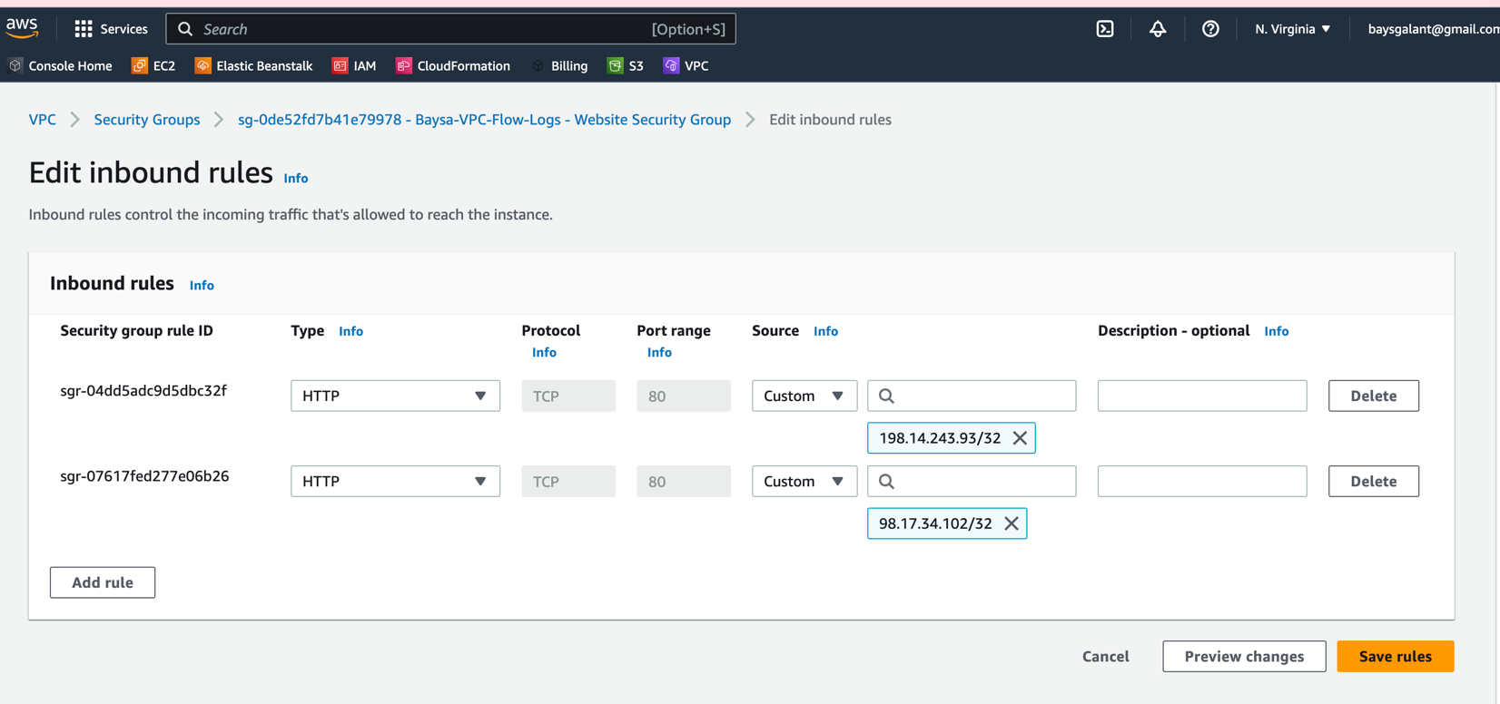

**ALSO CREATE CLOUDFORMATION BY CUSTOM YAML FILE**

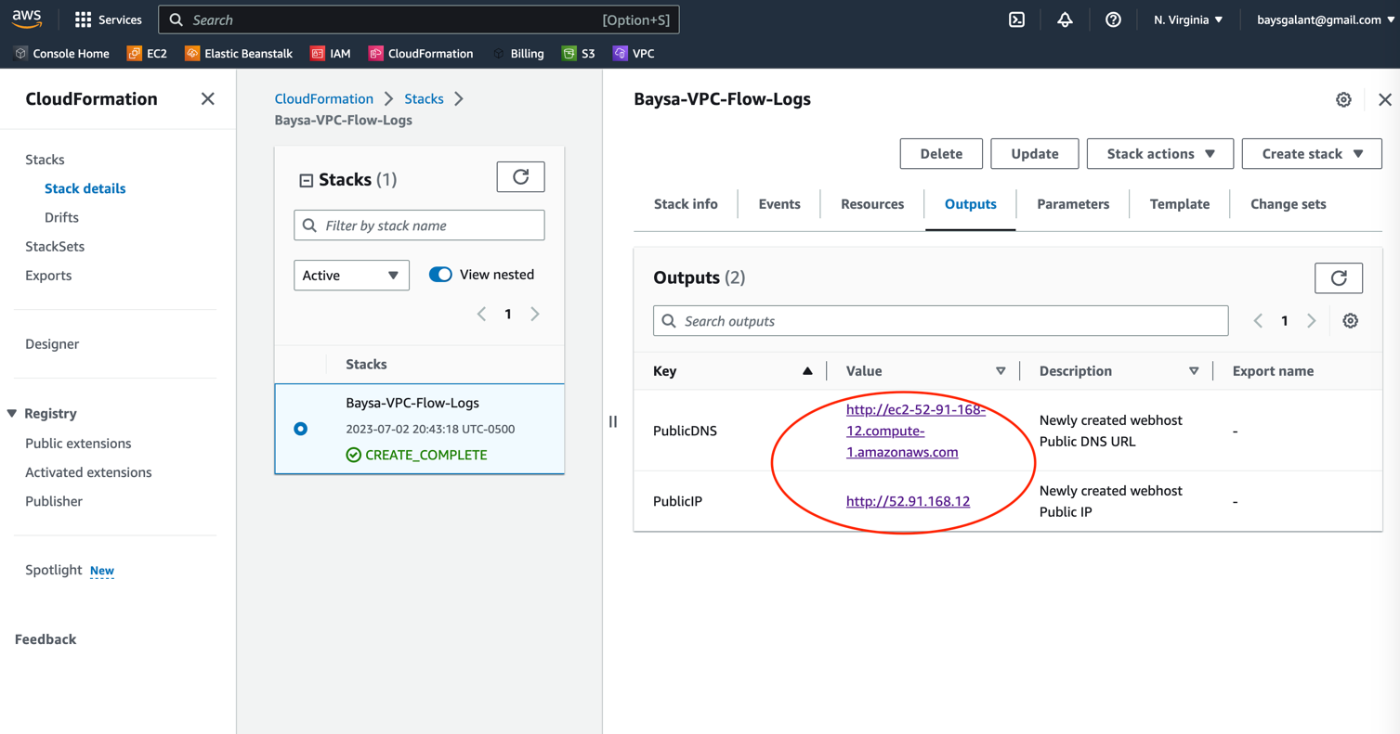

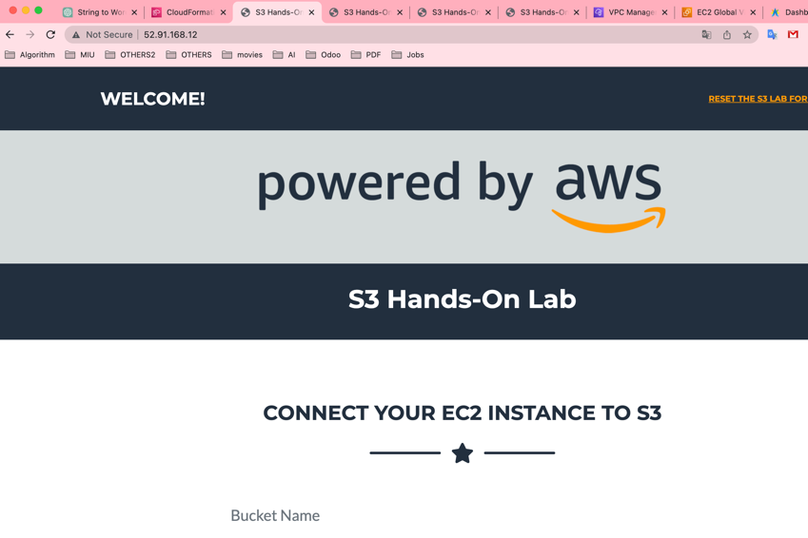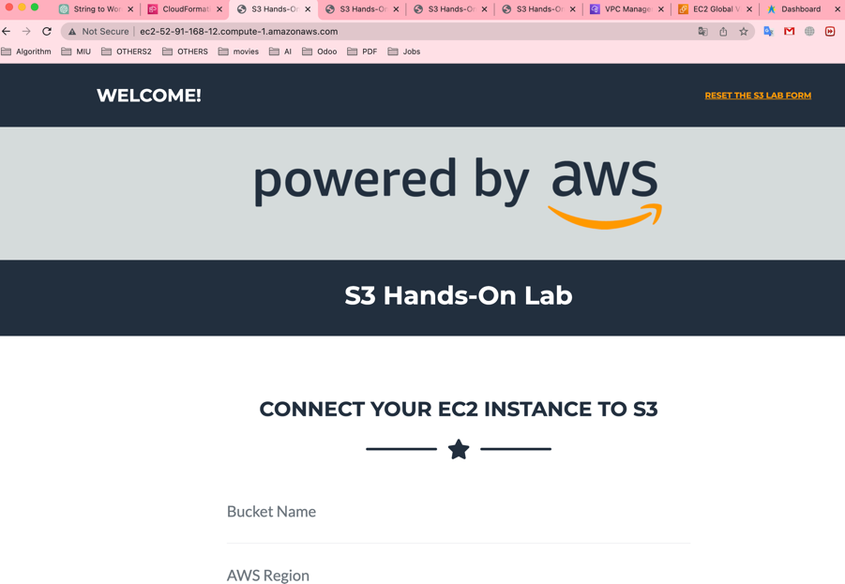**IT CAN SEEING AND IT JUST ALLOW MY REAL IP.**