LAB8

Follow the link https://catalog.workshops.aws/general-immersionday/en-US/basic-modules/50-rds/rds-mysql, perform all operations and use your name as the database name, upload a screenshot your database instance in the table as solution.

1. **First create MySQL Database**

1. **These things was important/Allowed EC2 IP, My Own IP, Publicly avialable/**

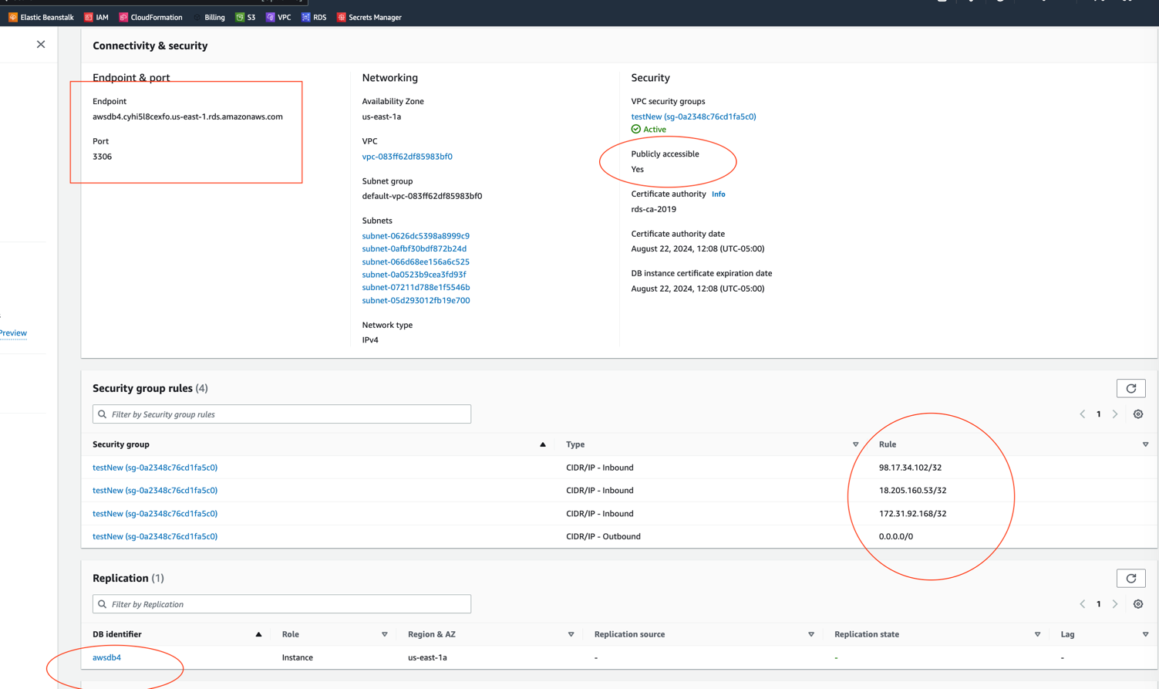

1. **After that I created EC2**

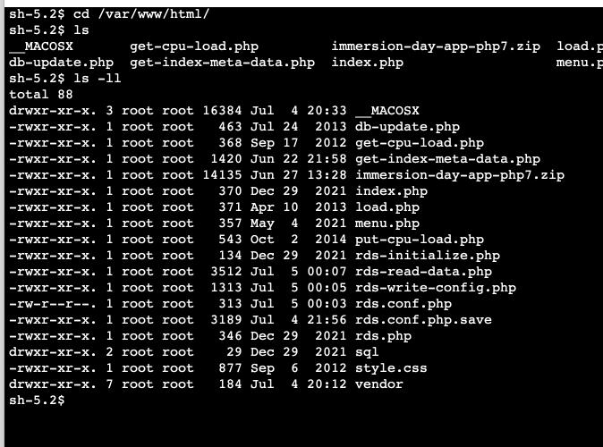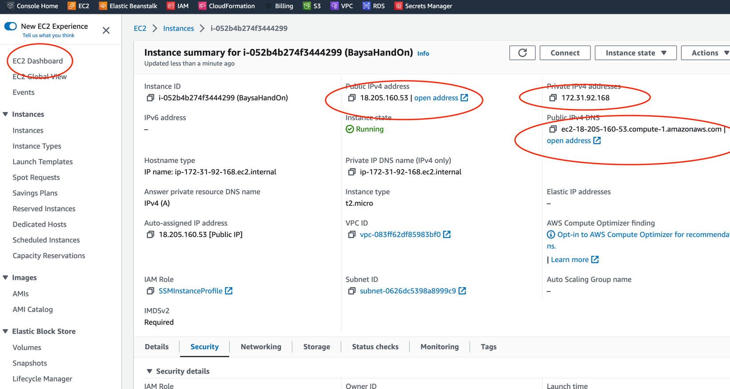

**I changed some code, EC2 instance connected to RDS MySQL.**

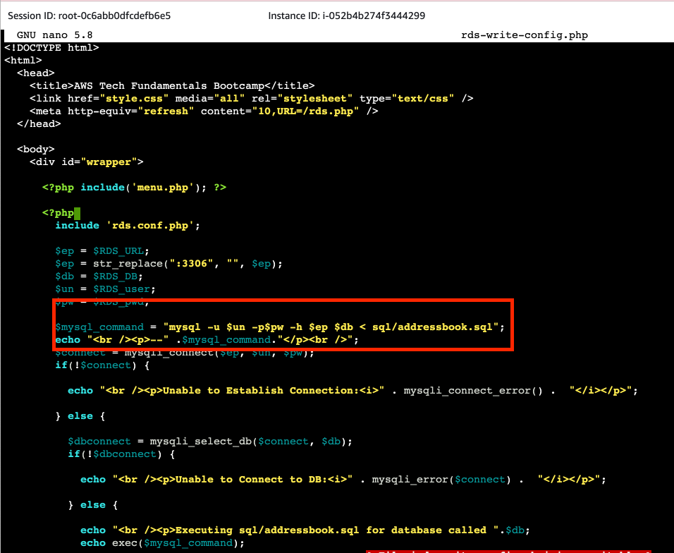

**I can managed database from EC2 web and Local MySQL editor.**

