LAB9

Follow the link https://docs.aws.amazon.com/amazondynamodb/latest/developerguide/getting-started-step-1.html, create dynamoDB table "Music" on Management Console( DO NOT using for other CRUD operation), then use the AWS SDK to write a program to add an item, update an item and delete an item.  Logging out to the console with format "<your name> added item xxxx" "<your name> updated item xxx", "<your name> added item xxxx" "<your name> deleted item xxx", upload the code with screenshot of the logging as solution.

**I created database from SDK.**

Create function

**Update function**

**Delete function**

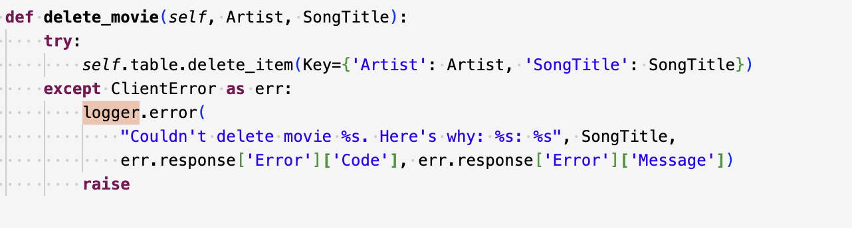

**Input the testing Data**

**Result, Also I attached python code**

